Resource: unfoldingWord® Open Bible Stories
unfoldingWord® Open Bible Stories © 2022 unfoldingWord. Released under CC BY-SA 4.0 license. unfoldingWord® Open Bible Stories has been adapted in the following languages: Tok Pisin, Arabic (عربي), French (Français), Hindi (हिंदी), Indonesian (Bahasa Indonesia), Portuguese (Português), Russian (Русский), Spanish (Español), Swahili (Kiswahili), and Simplified Chinese (简体中文) from unfoldingWord® Open Bible Stories © 2022 unfoldingWord. Released under CC BY-SA 4.0 license by Mission Mutual

unfoldingWord® Open Bible Stories

2. Taim Sin i Kamap Long Dispela Graun

Adam wantaim meri bilong em, ol i stap insait long dispela gutpela gaden God i wokim na givim long tupela na ol i amamas tru. Tupela wantaim i stap as nating, tasol tupela i no sem long tupela i stap as nating, long wanem i nogat sin long olgeta hap long graun long dispela taim. Olgeta taim tupela i save wokabaut insait long gaden na toktok wantaim God.
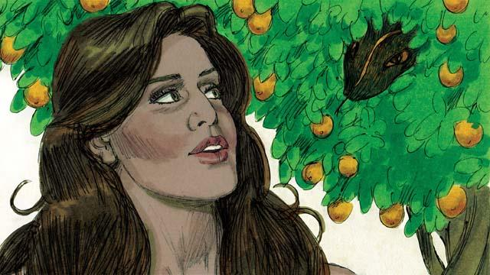
Tasol i bin gat wanpela snek bilong giaman i stap insait long gaden. Na dispela snek i askim meri, “Em i tru olsem God i tambuim yutupela long i noken kaikai pikinini bilong ol diwai insait long gaden?”
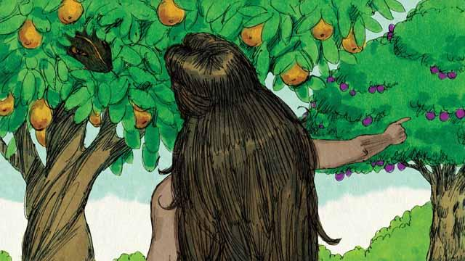
Na meri i bekim tok, “God i tokim mitupela long kaikai pikinini bilong olgeta diwai long gaden. Tasol mitupela i tambu long kaikai pikinini bilong diwai bilong givim save long gutpela na nogut. God i tokim mitupela olsem sapos mitupela i holim o kaikai, mitpela bai i dai.”
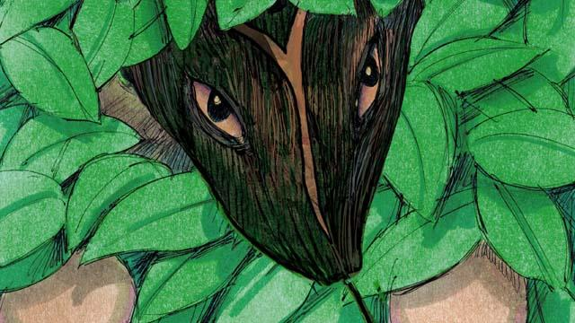
Tasol snek i bekim tok long meri olsem, “Em i no tru! Yuno inap long dai. God i save olsem sapos yutupela i kaikai bai yutupela i kamap olsem em, na yutupela bai save long gutpela na nogut olsem God.”
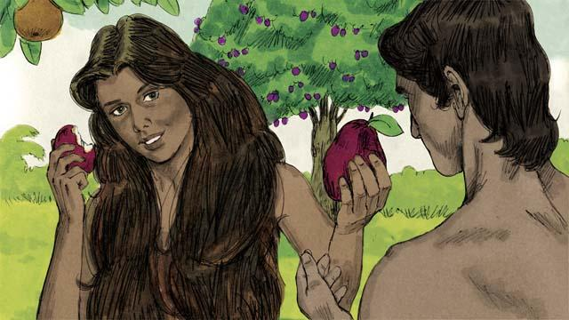
Na meri i lukim olsem pikinini bilong diwai i gutpela na swit moa long kaikai, na tu em laikim tumas long kamap save meri olsem na em i kisim sampela pikinini diwai na kaikai na givim sampela long man bilong em na man tu i kaikai.
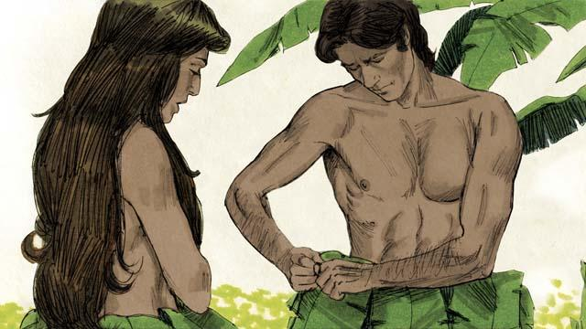
Na kwiktaim ai bilong tupela i op na tupela i luksave olsem tupela i stap as nating na tupela i sem, olsem na tupela i samapim ol lip long pasim na haitim as nating bilong tupela.
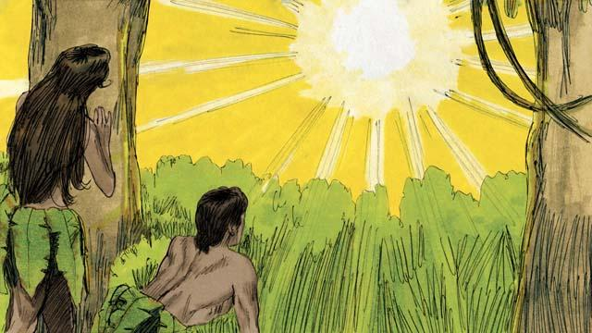
Nau man wantaim meri bilong em i harim nois bilong God i wokabaut insait long gaden, na tupela i hait long God. Na God i singaut long man, “Yu stap we?” Na Adam i bekim tok olsem, “Mi harim yu wokabaut long gaden na mi pret long wanem mi stap as nating. Olsem na mi hait.”
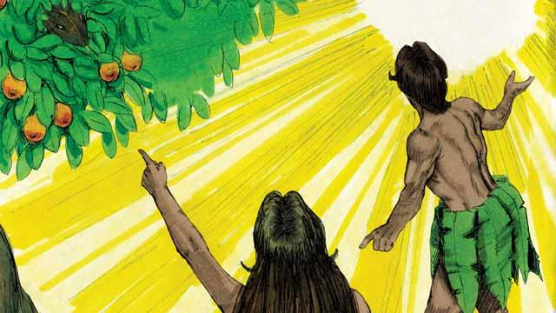
Na God i askim em, “Husat i tokim yu olsem yu stap as nating? Ating yu kaikai pinis pikinini bilong diwai mi tokim yu long noken kaikai.” Na man i bekim tok olsem, “Dispela meri yu givim long mi, em i givim pikinini bilong diwai long mi.” Na God i askim meri, “Meri yu mekim wanem samting?” Na meri i bekim tok, “Snek i giamanim mi.”

God i tokim snek, “Mi kros na mi gat strongpela tok bilong daunim yu.”Yu bai wokabaut long bel bilong yu na kaikai das. Yu bai no laikim meri na meri tu bai no laikim yu, na pikinini bilong yu na bilong meri ol tu bai i stap birua. Ol tumbuna bilong meri bai krungutim het bilong yu, na yu bai kaikaim lek bilong em."

Na God i tokim meri, “Taim yu karim pikinini bai yu kisim bikpela pen tru. Yu bai laik i stap wantaim man bilong yu, tasol man bai i stap bos bilong yu.”
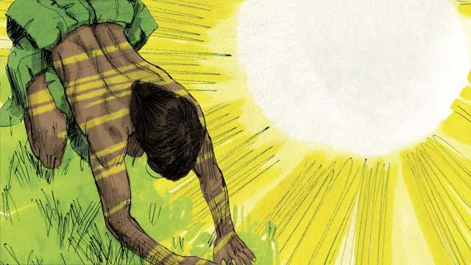
Na God i tokim man, “Yu harim tok bilong meri bilong yu na yu sakim tok bilong mi. Nau mi bagarapim graun olsem na yu bai wok hat tru long planim kaikai. Na bihain bai yu dai. Na bodi bilong yu bai i go bek long graun olsem das.” Man i kolim meri bilong em Iv, as bilong en i olsem “Meri bilong givim laip” long wanem em bai kamap mama bilong olgeta manmeri. Olsem na God i wokim klos long skin bilong ol abus na karamapim Adam na Iv.
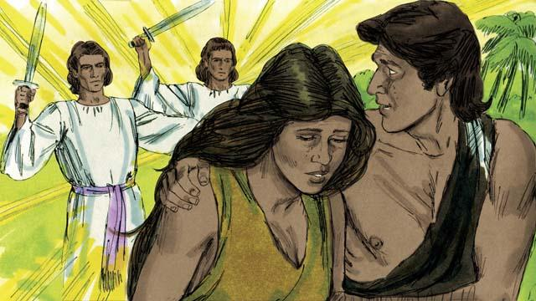
Na God i tok, “Nau ol manmeri bilong graun i kamap olsem yumi na save long gutpela na nogut, olsem na mipela bai i noken larim ol i kaikai pikinini bilong diwai i save givim laip long manmeri na ol bai ino inap dai na stap oltaim oltaim. Na God i rausim Adam na Iv long noken stap moa long dispela gutpela gaden. Na God putim ol strongpela ensel long maus rot bilong dispela gaden long tambuim arapela manmeri long kaikai pikinini bilong diwai i save givim laip.
Baibel Stori i Kam Long: Stat 3

