Resource: unfoldingWord® Open Bible Stories
unfoldingWord® Open Bible Stories © 2022 unfoldingWord. Released under CC BY-SA 4.0 license. unfoldingWord® Open Bible Stories has been adapted in the following languages: Tok Pisin, Arabic (عربي), French (Français), Hindi (हिंदी), Indonesian (Bahasa Indonesia), Portuguese (Português), Russian (Русский), Spanish (Español), Swahili (Kiswahili), and Simplified Chinese (简体中文) from unfoldingWord® Open Bible Stories © 2022 unfoldingWord. Released under CC BY-SA 4.0 license by Mission Mutual

unfoldingWord® Open Bible Stories

4. God i Wokim Kontrak Wantaim Abraham
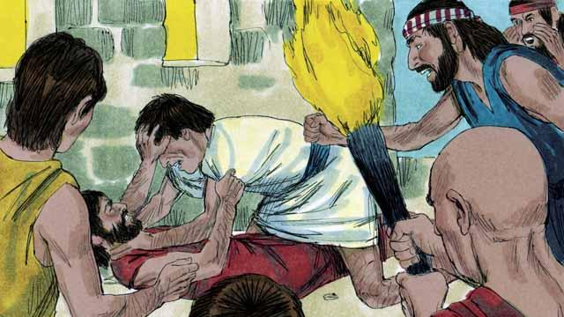
Planti yia i go pinis bihain long bikpela tait wara, planti manmeri i kamap gen na stap long graun. Na ol i gat wanpela tokples. God i bin tokim ol long kamap planti na pulap long graun tasol ol i no bin bihainim dispela tok. Nogat, ol i kam bung wantaim na wokim kamap bikpela taun.
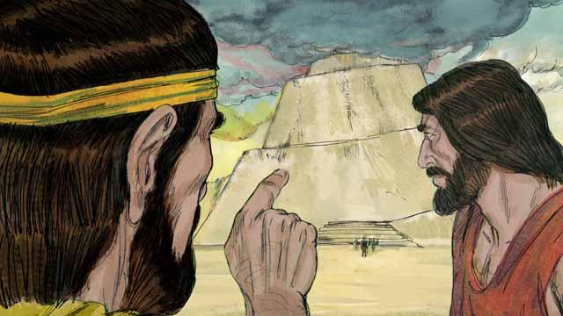
Olgeta manmeri i apim ol yet na ol i sakim tok bilong God. God i bin tokim ol long kamap planti na i go long olgeta hap graun na bosim graun. Tasol nogat, ol i stap bung wantaim na wok long wokim wanpela longpela tawa i go antap long skai. God i lukim dispela na em i save, sapos ol i stap bung wantaim, ol bai wokim planti moa kainkain pasin nogut.
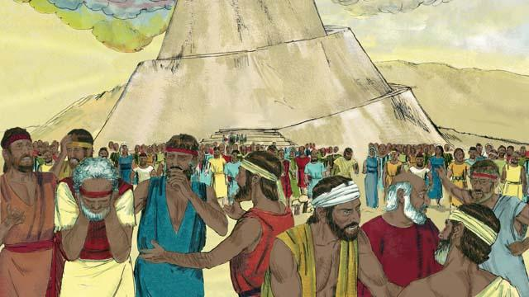
Olsem na God i senisim dispela wanpela tokples bilong ol i kamap planti kainkain tokples. Na em i mekim ol i go nabaut nabaut long olgeta hap graun. Nem bilong dispela tawa ol i bin wokim em Babel, na as bilong dispela nem i olsem, “tingting i paul.”
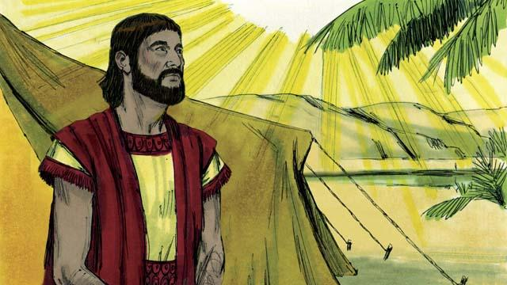
Planti handred yia i go pinis na God i bin toktok long wanpela man, nem bilong em Abram. God i tokim em olsem; “Lusim ples na lain bilong yu na i go long ples mi bai kisim yu i go long en. Mi bai blesim yu na mekim lain bilong yu i kamap wanpela bikpela lain. Mi bai mekim nem bilong yu i bikpela na blesim ol lain i blesim yu, na krosim na daunim ol lain i kros na daunim yu.”
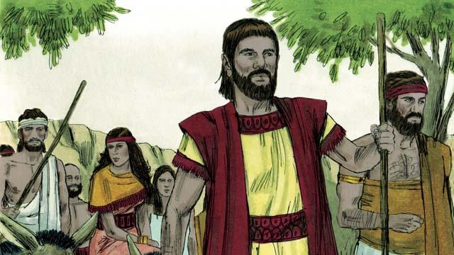
Abram i bihainim tok bilong God na kisim meri bilong em Sarai na olgeta kago na olgeta wok manmeri bilong em na ol i wokabaut i go long ples Kenan. Em i ples God i bin soim em.
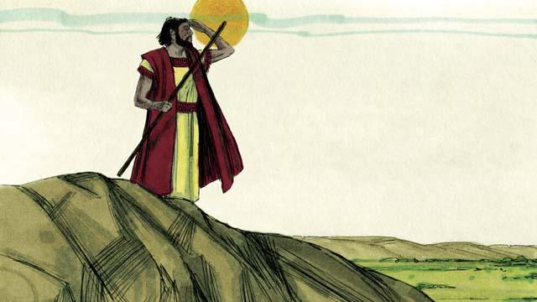
Taim Abram i kamap long ples Kenan, God tokim em, “Lukim olgeta graun. Mi bai givim yu na ol tumbuna lain bilong yu olgeta hap graun.” Abram i stap long Kenan.
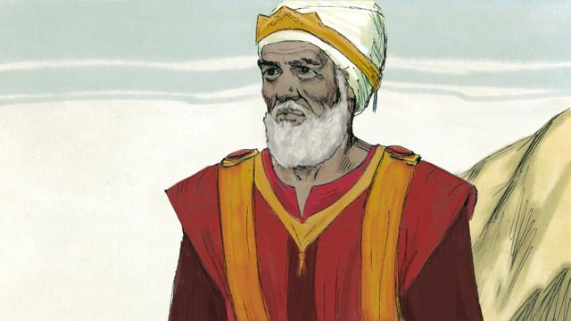
Wanpela de Abram i bungim Melkisedek, pris bilong Bikpela God Antap. Melkisedek i blesim Abram na tok, “Bikpela God Antap, husat i bosim olgeta samting long skai na graun i blesim yu.” Na Abram i tilim long 10-pela hap na 1-pela hap em i givim olsem ofa long Melkisedek.
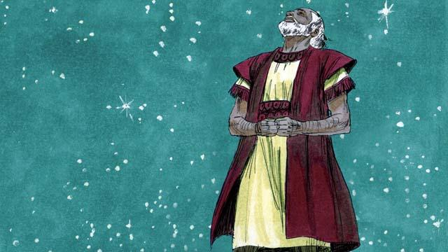
Planti yia i go pinis tasol Abram wantaim meri bilong em, tupela i no gat pikinini man. God i promisim wanpela moa taim olsem Abram bai i gat planti pikinini olsem sta long skai. Abram i bilipim promis God i bin tokim em. God i save Abram em stretpela man long wanem, em i bilip long promis God i mekim wantaim em.
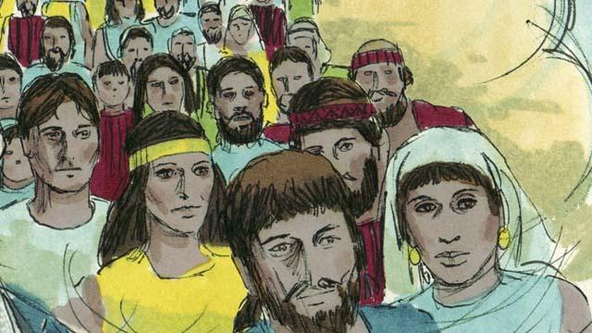
Na God i mekim kontrak wantaim Abram. Kontrak em wanbel namel long tupela lain manmeri. God i tok, “Mi bai givim yu wanpela pikinini man, yu bai karim long bodi bilong yu yet. Mi bai givim ples Kenan long ol tumbuna lain bilong yu.” Tasol Abram i no gat pikinini man yet.
Baibel Stori i Kam Long: Stat 11–15

