Resource: unfoldingWord® Open Bible Stories
unfoldingWord® Open Bible Stories © 2022 unfoldingWord. Released under CC BY-SA 4.0 license. unfoldingWord® Open Bible Stories has been adapted in the following languages: Tok Pisin, Arabic (عربي), French (Français), Hindi (हिंदी), Indonesian (Bahasa Indonesia), Portuguese (Português), Russian (Русский), Spanish (Español), Swahili (Kiswahili), and Simplified Chinese (简体中文) from unfoldingWord® Open Bible Stories © 2022 unfoldingWord. Released under CC BY-SA 4.0 license by Mission Mutual

unfoldingWord® Open Bible Stories

5. Promis Pikinini Man
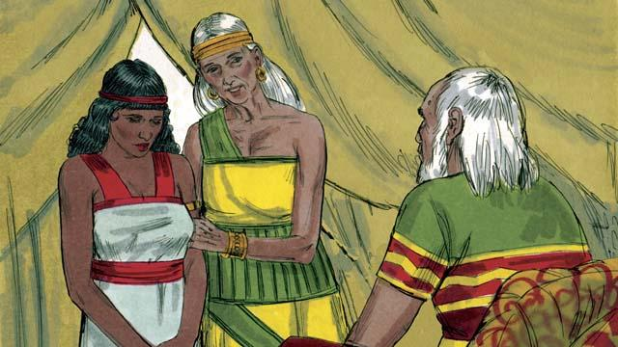
Abram na Sarai i stap long ples Kenan na 10-pela yia i go pinis, tasol tupela i nogat pikinini. Olsem na meri bilong Abram, Sarai i tokim em, “God i no larim mi long karim pikinini na nau mi lapun tru long karim pikinini, em wokmeri biong mi, Hagar. Maritim em na em bai karim pikinini bilong mi.”
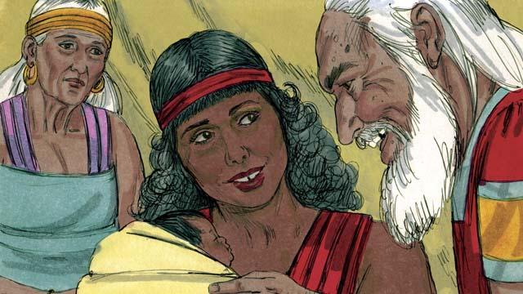
Olsem na Abram i maritim Hagar. Hagar i karim wanpela pikinini man na Abram i givim em nem Ismael. Tasol Sarai i tingting nogut long Hagar. Taim Ismael i kamap 13 yia, God i toktok gen long Abram.
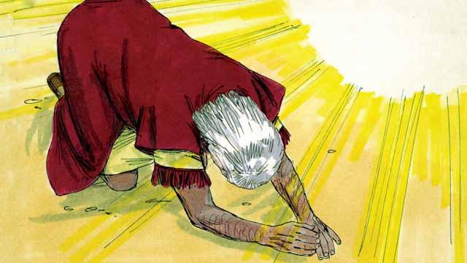
God i tok, “Mi God Bikpela. Mi bai mekim wanpela kontrak wantaim yu.” Abram i brukim skru na putim pes bilong em long graun. Na tu God i tokim Abram, “Yu bai kamap papa bilong planti lain manmeri. Mi bai givim yu na ol tumbuna pikinini bilong yu graun Kenan olsem samting bilong ol na mi bai stap God bilong ol oltaim oltaim. Yu mas katim skin bilong olgeta man long lain bilong yu.”
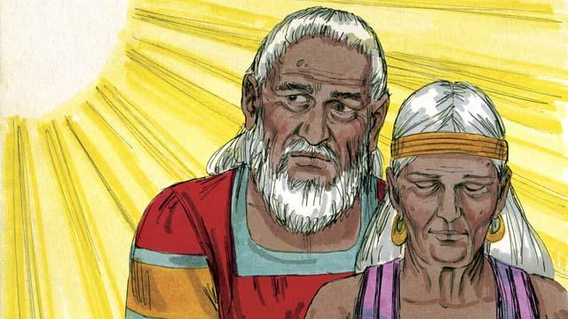
“Meri bilong yu, Sarai, bai karim wanpela pikinini man, em bai promis pikinini. Kolim nem bilong em Aisak. Mi bai mekim kontrak wantaim em, na em bai kamapim bikpela lain manmeri. Bai mi mekim Ismael i kamap bikpela lain manmeri tu. Tasol kontrak bilong mi bai i stap wantaim Aisak.” God i senisim nem Abram na kolim Abraham, as bilong en i olsem, “papa bilong planti manmeri.” Na tu God i senisim nem Sarai na kolim Sara, as bilong en i olsem, “pikinini meri bilong bikman.”
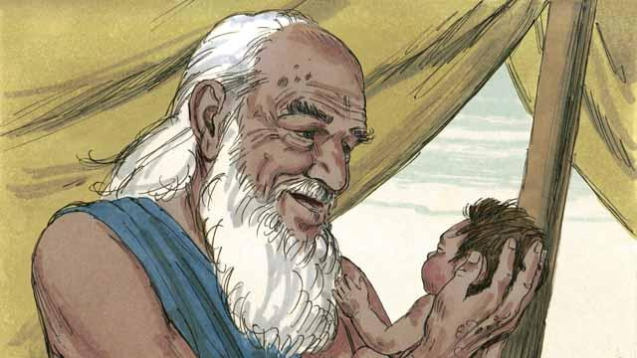
Long dispela de, Abraham i katim skin bilong olgeta man long lain bilong em. Bihain long wanpela yia i go pinis, taim Abraham i kamap 100 yia na Sara i gat 90 yia, Sara i karim pikinini man bilong Abraham. Ol i kolim nem bilong em Aisak olsem God i bin tokim ol.

Taim Aisak i kamap yangpela man, God i traim bilip bilong Abraham na i tok, “Kisim Aisak, wanpela pikinini man bilong yu, na kilim em olsem ofa na yu givim long mi.” Wanpela moa taim Abraham i bihainim tok bilong God na stretim ol samting long givim pikinini man bilong em olsem ofa long God.
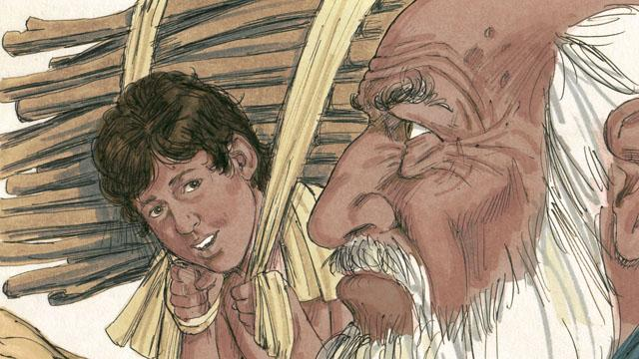
Abraham na Aisak i wokabaut i go yet long ples bilong mekim ofa, Aisak i askim, “Papa, yumi gat paiawut long long mekim ofa, tasol nogat sipsip?” Abraham i bekim tok, “Pikinini bilong mi, noken wari, God bai givim sipsip bilong mekim ofa.”
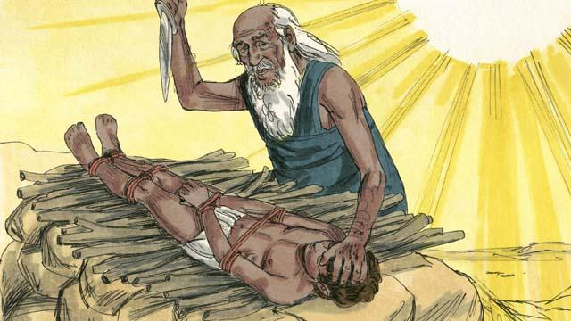
Taim ol i kamap long ples bilong mekim ofa, Abraham i pasim pikinini man bilong em Aisak na putim antap long alta. Em i laik kilim pikinini man bilong em stret na God i tok, “Stop! Noken bagarapim yangpela boi. Nau, mi save olsem yu pret long mi, long wanem yu no pasim wanpela pikinini boi bilong yu long mi.”
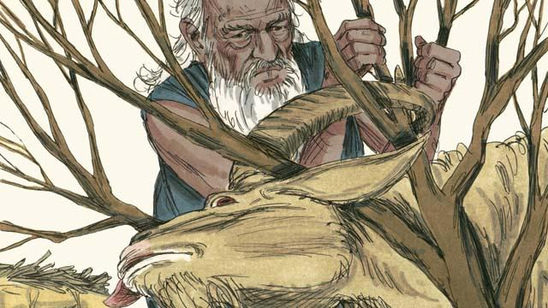
Klostu long ol, Abraham i lukim wanpela yangpela sipsip i pas long bus i stap. God i givim sipsip long mekim ofa. I no Aisak. Abraham i amamas na mekim ofa long yangpela sipsip.
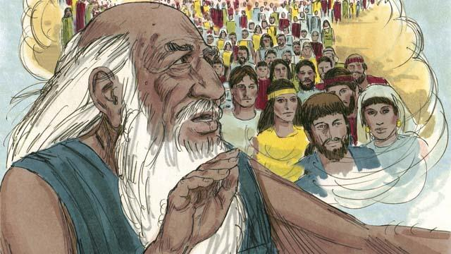
Bihain God i tokim Abraham, “Yu wanbel na givim mi olgeta samting yu gat, wanpela pikinini boi bilong yu tu. Mi promis long givim yu planti gutpela samting. Ol tumbuna lain bilong yu bai kamap olsem ol sta long skai, long wanem yu bin bihainim tok bilong mi, olgeta lain manmeri bilong graun bai i gat planti gutpela blesing long famili bilong yu.”
Baibel Stori i Kam Long: Stat 16–22

