Resource: unfoldingWord® Open Bible Stories
unfoldingWord® Open Bible Stories © 2022 unfoldingWord. Released under CC BY-SA 4.0 license. unfoldingWord® Open Bible Stories has been adapted in the following languages: Tok Pisin, Arabic (عربي), French (Français), Hindi (हिंदी), Indonesian (Bahasa Indonesia), Portuguese (Português), Russian (Русский), Spanish (Español), Swahili (Kiswahili), and Simplified Chinese (简体中文) from unfoldingWord® Open Bible Stories © 2022 unfoldingWord. Released under CC BY-SA 4.0 license by Mission Mutual

unfoldingWord® Open Bible Stories

6. God i Givim Ol Gutpela Samting Long Aisak
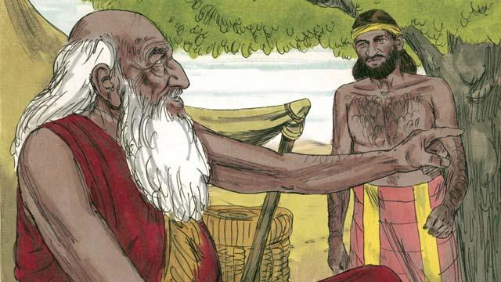
Taim Abraham i kamap lapun tru, pikinini man Aisak, i kamap man. Olsem na Abraham i salim wanpela wokman i go long graun ol lain bilong em i stap long bringim wanpela meri bilong pikinini man bilong em, Aisak.
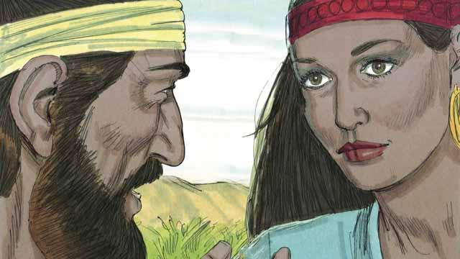
Bihain long longpela wokabaut i go long graun bilong ol lain bilong Abraham i stap long en, God i soim rot na bringim wokman i go stret long Rebeka. Em i tumbuna pikinini meri bilong brata bilong Abraham.
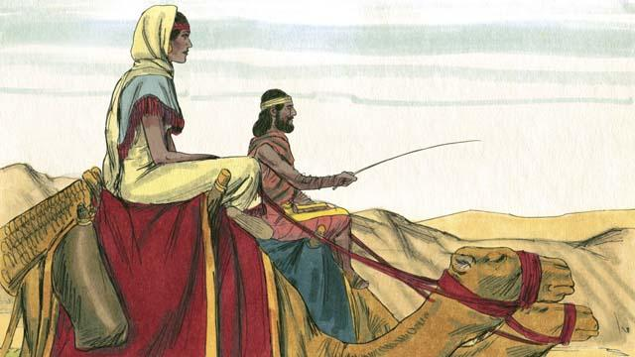
Rebeka i tok orait long lusim lain bilong em na i go wantaim wokman long haus bilong Aisak. Aisak i maritim Rebbeka taim em i kam kamap.
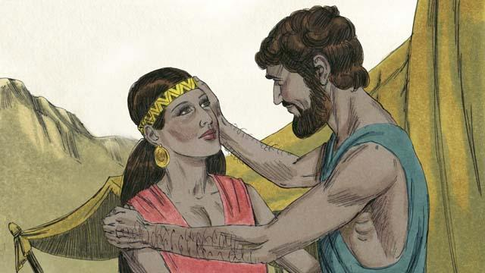
Longpela taim i go pinis, Abraham i dai na olgeta tok God i bin promis wantaim em na kontrak bai i gat planti tumbuna lain ol i no inap long kaunim, tasol meri bilong Aisak, Rebeka i no inap karim pikinini.
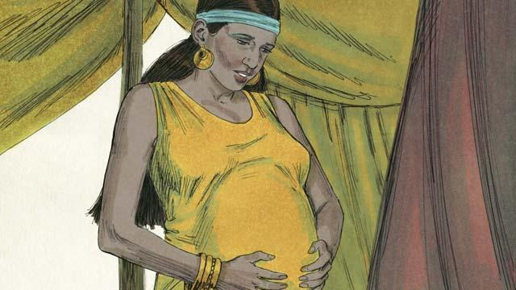
Aisak i beten long Rebeka na God i larim em i gat bel wantaim tupela pikinini insait long bel bilong em. Tupela pikinini i stap insait long bel bilong Rebeka, tupela i hatwok stret long i stap wantaim, olsem na Rebeka i askim God long wanem i wok long kamap.

God i tokim Rebeka, “Tupela lain manmeri bai kamap long tupela pikinini man i stap insait long bel bilong yu. Ol bai hatwok tru namel long ol yet na bikpela pikinini man bai wok aninit long yangpela pikinini man.”
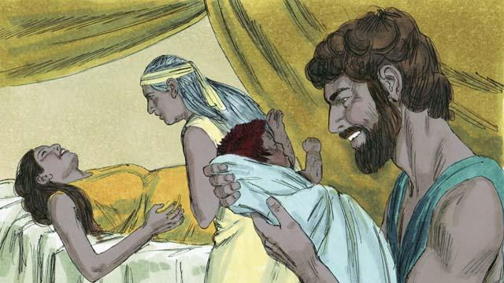
Taim Rebeka i karim nambawan pikinini man, pikinini i gat retpela skin na planti gras long skin bilong em. Ol i kolim nem bilong em Iso. Namba tu pikinini Rebeka i karim, em i holim lek bilong Iso. Ol i kolim nem bilong em Jekop.
Baibel Stori i Kam Long: Stat 24:1–25:26

