Resource: unfoldingWord® Open Bible Stories
unfoldingWord® Open Bible Stories © 2022 unfoldingWord. Released under CC BY-SA 4.0 license. unfoldingWord® Open Bible Stories has been adapted in the following languages: Tok Pisin, Arabic (عربي), French (Français), Hindi (हिंदी), Indonesian (Bahasa Indonesia), Portuguese (Português), Russian (Русский), Spanish (Español), Swahili (Kiswahili), and Simplified Chinese (简体中文) from unfoldingWord® Open Bible Stories © 2022 unfoldingWord. Released under CC BY-SA 4.0 license by Mission Mutual

unfoldingWord® Open Bible Stories

12. Ol Lain Israel I Lusim Isip
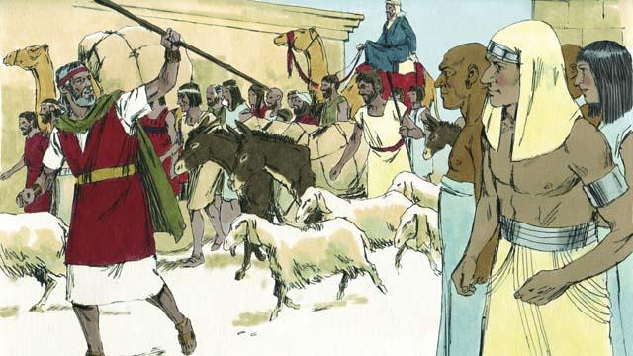
Ol manmeri bilong Israel i amamas tru long lusim Isip. Ol i no stap wokboi nating aninit long ol lain Isip moa. Nogat. Ol i lusim Isip na wokabaut i go long graun God i bin Promis long givim long ol tumbuna bilong ol. Na taim ol i lusim Isip, wanem samting ol i askim long ol Isip, ol lain Isip i givim ol tasol na tu ol i givim gol na silva na ol narapela samting i dia tumas tu. Long dispela taim, ol lain long narapela kantri ol tu i bilip long God na ol i lusim Isip wantaim ol lain Israel.
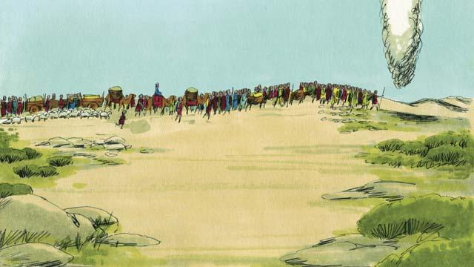
Na taim ol i go, God i go paslain long ol long longpela klaut olsem pos long san na long nait dispela klaut i kamap olsem paia i lait . Na taim ol i wokabaut i go, olgeta taim God i soim ol rot long go. Wanpela samting ol lain Israel inap long wokim em ol i bihainim em tasol.
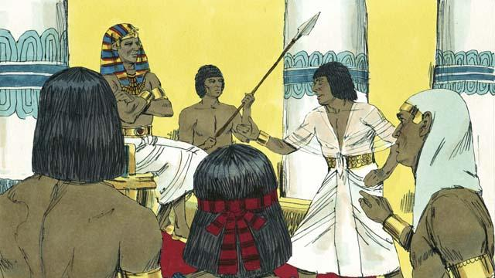
Sotpela taim bihain, Fero na ol lain bilong em i senisim tingting bilong ol na ol i laik kisim ol lain Israel i kam bek na larim ol i kamap wokboi nating bilong ol gen. Dispela samting i kamap long wanem God i pasim bel na tingting bilong Fero na tu em i laikim ol manmeri i luksave olsem em wanpela tasol em i trupela God, na tu em i laikim ol long save olsem, em Yaweh, na pawa bilong em i winim pawa bilong Fero na ol giaman god bilong en.
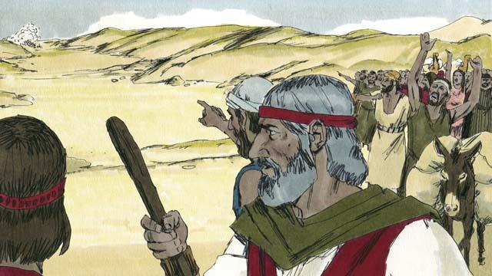
Olsem na Fero na ol soldia bilong em i ranim ol Israel i go long kisim ol na mekim ol i kamap wokboi nating bilong ol gen. Na taim ol lain Israel i lukim ol soldia bilong Isip i kam, ol i luksave olsem ol i stap kalabus namel long Solwara Retsi na ol soldia bilong Isip. Olsem na ol i pret nogut tru na tokaut olsem, “Bilong wanem na yumi lusim Isip. Bai yumi dai nau!”
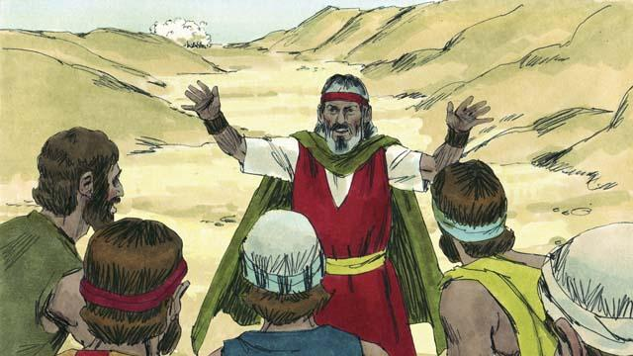
Tasol Moses i tokim ol lain Israel olsem, “Noken pret! God bai i pait long yupela na helpim yupela.” Na God i tokim Moses olsem, “Tokim ol manmeri long go klostu long Solwara Retsi.”
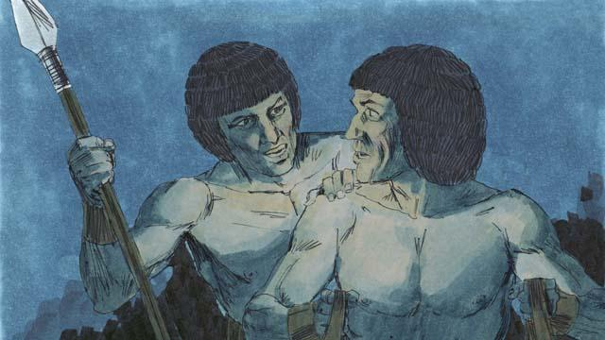
Na bihain God i kisim klaut na putim namel long ol lain Israel na ol lain Isip na ol lain Isip i no inap long lukim ol lain Israel.
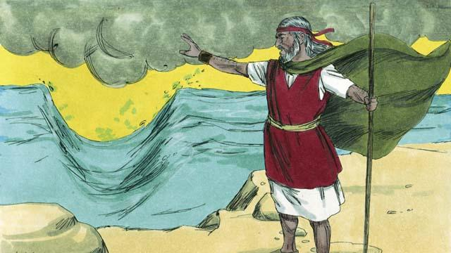
Na God i tokim Moses long apim han na putim i go antap long Solwara. Na taim Moses i wokim olsem, God i kirapim win i kam na brukim wara long namel, hap i go long hankais na hap i go long hansut. Dispela i kamap na rot i kamap namel long solwara.
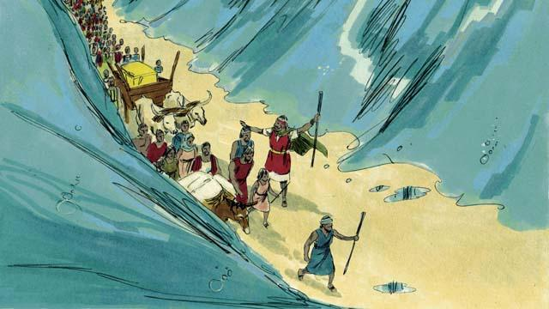
Na wara i kamap olsem wol long tupela sait na ol manmeri bilong Israel i wokabaut long drai graun na i go.
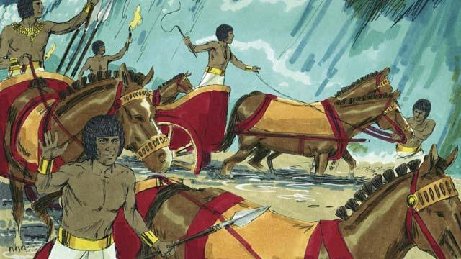
Long dispela taim God i apim klaut na rausim long ai bilong ol lain Isip na ol inap long lukim ol lain Israel i ranawe i go. Na ol lain Isip i tingting strong long bihainim ol i go.
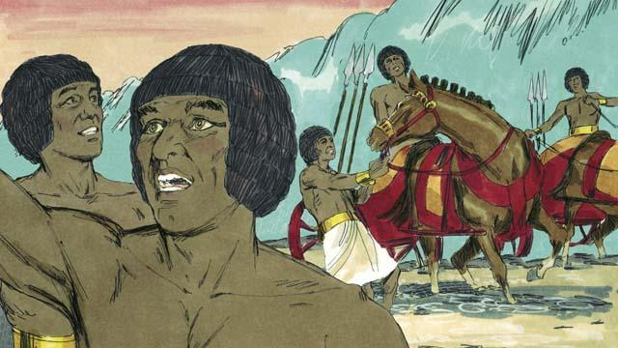
Olsem na ol i bihainim ol lain Israel i go long dispela rot i kamap namel long Solwara. Tasol God i wokim ol i kamap tubel na pret na tu em i mekim karis bilong ol i pas long wesan. Na ol i singaut olsem, “Ranawe! God i pait long helpim ol lain Israel!”
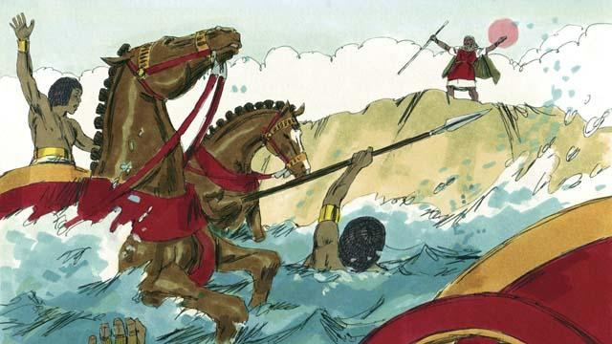
Na bihain taim olgeta lain Israel i go gut long narapela sait bilong solwara, God i tokim Moses long apim han bilong em antap long solwara gen. Na taim Moses i wokim olsem, wara i go bek gen long ples bilong em na karamapim olgeta soldia bilong Isip na olgeta i dai.
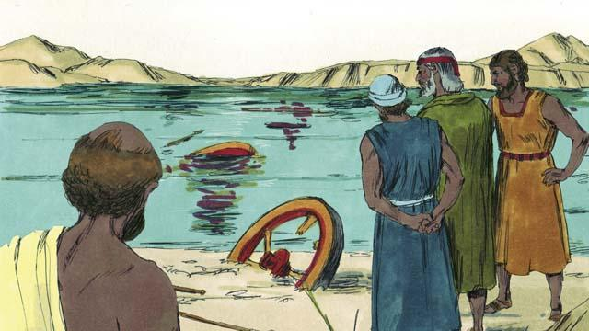
Taim ol lain Israel i lukim ol lain Isip i dai, ol i givim olgeta tingting na bel i go long God, na bilipim Moses olsem, em wanpela profet bilong God.
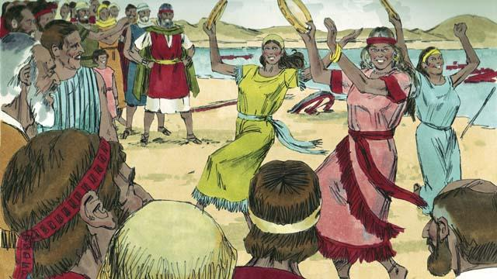
Na God i bin helpim ol long dai na long hevi bilong stap wokboi nating olsem na ol i singsing na danis wantaim bikpela amamas! Nau ol i kamap fri long wokim wok bilong God. Na ol i singim planti song long amamas long kamap fri long kalabus bilong ol na long litimapim nem bilong God, long wanem em i bin helpim ol long han bilong ol soldia bilong Isip.
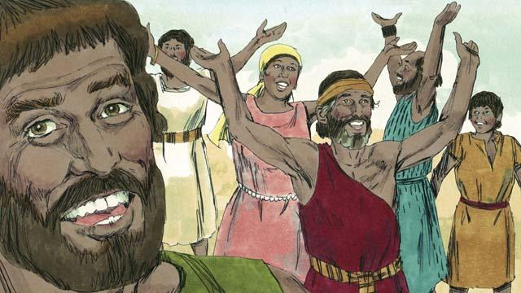
Na God i toktok strong long ol lain Israel long amamasim Pasova long tingim olsem wanem God i helpim ol long winim ol soldia bilong Isip na tu husat em i kisim ol i kamaut long hevi bilong stap wokboi nating. Na taim ol i wokim dispela pati, ol i kilim wanpela pikinini sipsip i nogat sik o bagarap long en, na ol i kaikai wantaim bret i nogat yis long en.
Baibel Stori i Kam Long: Kisim Bek 12:33–15:21

