Resource: unfoldingWord® Open Bible Stories
unfoldingWord® Open Bible Stories © 2022 unfoldingWord. Released under CC BY-SA 4.0 license. unfoldingWord® Open Bible Stories has been adapted in the following languages: Tok Pisin, Arabic (عربي), French (Français), Hindi (हिंदी), Indonesian (Bahasa Indonesia), Portuguese (Português), Russian (Русский), Spanish (Español), Swahili (Kiswahili), and Simplified Chinese (简体中文) from unfoldingWord® Open Bible Stories © 2022 unfoldingWord. Released under CC BY-SA 4.0 license by Mission Mutual

unfoldingWord® Open Bible Stories

18. Kantri Israel i Bruk Tupela Hap
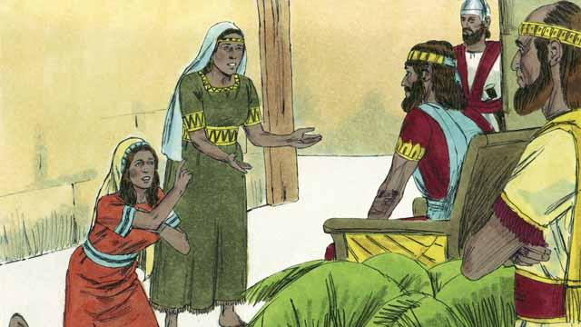
Planti yia i go pinis na Devit i dai na pikinini bilong Solomon na pikinini man bilong em Rihoboam i kamap King na bosim Israel. God i toktok long Solomon na i askim em long wanem samting em laikim tumas. Taim Solomon i askim God long givim em gutpela tingting, God i amamas na i mekim em i kamap wanpela gutpela saveman tru long graun. Solomon i lanim planti samting na em i kamap gutpela saveman long skelim ol tok. God i mekim em i gat planti samting.
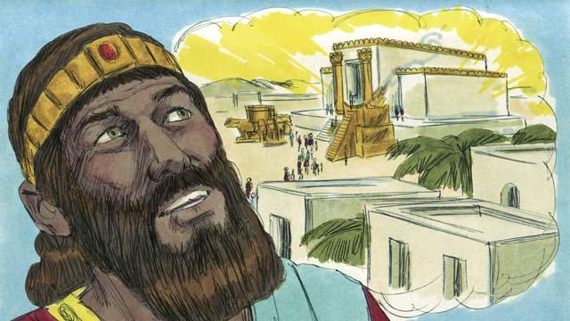
Na Solomon i wokim temel long Jerusalem. Dispela tempel em papa bilong em Devit i bin tingting long em na bungim ol diwai samting long em. Nau ol manmeri i lotuim God long tempel na givim ofa i go long God na i no moa wokim olsem long haus sel bilong bung, na em i stap wantaim ol manmeri bilong em.
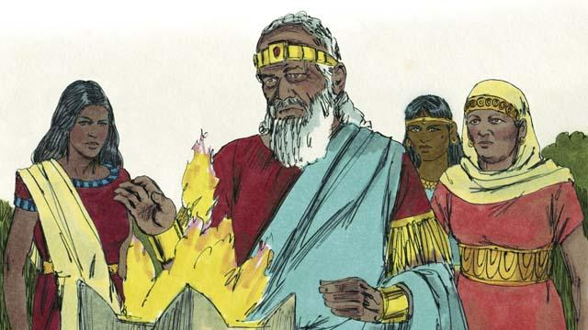
Tasol Solomon i laikim ol meri bilong narapela kantri. Em sakim tok bilong God na maritim planti meri, klostu 1,000 meri. Planti bilong dispela meri i kam long arapela kantri na kisim ol giaman god bilong ol na stat long lotuim ol. Taim Solomon i kamap lapun, em tu i lotuim ol giaman god bilong ol.
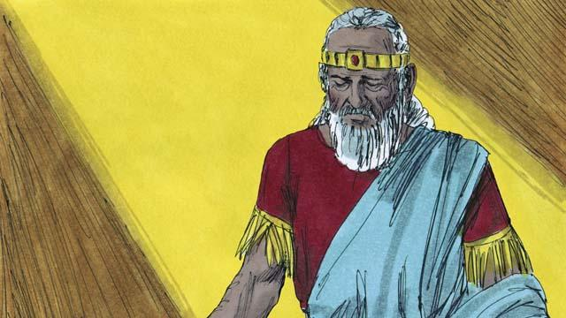
God i belhat long Solomon, na givim pe nogut long Solomon i bin lusim God na lotuim ol narapela giaman god, God i tok promis olsem bihain long taim Solomon i dai pinis, em bai brukim kantri Israel i kamap tupela.
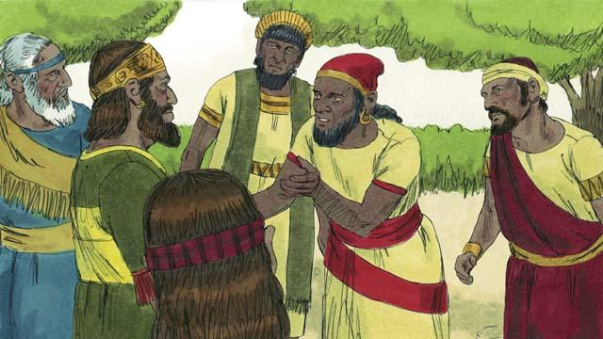
Bihain long dai bilong Solomon, pikinini man bilong em Rehoboam i kamap king. Rehoboam em man i nogat gutpela tingting . Olgeta manmeri bilong kantri Israel i kam bung long soim tru olsem em i king. Ol i kam na toktok planti long ol belhevi bilong ol long Rehoboam olsem Solomon i bin givim planti hatwok long ol na ol baim planti takis.
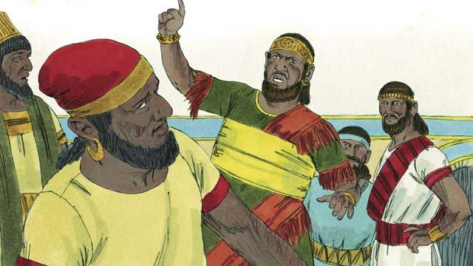
Na Rehoboam i no tingting gut na bekim tok olsem, “Yupela ting olsem papa bilong mi Solomon i mekim yupela wok hat a, tasol mi bai mekim yupela wok hat moa, na em bai winim hat wok em i bin givim yupela, na pe nogut mi givim yupela, em bai winim moa pe nogut em givim long yupela.
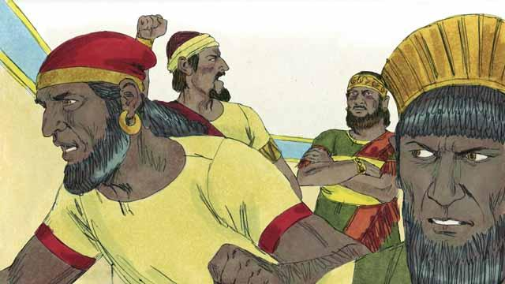
Olsem na lain bilong kantri Israel i les long bihainim tok long pait wantaim Rehoboam. Tupela lain tasol i stap wanbel wantaim em. Dispela tupela lain i kamap olsem lain bilong Juda.
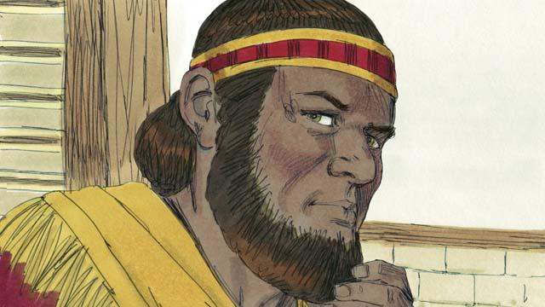
Na arapela tenpela lain bilong kantri Israel i les long Rehoboam, ol i makim wanpela man nem bilong em Jeroboam long kamap King bilong ol. Ol i kisim graun hapsait long not na ol i kolim dispela ples olsem lain bilong Israel.
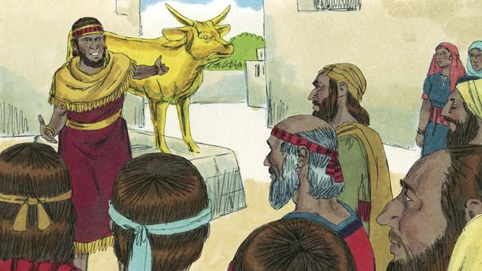
Jeroboam i sakim tok bilong God na i mekim ol manmeri long mekim pasin i no stret. Em i wokim tupela god giaman long ol manmeri long lotuim na ol i noken lotuim God long tempel long ol graun bilong ol lain Juda.
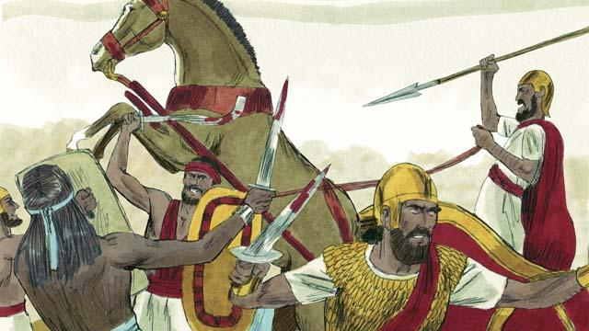
Ol lain Juda na Israel i kamap birua na pait klostu klostu namel long ol yet.
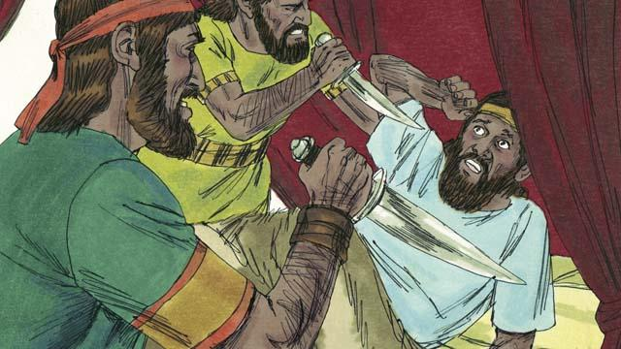
Long lain Israel, olgeta king i no gutpela. Planti bilong ol dispela king, ol arapela lain Israel husat i laik kisim ples bilong ol long kamap king i kilim ol na kisim ples bilong ol.
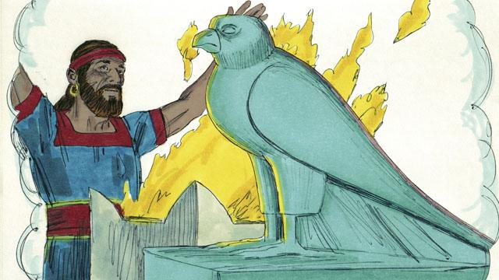
Olgeta King na planti ol manmeri long lain Israel i lotuim ol giaman god. Taim ol i lotu long giaman god ol i wokim pasin pamuk na sampela taim ol i kilim ol pikinini long mekim ofa i go long ol giaman god bilong ol.
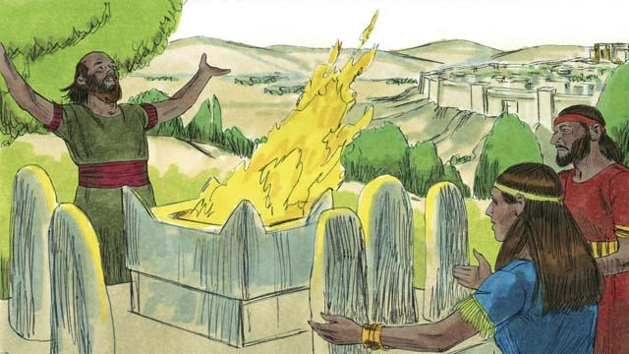
Ol King bilong Juda i kamap long lain bilong Devit, sampela bilong ol dispela King em ol gutpela man husat i save bihainim strepela pasin na lotuim God. Tasol planti bilong ol King bilong Juda i save mekim pasin i no gutpela, pasin bagarap na ol i save lotuim ol giaman god. Planti bilong ol manmeri bilong Juda tu i les long bihainim God na lotuim arapela god.
Baibel Stori i Kam Long: 1King 1–6; 11–12

