Resource: unfoldingWord® Open Bible Stories
unfoldingWord® Open Bible Stories © 2022 unfoldingWord. Released under CC BY-SA 4.0 license. unfoldingWord® Open Bible Stories has been adapted in the following languages: Tok Pisin, Arabic (عربي), French (Français), Hindi (हिंदी), Indonesian (Bahasa Indonesia), Portuguese (Português), Russian (Русский), Spanish (Español), Swahili (Kiswahili), and Simplified Chinese (简体中文) from unfoldingWord® Open Bible Stories © 2022 unfoldingWord. Released under CC BY-SA 4.0 license by Mission Mutual

unfoldingWord® Open Bible Stories

23. Maria i Karim Jisas
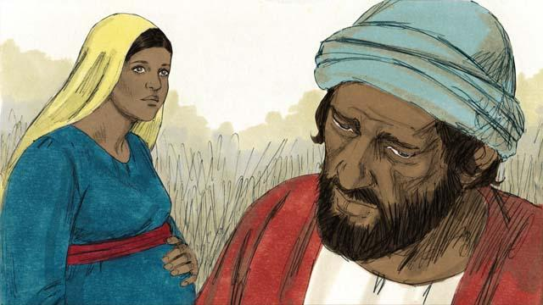
Maria i promis long maritim wanpela stretpela man nem bilong em, Josep. Taim Josep i harim olsem Maria i gat bel, em i save olsem dispela pikinini i no bilong em. Olsem na em i tingting long lusim em isi tasol. Tasol em i no laik givim sem long Maria. Bihain long em i mekim olsem, wanpela ensel i kamap long em long driman na i tokim em olsem,

“Josep, yu noken pret long kisim Maria olsem meri bilong yu. Pikinini i stap long bel bilong em i kam long Holi Spirit. Maria bai karim wanpela pikinini man na bai yu kolim nem bilong em, Jisas ( em i olsem Yahweh i kisim bek) long wanem em bai kisim bek olgeta manmeri long sin bilong ol.”

Olsem na Josep i maritim Maria na kisim em i go long haus bilong em na Maria i kamap meri bilong em. Tasol Josep i no slip wantaim Maria inap em i karim pikinini.
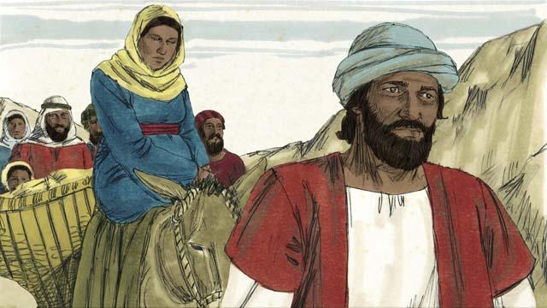
Na taim bilong Maria long karim pikinini i kamap klostu na gavman bilong Rom i tokim olgeta manmeri long ol i mas i go givim nem bilong ol long buk bilong gavman long asples bilong tumbuna bilong ol i bin stap long en. Olsem na Josep na Maria i kirap long hap ol i stap long en long Nasaret na wokabaut longwe rot i go long Betlehem. Long wanem Betlehem em i asples bilong tumbuna bilong ol Devit.
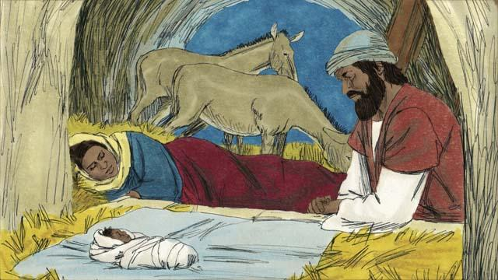
Taim ol i kamap long Betlehem i no gat ples bilong ol long stap. Wanpela ples tasol tupela i painim em i haus bilong ol bulmakau. Tupela i stap long en na long nait Maria i karim pikinini bilong en na slipim em long bokis kaikai bilong bulmakau. Long wanem ol i nogat ples bilong putim pikinini. Na ol i kolim nem bilong em, Jisas.
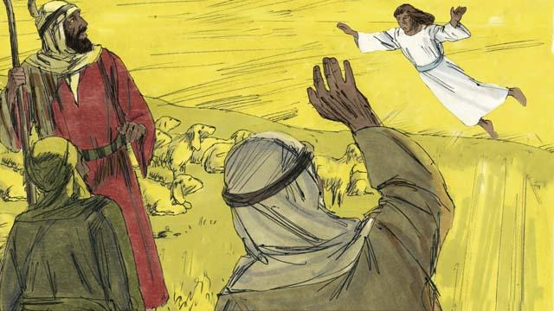
Long dispela nait ol wasman bilong ol sipsip i was long sipsip bilong ol ausait long taun i stap. Na wantu wanpela ensel i gat lait i kamap long ol na ol i pret nogut tru. Na ensel i tokim ol, “Yupela i noken pret, long wanem mi gat gutnius long tokim yupela. Mesaia ,Bikpela, em i kamap pinis long Betlehem!”

Yupela i go na lukim dispela pikinini, ol i karamapim em long ol hap laplap na putim long bokis kaikai bilong ol bulmakau i stap. Na wantu antap long skai ol ensel i pulap na ol i litimapim nem bilong God na tok, “Glori i go long God long heven, na bel isi i go long graun long ol manmeri em i laikim!”
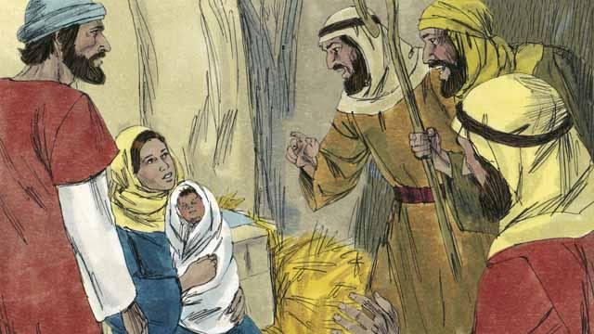
Ol wasman bilong sipsip i kam kamap long ples pikinini Jisas i stap long en, na ol i lukim em i slip long bokis kaikai bilong bulmakau i stap, olsem ensel i bin tokim ol. Na bel bilong ol i amamas na Maria tu i amamas tru. Ol wasman bilong ol sipsip i go bek long ples ol sipsip bilong ol i stap long en, na ol i litimapim nem bilong God long ol samting ol i bin harim na lukim.
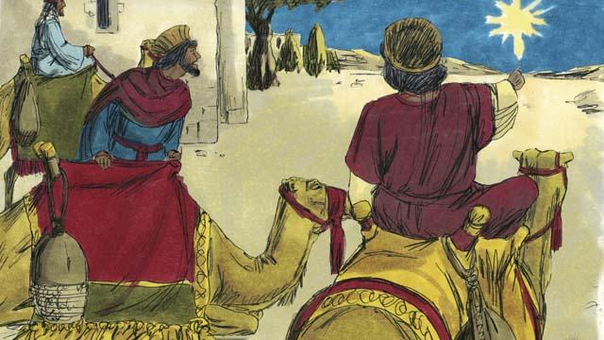
Sampela taim bihain ol saveman bilong ol kantri i stap longwe long hap san kamap i lukim narakain sta long skai. Na ol i luksave olsem nupela king bilong ol Juda i bin kamap. Olsem na ol i wokabaut long longpela hap i kam long lukim dispela King. Ol i kam kamap long Betlehem na i go long haus Jisas wantaim papa na mama bilong em i stap long en.
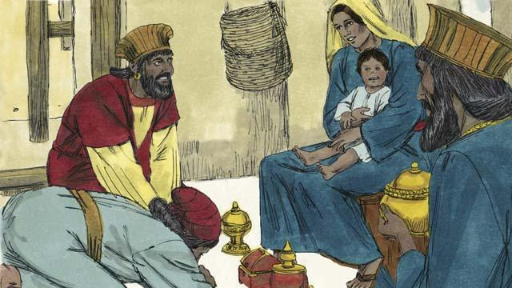
Taim ol saveman i lukim Jisas wantaim mama bilong em, ol i brukim skru na lotuim em. Na ol i givim ol presen i gat bikpela pe long Jisas na bihain ol i tanim bek na go long kantri bilong ol.
Baibel Stori i Kam Long: Matyu 1; Luk 2

