Resource: unfoldingWord® Open Bible Stories
unfoldingWord® Open Bible Stories © 2022 unfoldingWord. Released under CC BY-SA 4.0 license. unfoldingWord® Open Bible Stories has been adapted in the following languages: Tok Pisin, Arabic (عربي), French (Français), Hindi (हिंदी), Indonesian (Bahasa Indonesia), Portuguese (Português), Russian (Русский), Spanish (Español), Swahili (Kiswahili), and Simplified Chinese (简体中文) from unfoldingWord® Open Bible Stories © 2022 unfoldingWord. Released under CC BY-SA 4.0 license by Mission Mutual

unfoldingWord® Open Bible Stories

24. Jon i baptaisim Jisas
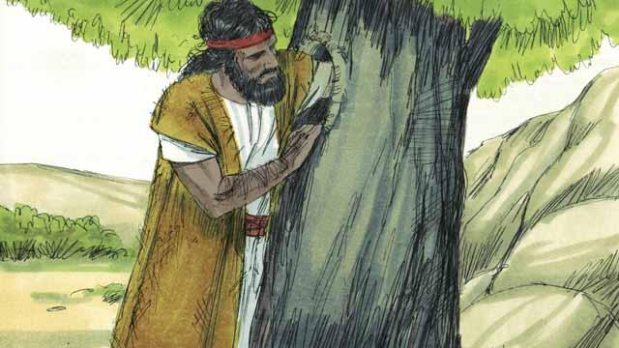
Jon em i pikinini bilong Sekaraia na Elisabet, em i kamap bikpela man na i kamap wanpela profet. Em i stap long ples i no gat man na kaikai wel hani na grasopa na pasim klos ol i wokim long gras bilong kamel.
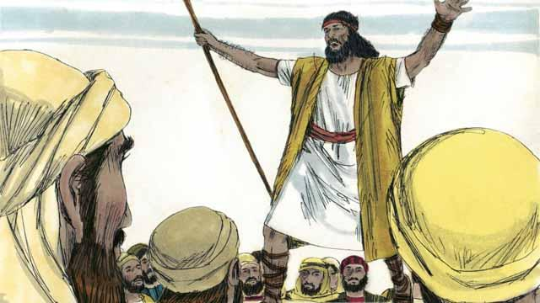
Planti manmeri i kam long ples i no gat man long harim tok bilong Jon na em i tokim ol olsem, “Yupela i mas tanim bel long wanem Kindom bilong God i kam klostu pinis!”
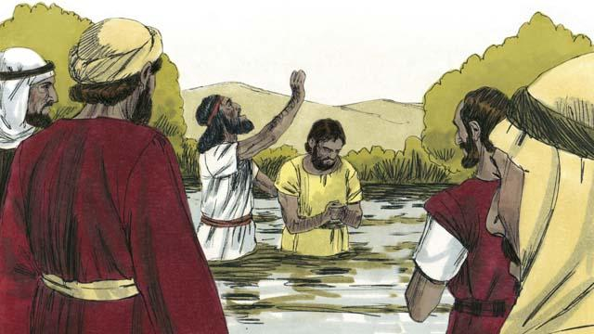
Taim ol manmeri i harim tok bilong Jon, planti bilong ol i tanim bel na givim baksait long ol sin bilong ol na Jon i baptaisim ol. Na tu planti hetman bilong haus lotu i kam long kisim baptais, tasol ol i no tanim bel na autim sin bilong ol.
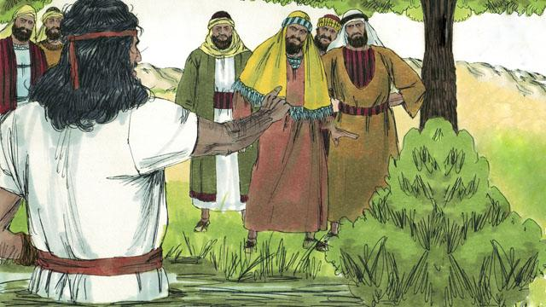
Na Jon i tokim ol hetman bilong haus lotu olsem, “Yupela ol posin snek, yupela i mas tanim bel na senisim pasin bilong yupela. Olgeta diwai i no save karim gutpela kaikai, bai ol i katim na tromoi i go long paia.” Jon i inapim tok ol profet i bin tok, “Mi salim wokman bilong mi i go pas long yu long stretim rot bilong yu.”
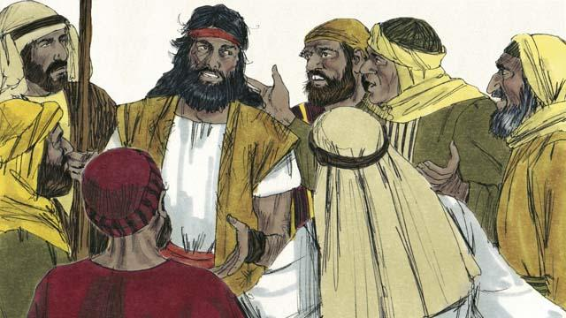
Sampela Juda i askim Jon olsem, “Yu Mesaia a?” Na Jon i bekim tok olsem, “Mi yet i no Mesaia, tasol wanpela man i kam bihain long mi, em i bikpela tumas na mi i no gutpela man inap long rausim rop long sendol bilong em.”
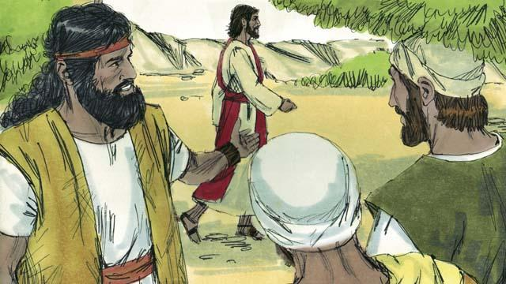
Narapela de bihain Jisas i kam long Jon long Jon i ken baptaisim em. Na Jon i lukim em na i tok, “Lukim, dispela em i pikinini sipsip bilong God, em bai tekewe sin bilong ol manmeri bilong graun.”
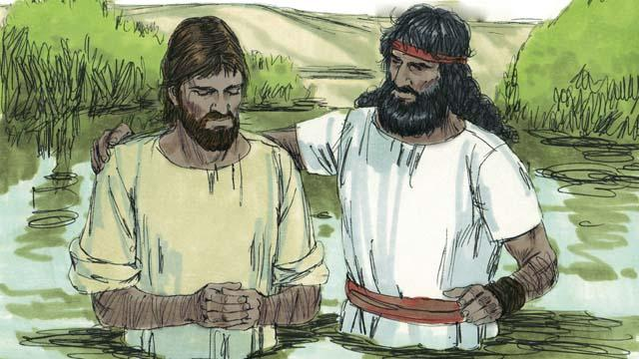
Na Jon i tokim Jisas olsem, “Mi no gutpela inap long baptaisim yu, olsem na yu mas baptaisim mi?” Tasol Jisas i bekim tok olsem, “Yu mas baptaisim mi, long wanem dispela em i stretpela rot long yu mekim olsem.” Na Jon i baptaisim Jisas. Tasol Jisas i no bin mekim sin.

Taim Jisas i baptais pinis na kam antap long wara, Holi Spirit bilong God i kam daun olsem balus pisin na sindaun antap long em. Long dispela taim tasol maus bilong God i singaut long heven na i tok olsem, “Yu Pikinini bilong Mi na Mi laikim yu tumas na belgut long yu.”
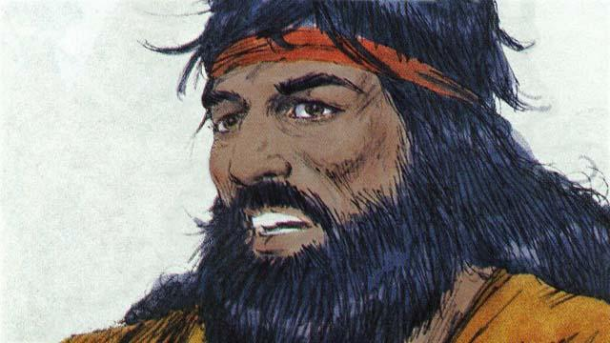
God i bin tokim Jon olsem, “Taim yu baptaisim wanpela man na Holi Spirit i kam daun na sindaun antap long em, dispela man em i pikinini bilong God.” I gat wanpela God tasol. Long taim Jon i baptaisim Jisas, em i harim Papa God i toktok na em i lukim Jisas Pikinini bilong God na em i lukim Holi Spirit.
Baibel Stori i Kam Long Matyu 3; Mak 1:9–11; Luk 3:1–23

