Resource: unfoldingWord® Open Bible Stories
unfoldingWord® Open Bible Stories © 2022 unfoldingWord. Released under CC BY-SA 4.0 license. unfoldingWord® Open Bible Stories has been adapted in the following languages: Tok Pisin, Arabic (عربي), French (Français), Hindi (हिंदी), Indonesian (Bahasa Indonesia), Portuguese (Português), Russian (Русский), Spanish (Español), Swahili (Kiswahili), and Simplified Chinese (简体中文) from unfoldingWord® Open Bible Stories © 2022 unfoldingWord. Released under CC BY-SA 4.0 license by Mission Mutual

unfoldingWord® Open Bible Stories

25. Satan i Traim Jisas
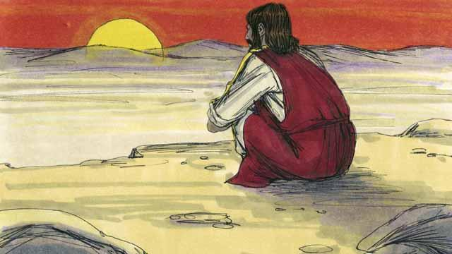
Bihain liklik long taim Jisas i kisim baptais, Holi Spirit i kisim em i go long ples i nogat man. Na em i no bin kaikai inap long 40 de na 40 nait. Na Satan i kam traim em long mekim sin.

Satan i traim Jisas na i tok olsem, “Sapos yu Pikinini bilong God, orait tokim dispela ston i tanim kamap bret na yu ken kaikai!”

Na Jisas i bekim tok olsem, “Tok bilong God i tok olsem, ol manmeri i no inap i stap laip long bret tasol, ol i mas bihainim olgeta tok bilong God!”
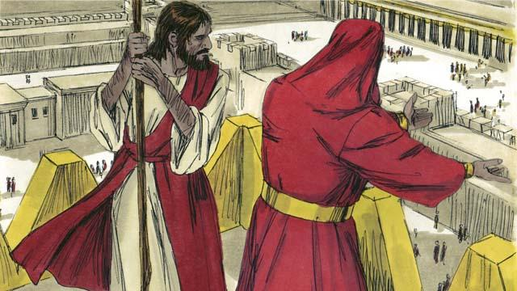
Na Satan i kisim Jisas i go antap long het bilong tempel long Jerusalem na i tokim em olsem, “Sapos yu Pikinini bilong God orait tromoi yu yet i go daun, long wanem tok bilong God i tok olsem, em bai tokim ol ensel i kam karim yu na ston i no inap sutim lek bilong yu.”

Tasol Jisas i bekim tok bilong Satan wantaim tok bilong Baibel na tok, “Tok bilong God i tok strong long ol manmeri olsem, noken traim God Bikpela bilong yupela.”
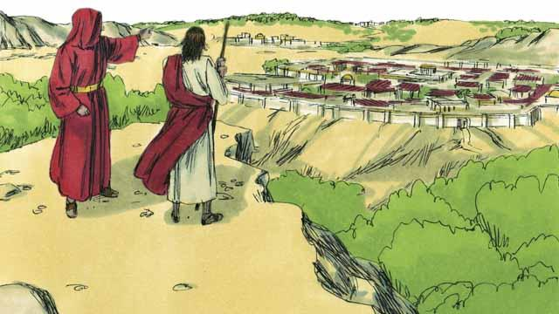
Na Satan i soim Jisas long olgeta strong na pawa bilong graun wantaim ol gutpela bilas bilong en, na tok olsem, “Bai mi givim dispela olgeta samting long yu, sapos yu brukim skru na lotu long mi.”

Na Jisas i tok,“Satan klia long mi! Tok bilong God i tok strong long ol manmeri olsem, lotu long God Bikpela bilong yupela tasol na aninit long em wanpela tasol.”
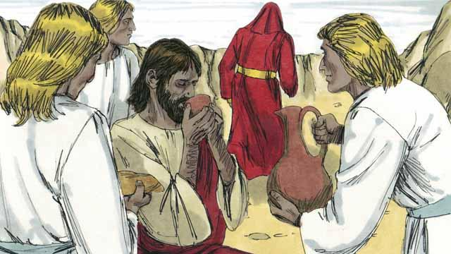
Jisas i no pundaun long traim bilong Satan olsem na Satan i lusim em na ol ensel i kam lukautim em.
Baibel Stori i Kam Long: Matyu 4:1–11; Mak 1:12–13; Luk 4:1–13

