Resource: unfoldingWord® Open Bible Stories
unfoldingWord® Open Bible Stories © 2022 unfoldingWord. Released under CC BY-SA 4.0 license. unfoldingWord® Open Bible Stories has been adapted in the following languages: Tok Pisin, Arabic (عربي), French (Français), Hindi (हिंदी), Indonesian (Bahasa Indonesia), Portuguese (Português), Russian (Русский), Spanish (Español), Swahili (Kiswahili), and Simplified Chinese (简体中文) from unfoldingWord® Open Bible Stories © 2022 unfoldingWord. Released under CC BY-SA 4.0 license by Mission Mutual

unfoldingWord® Open Bible Stories

27. Stori Bilong Gutpela Man Bilong Samaria

Wanpela de, wanpela saveman bilong Juda i kam long Jisas na traim em na tok olsem, “Tisa, bai mi mekim wanem samting long kisim laip i stap oltaim oltaim?” Na Jisas i tok, “Wanem tok i stap long lo bilong God?”

Na saveman bilong lo i bekim tok olsem, “Lo bilong God i tok, laikim God Bikpela bilong yu wantaim olgeta bel bilong yu na spirit bilong yu na strong bilong yu na tingting bilong yu, na laikim wantok bilong yu olsem yu laikim yu yet.”Na Jisas tok, “Yu tok stret, mekim olsem na bai yu stap laip oltaim.”

Tasol saveman bilong lo i laik soim em yet olsem em i stretpela man, olsem na em i askim, “Husat em i wantok bilong mi?”
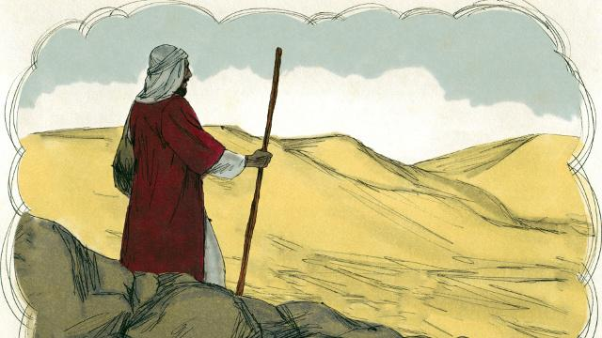
Na Jisas i bekim tok bilong saveman wantaim wanpela stori, “Wanpela man bilong Juda i wokabaut long Jerusalem na i go long Jeriko.”
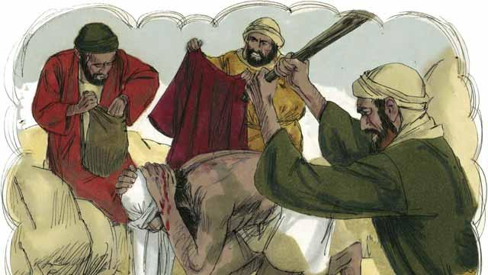
“Dispela man i wokabaut i go na sampela stilman i holim em na paitim em nogut tru, inap em i hap i dai na ol i kisim olgeta samting bilong em na ranawe.”
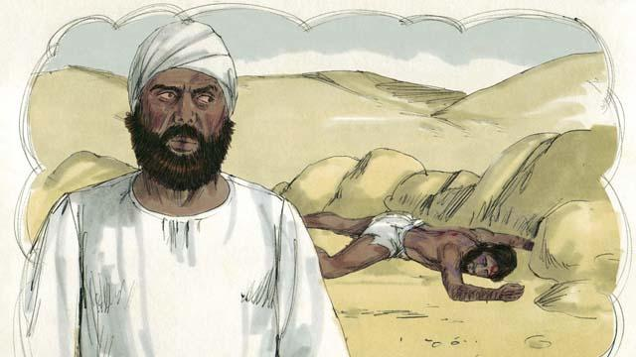
“Bihain liklik wanpela pris bilong Juda i wokabaut i kam daun long dispela rot. Na taim dispela pris i lukim dispela man ol stilman i bin paitim em na kisim ol samting bilong em i hap i dai na i stap, em i saitim na wokabaut long narapela sait bilong rot na abrusim dispela man na i go na i no helpim em.”

“I no long taim wanpela Livai i wokabaut i kam daun long rot.(ol lain bilong Livai long Israel i save helpim ol pris long Tempel) Livai tu i kalapim rot i go long hapsait bilong rot na abrusim dispela man ol stilman i bin paitim na kisim ol samting bilong em na i go.”

“Narapela man i wokabaut i kam daun long dispela rot, em i wanpela man bilong Samaria.(ol Samaria em ol hapkas bilong ol Juda i marit long ol arapela kantri.) Tasol taim man Samaria i lukim dispela man Juda, em i pilim bikpela sori long en. Olsem na em i helpim em na pasim sua bilong em.”
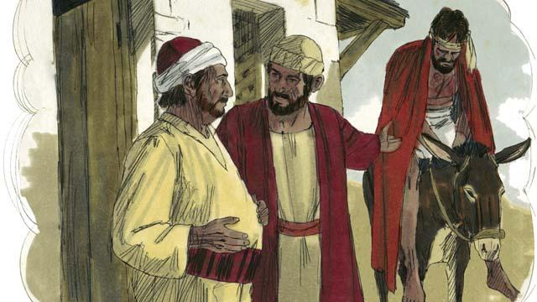
“Man Samaria i apim dispela man Juda na putim em long donki bilong em yet na karim i go long wanpela haus pasindia i stap arere long rot na em i lukautim em.”
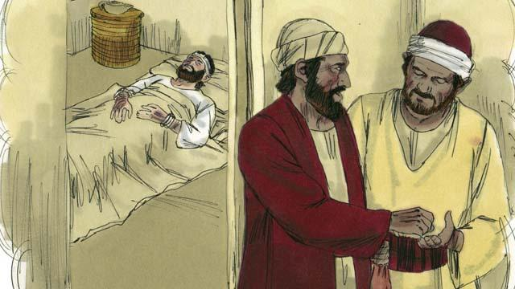
“Narapela de man Samaria i laik skruim wokabaut bilong em olsem na em i givim sampela mani long bosman bilong haus pasindia na i tok olsem,”Lukautim em na sapos yu tromoi sampela mani moa antap long dispela, orait bai mi bekim bek dispela long taim mi kam bek."

Jisas i askim saveman bilong lo na i tok, “Yu ting wanem? Husat man bilong dispela ol 3-pela man i wantok bilong dispela man ol stilman i paitim na stilim olgeta samting bilong em?” Na em i tok, “Man husat i bin sori long em,” Na Jisas i tokim em, “Yu go na mekim wankain pasin.”
Baibel Stori i Kam Long: Luk 10:25–37

