Resource: unfoldingWord® Open Bible Stories
unfoldingWord® Open Bible Stories © 2022 unfoldingWord. Released under CC BY-SA 4.0 license. unfoldingWord® Open Bible Stories has been adapted in the following languages: Tok Pisin, Arabic (عربي), French (Français), Hindi (हिंदी), Indonesian (Bahasa Indonesia), Portuguese (Português), Russian (Русский), Spanish (Español), Swahili (Kiswahili), and Simplified Chinese (简体中文) from unfoldingWord® Open Bible Stories © 2022 unfoldingWord. Released under CC BY-SA 4.0 license by Mission Mutual

unfoldingWord® Open Bible Stories

31. Jisas i Wokabaut Antap Long Wara

Bihain Jisas i salim ol manmeri i go na tokim ol disaipel long kalap long bot na pul i go long hapsait bilong raunwara. Jisas em yet i go antap long mauten long prea bihain long em i salim ol manmeri i go. Jisas em yet i stap na prea inap biknait.
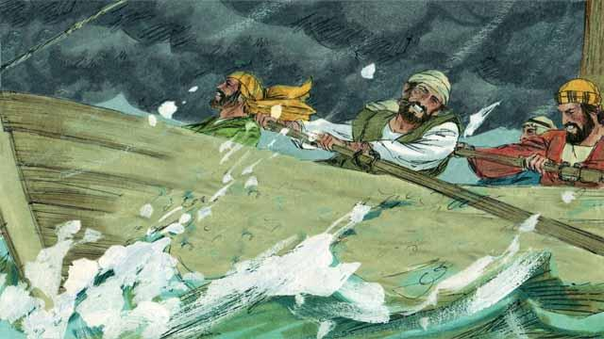
Long dispela taim yet, ol disaipel i pul long bot bilong ol, tasol ol i pul i go namel long raunwara inap long biknait. Ol i hatwok tru long pul, long wanem win i sakim wara i kam strong tru long ol.

Bihain Jisas i pinisim prea na i go long ol disaipel. Em i wokabaut antap long wara i go long bot long raunwara.

Ol disaipel i pret nogut tru taim ol i lukim Jisas, long wanem ol i ting ol lukim wanpela tewel man. Jisas i save olsem ol i pret olsem na em i singaut long ol na i tok, “Noken pret. Em mi tasol!”

Na Pita i tokim Jisas, “Masta, sapos em yu, inap yu tokim mi na mi ken kam long yu antap long wara.” Jisas i tokim Pita, “Yu kam!”

Olsem na Pita i kalap i kam aut long bot na stat long wokabaut i go long Jisas antap long wara. Tasol taim em i wokabaut i go liklik em i tanim ai bilong en long Jisas na lukluk i go long strong bilong wara win i sakim i kam.

Long dispela taim Pita i pret na i stat long go insait long wara. Na em i singaut olsem, “Masta, helpim mi.” Jisas i putim han i go kwiktaim tru na holim em. Na em i tokim Pita, “Yu gat liklik bilip tasol, bilong wanem yu tubel?”
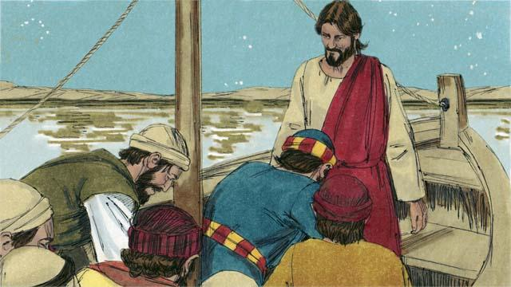
Taim Pita wantaim Jisas i kalap long bot kwiktaim win i stop na wara i stap isi. Ol disaipel i lukim dispela na kirap nogut. Na ol i lotu long Jisas na i tok, “Tru tumas, yu Pikinini bilong God.”
Baibel Stori i Kam Long: Matyu 14:22–33; Mak 6:45–52; Jon 6:16–21

