Resource: unfoldingWord® Open Bible Stories
unfoldingWord® Open Bible Stories © 2022 unfoldingWord. Released under CC BY-SA 4.0 license. unfoldingWord® Open Bible Stories has been adapted in the following languages: Tok Pisin, Arabic (عربي), French (Français), Hindi (हिंदी), Indonesian (Bahasa Indonesia), Portuguese (Português), Russian (Русский), Spanish (Español), Swahili (Kiswahili), and Simplified Chinese (简体中文) from unfoldingWord® Open Bible Stories © 2022 unfoldingWord. Released under CC BY-SA 4.0 license by Mission Mutual

unfoldingWord® Open Bible Stories

33. Stori Bilong Wanpela Fama
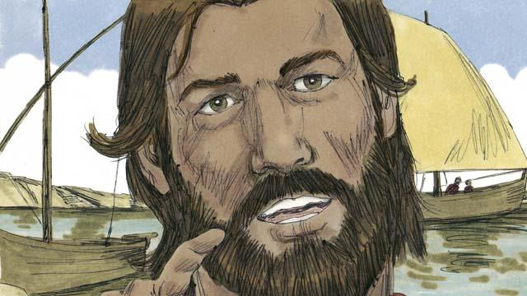
Wanpela de, Jisas i skulim planti manmeri i stap klostu long arere bilong raunwara. Planti manmeri i kam long harim em. Jisas i stap arere long wara na kalap insait long wanpela bot long mekim spes long autim tok long ol. Na Jisas i sindaun insait long bot na skulim ol manmeri.

Jisas i tokim ol dispela stori. Wanpela fama i go long gaden long planim sid kaikai. Taim em i tromoi sid kaikai long han bilong en sampela sid i lus na punaun antap long rot, na ol pisin i kam na kaikaim olgeta dispela sid kaikai.

Sampela sid kaikai i pundaun long graun i gat ston we i gat liklik graun i stap i gat ston. Sid kaikai i pundaun long dispela graun i kamap kwiktaim, tasol rop bilong sid kaikai i no inap go daun insait long graun. Taim san i kamap hat i kukim ol nupela pikinini kaikai na ol i drai na i dai.
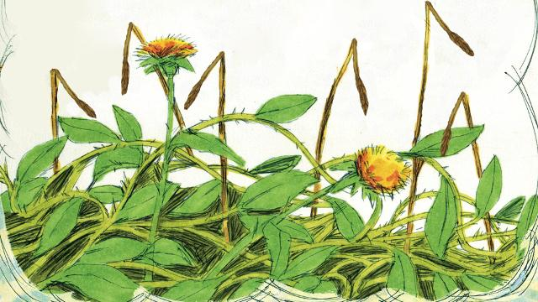
Ol arapela sid kaikai i pundaun namel long nil gras i stap long en. Sid kaikai i stat long kamap, tasol nil grass i wok long pasim ol. Olsem na ol sid kaikai i kamap long nil gras i no karim planti kaikai.
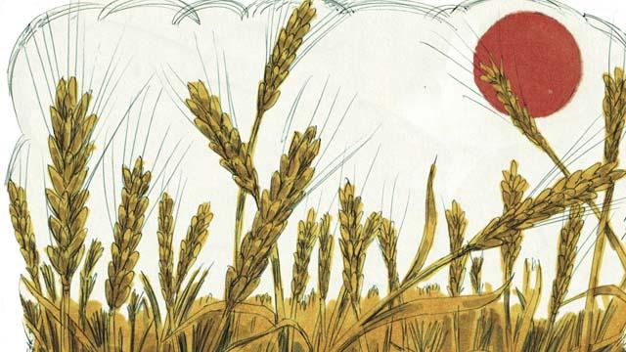
Arapela sid kaikai i pundaun long gutpela graun i kamap gut na karim planti kaikai olsem 30, 60, na tu 100 taim moa long dispela ol sid kaikai ol i planim. Husat i gat yau long harim, larim em harim.
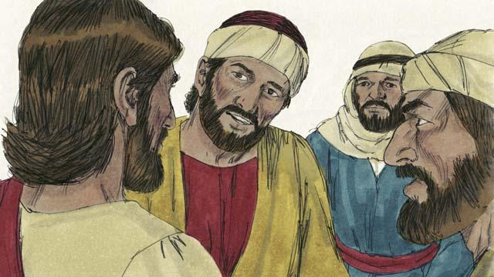
Dispela stori i paulim ol disaipel olsem na Jisas i tokaut klia. Sid kaikai em i tok bilong God. Na rot em i olsem manmeri husat i harim tok bilong God, tasol tok i no klia long ol na Satan i rausim dispela tok long ol.

Graun i gat ston long en i olsem ol manmeri husat i harim tok bilong God na kisim wantaim amamas. Tasol taim ol i bungim hevi na traim ol i pundaun.
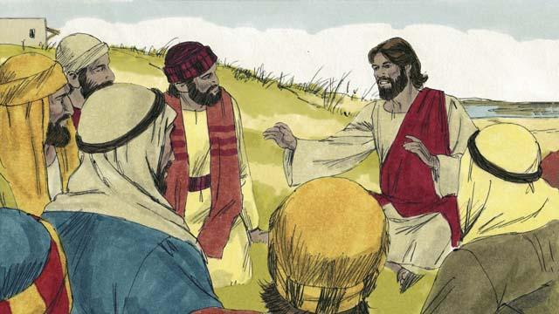
“Graun i gat nil gras long en em i olsem manmeri i harim tok bilong God, tasol taim i go on na ol kago na bilas na amamas bilong laip i pasin laikim bilong ol long God. Dispela as wanem samting Jisas i skulim ol i no karim gutpela kaikai. Dispela graun i gat planti gras nogut i pasim sid kaikai i no karim kaikai.”

Tasol gutpela graun i olsem ol manmeri husat i harim gut tok bilong God na bilip long en, i karim planti kaikai.
Baibel Stori i Kam Long: Matyu.13:1–8;18:23; Mak. 4:1–8,13–20; Luk 8:4–15

