Resource: unfoldingWord® Open Bible Stories
unfoldingWord® Open Bible Stories © 2022 unfoldingWord. Released under CC BY-SA 4.0 license. unfoldingWord® Open Bible Stories has been adapted in the following languages: Tok Pisin, Arabic (عربي), French (Français), Hindi (हिंदी), Indonesian (Bahasa Indonesia), Portuguese (Português), Russian (Русский), Spanish (Español), Swahili (Kiswahili), and Simplified Chinese (简体中文) from unfoldingWord® Open Bible Stories © 2022 unfoldingWord. Released under CC BY-SA 4.0 license by Mission Mutual

unfoldingWord® Open Bible Stories

36. Lukluk Bilong Jisas i Senis Na i Kamap Narakain

Wanpela de, Jisas i kisim 3-pela disaipel bilong en, Pita, Jems na Jon i go wantaim em. (Dispela Jon i no dispela man husat i baptaisim Jisas.) Ol i go long wanpela maunten i antap long mekim prea.

Taim Jisas i wok long prea, pes bilong em i lait olsem san na klos bilong em i kamap wait olsem lait, wait tru olsem man bilong graun i no inap mekim i kamapim.

Na Moses na profet Elaisa i kamap. Ol dispela man i bin stap long graun planti handred yia bipo. Ol i toktok wantaim Jisas long dai bilong em we bai i kamap klostu taim long Jerusalem.

Taim Moses na Elaisa i toktok wantaim Jisas, Pita i tokim Jisas, “I gutpela long yumi stap hia. Larim mipela i wokim 3-pela hauswin, wanpela bilong yu, wanpela bilong Moses na wanpela bilong Elaisa.” Pita i no save wanem samting em i tok.
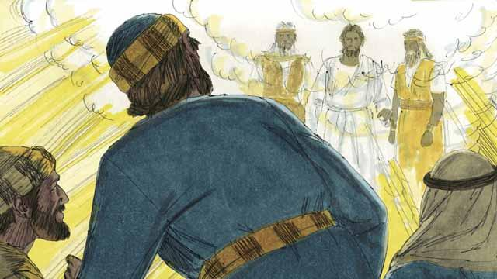
Taim Pita i toktok yet, klaut i lait strong i kam daun na raunim ol na wanpela nek long klaut i tok, “Dispela em i piknini bilong mi, mi laikim. Mi amamas long em. Yupela harim tok bilong em.” Na 3-pela disaipel i pret na pundaun i go long graun.

Na Jisas i tasim ol na i tok, “No ken pret. Kirap.” Taim ol i lukluk raun, ol i lukim Jisas tasol i stap.

Jisas wantaim 3-pela disaipel i go daun long maunten. Na Jisas i tokim ol, “Yupela i no ken tokim ol man long wanem samting i kamap long hia. Bai mi dai klostu taim na bai mi kam bek gen long laip. Bihain long dispela, yupela i ken tokim ol manmeri.”
Baibel Stori i Kam Long: Matyu.17:1–9; Mak 9:2–8; Luk 9:28–36

