Resource: unfoldingWord® Open Bible Stories
unfoldingWord® Open Bible Stories © 2022 unfoldingWord. Released under CC BY-SA 4.0 license. unfoldingWord® Open Bible Stories has been adapted in the following languages: Tok Pisin, Arabic (عربي), French (Français), Hindi (हिंदी), Indonesian (Bahasa Indonesia), Portuguese (Português), Russian (Русский), Spanish (Español), Swahili (Kiswahili), and Simplified Chinese (简体中文) from unfoldingWord® Open Bible Stories © 2022 unfoldingWord. Released under CC BY-SA 4.0 license by Mission Mutual

unfoldingWord® Open Bible Stories

38. Judas i Putim Jisas Long Han Bilong Ol Birua

Long olgeta yia ol lain Juda i save amamasim Pasova. Dispela amamas em i makim taim ol tumbuna bilong ol lain Juda i stap kalabus long kantri Isip na God i bin helpim ol. Samting olsem 3-pela yia bihain Jisas i tokim ol disaipel olsem em bai amamasim dispela Pasova wantaim ol long Jerusalem na em bai dai long hap.
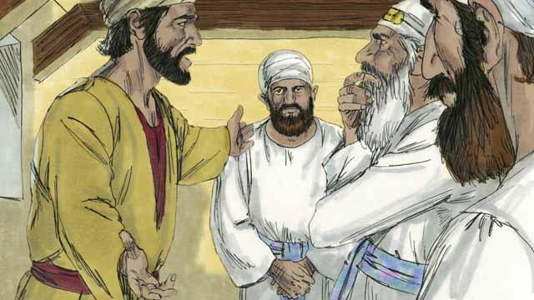
Wanpela disaipel bilong Jisas nem bilong en Judas. Judas i save lukautim mani bek bilong ol disaipel, tasol em i save laikim tumas mani na stilim long bek. Bihain Jisas na ol disaipel i kamap long Jerusalem, Judas i go long ol lida bilong ol lain Juda na promis long senisim Jisas long kisim mani. Judas i save olsem lida bilong ol Juda i no bilip long Jisas em i Mesaia na ol i painim rot long kilim em i dai.
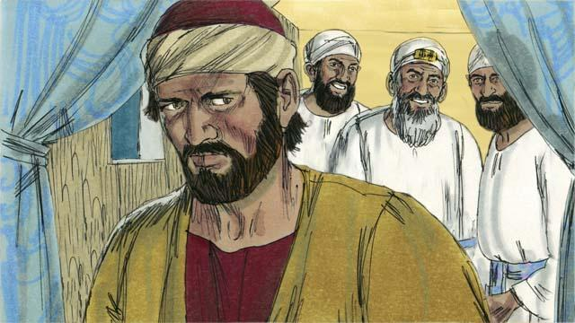
Ol lida bilong lain Juda wantaim hetpris i givim 30 silva mani long Judas bilong givim Jisas long ol. Dispela i kamap olsem ol profet bipo ol i tok long en. Judas i wanbel na kisim dispela mani na i go pinis. Na em i painim wanpela rot long helpim ol i ken holimpas Jisas.

Long Jerusalem Jisas i amamasim Pasova wantaim ol disaipel bilong em. Taim bilong Pasova kaikai Jisas i kisim sampela bret na brukim na i tok, “Dispela em i bodi bilong mi, mi givim long yupela. Taim yupela i kaikai dispela yupela i ken tingim mi.” Long dispela rot , Jisas i tok olsem bodi bilong em bai i kamap ofa bilong ol.
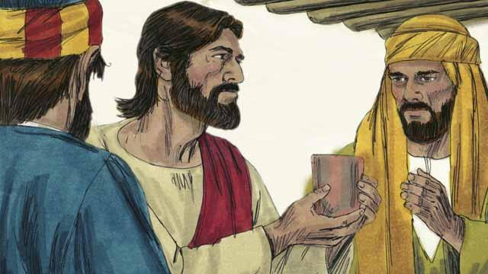
Na bihain Jisas i kisim wanpela kap na i tok, “Dring long em, dispela em i blut bilong mi long nupela kontrak em i kapsait long tekewe sin. Taim yupela i dring long dispela yupela i mas tingim mi oltaim.”
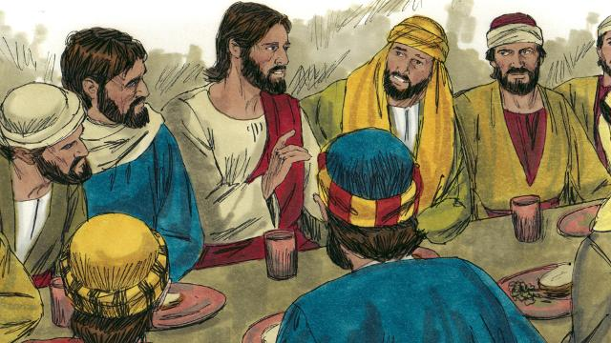
Bihain Jisas i tokim ol disaipel, “Wanpela bilong yupela bai i givim mi i go long ol birua.” Ol disaipel i kirap nogut na i tok, “Em husat bai i mekim dispela kain pasin?” Na Jisas i tok, “Husat long yupela, mi givim dispela bret, em bai i givim mi long ol birua.” Na em i givim dispela bret long Judas.
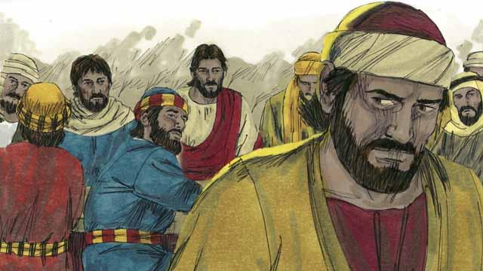
Bihain long Judas i kisim dispela bret, Satan i go insait long em. Judas i lusim ol na i go bilong helpim ol lida bilong ol Juda long holimpas Jisas. Na tudak i kamap.
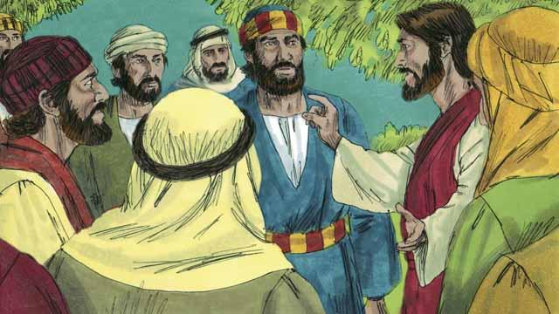
Bihain long kaikai, Jisas na ol disaipel bilong en i wokabaut i go long maunten Oliv. Na Jisas i tok, “Yupela olgeta bai i lusim mi nau long nait.” Ol i raitim pinis long buk, “Mi bai paitim wasman na ol sipsip bai i lus nabaut.”

Pita i bekim tok, “Maski ol arapela i ranawe, mi no inap lusim yu.” Na Jisas i tokim Pita, “Satan i laik kisim yupela olgeta, tasol mi bin prea pinis long yu, Pita, olsem bilip bilong yu i noken lus. Olsem tasol nau long nait taim kakaruk i no krai yet, yu bai tok yu no save long mi 3-pela taim.”

Na Pita i tokim Jisas gen olsem, “Maski sapos mi dai, mi no inap tok mi no save long yu!” Olgeta arapela disaipel i mekim wankain tok tasol.
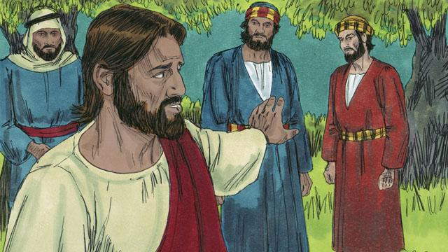
Na bihain Jisas i go wantaim ol disaipel bilong em long wanpela ples ol i kolim Getsamani. Jisas i tokim ol disaipel long prea long ol i noken lus long ol traim i kam. Olsem na Jisas em yet i go prea.
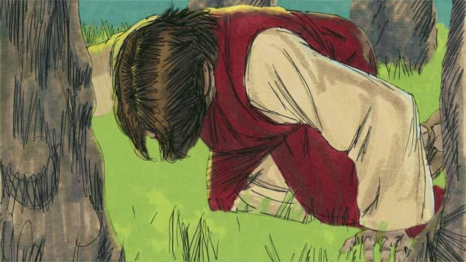
Jisas i prea 3-pela taim na i tok," Papa bilong mi, sapos em orait long yu, larim mi noken dring long dispela kap i gat pen. Tasol sapos i nogat narapela rot bilong tekewe sin bilong olgeta manmeri, orait larim laik bilong yu i ken kamap." Jisas i bungim bikpela hevi na tuhat long bodi bilong em i pundaun olsem blut. God i salim wanpela ensel long strongim em.

Bihain long wanwan prea taim, Jisas i go bek long ol disaipel, tasol ol i slip i stap. Taim em i go bek namba 3 taim, Jisas i tokim ol olsem, “Kirap! Ol birua bilong mi i kam pinis.”

Judas i kam wantaim ol lida bilong lain Juda, ol soldia na planti man. Ol i karim bainat na stik bilong pait. Judas i kam long Jisas na tok, “Gutnait, Tisa,” na kis long em. Dispela pasin i soim mak bilong ol lida bilong lain Juda long luksave na holimpasim em. Na Jisas i tok, “Judas, yu putim mi long han bilong ol birua wantaim kis?”
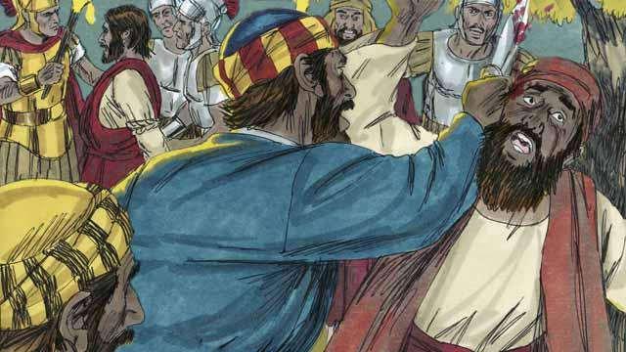
Taim ol soldia i holimpas Jisas, Pita i rausim bainat bilong em na katim yau bilong wanpela wokman bilong hetpris. Na Jisas i tok, “Putim bainat i go bek! Mi inap askim Papa long ami bilong ensel long lukautim mi. Tasol mi mas bihainim tok bilong Papa bilong mi.” Na Jisas i oraitim yau bilong wokman. Bihain long ol i holimpas em, olgeta disaipel bilong em i ranawe.
Baibel Stori i Kam Long: Matyu 26:14–56; Mak 14:10–50; Luk 22:1–53; Jon12:6;18:1–11

