Resource: unfoldingWord® Open Bible Stories
unfoldingWord® Open Bible Stories © 2022 unfoldingWord. Released under CC BY-SA 4.0 license. unfoldingWord® Open Bible Stories has been adapted in the following languages: Tok Pisin, Arabic (عربي), French (Français), Hindi (हिंदी), Indonesian (Bahasa Indonesia), Portuguese (Português), Russian (Русский), Spanish (Español), Swahili (Kiswahili), and Simplified Chinese (简体中文) from unfoldingWord® Open Bible Stories © 2022 unfoldingWord. Released under CC BY-SA 4.0 license by Mission Mutual

unfoldingWord® Open Bible Stories

39. Ol i Kotim Jisas
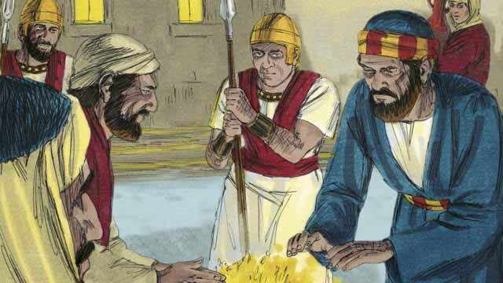
Nau em i namel long nait. Ol soldia i kisim Jisas i go long haus bilong hetpris olsem bai hetpris i ken askim em. Pita i bihainim ol i go longwe long ol. Taim ol i kisim Jisas i go insait long haus, Pita i stap autsait na hatim skin klostu long paia.
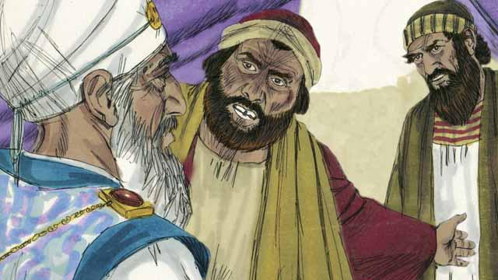
Insait long haus, ol lida bilong lain Juda i sanapim Jisas long kot. Ol i bringim planti giaman lain i kamap witnes long kot. Tasol toktok bilong ol i no wanbel wantaim tok bilong ol yet. Olsem na ol lida bilong lain Juda i no inap painim wanpela asua long em. Jisas tu i no mekim wanpela tok.
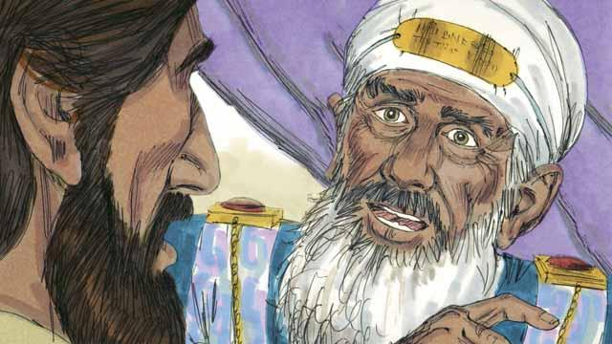
Bihain tru, hetpris i lukluk stret long Jisas na i tok,“Tokim mipela, i tru yu dispela Mesaia, Pikinini bilong God i stap oltaim?”
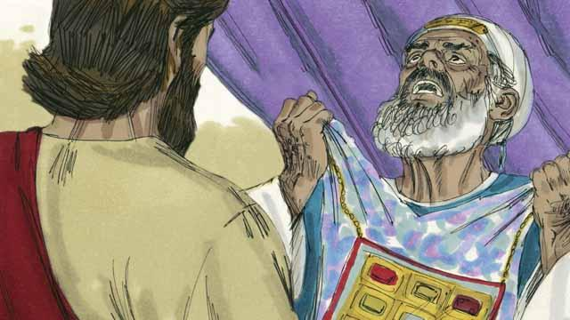
Jisas i tok, “Em mi tasol, na yu bai lukim mi sindaun wantaim God na kam daun lusim heven.” Hetpris i brukim klos bilong em wantaim belhat na singaut long ol arapela lida lain bilong lotu na tok,“Yumi no ken painim narapela witnes. Yu yet i harim em i tok em i Pikinini bilong God. Yupela i skelim em olsem wanem?”
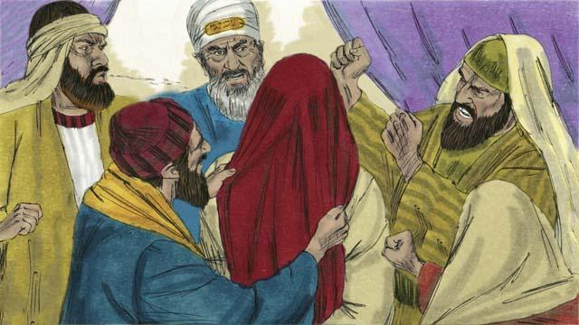
Ol lida bilong lain Juda olgeta i bekim tok bilong hetpris, “Maski, em i ken dai!” Na ol pasim ai bilong Jisas wantaim laplap na spet long em, paitim em na tok bilas long em.
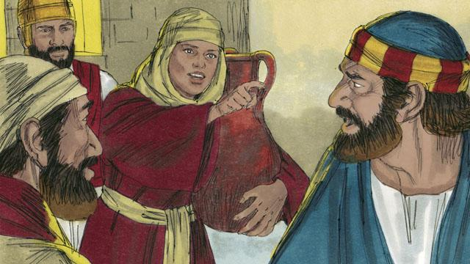
Taim Pita i wet i stap autsait long haus, wanpela wokmeri i lukim em na i tok, “Yu tu yu bin i stap wantaim Jisas.” Na Pita i tok nogat. Bihain narapela wokmeri tu i tok wankain samting, na Pita i tok nogat gen. Bihain tru, ol manmeri i tok, “Mipela i save yu stap wantaim Jisas, long wanem yutupela i bilong Galili.”
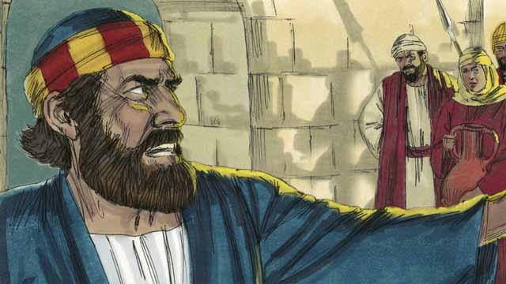
Na bihain Pita i tok strong tru antap, “God inap long bagarapim mi sapos mi tok mi save long em.” Kwiktaim, kakaruk i krai na Jisas i tanim na lukim Pita.

Pita i kirap i go na krai nogut tru. Long dispela taim yet, Judas, man i givim Jisas long ol birua i lukim ol lida bilong lain Juda i tokaut olsem Jisas i mas dai. Judas i pulap long bel sori na i go kilim em yet na i dai.
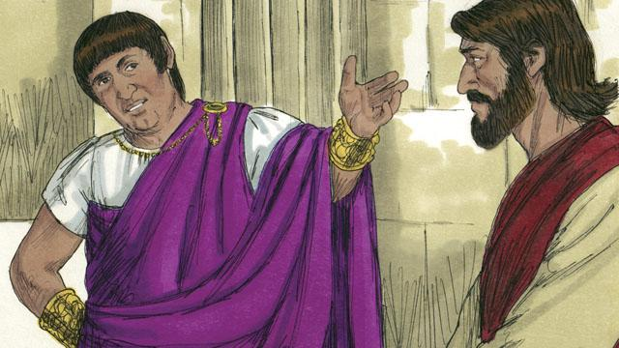
Bikmonin long narapela de, ol lida bilong lain Juda i bringim Jisas i go long Pailet, em i Gavana bilong Rom. Ol i laikim Pailet bai tokaut long Jisas i mas i dai olsem em i gat asua. Na Pailet i askim Jisas, “Yu king bilong ol lain Juda?”

Na Jisas i bekim tok olsem, “Em yu tok pinis, tasol kingdom bilong mi i no bilong dispela graun. Sapos em i olsem, ol wokman bilong mi bai pait long helpim mi. Mi kam long dispela graun long mekim tok tru long God. Olgeta man husat i save laikim tok tru i save harim mi.” Na Pailet i tok, “Wanem em i tok tru?”
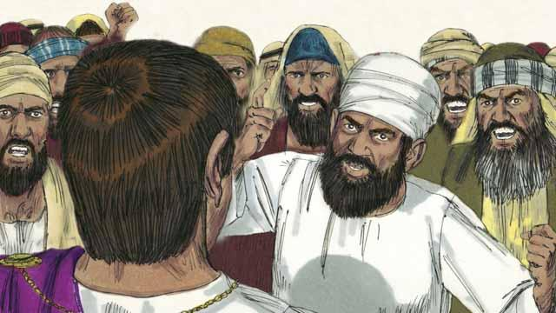
Bihain long Pailet i toktok wantaim Jisas, em i go autsait long ol bikpela lain manmeri na i tokim ol, “Mi no painim wanpela asua long dispela man.” Tasol ol lida bilong lain Juda na bikpela lain manmeri i singaut bikmaus na tok, “Hangamapim em!” Pailet i bekim tok, “Em i no gat asua long i dai.” Tasol ol i singaut bikmaus moa yet. Na Pailet i mekim dispela tok 3-pela taim, “Em i nogat asua long i dai!”

Pailet i pret, olsem nogut ol bikpela lain manmeri i kirapim pait na em i tokim ol soldia long hangamapim Jisas. Ol soldia bilong Rom i wipim Jisas na putim wanpela retpela laplap long Jisas na putim hat kraun i gat nil. Ol i tok bilas long em na tok, “Lukim, dispela em i King bilong ol Juda!”
Baibel Stori i Kam Long: Matyu 26:57–27:26; Mak 14:53,15:15; Luk 22:54,23:25; Jon 18:12–19:16

