Resource: unfoldingWord® Open Bible Stories
unfoldingWord® Open Bible Stories © 2022 unfoldingWord. Released under CC BY-SA 4.0 license. unfoldingWord® Open Bible Stories has been adapted in the following languages: Tok Pisin, Arabic (عربي), French (Français), Hindi (हिंदी), Indonesian (Bahasa Indonesia), Portuguese (Português), Russian (Русский), Spanish (Español), Swahili (Kiswahili), and Simplified Chinese (简体中文) from unfoldingWord® Open Bible Stories © 2022 unfoldingWord. Released under CC BY-SA 4.0 license by Mission Mutual

unfoldingWord® Open Bible Stories

40. Ol i Hangamapim Jisas Long Diwai Kros
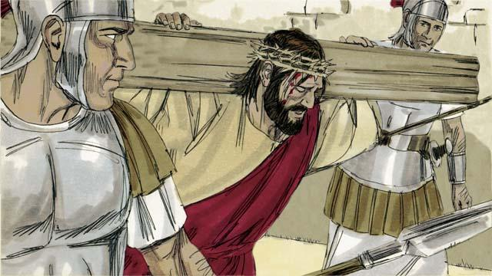
Bihain long ol soldia i tok bilas long Jisas, ol i kisim em i go long hangamapim em. Ol i mekim em i karim diwai kros bilong em yet bai em i dai long en.

Ol soldia i bringim Jisas i go long ples ol i kolim “Bun bilong Het” na paitim tupela nil long tupela han na lek bilong em long diwai kros. Tasol Jisas i tok, “Papa lusim sin bilong ol, long wanem ol i no save wanem ol i mekim.” Pailet i tok ol i mas raitim olsem, “King bilong ol lain Juda” na putim long diwai kros antap long het bilong Jisas.
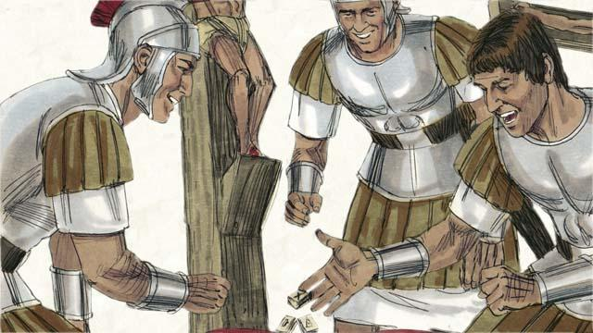
Ol soldia i pilai kas long klos bilong Jisas. Taim ol i mekim olsem, ol inapim wanem profet bipo i tok, “Ol i skelim klos bilong mi namel long ol na pilai kas long kisim klos bilong mi.”

Ol i hangamapim Jisas namel long tupela stilman. Wanpela i tok bilas long Jisas, tasol narapela i tok, “Yu no pret long God a? Mitupela i gat asua tasol dispela man i no gat asua. Na em i tokim Jisas,”Plis, yu mas tingim mi long kingdom bilong yu." Na Jisas i tokim em, “Nau tasol yu bai stap wantaim mi long Paradais.”
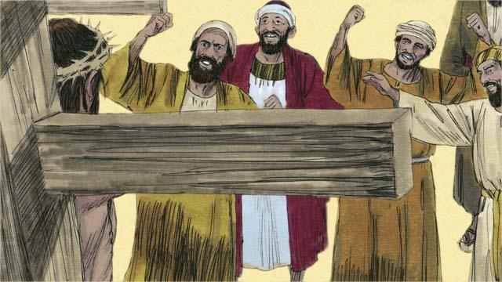
Ol lida bilong lain Juda na arapela lain manmeri i tok bilas long Jisas. Ol i tokim em, “Sapos yu pikinini bilong God, orait yu kam daun long diwai kros na helpim yu yet. Na bai mipela i bilip.”
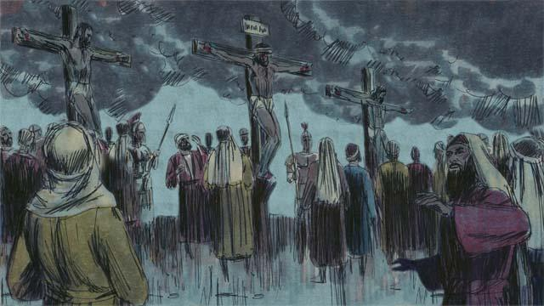
Kwiktaim skai antap long dispela hap ples i kamap tudak, maski em i namel long de taim. Ples i kamap tudak long belo i go inap 3-pela aua long apinun.

Na Jisas i singaut na krai bikmaus, “Em i pinis! Papa mi givim spirit bilong mi i go long han bilong yu.” Na em daunim het bilong em na givim spirit bilong en i go. Taim em i dai, bikpela guria i kamap na bikpela laplap i banisim glori bilong God na manmeri, insait long Tempel i bruk long tupela hap, antap i go daun.
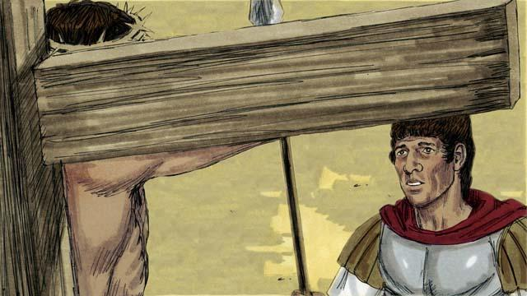
Long dai bilong Jisas, em i opim rot bilong ol manmeri long kam long God. Taim wanpela soldia i stap wasman em i lukim olgeta samting i kamap long Jisas, em i tok, “Tru tumas em i nogat asua. Na em i Pikinini bilong God.”
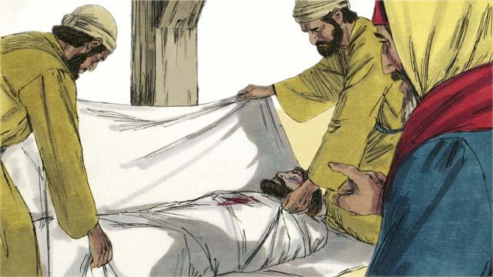
I gat tupela lida bilong lain Juda, nem bilong ol em Josep na Nikodimas, tupela i bilip olsem Jisas em i Mesaia. Tupela i askim Pailet long kisim bodi bilong Jisas. Ol i karamapim bodi long laplap na putim em insait long ston matmat. Bihain tupela i tanim wanpela bikpela ston na pasim maus bilong dispela matmat.
Baibel Stori i Kam Long: Matyu 27:27–61; Mak 15:16–47; Luk 23:26–56; Jon 19:17–42

