Resource: unfoldingWord® Open Bible Stories
unfoldingWord® Open Bible Stories © 2022 unfoldingWord. Released under CC BY-SA 4.0 license. unfoldingWord® Open Bible Stories has been adapted in the following languages: Tok Pisin, Arabic (عربي), French (Français), Hindi (हिंदी), Indonesian (Bahasa Indonesia), Portuguese (Português), Russian (Русский), Spanish (Español), Swahili (Kiswahili), and Simplified Chinese (简体中文) from unfoldingWord® Open Bible Stories © 2022 unfoldingWord. Released under CC BY-SA 4.0 license by Mission Mutual

unfoldingWord® Open Bible Stories

43. Stat Bilong Sios
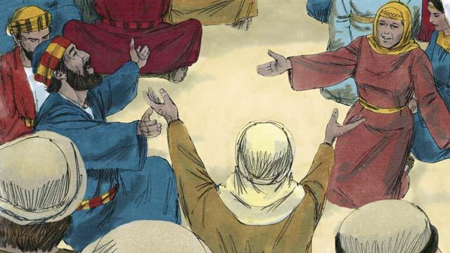
Bihain long Jisas i go bek gen long heven, ol disaipel i stap long Jerusalem long wanem Jisas i bin tok strong long ol i mas mekim olsem. Ol bilip manmeri olgeta taim ol i save bung na beten.
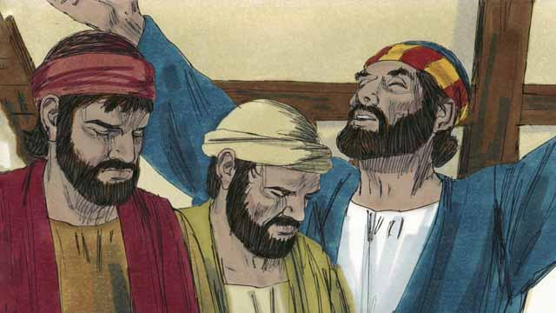
Olgeta yia, 50 de bihain long Pasova, Ol Juda i save amamas na tingim bikpela de ol i kolim Pentikos. Pentikos em i taim bilong ol Juda i amamas na kaumautim ol kaikai bilong ol. Ol Juda i save kam long olgeta hap bilong graun long bung wantaim na amamas long Jerusalem long dispela de Pentikos. Long dispela yia, taim bilong Pentikos i kam olsem wanwik bihain long Jisas i go bek pinis long heven.
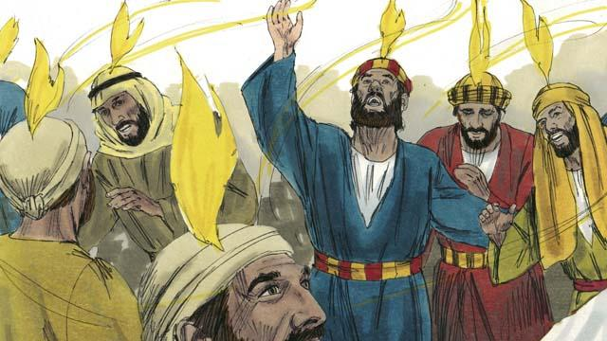
Taim ol bilip manmeri olgeta i bung na stap wantaim, na wantu tasol haus we ol i stap long en i gat bikpela nois i olsem strongpela win i kamap. Na samting olsem paia i kamap antap long het bilong olgeta bilip manmeri. Olgeta yet i pulap long Holi Spirit na ol i toktok long kain kain tokples.
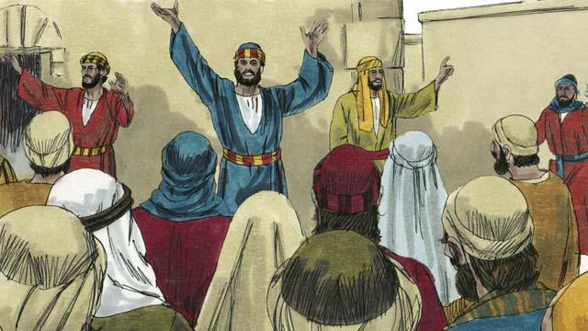
Taim ol manmeri long Jerusalem i harim nois, planti moa arapela manmeri tu i kam long lukim wanem samting i kamap. Taim olgeta manmeri i harim ol bilip manmeri i tokaut long ol gutpela ol wok bilong God, olgeta yet i kirap nogut long harim dispela ol samting i kamap long wanwan tokples bilong ol yet.
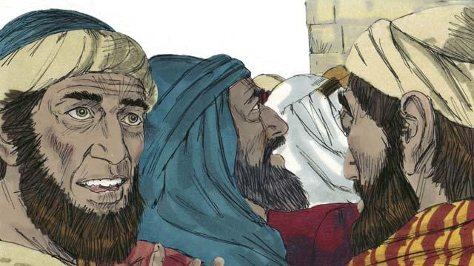
Sampela manmeri i sutim tok long ol disaipel olsem ol i dring na spak. Tasol Pita i sanap na i tokim ol, “Yupela harim mi! Dipela ol manmeri i no spak! Dispela samting i kamap long nau i makim wanpela tok i kam long profet Joel long God i tok, ’Long taim bilong las de mi bai kapsatim Spirit bilong mi.”
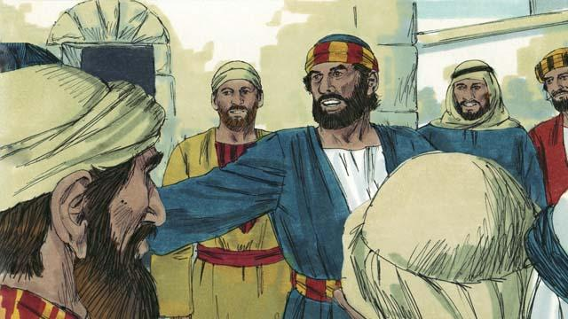
“Ol man bilong Israel, Jisas em man i bin mekim bikpela wok long pawa bilong God, olsem yupela i lukim na save pinis. Tasol yupela yet i nilim em antap long diwai kros!”

“Taim Jisas i dai, tasol God i kirapim em bek gen long dai. Dispela em tok tru long God i bin givim tok long wanpela profet na em i tokaut na i tok, ‘Long wanem, bai yu no larim mi i go i stap long ples bilong ol man i dai pinis na sting long matmat.’ Na mipela i kamap witnes long God i kirapim bek Jisas long i stap laip gen.”
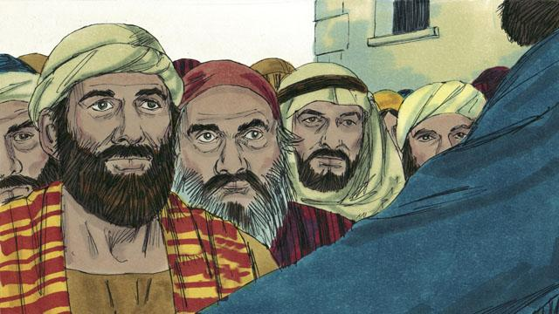
“Jisas i kirap bek pinis na i stap long han sut bilong Papa God. Na Jisas i salim Holi Spirit pinis olsem em i bin promis long mekim. Dispela Holi Spirit tasol i wokim ol samting na yupela i lukim na harim.”
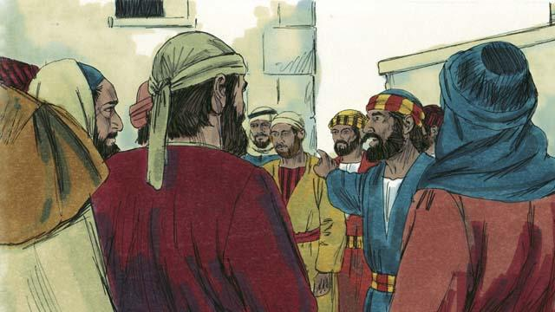
“Yupela i hangamapim dispela man Jisas long diwai kros. Tasol yupela i mas save gut, nau em tru olsem God i mekim Jisas i kamap Bikpela na Mesaia!”
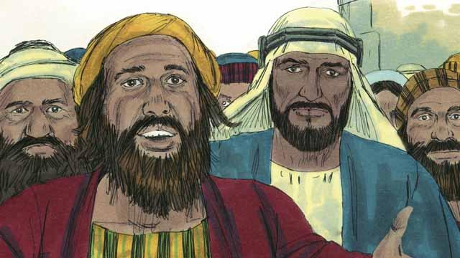
Olgeta manmeri i harim tok bilong Pita na olgeta i wanbel long olgeta samting em i toktok long ol. Olsem na ol i askim Pita na ol disaipel, “Ol brata, bai mipela i mekim wanem?”

Pita i bekim tok bilong ol olsem, “Yupela olgeta manmeri i mas tanim bel na kisim baptais long nem bilong Jisas Krais na God bai lusim sin bilong yupela. Olsem na em tu bai i givim presen bilong Holi Spirit long yupela.”

Samting olsem 3,000 manmeri i bilip long tok Pita i autim na ol i kamap disaipel bilong Jisas. Olgeta i kisim baptais na kamap olsem memba bilong sios long Jerusalem.
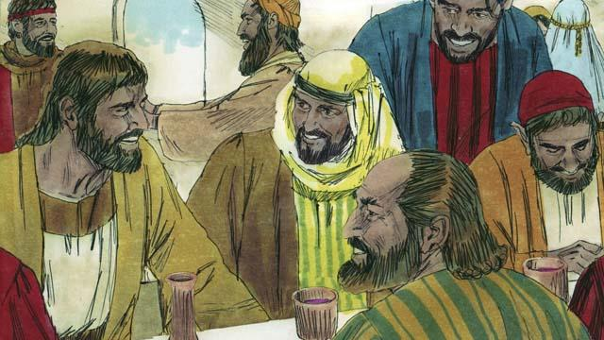
Ol disaipel i wok long harim skul i kam long ol aposel olgeta de, na olgeta taim ol i bung na kaikai na beten wantaim. Ol i amamas wantaim long litimapim nem bilong God. Na wanem samting ol i gat ol i skelim namel long ol yet. Olgeta manmeri i gat gutpela tingting namel long ol yet. Olgeta de planti moa pipel i kamap bilip manmeri.
Baibel Stori i Kam Long: Aposel 2

