Resource: unfoldingWord® Open Bible Stories
unfoldingWord® Open Bible Stories © 2022 unfoldingWord. Released under CC BY-SA 4.0 license. unfoldingWord® Open Bible Stories has been adapted in the following languages: Tok Pisin, Arabic (عربي), French (Français), Hindi (हिंदी), Indonesian (Bahasa Indonesia), Portuguese (Português), Russian (Русский), Spanish (Español), Swahili (Kiswahili), and Simplified Chinese (简体中文) from unfoldingWord® Open Bible Stories © 2022 unfoldingWord. Released under CC BY-SA 4.0 license by Mission Mutual

unfoldingWord® Open Bible Stories

45. Wanpela Gavana Bilong Itiopia Wantaim Pilip
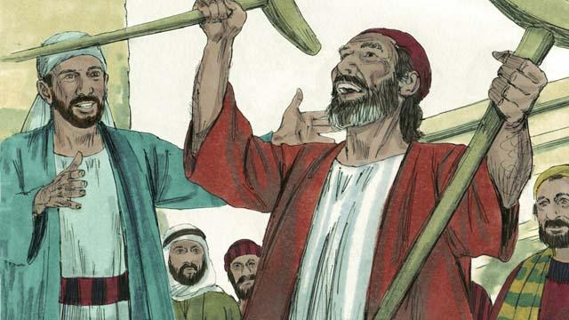
Wanpela lida bilong sios nem bilong em Stiven. Em i gat gutpela nem na pulap long Holi Spirit na gutpela tingting. Stiven i wokim kainkain mirakel na autim strong tok bilong God we ol manmeri i mas kam na bilip long Jisas.
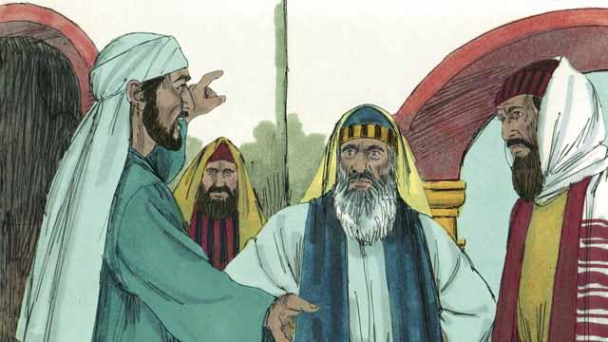
Long wanpela de, Stiven i wok long skulim ol long gutnius bilong Jisas. Sampela bilong ol Israel husat i no bilip long Jisas i stat long tok pait wantaim Stiven. Ol i belhat nogut tru na i mekim tok giaman long Stiven long ol lidaman bilong ol Israel. Na ol i tok olsem, “Mipela i harim em i mekim sampela tok nogut long Moses na God!” Olsem na ol lidaman bilong ol Israel i holimpasim Stiven na kisim em i go long hetpris na ol arapela lida bilong Israel, long hap sampela man moa i mekim tok giaman long Stiven.
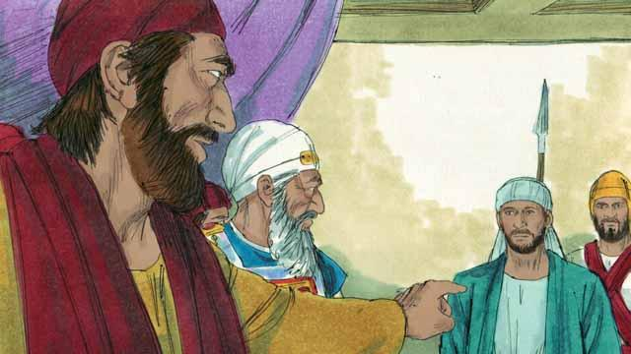
Hetpris i askim Stiven, “Ol dispela samting i tru a?” Na Stiven i bekim tok olsem, “God i bin mekim planti gutpela samting long taim bilong Abraham i kam inap long taim bilong Jisas, tasol ol manmeri bilong God i no save bihainim tok bilong em.” Na em i tok. “Yupela manmeri bilong sakim tok na strongim bel na birua long Holi Spirit olsem ol tumbuna bilong yupela i no save bihainim God, na kilim ol propet bilong em. Tasol yupela i mekim pasin i no stret i winim pasin ol i bin mekim na yupela i bin kilim Mesaia!”
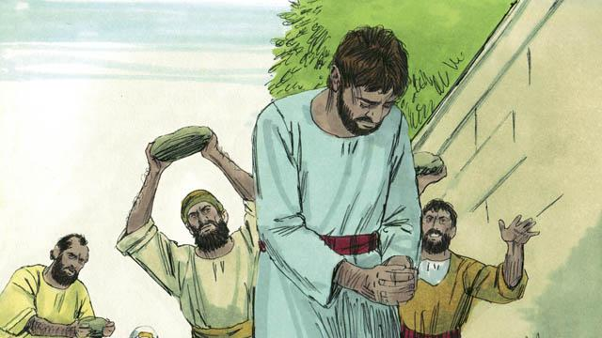
Taim ol lidaman bilong Israel i harim dispela tok, ol i belhat nogut tru na pasim han long yau bilong ol na bikmaus strong na ol i pulim Stiven i go autsait long taun na tromoi ston long kilim em.

Taim Stiven i laik lusim laip, em i singaut na tok, “Jisas, kisim spirit bilong mi.’’ Na em i pundaun i go daun long skru bilong em na i singaut gen olsem,”Masta, noken bekim dispela pasin nogut ol i mekim long mi." Na em i dai.
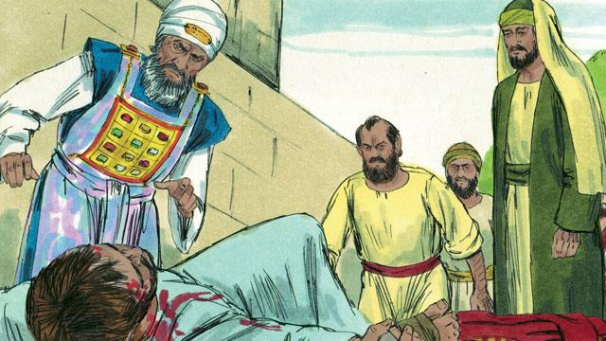
Wanpela yangpela man nem bilong em Sol, em i wanbel wantaim ol manmeri husat ol i bin kilim Stiven na lukautim klos bilong ol lain taim ol i tromoi ston long em. Dispela de, ol planti manmeri long Jerusalem ol i stat long bagarapim ol lain husat i bihainim Jisas, olsem na ol bilip manmeri i ranawe i go nabaut long olgeta hap ples. Tasol insait long dispela taim, ol i wok long autim gutnius bilong Jisas long ol ples ol i stap long en.
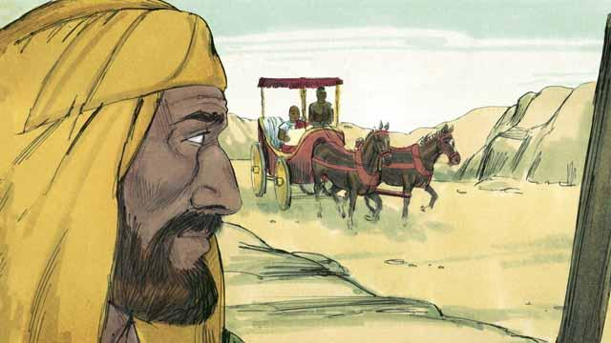
Wanpela disaipel bilong Jisas nem bilong en Filip em wanpela bilong ol dispela bilip man husat i ranawe long Jerusalem long taim bilong dispela hevi. Em i go long Samaria na autim gutnius bilong Jisas na planti manmeri ol i tanim bel. Na long wanpela de, ensel bilong God i tokim Filip long go long wanpela rot i stap long ples nating. Taim em i wokabaut arere long rot, Filip i lukim wanpela bikman bilong Itiopia i sindaun long karis na i go. Holi Spirit i tokim Pilip long go na toktok long dispela man.
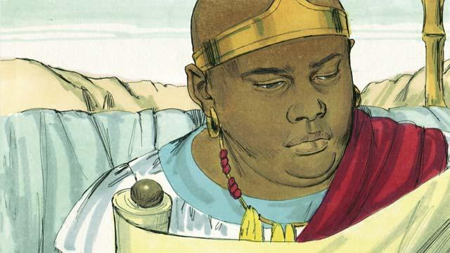
Orait taim Filip i go klostu long dispela karis, em i harim dispela man Itiopia i rit long wanem samting profet Aisaia i bin raitim. Dispela man i ritim olsem, “Ol i pulim em olsem wanpela pikinini sipsip long kilim em, tasol dispela sipsip i stap isi, em i no mekim wanpela tok. Ol i mekim pasin nogut na pasin i no stret long em. Na ol i kilim em i dai.”
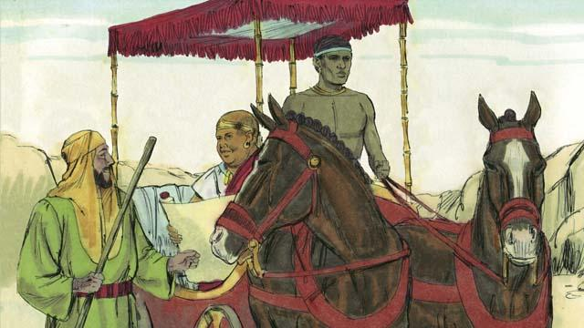
Filip i askim dispela man Itiopia olsem, “Yu save long wanem samting yu ritim?” Na man Itiopia i bekim na tok, “Nogat. Mi no save long as bilong dispela tok inap wanpela man i ritim na tokim mi. Inap yu kam antap na sindaun klostu long mi? Taim Aisaia i raitim dispela tok, em i raitim long em yet o long narapela man?”
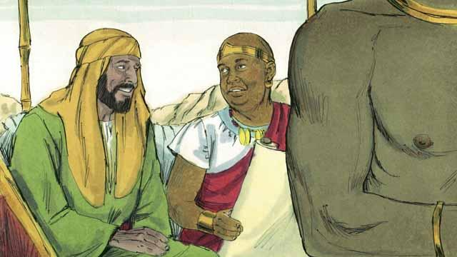
Na Filip i bekim tok bilong dispela man Itiopia olsem; Aisaia i bin raitim stori bilong Jisas. Olsem na Filip i tokim em narapela tok bilong God long gutnius bilong Jisas.
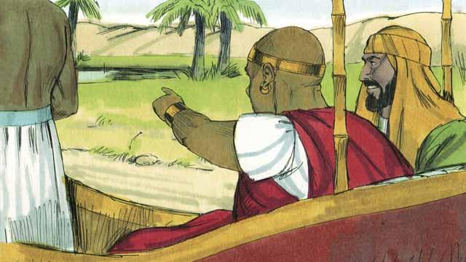
Taim Filip na man Itiopia tupela i ran i go kamap long wanpela wara. Na man Itiopia i tok olsem, “Lukim! Hia i gat sampela wara i stap! Inap yu baptaisim mi?” Na em i tokim draiva bilong karis long stop.
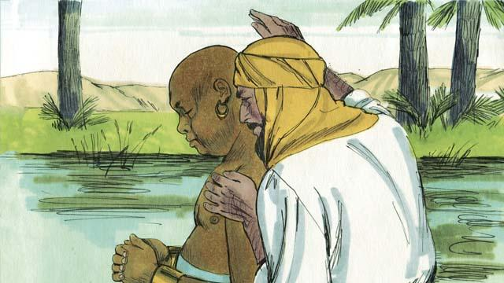
Olsem na ol i go daun long wara, na Filip i baptaisim man Itiopia. Bihain ol i kamaut long wara, na wantu tasol Holi Spirit i kisim Filip i go long narapela ples long autim gutnius bilong Jisas long ol manmeri.
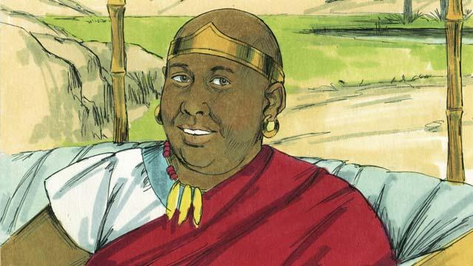
Na dispela man Itiopia i amamas na bihainim rot i go long haus bilong em, na em i amamas olsem em i save long Jisas.
Baibel Stori i Kam Long: Aposel 6:8–8:5; 8:26–40

