Resource: unfoldingWord® Open Bible Stories
unfoldingWord® Open Bible Stories © 2022 unfoldingWord. Released under CC BY-SA 4.0 license. unfoldingWord® Open Bible Stories has been adapted in the following languages: Tok Pisin, Arabic (عربي), French (Français), Hindi (हिंदी), Indonesian (Bahasa Indonesia), Portuguese (Português), Russian (Русский), Spanish (Español), Swahili (Kiswahili), and Simplified Chinese (简体中文) from unfoldingWord® Open Bible Stories © 2022 unfoldingWord. Released under CC BY-SA 4.0 license by Mission Mutual

unfoldingWord® Open Bible Stories

29. Simulizi ya Mtumishi Asiye na Huruma.
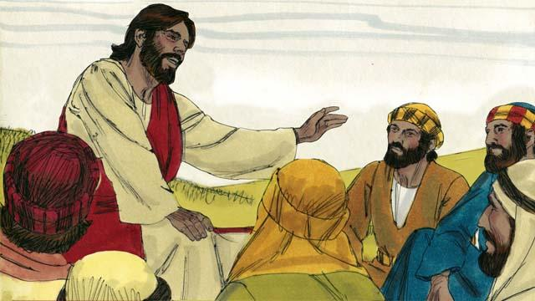
Siku moja, Petro alimuuliza Yesu "Bwana, ni mara ngapi inanipasa kumsamehe ndugu yangu akinikosea? Hadi mara saba?" Yesu akasema, "Sio mara saba, bali sabini mara saba!" Kwa hili, Yesu alimaanisha inatupasa kusamehe kila wakati. Yesu akawaambia habari hii.
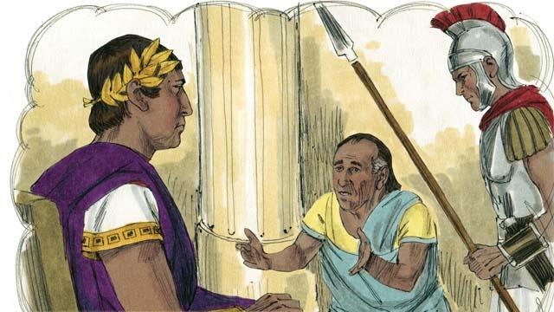
Yesu akasema, " Ufalme wa Mungu unafananishwa na mfalme alie taka kukusanya madeni yake kutoka kwa watumishi wake. Mmoja wa watumishi wake alikua anadaiwa deni kubwa lenye thamani ya mshahara wa miaka 200,000."
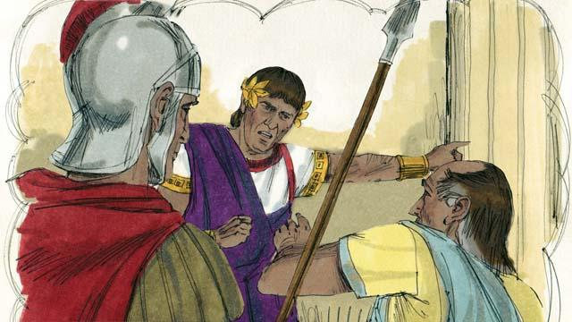
"Kwakua yule mtuishi hakuweza kulipa deni, mfalme alisema, 'muuzeni huyu mtu na familia yake kama watumwa ili kulipa deni lake."
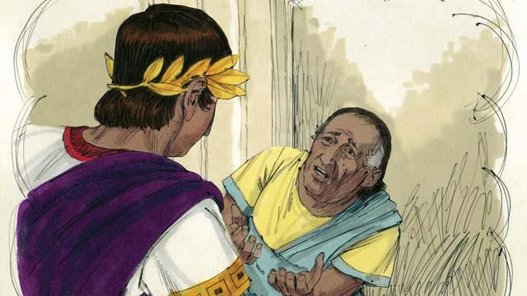
"Yule mtumishi alianguka na kupiga magoti mbele ya mfalme na kusema, ' naomba nivumilie, na nitalipa deni loote unalonidai.' Mfalme alimuonea huruma yule mtumishi, ndipo akafuta deni lake lote na kumuacha aende zake."
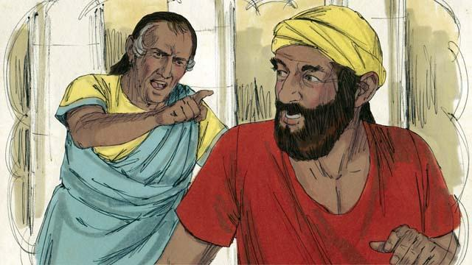
"Ila baada ya mtumishi kutoka kwa mfalme, alimpata mtumishi mwenzake aliekua akimdai deni lenye thamani ya mshahara wa miezi minne. Alimkamata yule mtumishi mwenzake na kusema, ' Nilipe hela ninayo kudai!"'
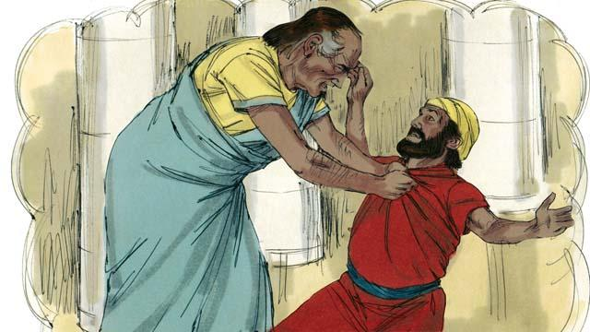
"Yule mtumishi mwenzake alianguka na kupiga magoti na kumwambia, 'Tafadhali nivumilie, nitakulipa kiasi chote unachonidai.' Ila, yule mtumishi alimtupa mtumishi mwenzake ndani ya gereza hadi atakapo lipa deni lake."
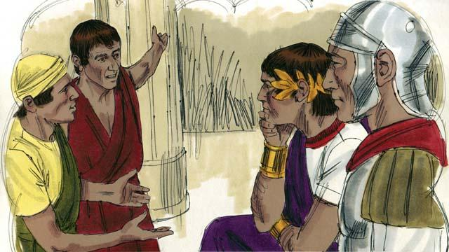
"Baadhi ya watumishi wengine walioona kilicho tokea walifadhaika sana. Wakaenda kwa mfalme na kumuambia kila kitu."
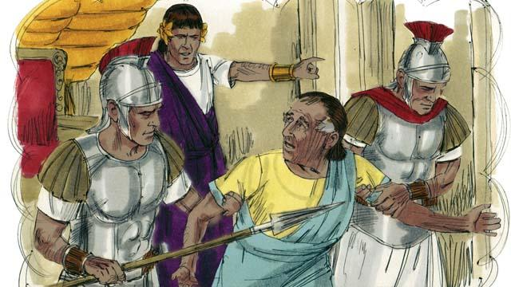
"Mfalme alimwita yule mtumishi nakumuambia, 'Ewe mtumishi muovu! Nilikusamehe deni lako kwasababu ulinisihi. Ungefanya vivyo hivyo.' Mfalme alikasirika sana na kumtupa yule mtumishi muovu gerezani mpaka atakapo lipa deni lake lote."
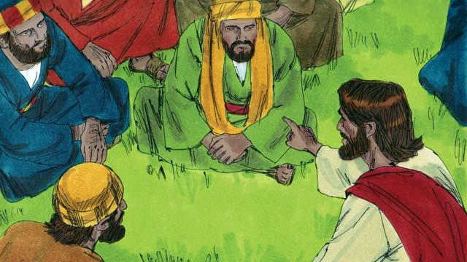
Ndipo Yesu akasema " Hivi ndivyo baba yangu wa mbinguni atakavyo fanya kwa kila mmoja wenu kama hamtawasamehe ndugu zenu kutoka moyoni".
Simulizi ya Biblia kutoka: Matayo18:21–35

