Resource: unfoldingWord® Open Bible Stories
unfoldingWord® Open Bible Stories © 2022 unfoldingWord. Released under CC BY-SA 4.0 license. unfoldingWord® Open Bible Stories has been adapted in the following languages: Tok Pisin, Arabic (عربي), French (Français), Hindi (हिंदी), Indonesian (Bahasa Indonesia), Portuguese (Português), Russian (Русский), Spanish (Español), Swahili (Kiswahili), and Simplified Chinese (简体中文) from unfoldingWord® Open Bible Stories © 2022 unfoldingWord. Released under CC BY-SA 4.0 license by Mission Mutual

unfoldingWord® Open Bible Stories

36. Kubadilika Sura
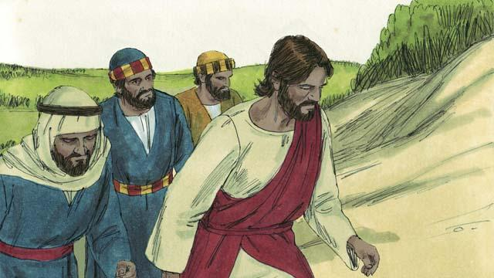
Siku moja, Yesu aliwachukua wanafunzi wake watatu Yakobo, Petro na Yohana. ( Mwanafunzi aitwae Yohana sio yule aliyembatiza Yesu.) Walipanda juu ya mlima mrefu kuomba pekeyao.
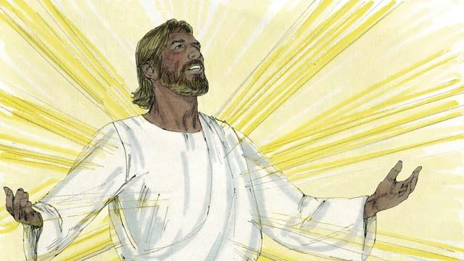
Yesu akiwa anaomba uso wake ulibadilika na kung'aa kama jua na mavazi yake yakawa meupe kama mwanga, yalikua meupe sana zaidi awezavyo mtu duniani kuyafanya yang'ae.
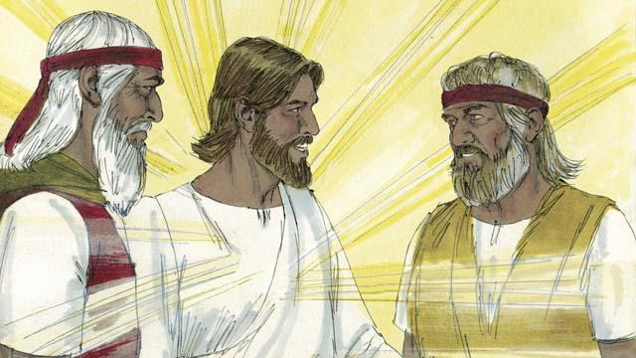
Ndipo Musa na nabii Eliya wakawatokea. Watu hawa waliishi duniani miaka mingi kabla. Waliongea na Yesu juu ya kifo chake ambacho kitatokea Yerusalemu siku chache baadae.
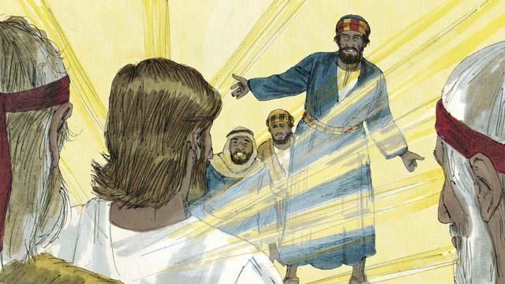
Wakati Musa na Eliya wanaongea na Yesu, Petro akamwambia Yesu, "Ni vizuri sisi kuwa hapa, hivyo naomba tutengeneze nyumba tatu moja ya kwako, nyingine ya Eliya na nyingine ya Musa". Lakini Petro hakujua alinenalo.
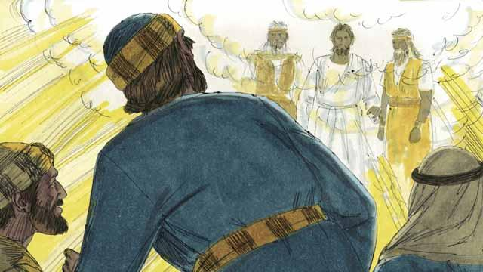
Wakati Petro anaongea wingu jeupe lilishuka na kuwazunguka na sauti ikatoka katika lile wingu ikisema " Huyu ni Mwanagu nimpendaye. Ninayependezwa naye msikilizeni yeye".Wale wanafunzi watatu waliogopa na kuanguka chini.
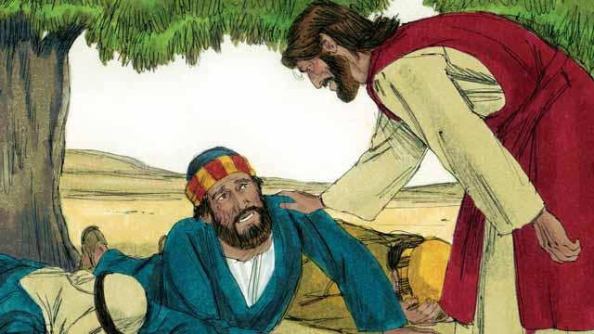
Ndipo Yesu akawagusa na kuwaambia "Msiogope inukeni". walipotazama pembeni ni Yesu pekee ndiye aliyebaki pale.
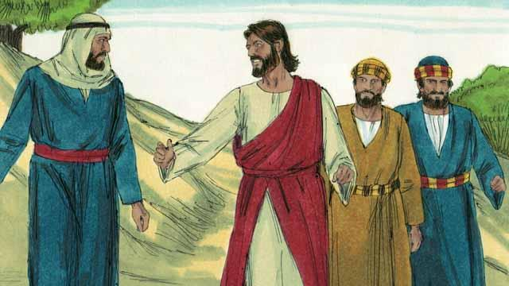
Yesu pamoja na wanafunzi wake watatu wakashuka kutoka mlimani. Yesu akawaambia "Msimwambie mtu yeyote yale yaliyotokea, siku chache baadae nitakufa kisha nitakua hai tena. Baada ya hapo mtawaambia watu."
Simulizi ya Biblia kutoka: Mathayo 17: 1–9; Marko 9:2–8; Luka 9:28–36

