Resource: unfoldingWord® Open Bible Stories
unfoldingWord® Open Bible Stories © 2022 unfoldingWord. Released under CC BY-SA 4.0 license. unfoldingWord® Open Bible Stories has been adapted in the following languages: Tok Pisin, Arabic (عربي), French (Français), Hindi (हिंदी), Indonesian (Bahasa Indonesia), Portuguese (Português), Russian (Русский), Spanish (Español), Swahili (Kiswahili), and Simplified Chinese (简体中文) from unfoldingWord® Open Bible Stories © 2022 unfoldingWord. Released under CC BY-SA 4.0 license by Mission Mutual

unfoldingWord® Open Bible Stories

7. God i Blesim Jekop
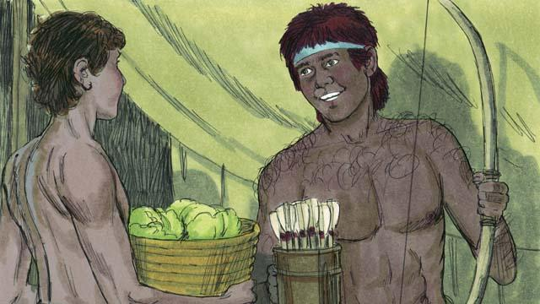
Taim Jekop na Iso i wok long kamap bikpela, Jekop i save laikim tumas long i stap long ples, tasol Iso i save laikim tumas long i go painim abus. Rebeka i save laikim Jekop na Aisak i save laikim Iso.
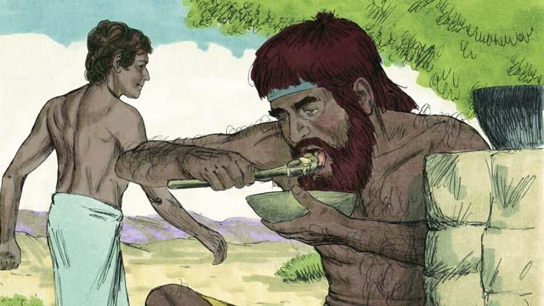
Wanpela de Iso i kam bek biihain long painim abus na em i hangre nogut tru na i tokim Jekop olsem, “I nap yu givim mi sampela kaikai na mi kaikai.” Tasol Jekop i bekim tok olsem, “Pastaim yu mas givim mi dispela namba bilong yu olsem nambawan pikinini man.” Olsem na Iso i givim em namba bilong em olsem nambawan pikinini man na Jekop i givim sampela kaikai long Iso.
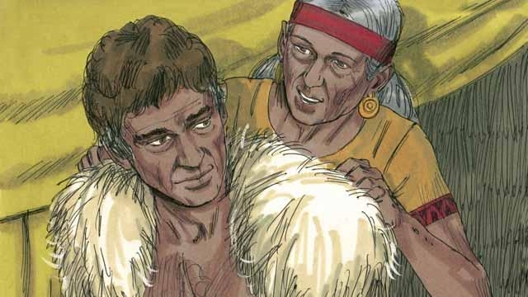
Aisak i laik givim blesing long Iso. Tasol bihain long em bai mekim olsem, Rebeka na Jekop i giamanim em na Jekop i tanim kamap olsem Iso. Aisak i lapun tru na ai bilong em i pas na i no moa lukim samting. Orait Jekop i putim ol klos bilong Iso na karamapim han na nek bilong em long skin bilong meme.
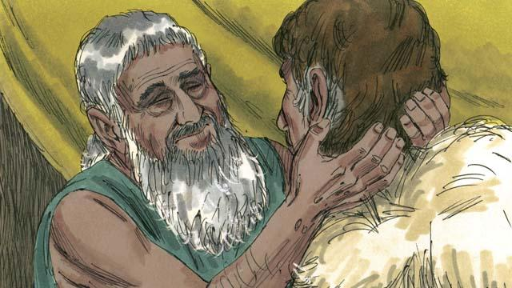
Jekop i kam long Aisak na tokim em olsem, “Mi Iso. Mi kam long yu na bai yu givim blesing long mi.” Taim Aisak i pilim skin bilong meme na smelim ol klos, em i ting Iso na givim blesing long Jekop.
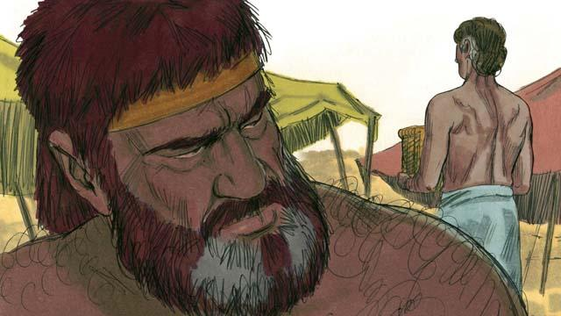
Iso i belhat na i no moa laikim Jekop bilong wanem, em i stilim namba bilong em olsem nambawan pikinini man na tu blesing bilong Iso. Olsem na Iso i tingting long kilim Jekop bihain taim papa bilong tupela i dai.
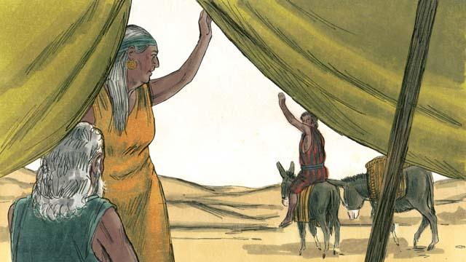
Tasol Rebeka i harim tok long dispela samting Iso i tingting long mekim. Olsem na Rebeka wantaim Aisak i salim Jekop i go longwe na i stap wantaim ol lain bilong Rebeka.
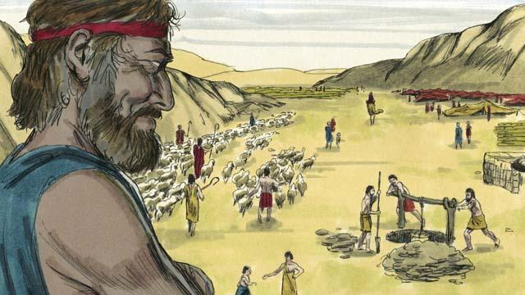
Jekop i stap wantaim ol lain bilong mama bilong em Rebeka planti yia. Long taim em i stap yet long hap em i marit na i gat 12-pela pikinini man na wanpela pikinini meri. God i mekim em i kamap man i gat planti samting.
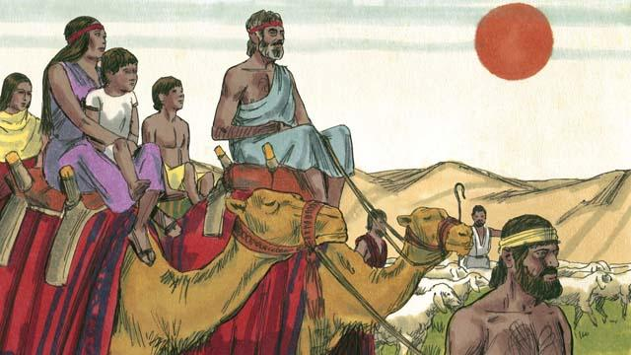
Jekop i bin stap longwe long asples bilong em Kenan inap 20 yia na em i kam bek wantaim ol meri na ol pikinini na ol wokman na wokmeri na ol kainkain abus bilong em.
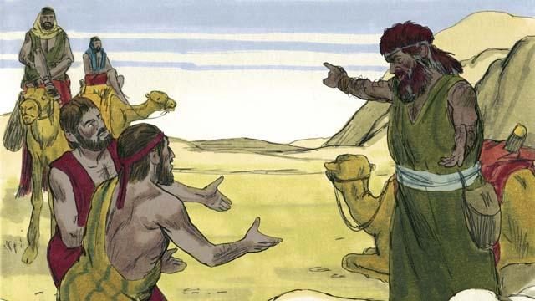
Jekop i pret nogut tru na em i ting, Iso bai kilim em. Olsem na em i salim planti lain abus i go long Iso olsem presen. Dispela wokman husat i bringim ol kainkain abus i go i tokim Iso olsem, “Wokman bilong yu Jekop, i givim yu ol dispela abus. Na em bai i kam bihain liklik.”
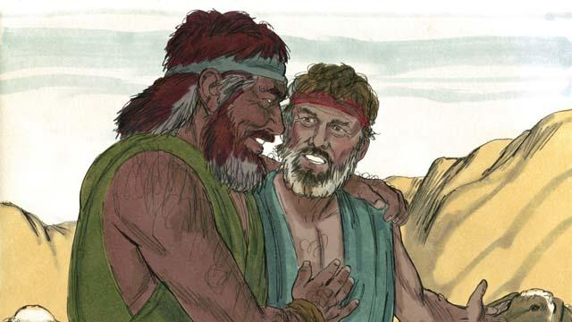
Tasol Iso i bin lusim sin bilong Jekop pinis, olsem na tupela i amamas long lukim tupela yet gen. Na Jekop i stap bel isi long Kenan. Na Aisak i dai na Jekop wantaim Iso i planim em. Dispela kontrak na promis God i bin mekim wantaim Abraham nau em i givim i go long Aisak na long Aisak i go long Jekop.
Baibel Stori i Kam Long: Stat 25:27–33:20

