Resource: unfoldingWord® Open Bible Stories
unfoldingWord® Open Bible Stories © 2022 unfoldingWord. Released under CC BY-SA 4.0 license. unfoldingWord® Open Bible Stories has been adapted in the following languages: Tok Pisin, Arabic (عربي), French (Français), Hindi (हिंदी), Indonesian (Bahasa Indonesia), Portuguese (Português), Russian (Русский), Spanish (Español), Swahili (Kiswahili), and Simplified Chinese (简体中文) from unfoldingWord® Open Bible Stories © 2022 unfoldingWord. Released under CC BY-SA 4.0 license by Mission Mutual

unfoldingWord® Open Bible Stories

8. God i Mekim Gut Long Josep Wantaim Ol Lain Bilong Em.
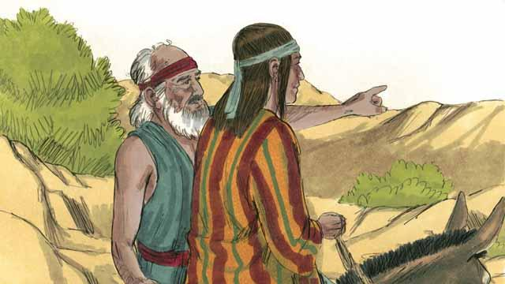
Planti yia bihain, taim Jekop i kamap lapun pinis, em i salim pikinini bilong em Josep, dispela pikinini em i save laikim tumas long igo lukim ol brata bilong em ol i wok long was long ol kain kain abus i stap.
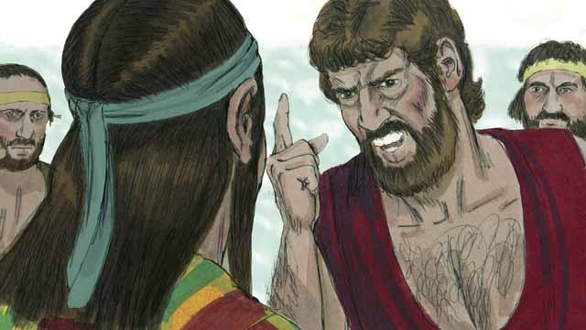
Ol brata bilong Josep i belhat na ino moa laikim em bilong wanem, papa bilong ol i save laikim tumas Josep na tu, Josep i bin driman olsem em bai bosim ol. Taim Josep i kam kamap long ol brata bilong em, ol i holimpasim em na salim em igo long ol bisnisman bilong salim wokboi nating.
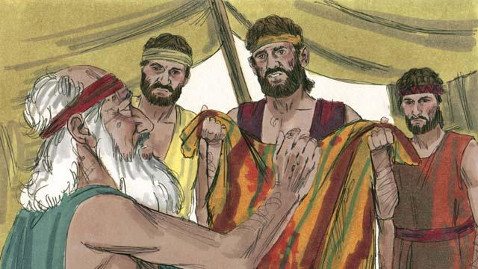
Taim ol brata bilong Josep ol i laik i go bek gen long ples, ol i brukim saket bilong Josep na putim long blut bilong meme. Ol i kisim dispela saket i go na soim long papa bilong ol, na em i ting wanpela wel abus i kilim Josep. Na Jekop i wari tru.
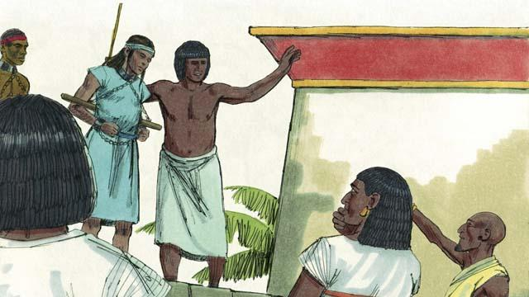
Ol bisnisman bilong salim ol wokboi nating i kisim Josep i go long Isip. Isip em i bikpela na strongpela kantri i stap arere long wara Nail. Ol dispela man i salim Josep olsem wokboi nating i go long wanpela ofisa bilong gavman i gat biknem na planti samting. Josep i mekim gut long bos bilong em, na God i blesim em.
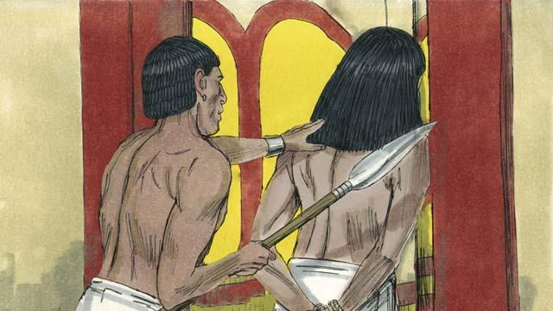
Meri bilong bos bilong Josep i traim long slip wantaim em, tasol Josep i no laik mekim sin long ai bilong God long dispela rot. Olsem na meri bilong bos bilong Josep i belhat na sutim ol giaman tok long em na ol i holimpas Josep na putim em long kalabus. Josep i stap long kalabus tasol em i bihainim God yet na God i blesim em.
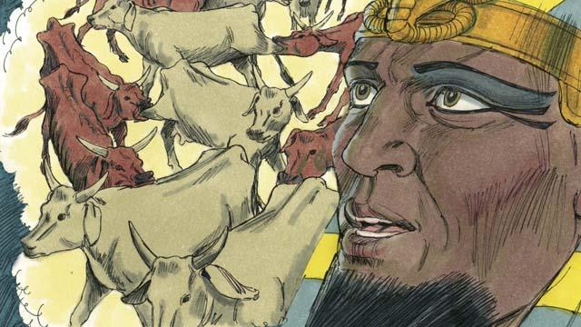
Bihain long 2-pela yia, Josep i stap yet long kalabus, tasol em i no gat asua. Long wanpela nait, Fero, em nem ol Isip i save kolim ol king bilong ol, em i slip na lukim 2-pela kain driman i mekim em tingting i planti. I nogat wanpela man inap givim gutpela tingting long Fero inap long autim as bilong driman.
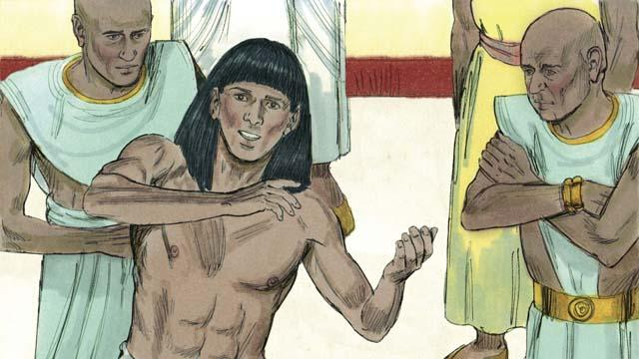
God i givim gutpela save na tingting long Josep long autim ol as bilong driman, olsem na Fero i salim tok i go long haus kalabus long bringim Josep i kam long em. Josep i autim as bilong driman bilong Fero na tokim em olsem, “God bai i mekim 7-pela yia bai i gat planti kaikai, tasol bihain bai i gat 7-pela yia bilong bikpela hangre.”
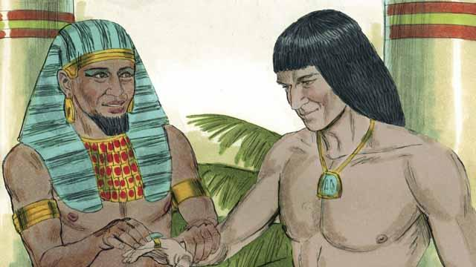
Fero i amamas stret long Josep na makim em i kamap namba 2 bikpela man bilong olgeta hap bilong Isip.
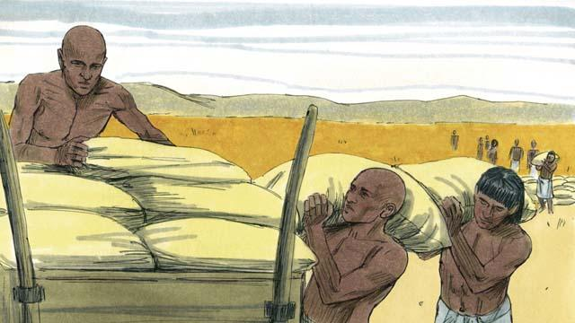
Josep i tokim ol manmeri long bungim planti kaikai long taim bilong kaikai long 7-pela yia. Na long taim bilong bikpela hangre long 7-pela yia Josep i salim kaikai long ol manmeri inap long ol i kaikai.
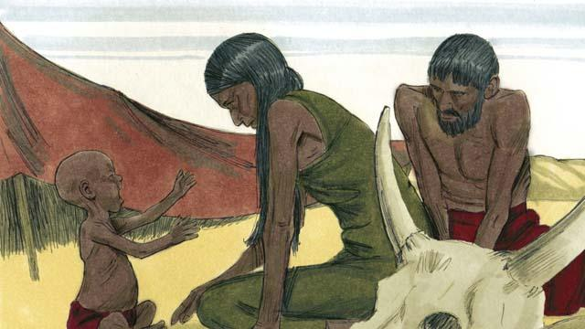
Taim bilong bikpela hangre i no kamap long Isip tasol, em i kamap tu long Kenan we Jekop wantaim ol lain bilong em i stap.
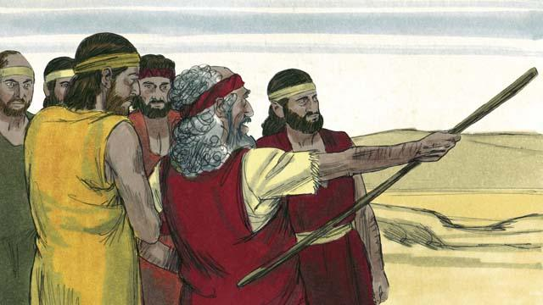
Jekop i salim ol bikpela pikinini man bilong em i go long Isip long baim kaikai. Ol brata bilong Josep i sanap klostu long Josep na baim kaikai, tasol ol i no luksave long em. Tasol Josep i luksave long ol.
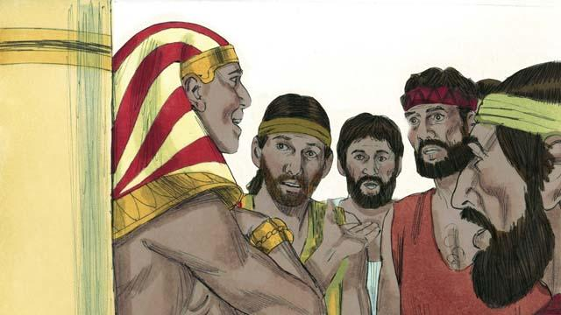
Bihain long Josep i traim ol brata bilong em long lukim ol i senis pinis o nogat, em i tokim ol olsem, “Mi brata bilong yupela, Josep! Yupela i noken pret. Yupela i bin traim long mekim nogut long mi taim yupela i salim mi olsem wokboi nating, tasol God i mekim nogut i kamap gutpela! Kam i stap long Isip na mi ken givim kaikai long yupela na ol lain bilong yupela.”
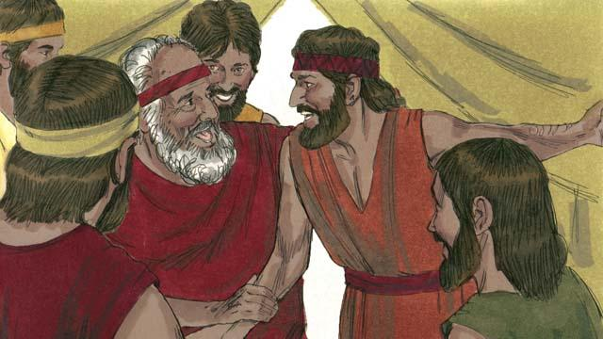
Taim ol brata bilong Josep i go kamap long ples Kenan, ol i tokim papa bilong ol Jekop olsem Josep i stap laip yet na Jekop i amamas moa yet. Jekop i lapun pinis tasol em wantaim olgeta lain bilong em ol i go stap long Isip. Bihain long Jekop i dai, em i givim blesing long ol wanwan pikinini man bilong em.
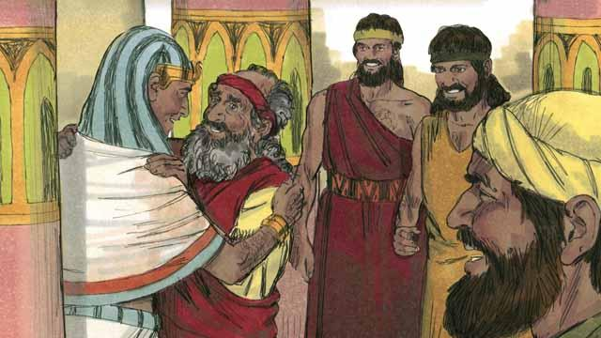
Maski Jekop I lapun tru, em i go long Isip wantaim olgeta famili bilong em na olgeta i stap long hap. Bipo long Jekop i dai, em i blesim wanwan pikinini bilong em.
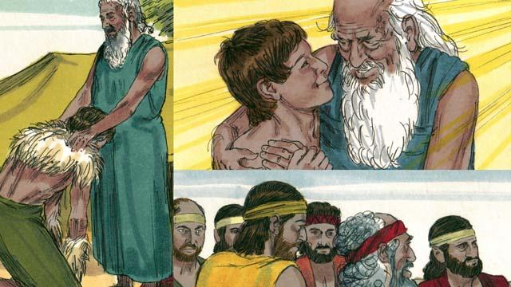
Dispela kontrak na promis God i bin mekim wantaim Abraham em i givim i go long Aisak, na Aisak i go long Jekop, na i go long 12-pela pikinini bilong Jekop wantaim ol lain bilong ol. Ol tumbuna bilong 12-pela pikinini man i kamap 12-pela lain manmeri bilong Israel.
Baibel Stori i Kam Long: Stat 37–50

