Resource: unfoldingWord® Open Bible Stories
unfoldingWord® Open Bible Stories © 2022 unfoldingWord. Released under CC BY-SA 4.0 license. unfoldingWord® Open Bible Stories has been adapted in the following languages: Tok Pisin, Arabic (عربي), French (Français), Hindi (हिंदी), Indonesian (Bahasa Indonesia), Portuguese (Português), Russian (Русский), Spanish (Español), Swahili (Kiswahili), and Simplified Chinese (简体中文) from unfoldingWord® Open Bible Stories © 2022 unfoldingWord. Released under CC BY-SA 4.0 license by Mission Mutual

unfoldingWord® Open Bible Stories

9. God i Singautim Moses
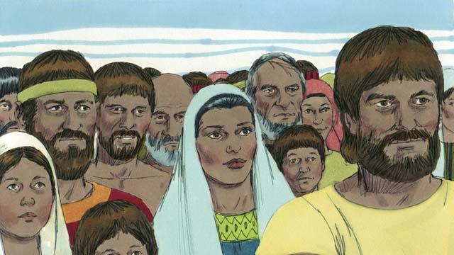
Bihain long Josep i dai, olgeta lain manmeri bilong em ol i stap long kantri Isip. Olgeta manmeri na olgeta tumbuna pikinini bilong ol i stap long planti yia long Isip na karim planti pikinini. Dispela lain manmeri na pikinini ol i kolim ol lain bilong Israel.
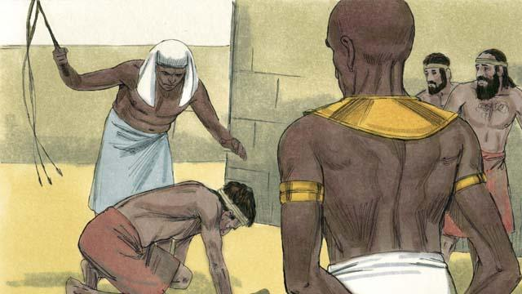
Bihain long sampela handred yia i go pinis namba bilong ol Israel i kamap planti tru. Ol lain bilong kantri Isip i no moa save long Josep na long planti gutpela samting em i bin mekim long helpim ol. Olsem na ol Isip i pret long ol lain Israel long wanem ol i kamap planti tumas. King Fero bilong Isip i lukautim Isip long dispela taim i mekim ol Israel i kamap wokboi nating bilong ol lain Isip.
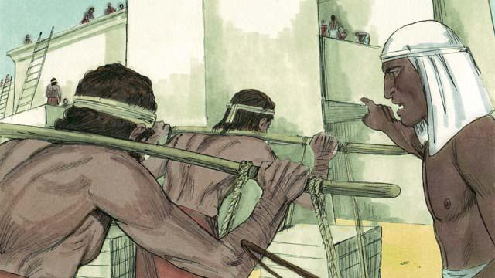
Ol Isip i hariapim ol Israel long wokim planti haus na wokim ol bikpela taun. Hatpela wok i mekim ol Israel laip bilong ol i no stap gut, tasol God i blesim ol, na ol i kamapim planti moa pikinini.
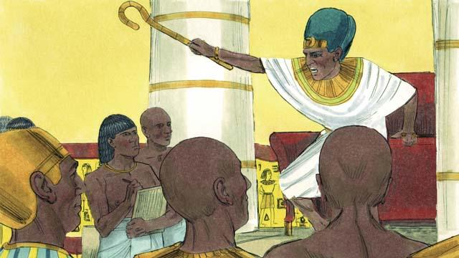
King Fero bilong Isip i lukim olsem ol Israel i wok long kamapim planti ol pikinini. Olsem na em i givim strongpela tok long kilim olgeta ol pikinini man bilong ol Israel na tromoi ol pikinini i go insait long bikpela wara Nail.
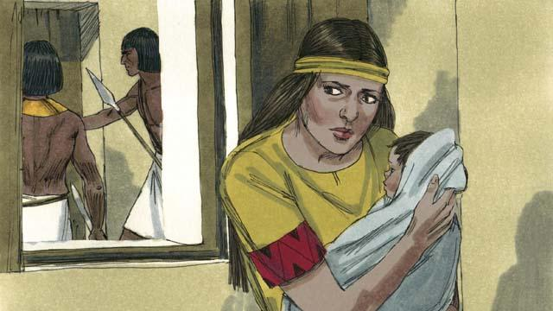
Wanpela meri Israel i karim wanpela pikinini man. Dispela meri wantaim man bilong em i haitim na lukautim liklik pikinini boi longpela taim.
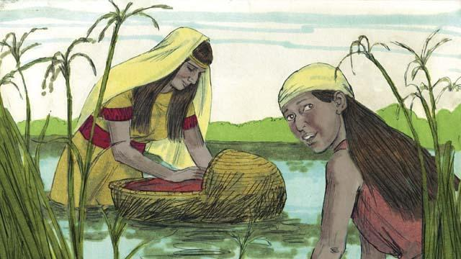
Tasol papa na mama bilong pikinini boi i no inap long haitim em moa, olsem na ol i putim em insait long wanpela basket inap long basket i ken trip antap long wara, namel long ol pitpit i kamap arere long wara Nail. Long wanem, ol i laik bai pikinini i mas i stap laip, em i noken i dai. Na bikpela susa i was na lukluk i stap long lukim wanem samting bai i kamap long dispela pikinini.
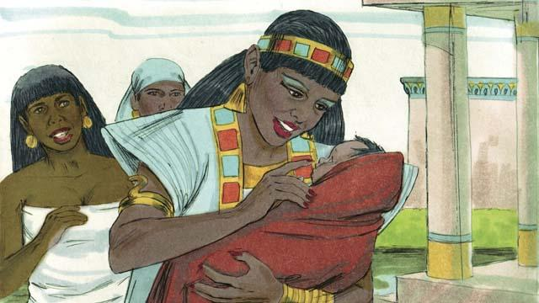
Wanpela pikinini meri bilong King Fero i lukim basket na em lukluk i go insait. Taim em i lukim pikinini, em i kisim pikinini boi na lukautim em olsem pikinini man bilong em yet. Em i askim wanpela meri Israel long lukautim em. Tasol em i no save olsem dispela meri em mama tru bilong pikinini. Taim pikinini i kamap bikpela na em i no inap dring susu moa bilong mama, mama i kisim i go bek long pikinini meri bilong King Fero na em i kolim nem bilong em Moses.
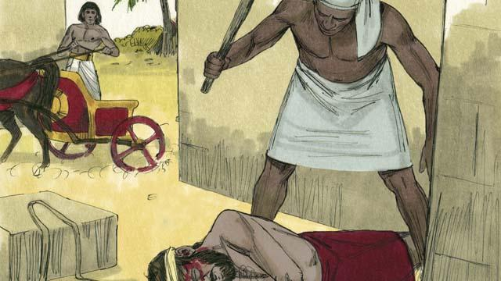
Wanpela de, taim Moses i kamap bikpela man pinis, em i lukim wanpela man Isip i paitim wanpela man Israel husat em i wokboi nating. Moses i traim long helpim wantok bilong em Israel, bai man Isip i noken kilim em i dai.
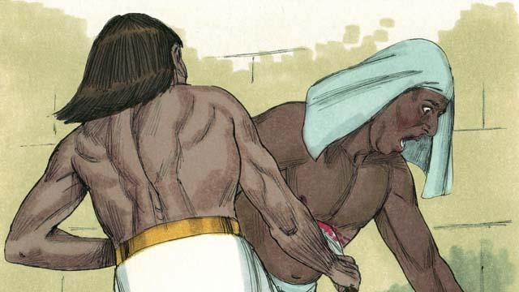
Taim Moses i ting olsem nogat man i lukim. Em i kilim man Isip na planim em. Tasol i gat man i lukim pasin Moses i mekim.
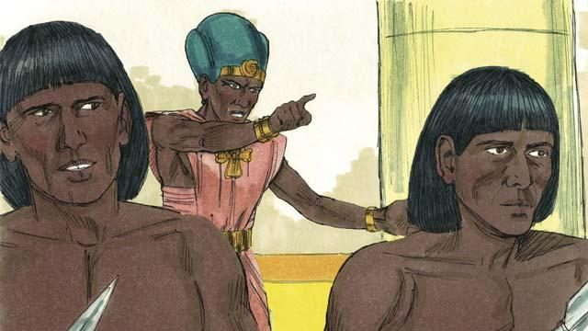
Taim Fero i harim pasin Moses i mekim, em i traim long kilim em na Moses i ranawe na lusim Isip na i go i stap long ples i nogat man long en. Bai em i hait long ol soldia bilong Fero.
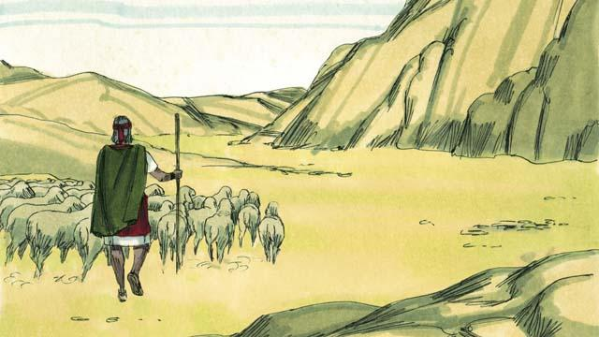
Moses i kamap olsem wasman bilong sipsip long ples i nogat man long en na longwe long ples Isip. Em i maritim meri long dispela ples na i gat tupela pikinini man.
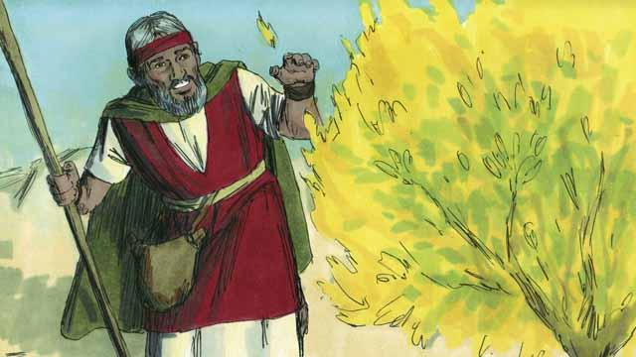
Wanpela de Moses i stap na was long ol sipsip, em i lukim bus i paia. Tasol paia i no kukim dispela bus olgeta. Moses i wokabaut i go klostu long lukim gut paia. Taim em i go klostu long bus i paia, em i harim nek bilong God i tok, “Moses, rausim su bilong yu. Nau yu sanap antap long graun em i holi.”
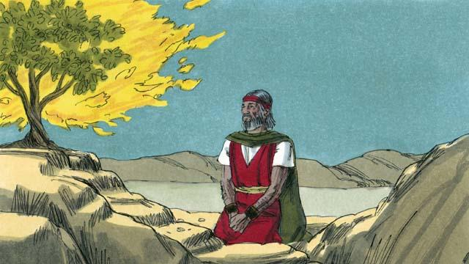
God i tok, “Mi lukim pen ol pipel bilong mi, ol i go insait long en. Mi bai salim yu i go long Fero na yu bai kisim ol pipel bilong mi i kam aut long ples Isip long pasin nogut ol i mekim long ol, olsem ol manmeri nating husat i no save kisim pe long wok ol i save mekim. Mi bai givim graun Kenan, mi bin promis long givim Abraham, Aisak na Jekop.”
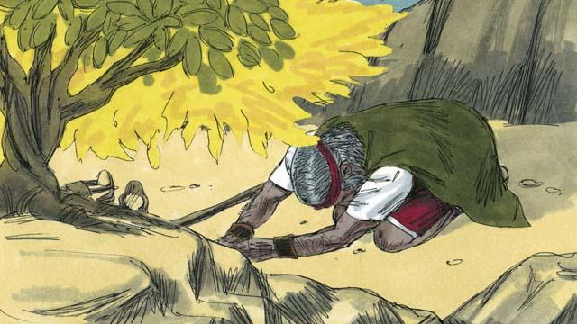
Na Moses i askim, “Na sapos ol manmeri i askim mi long husat i salim mi, na mi bai tok wanem long ol?” God i tok, “BIKPELA EM I NEM BILONG MI. Tokim ol, MI YET i salim mi long yupela.‘Na tokim ol tu, ’Mi God bilong ol tumbuna bilong yupela, Abraham, Aisak na Jekop mi God Yaweh.’ Dispela em i nem bilong mi bai i stap oltaim oltaim.”
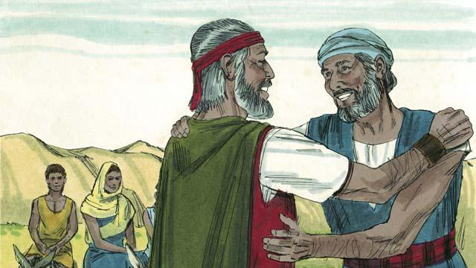
Moses i pret na em i no laik i go lukim Fero, long wanem em yet i no inap toktok gut, olsem na God i salim brata bilong em Aron long helpim Moses. Tasol God i tokim Moses na Aron olsem, “Bel bilong Fero bai i strong tumas na bai em i no harim yutupela.
Baibel Stori i Kam Long: Kisim Bek 1–4

