Resource: unfoldingWord® Open Bible Stories
unfoldingWord® Open Bible Stories © 2022 unfoldingWord. Released under CC BY-SA 4.0 license. unfoldingWord® Open Bible Stories has been adapted in the following languages: Tok Pisin, Arabic (عربي), French (Français), Hindi (हिंदी), Indonesian (Bahasa Indonesia), Portuguese (Português), Russian (Русский), Spanish (Español), Swahili (Kiswahili), and Simplified Chinese (简体中文) from unfoldingWord® Open Bible Stories © 2022 unfoldingWord. Released under CC BY-SA 4.0 license by Mission Mutual

unfoldingWord® Open Bible Stories

10. Tenpela Samting Nogut
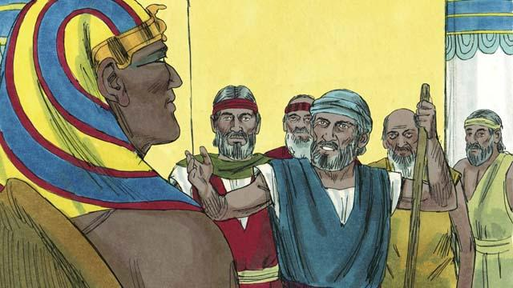
Moses na Aron i go long Fero. Tupela i tok, “Dispela em wanem God bilong Israel i tok,”Larim ol manmeri bilong mi i go!" Fero i no harim tok bilong tupela. Em i larim ol manmeri i stap na tokim ol long wok hat na strong moa.
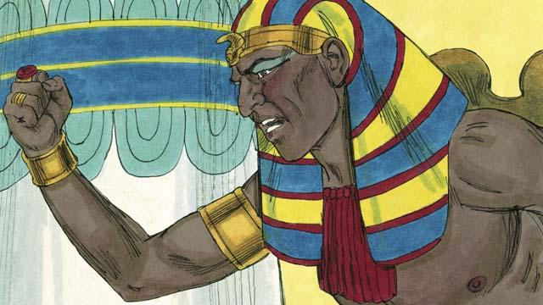
Fero i no laik long larim ol manmeri i go, olsem na God i salim 1–0pela samting nogut long Isip. Insait long dispela ol samting nogut, God i soim Fero olsem em i strongpela moa long Fero na olgeta ol god giaman bilong Isip.
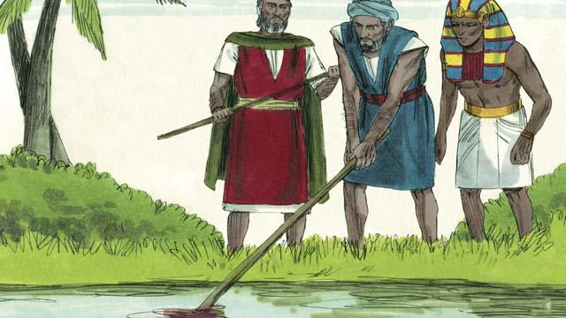
God i tanim wara Nail i kamap blut. Tasol Fero i no larim ol Israel i go.
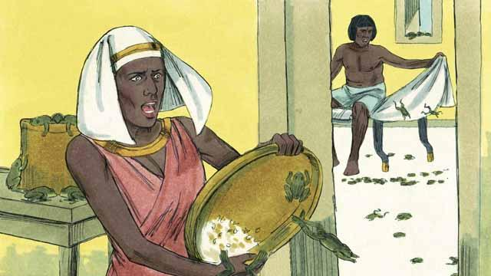
God i salim rokrok i kamap long olgeta hap graun long Isip. Fero i tokim Moses long rausim olgeta rokrok. Tasol bihain long olgeta rokrok i dai pinis, tingting na bel bilong Fero i kamap strong na em i no laik larim ol manmeri bilong Israel i lusim Isip.
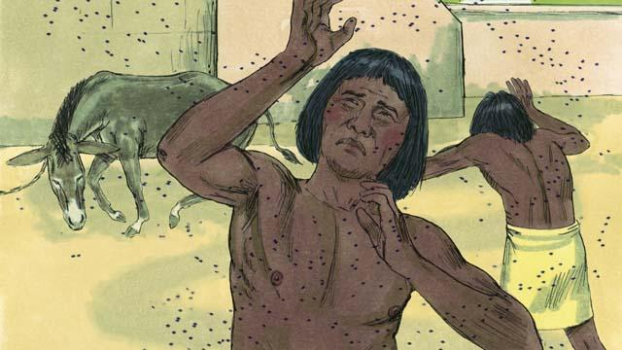
Olsem na God i salim ol liklik binatang nogut i kam. Bihain em i salim ol lang nogut. Fero i singautim Moses na Aron na tokim tupela olsem, “Sapos yutupela inap tok nogat, long ol samting nogut i wok long kamap na rausim, orait olgeta manmeri bilong Israel bai i lusim Isip. Olsem na taim Moses i beten, God i rausim olgeta lang nogut long Isip. Tasol tingting na bel bilong Fero i strong olsem na em i no larim ol manmeri i go.
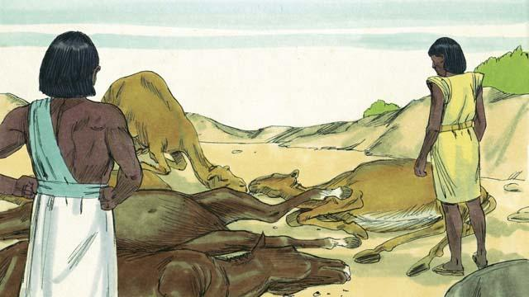
Narapela samting nogut i kamap em i olsem, God i mekim olgeta abus ol Isip i lukautim i sik na i dai. Tasol tingting na bel bilong Fero i strong na em i no larim ol Israel i go.
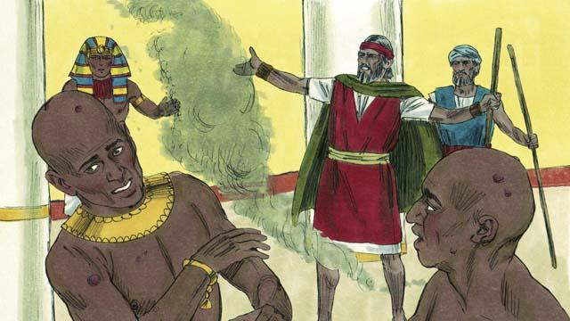
Nau God i tokim Moses long tromoi sit paia long win long pes bilong Fero. Taim Moses i mekim olsem, strongpela sua i kamap long skin bilong olgeta manmeri bilong Isip, tasol i no long ol Israel manmeri. God i mekim tingting na bel bilong Fero i strong na Fero i no inap larim ol Israel i go.
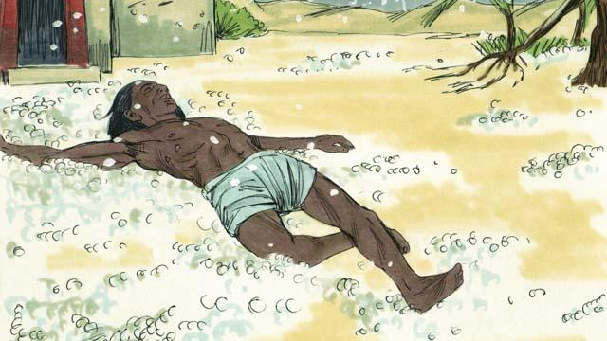
Bihain, God i salim ais i pundaun long graun na kukim olgeta kaikai ol Isip i planim na olgeta kaikai i dai. Na ol manmeri husat i go autsait long haus, ais i kilim ol tu. Fero i singautim Moses na Aron na tokim tupela, “Mi i bin mekim sin. Yupela i ken go.” Olsem na Moses i beten, na ais i no pundaun moa long skai.
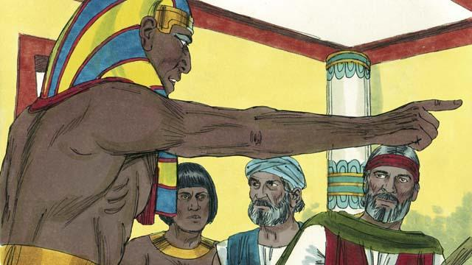
Tasol Fero i mekim sin gen na tingting na bel bilong em i strong. Em i no inap larim ol Israel i go.
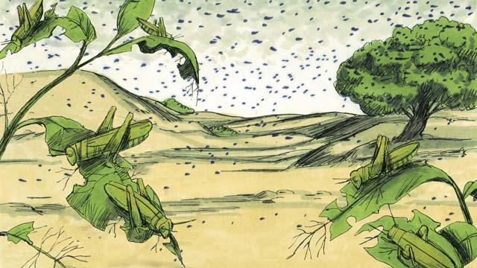
Olsem na God i salim ol grasopa i kam na kaikaim olgeta kaikai ais i no bin bagarapim.
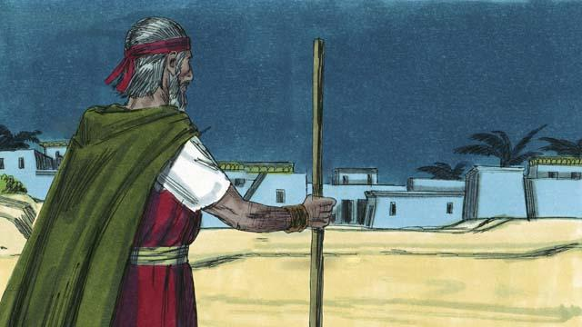
Bihain God i salim tudak i kam i stap inap long 3-pela de. Em i tudak nogut tru na ol Isip i no inap long kam autsait long haus bilong ol. Tasol i bin i gat lait long hap ol Israel i stap long en.
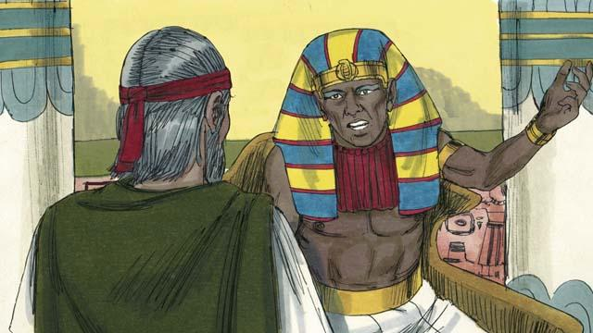
Bihain long ol dispela 9-pela ol samting nogut i kamap, Fero i no larim ol Israel i go. Fero i no harim tok, olsem na God i tingting long salim wanpela moa samting nogut na em bai pinis. Dispela bai inap long senisim tingting na bel bilong Fero.
Baibel Stori i Kam Long: Kisim Bek 5–10

