Resource: unfoldingWord® Open Bible Stories
unfoldingWord® Open Bible Stories © 2022 unfoldingWord. Released under CC BY-SA 4.0 license. unfoldingWord® Open Bible Stories has been adapted in the following languages: Tok Pisin, Arabic (عربي), French (Français), Hindi (हिंदी), Indonesian (Bahasa Indonesia), Portuguese (Português), Russian (Русский), Spanish (Español), Swahili (Kiswahili), and Simplified Chinese (简体中文) from unfoldingWord® Open Bible Stories © 2022 unfoldingWord. Released under CC BY-SA 4.0 license by Mission Mutual

unfoldingWord® Open Bible Stories

15. Promis Graun
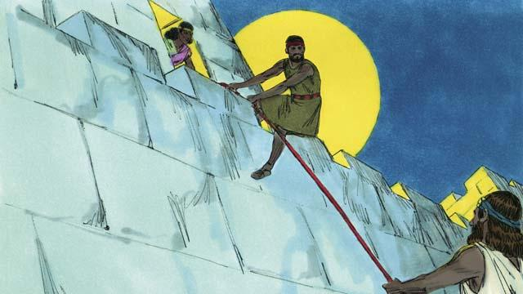
Nau ol lain Israel i laik i go insait long Kenan, graun God i bin tokim ol long kisim. Josua i i salim tupela man long lukstil long strongpela banis bilong siti bilong ol Kenan long Jeriko. Insait long dispela siti wanpela pamuk meri nem bilong em Rehap, em i helpim tupela man na bihain em i haitim tupela na salim tupela long nait. Em i mekim dispela long wanem em i bilip long God na tupela man i tokim em olsem, taim ol Israel i kam long bagarapim dispela siti ol bai i no inap bagarapim yu wantaim ol lain bilong yu.
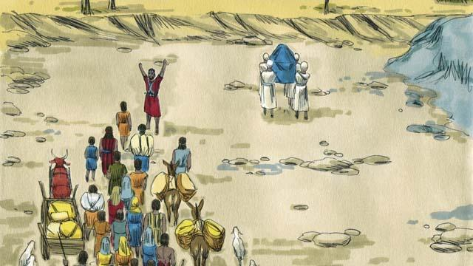
Ol Israel i brukim wara Joden na i laik i go insait long graun God i bin promisim ol pinis long en. God i tokim Josua, “Larim ol pris i go pas!” Taim ol pris i stat long putim lek i go insait long wara Joden, wara i stop na i no ran moa, ol Israel i brukim wara na i go long hapsait long drai graun.
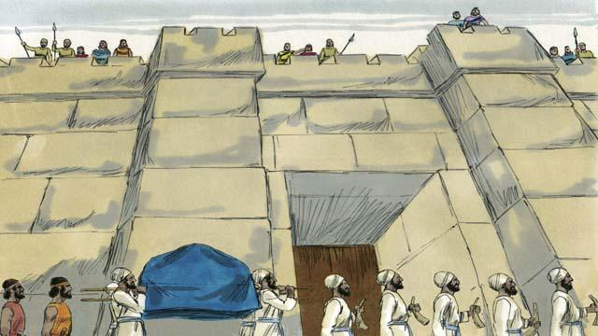
Bihain ol i brukim wara Joden pinis God i tokim Josua long wanem rot ol bai i brukim strongpela banis bilong Jeriko. Ol i bihainim wanem samting God i bin tokim ol long mekim. Ol ami na ol pris ol i wokabaut na raunim Jeriko siti long wanpela taim insait long 6-pela de.
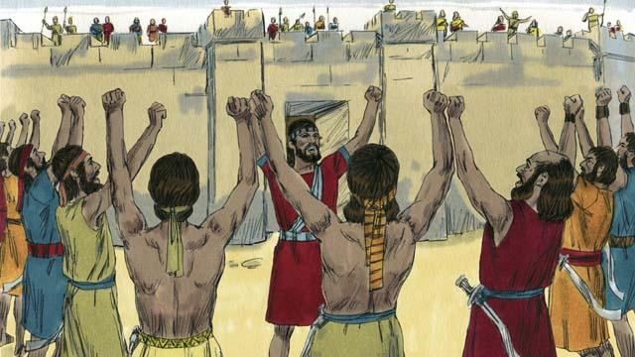
Long de seven ol Israel i wokabaut raunim siti 7-pela taim moa na las long en ol ami i singaut na ol pris i winim biugel.
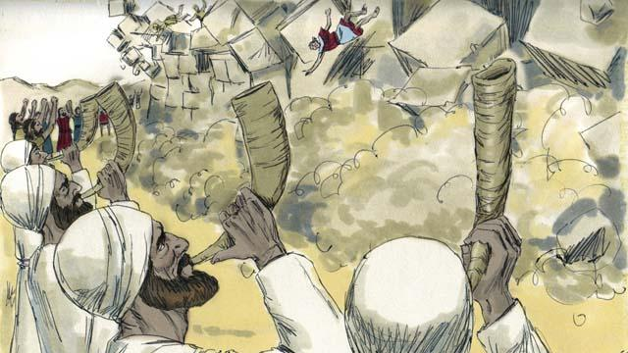
Banis bilong Jeriko i bruk i kam daun! Ol Israel i bagarapim olgeta samting insait long siti olsem God yet i bin tokim ol. Ol i bagarapim olgeta tasol ol i no bagarapim Rehap wantaim ol lain bilong em, ol i kamap wanlain bilong Israel. Taim ol arapela lain i stap long Kenan i harim olsem ol Israel i bagarapim Jeriko, ol i pret nogut tru ol bai bagarapim ol tu.
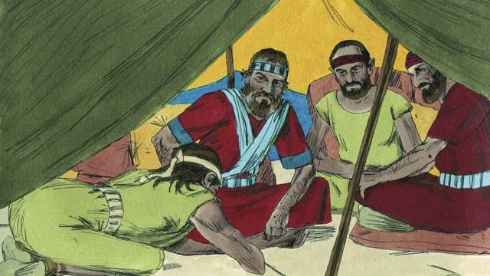
God i tokim ol Israel long i noken wokim pasin wanbel wantaim ol lain husat i bin i stap long dispela ples Kenan. Tasol wanpela grup lain bilong Kenan nem bilong ol em Gibion ol i kam giamanim Josua na tokim em olsem; ol i bilong longwe ples long Kenan. Na ol i askim Josua long wokim wanbel pasin wantaim ol. Josua wantaim ol Israel i no bin askim God olsem ol dispela Gibion lain ol i stap long wanem hap tru. Tasol Josua i mekim wanbel pasin wantaim ol.
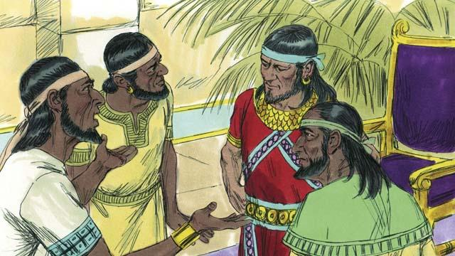
Ol Israel i belhat long ol lain Gibeon long giamanim ol long wokim wanbel pasin tasol ol i holim olsem tasol long wanem ol i mekim promis pinis long ai bilong God. Bihain long sampela taim i go pinis king bilong Amo na arapela lain long Kenan i harim olsem ol Gibeon i mekim wanbel pasin wantaim ol Israel na olgeta i kam bung na ol i go pait wantaim ol Gibion. Ol Gibion i lukim dispela na ol i salim tok long Josua long helpim ol.
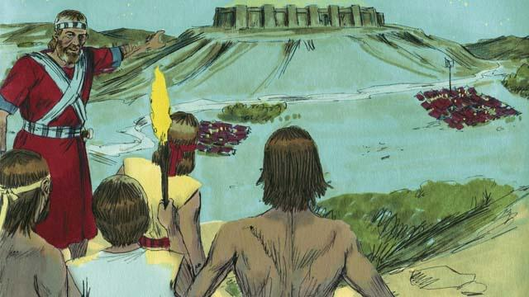
Olsem na Josua i bungim ol ami bilong en na em i salim ol long nait yet i go. Long bikmonin tru ol i go mekim ol ami bilong Amo i kirap nogut na ol i bagarapim ol.

God i helpim ol Israel na winim pait long dispela de. God i salim bikpela ais ston olsem ren na paulim ol Amo na kilim i dai planti bilong ol.
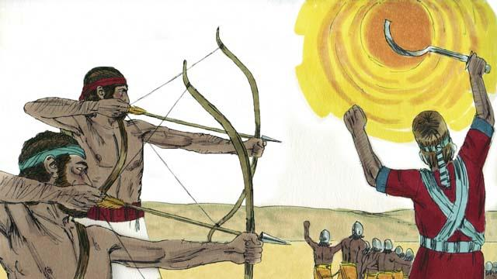
Na tu God i mekim san i stap long wanpela hap longpela taim na ol Israel i pait na winim ol Amo. Long dispela de God i winim pait bilong ol Israel.
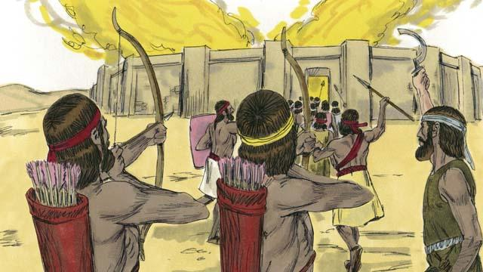
Bihain long God i winim ol dispela ami bilong Amo. Ol Kenan wantaim ol arapela lain ol i kam bung long pait wantaim ol Israel. Tasol Josua wantaim ol Israel i bagarapim ol na winim ol. Josua 1–24
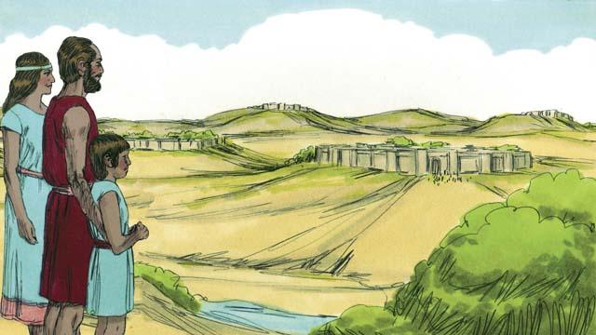
Bihain long pait i pinis, dispela graun God i bin promis long givim ol, em i givim i go long wanwan lain bilong Israel. Na God i givim bel isi long ol Israel long olgeta hap graun we mak bilong boda i stap.
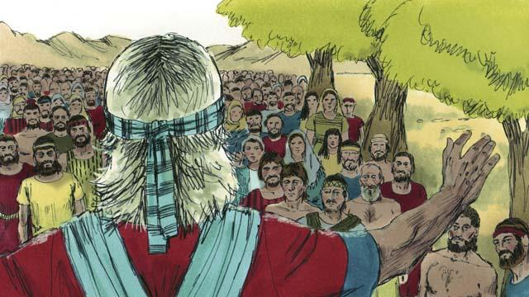
Nau dispela taim Josua i lapun pinis, na em i singautim olgeta Israel . Na em i tokim ol long ol i mas i stap aninit long olgeta lo ol i bin kisim antap long maunten Sainai. Na ol Israel i promis long ol bai i stap aninit long God na ol bai i bihainim olgeta lo bilong em.
Baibel Stori i Kam Long: Josua 1–24

