Resource: unfoldingWord® Open Bible Stories
unfoldingWord® Open Bible Stories © 2022 unfoldingWord. Released under CC BY-SA 4.0 license. unfoldingWord® Open Bible Stories has been adapted in the following languages: Tok Pisin, Arabic (عربي), French (Français), Hindi (हिंदी), Indonesian (Bahasa Indonesia), Portuguese (Português), Russian (Русский), Spanish (Español), Swahili (Kiswahili), and Simplified Chinese (简体中文) from unfoldingWord® Open Bible Stories © 2022 unfoldingWord. Released under CC BY-SA 4.0 license by Mission Mutual

unfoldingWord® Open Bible Stories

26. Jisas i Statim Wok Misin
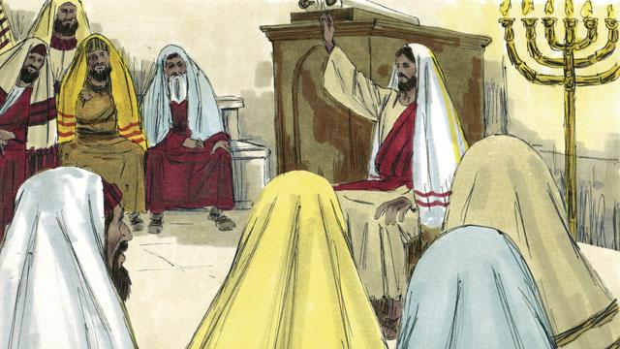
Jisas i winim traim bilong Satan pinis orait em i go bek wantaim strong bilong Holi Spirit long hap bilong Galili, long ples em i bin stap long en. Jisas i raun long olgeta hap ples na skulim ol manmeri . Na ol manmeri i save mekim gutpela tok long em.
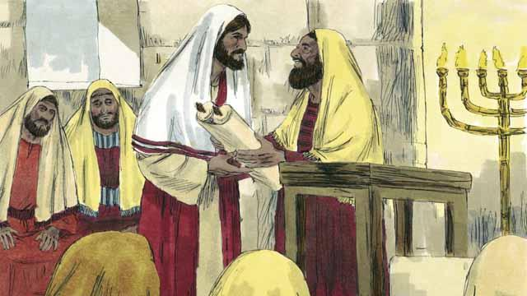
Jisas i go long taun Nasaret, dispela ples em i bin stap long taim em i mangi yet. Na long Sabat em i go long ples bilong lotu na ol i givim em buk bilong profet Aisaia long em i ken ritim. Jisas i opim buk na ritim hap tok i go long ol manmeri.
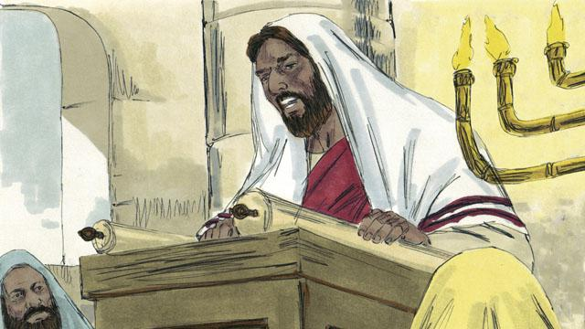
Na Jisas i ritim olsem, “God i givim Spirit bilong em long mi long autim gutnius i go long ol rabisman na rausim ol kalabus man i go fri na opim ai bilong ol aipas na givim malolo long ol manmeri i karim hevi. Dispela em i yia bilong God i mekim gut long ol manmeri.”
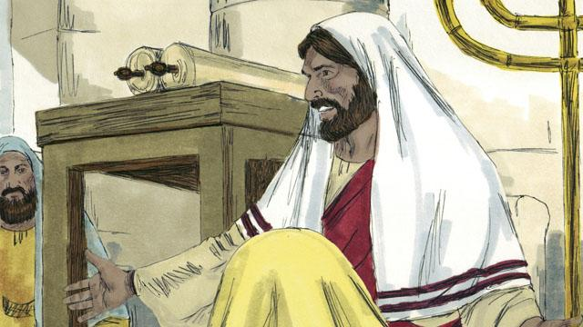
Jisas i go sindaun na ol manmeri i lukluk strong long em, long wanem ol i save olsem dispela tok em i bin ritim i toktok long Mesaia. Na Jisas i tok, “Dispela tok mi ritim long yupela, em i kamap tru nau.” Ol manmeri i kirap nogut na i tok, “Dispela em i pikinini bilong Josep, a?”

Na Jisas i tok, “Em i tru olsem, ol profet i no bin gat luksave long ol asples bilong em yet. Long taim bilong Elaisa, i gat planti ol manmeri bilong ol i dai pinis i bin stap long Israel. Tasol taim ren i no pundaun long 3 na hap yia, God i no salim Elaisa i go na helpim wanpela meri bilong Israel man bilong em i dai pinis, nogat em i go long meri bilong narapela kantri man bilong em i dai pinis.”

Na Jisas i tok moa olsem, “Long taim bilong profet Elisa i bin gat planti manmeri bilong Israel i gat narakain sua long skin tasol Elisa i no mekim orait sua bilong ol. Tasol em i bin oraitim skin sua bilong Naman opisa bilong ami bilong ol birua bilong Israel. Ol Israel i wok long harim tok bilong Jisas i stap na taim ol i harim dispela tok ol i bel kaskas long em. (* Ol Israel i ting ol tasol i lain bilong God)
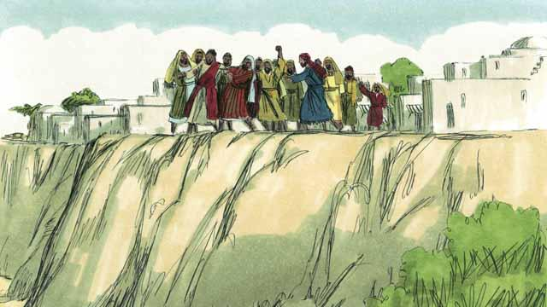
Ol manmeri bilong Nasaret i pulim Jisas long ples bilong lotu na kisim em i go long ples nogut long tromoi em i go daun long kilim em, tasol Jisas i wokabaut namel long ol manmeri na lusim taun na i go.

Jisas i wokabaut long olgeta hap bilong Galili na bikpela lain manmeri i kam long em. Ol i bringim ol sik manmeri na ol lek na han nogut na ol aipas na ol lek nogut na yaupas na ol mauspas long Jisas na em i mekim orait olgeta.

Ol i bringim ol man manmeri i gat spirit nogut i kam long Jisas na Jisas i tok na ol spirit nogut i kamaut long ol manmeri na i save singaut long Jisas olsem," Yu Pikinini bilong God!" Na ol planti manmeri i kirap nogut na litimapim nem bilong God.
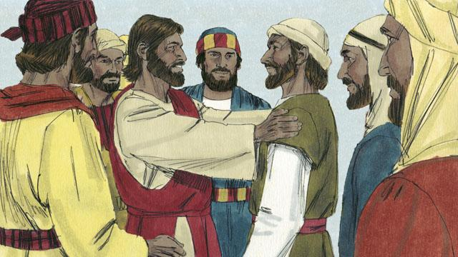
Jisas i makim ol 12-pela man na em i kolim ol aposel bilong em. Na ol aposel i wokabaut wantaim Jisas na ol i lainim ol samting long em.
Baibel Stori i Kam Long: Matyu 4:12–25; Mak 1:14–15,35–39; 3:13–21; Luk 4:14–30,38–44

