Resource: unfoldingWord® Open Bible Stories
unfoldingWord® Open Bible Stories © 2022 unfoldingWord. Released under CC BY-SA 4.0 license. unfoldingWord® Open Bible Stories has been adapted in the following languages: Tok Pisin, Arabic (عربي), French (Français), Hindi (हिंदी), Indonesian (Bahasa Indonesia), Portuguese (Português), Russian (Русский), Spanish (Español), Swahili (Kiswahili), and Simplified Chinese (简体中文) from unfoldingWord® Open Bible Stories © 2022 unfoldingWord. Released under CC BY-SA 4.0 license by Mission Mutual

unfoldingWord® Open Bible Stories

28. Yangpela Lida i Gat Planti Mani na Kago
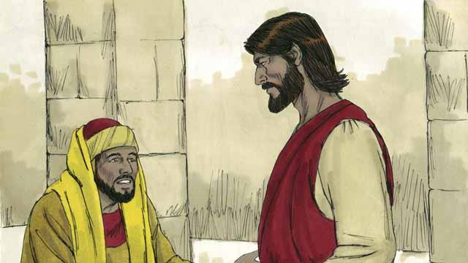
Wanpela de wanpela yangpela lida i gat planti mani na kago i kam long Jisas na askim em olsem, “Gutpela tisa, bai mi mekim wanem na kisim laip i stap oltaim?” Na Jisas i tok, “Bilong wanem yu kolim mi ‘gutpela?’ I gat wanpela man tasol i gutpela man, em i God wanpela tasol. Tasol sapos yu laik kisim laip i stap oltaim, orait yu mas bihainim ol lo bilong God.”
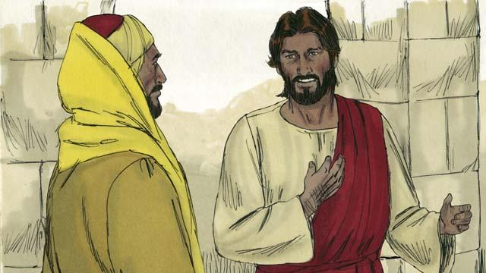
Na dispela yangpela lida i bekim tok olsem, “Wanem lo bai mi bihainim?” Na Jisas i bekim tok olsem, “Yu noken kilim man i dai na yu noken mekim pasin pamuk na yu noken stil na yu noken tok giaman. Na yu mas aninit long papa na mama bilong yu, na yu mas laikim ol arapela manmeri olsem yu laikim yu yet.”
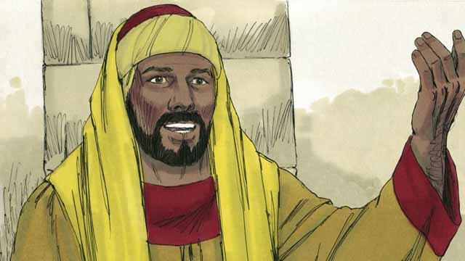
Tasol dispela yangpela man i bekim tok olsem, “Mi bihainim dispela olgeta lo taim mi mangi yet. Tasol wanem samting moa bai mi mekim na bai mi stap laip?” Jisas i lukim em na laikim em.
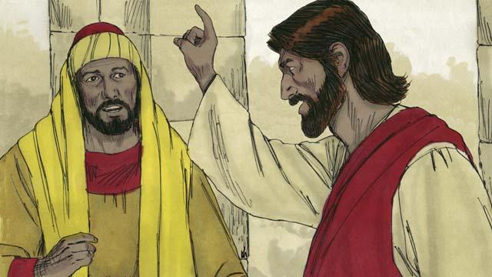
Na Jisas i bekim tok olsem,“Sapos yu laik kamap nambawan, orait yu go na salim olgeta samting yu gat, na kisim mani i go na givim ol rabisman na kam bihainim mi na bai yu kisim olgeta gutpela samting long heven.”

Taim yangpela man i harim dispela tok Jisas i tok, em i bel hevi nogut tru. Long wanem em i gat planti mani na kago samting, na em i no laik givim ol samting bilong em long ol arapela. Na em i tanim na lusim Jisas na i go.
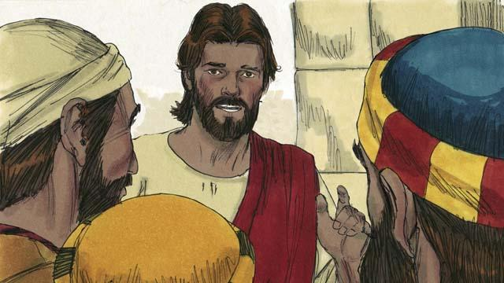
Bihain long dispela Jisas i tokim ol disaipel bilong em olsem,“Tru tumas, em i no isi long ol maniman bai i go insait long Kindom bilong God. Yes, em i isi long kamel i go insait long hul bilong nil bilong samap, tasol em i hat tumas long maniman long go insait long kindom bilong God.”
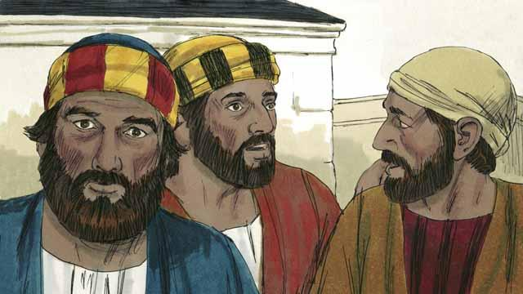
Taim ol disaipel i harim dispela tok, ol i kirap nogut na ol i tok, “Olsem na husat bai God inap long kisim bek?”

Na Jisas i lukluk long ol disaipel na em i tok, “Long ol manmeri em i hat, tasol long God, olgeta samting i no hat.”
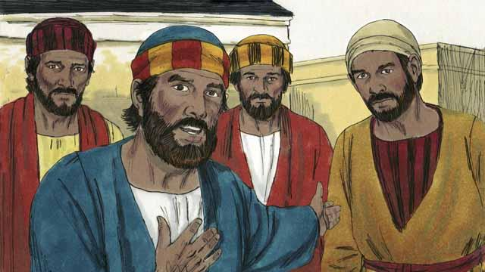
Na Pita i askim Jisas olsem, “Mipela i bin lusim olgeta samting bilong mipela na bihainim yu, olsem na wanem samting bai i olsem pe bilong mipela?”

Na Jisas i bekim tok olsem, “Olgeta manmeri husat i lusim ol haus na ol brata na ol susa na ol papa na mama na ol pikinini na ol samting bilong ol long nem bilong mi, ol bai kisim samting 100 taim moa na kisim laip i stap oltaim oltaim. Tasol, ol planti lain i go pas bai kam bihain na ol lain husat i kam bihain bai i go paslain.”
Baibel Stori i Kam Long: Matyu 19:16–30; Mak 10:17–31; Luk 18:18–30.

