Resource: unfoldingWord® Open Bible Stories
unfoldingWord® Open Bible Stories © 2022 unfoldingWord. Released under CC BY-SA 4.0 license. unfoldingWord® Open Bible Stories has been adapted in the following languages: Tok Pisin, Arabic (عربي), French (Français), Hindi (हिंदी), Indonesian (Bahasa Indonesia), Portuguese (Português), Russian (Русский), Spanish (Español), Swahili (Kiswahili), and Simplified Chinese (简体中文) from unfoldingWord® Open Bible Stories © 2022 unfoldingWord. Released under CC BY-SA 4.0 license by Mission Mutual

unfoldingWord® Open Bible Stories

29. Stori Bilong Wokman Nogut
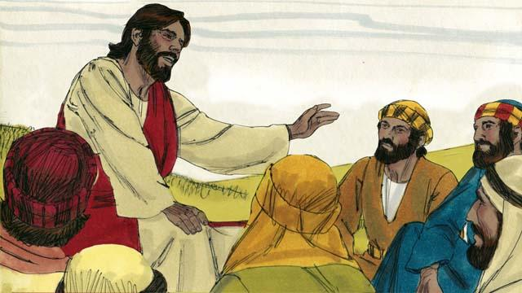
Wanpela de Pita i askim Jisas olsem, “Bikpela, hamas taim bai mi mas lusim sin bilong brata bilong mi taim em i mekim sin long mi? Ating bai mi lusim sin bilong em 7-pela taim a?” Na Jisas i tok, “I no 7-pela taim, Nogat, 70 taim 7-pela taim!” Em i olsem yumi mas lusim sin bilong arapela olgeta taim. Na Jisas i mekim dispela stori.
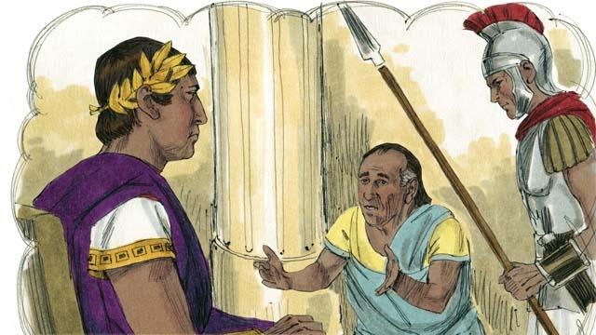
Jisas i tok, “Kindom bilong God i wankain olsem wanpela king i laik stretim ol dinau wantaim ol wokman bilong em. Wanpela wokman i kisim bikpela dinau inap long ol pe bilong 200,000 yia.”
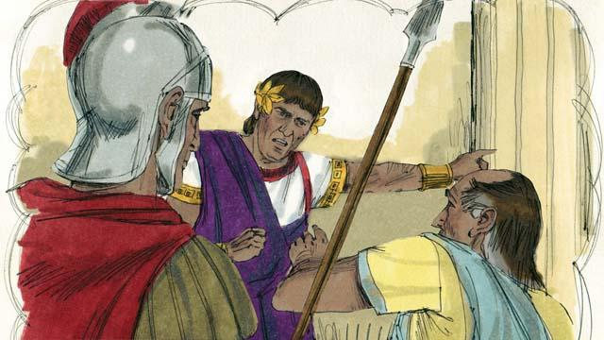
“King i tok, ’Dispela wokman i no bin bekim dinau bilong em, olsem na salim dispela man wantaim ol meri pikinini bilong em olsem wokboi nating long bekim dinau bilong em.”
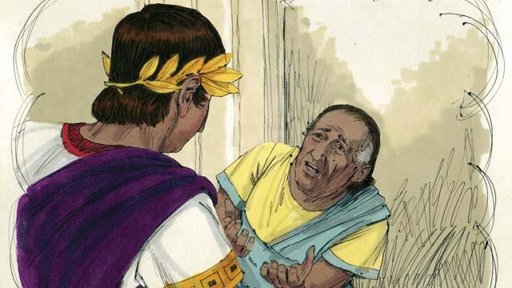
“Dispela wokman i pundaun na brukim skru long pes bilong King na i tok,”O bikman inap yu sori long mi na tok isi long mi, na bai mi ken bekim olgeta mani mi bin kisim long yu. “Na King i sori long wokman na em i rausim olgeta dinau bilong em na larim em i go.”

“Tasol taim wokman i lusim King na i go ausait, em i bungim wanpela wanwok bilong em husat i gat dinau long em inap long pe bilong 4-pela mun. Na em i holim pasim wanwok bilong em na i tok, ’Bekim bek mani yu bin dinau long mi.”

“Na wanwok bilong em i brukim skru long em na tok, ‘Inap yu isi na givim taim long mi na bai mi bekim olgeta mani bilong yu mi bin kisim.’ Tasol nogat, wokman i tromoi wanwok bilong em i go long kalabus inap em i ken bekim olgeta dinau.”
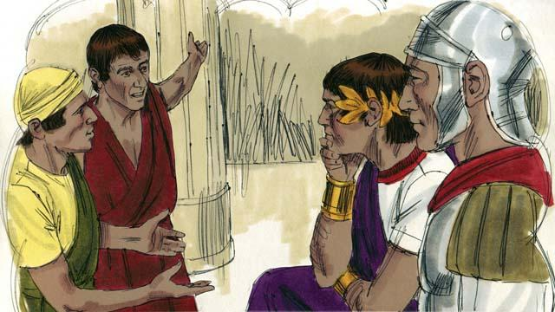
“Ol arapela wanwok i lukim samting i bin kamap na ol i bel hevi tru. Na ol i go long king na stori long olgeta samting i bin kamap.”

“Na King i singautim dispela wokman i kam na em i tok, ‘Yu wokman nogut, yu askim mi long marimari long dinau bilong yu. Yu inap long mekim wankain pasin long wanwok bilong yu.’ King i belhat nogut tru olsem na em i tromoi dispela wokman nogut i go long kalabus, inap em i ken bekim olgeta dinau bilong em.”
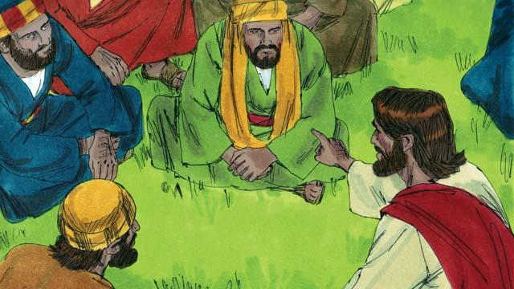
Na Jisas i tok, “Wankain pasin bai Papa bilong mi long heven bai mekim long yupela wanwan sapos yupela i no lusim sin bilong ol brata bilong yupela long bel bilong yupela.”
Baibel Stori i Kam Long: Matyu 18:21–35

