Resource: unfoldingWord® Open Bible Stories
unfoldingWord® Open Bible Stories © 2022 unfoldingWord. Released under CC BY-SA 4.0 license. unfoldingWord® Open Bible Stories has been adapted in the following languages: Tok Pisin, Arabic (عربي), French (Français), Hindi (हिंदी), Indonesian (Bahasa Indonesia), Portuguese (Português), Russian (Русский), Spanish (Español), Swahili (Kiswahili), and Simplified Chinese (简体中文) from unfoldingWord® Open Bible Stories © 2022 unfoldingWord. Released under CC BY-SA 4.0 license by Mission Mutual

unfoldingWord® Open Bible Stories

30. Jisus I Givim Kaikai Long 5000 Manmeri
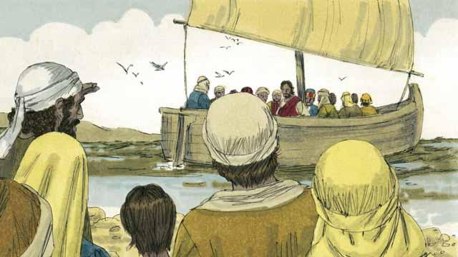
Jisas i salim ol aposel bilong em i go autim tok na skulim ol manmeri long olgeta ples. Taim ol i kam bek long ples Jisas i stap long en, ol i tokim em long wanem samting ol i bin mekim. Na Jisas i tokim ol long i go wantaim em long hapsait bilong raunwara long ples i nogat nois, na malolo liklik taim. Olsem na ol i kalap long bot na i go long hapsait bilong raunwara.
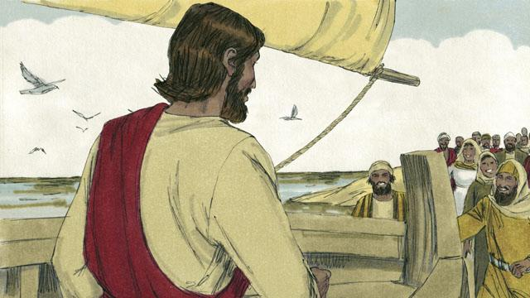
Tasol planti manmeri i lukim Jisas wantaim ol disaipel bilong em i stap long bot. Ol dispela manmeri i ran arere long raunwara na i go long hapsait paslain long ol. Na taim Jisas na ol disaipel i go kamap, planti lain manmeri i stap pinis na wetim ol.
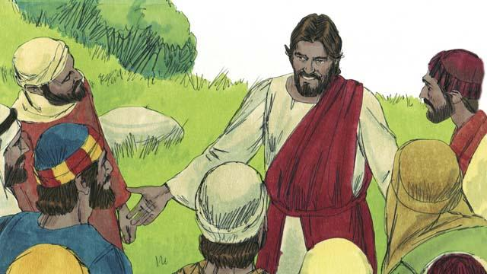
Namba bilong ol dispela man em 5,000. Ol i no kaunim meri na pikinini. Jisas i sori tumas long ol manmeri. Em i lukim ol dispela manmeri i olsem sipsip i nogat wasman. Olsem na em skulim ol na oraitim ol sik manmeri i stap wantaim ol.
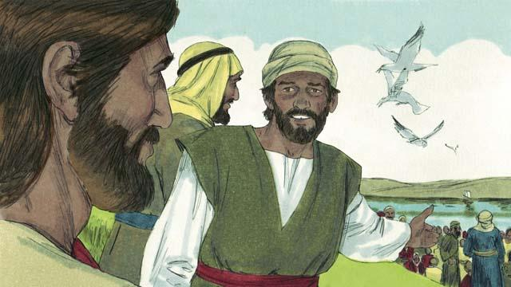
Long apinun ol disaipel i tokim Jisas, “Em i apinun pinis na i nogat ol ples i stap klostu. Salim ol manmeri i go bai ol i ken painim sampela kaikai long kaikai.”
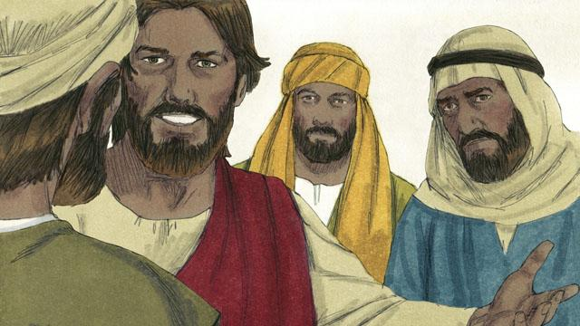
Tasol Jisas i tokim ol disaipel, “Yupela givim kaikai long ol long kaikai.” Na ol i bekim tok olsem, “Bai mipela i mekim olsem wanem? Mipela i gat 5-pela bret na 2-pela liklik pis tasol.”
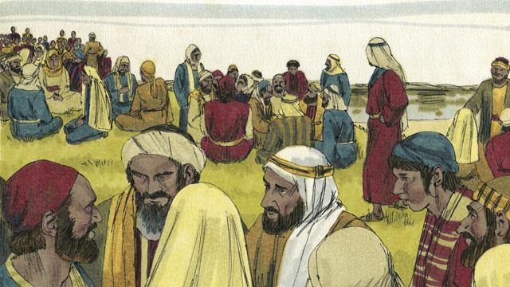
Na Jisas i tokim ol disaipel bilong em long tokim ol manmeri long sindaun long gras inap olsem 50 man long wanwan grup.
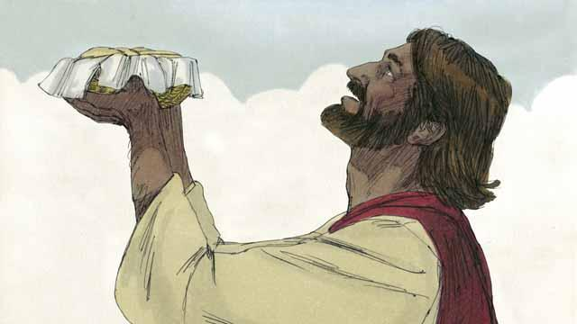
Na Jisas i kisim 5-pela bret na 2-pela pis, na em i lukluk i go antap long heven na tok tenkyu long God.
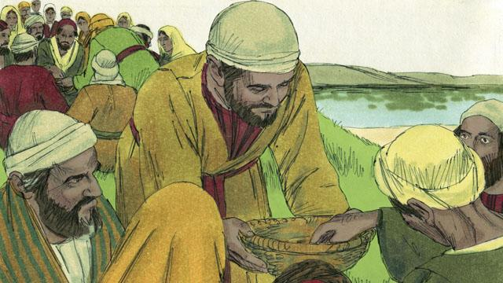
Na em i brukim bret na pis i go liklik. Na em i givim long ol disaipel bilong em long givim ol manmeri. Ol disaipel i givim ol tasol em i no pinis! Olgeta manmeri i kaikai na pulap.
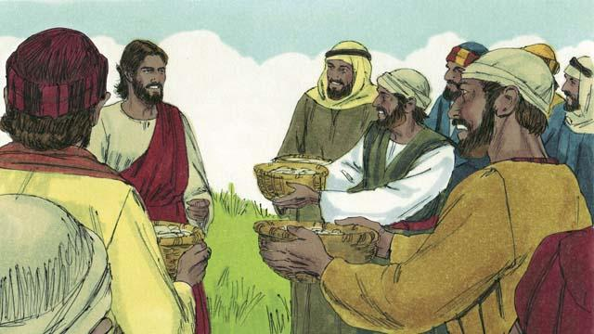
Ol i kaikai pinis na bihain ol disaipel i bungim ol hap kaikai na pulimapim long 12-pela basket. Olgeta dispela kaikai i kamap long 5-pela bret na 2-pela pis.
Baibel Stori i Kam Long: Matyu 14:13–21; Mak.6:31–44; Luk 9:10–17; Jon 6:5–15

