Resource: unfoldingWord® Open Bible Stories
unfoldingWord® Open Bible Stories © 2022 unfoldingWord. Released under CC BY-SA 4.0 license. unfoldingWord® Open Bible Stories has been adapted in the following languages: Tok Pisin, Arabic (عربي), French (Français), Hindi (हिंदी), Indonesian (Bahasa Indonesia), Portuguese (Português), Russian (Русский), Spanish (Español), Swahili (Kiswahili), and Simplified Chinese (简体中文) from unfoldingWord® Open Bible Stories © 2022 unfoldingWord. Released under CC BY-SA 4.0 license by Mission Mutual

unfoldingWord® Open Bible Stories

34. Jisas i Skulim Planti Arapela Stori
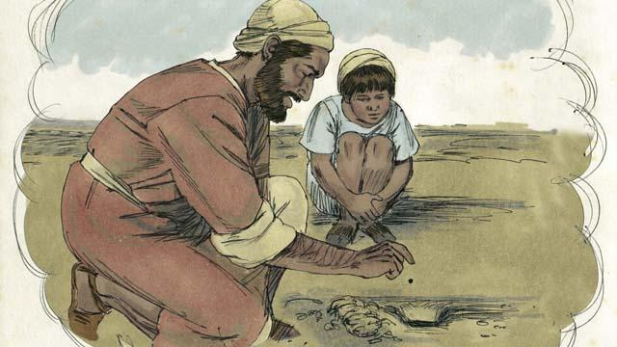
Jisas i tokaut long planti arapela stori long kingdom bilong God. Eksampel olsem, em i tok, “Kingdom bilong God i olsem masted sid. Wanpela i planim long gaden bilong em. Yu save dispela masted sid, em i liklik long olgeta sid.”
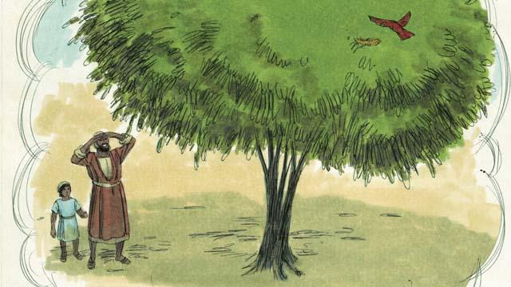
“Tasol, dispela masted sid i gro, na kamap bikpela long olgeta gaden diwai. Ol pisin inap long i go na sindaun long han bilong diwai na kisim malolo.”
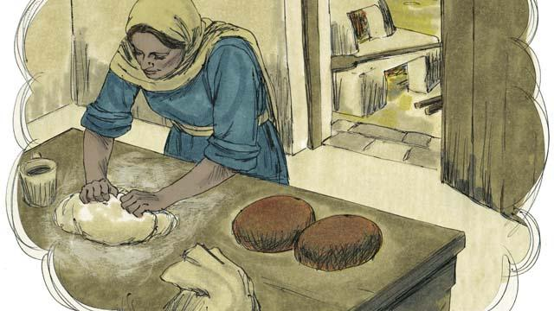
Jisas i tokim narapela stori, “Kingdom bilong God i olsem meri i tanim yis wantaim plaua inap yis i go i kam long olgeta plaua.”
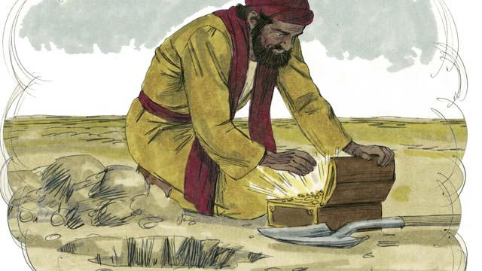
“Kingdom bilong God i olsem ol samitng i dia tumas. Wanplea i haitim long gaden. Narapela man i painim, na digim graun na planim gen. Em i amamas na salim olgeta samting bilong em na kisim mani na baim dispela graun.”
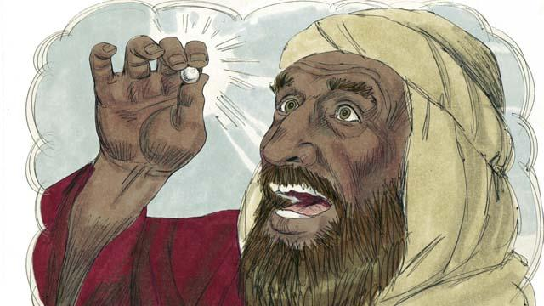
Kingdom bilong God i olsem naispela pel i gat gutpela prais. Taim man bilong baim pel i painim, em i salim olgeta samting bilong em, na yusim dispela mani long baim dispela pel.
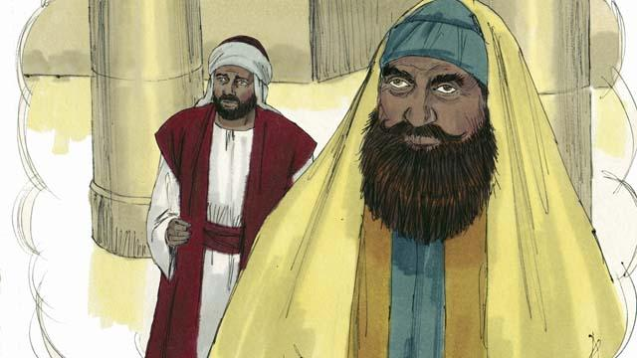
Na Jisas i stori long ol sampela manmeri husat i save putim tingting na bel bilong ol long gutpela pasin bilong ol yet na daunim arapela. Em i tok, “Tupela man i go prea long haus lotu. Wanpela bilong ol em man bilong kisim takis, na narapela em i lida bilong haus lotu.”
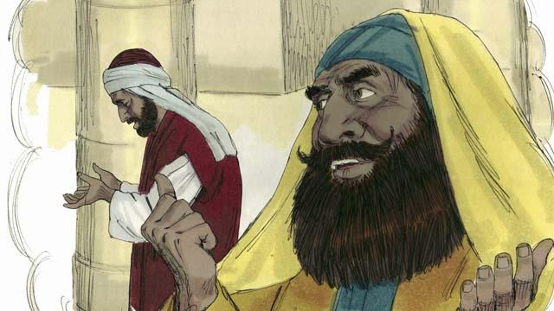
“Lida man bilong haus lotu i prea olsem, ’Tenkyu God, mi no sin man olsem narapela, mi no raskol, mi no olsem man i no save mekim pasin i no stret o mekim pasin pamuk olsem man i save kisim takis i stap long hapsait.”
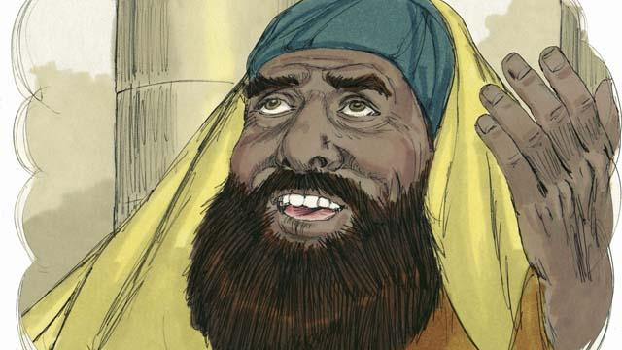
“Eksampel, mi save tambuim kaikai long tupela taim long wanpela wik, na tu mi save givim ten-hap mani i go long yu long ol gutpela samting mi save kisim.”
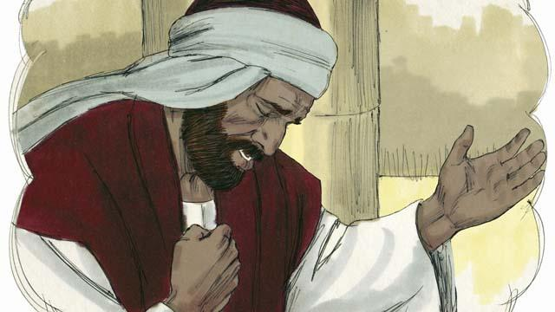
“Tasol man bilong kisim takis i sanap longwe liklik long lida bilong haus lotu, na i no lukluk i go long heven. Long wanem em i paitim bros bilong em wantaim han na prea. ’God, plis marimari long mi, long wanem mi sin man.”
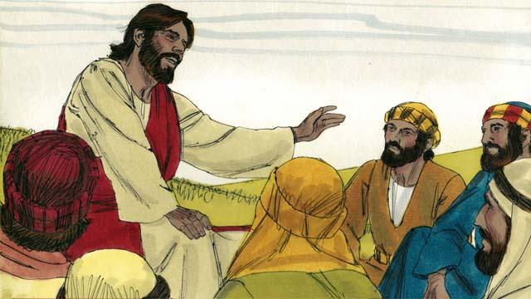
Na Jisas i tok, “Mi tok stret long yupela, God i harim prea bilong man i kisim takis na i tok klia olsem,”Em i stretpela man. Tasol em i no laik harim prea bilong dispela lida bilong haus lotu. God bai daunim olgeta manmeri husat i hapim ol yet, na em bai i hapim husat i daunim em yet."
Baibel Stori i Kam Long: Matyu 13:31–33,44–46; Mak 4:30–32; Luk 13:18–21;18:9–14

