Resource: unfoldingWord® Open Bible Stories
unfoldingWord® Open Bible Stories © 2022 unfoldingWord. Released under CC BY-SA 4.0 license. unfoldingWord® Open Bible Stories has been adapted in the following languages: Tok Pisin, Arabic (عربي), French (Français), Hindi (हिंदी), Indonesian (Bahasa Indonesia), Portuguese (Português), Russian (Русский), Spanish (Español), Swahili (Kiswahili), and Simplified Chinese (简体中文) from unfoldingWord® Open Bible Stories © 2022 unfoldingWord. Released under CC BY-SA 4.0 license by Mission Mutual

unfoldingWord® Open Bible Stories

35. Stori Bilong Papa i Pulap Long Pasin Sori
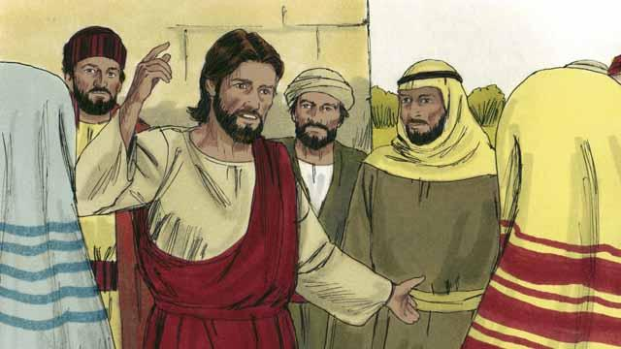
Wanpela de, Jisas i skulim ol man bilong kisim takis na ol arapela sin manmeri husat i kam bung long harim tok bilong em.
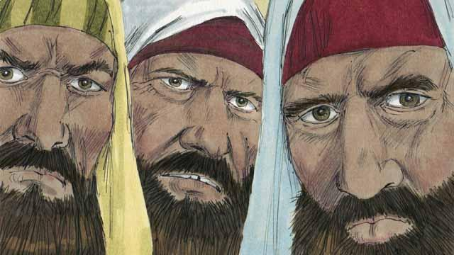
Sampela lida bilong sios husat i stap long dispela hap tu i lukim Jisas i mekim ol sin manmeri olsem pren bilong em, na ol i stat long tok bilas long em namel long ol yet. Olsem na Jisas i tokaut long ol dispela stori.
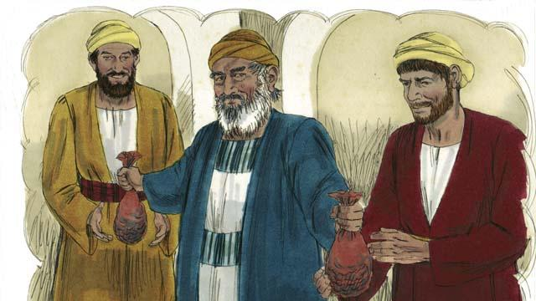
“Wanpela man i gat tupela pikinini man i stap. Liklik pikinini man i tokim papa bilong em olsem, ‘Papa, mi laik yu givim mi samting bilong mi long bihain, nau mi laik yu givim mi!’ Olsem na papa i brukim ol samting bilong em namel long tupela pikinini man bilong em.”
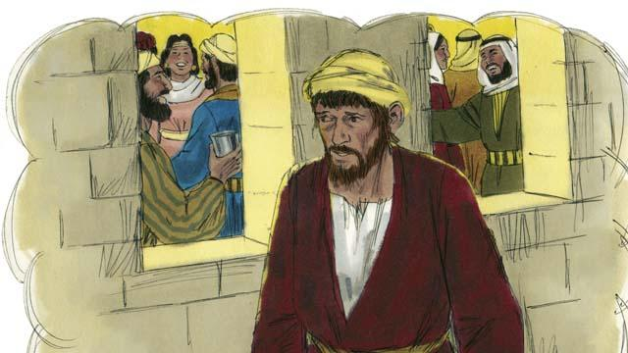
“I no long taim bihain, liklik pikinini man i kisim olgeta samting bilong em na i go longwe na pinisim nating mani bilong em long pasin nogut bilong dispela graun.”
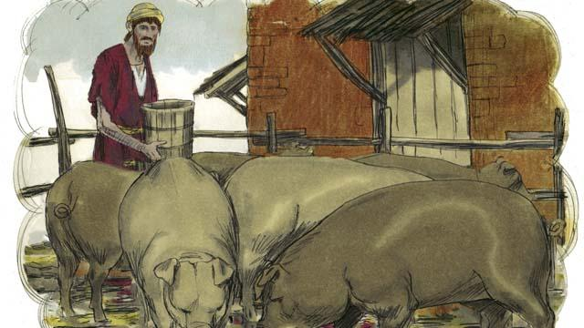
’’Bihain bikpela hangre i kamap long hap yangpela pikinini man i stap na em i no gat mani long baim kaikai. Olsem na wanpela wok em inap long painim, em givim kaikai long pik. Em i bagarap nogut tru na hangre olsem na em i laik kaikai, kaikai bilong ol pik."

“Bihain tru, yangpela pikinini man i tok long em yet olsem,”Mi mekim wanem samting? Olgeta wokboi bilong papa bilong mi i gat planti kaikai long kaikai tasol mi hangre i stap long hia. Bai mi go bek long papa bilong mi na askim em long kamap wanpela wokboi bilong em."

“Olsem na yangpela pikinini man i kirap na wokabaut i go long haus bilong papa bilong em. Taim em i stap longwe yet, papa bilong em i lukim em na i pilim sori long em. Em i ran i go long pikinini bilong em na holimpasim em, na kis long em.”

“Pikinini i tok olsem, ’Papa, mi mekim sin long God na long yu. Mi no gutpela inap long mi kamap pikinini bilong yu.”
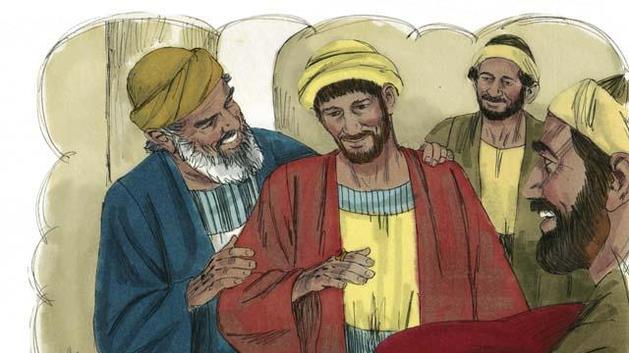
“Tasol papa bilong em i tokim wanpela wokboi bilong en, ’Yu go hariap na kisim naispela klos na putim long pikinini man bilong mi. Putim ring long pinga bilong en na putim sendol long lek bilong en. Kilim patpela pikinini bulmakau na bai yumi mekim pati na amamas, long wanem pikinini bilong mi i bin dai tasol nau em i stap laip! Em i bin lus tasol nau mi painim em.”
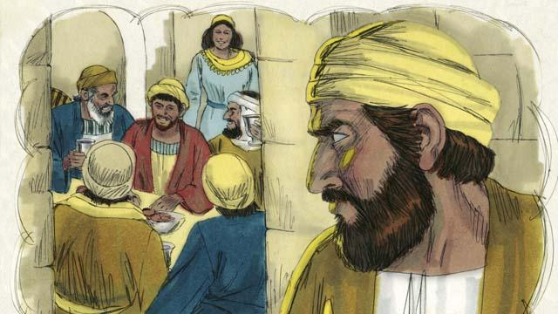
“Olsem na ol manmeri i stat long amamas. I no long taim bihain nambawan pikinini man i lusim ples bilong wok na kam long haus. Em i harim musik na danis na tingting planti long wanem samting i wok long kamap.”
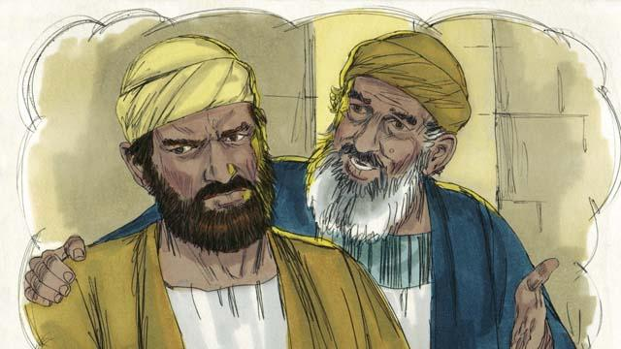
“Taim nambawan pikinini man i painim aut olsem ol i amamas long brata bilong em i kam pinis long haus, em i belhat nogut tru na em les long i go insait long haus. Papa bilong em i kam autsait na askim em long kam amamas wantaim ol, tasol em i no laik.”
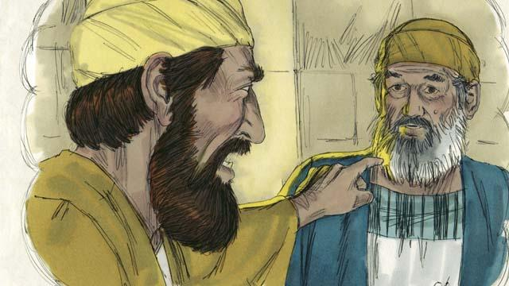
“Na nambawan pikinini man i tokim papa bilong em olsem, ‘Olgeta dispela yia mi bin wok stret na wokim wok gut long yu! Na mi no bin sakim tok bilong yu, tasol yu no bin givim mi wanpela liklik meme long mi inap long amamas wantaim ol pren bilong mi. Tasol taim dispela pikinini man bilong yu husat i bin yusim nating mani long ol pasin nogut na i kam long haus, yu kilim gutpela patpela pikinini bulmakau long em!’”
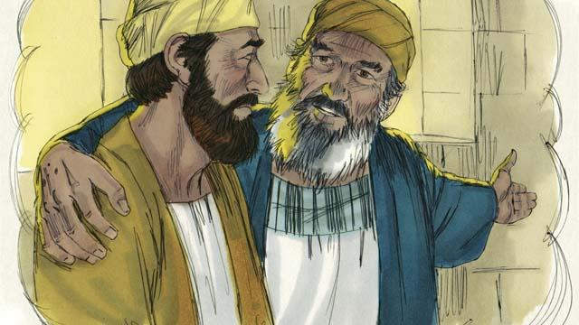
“Na papa i bekim tok olsem,”Pikinini bilong mi, yu save stap wantaim mi olgeta taim. Na olgeta samting mi gat em i bilong yu. Tasol i orait long yumi amamas, long wanem brata bilong yu i bin dai tasol nau em i stap laip gen. Em i bin lus tasol nau mi painim em pinis!"
Baibel Stori i Kam Long: Luk 15:11–32

