Resource: unfoldingWord® Open Bible Stories
unfoldingWord® Open Bible Stories © 2022 unfoldingWord. Released under CC BY-SA 4.0 license. unfoldingWord® Open Bible Stories has been adapted in the following languages: Tok Pisin, Arabic (عربي), French (Français), Hindi (हिंदी), Indonesian (Bahasa Indonesia), Portuguese (Português), Russian (Русский), Spanish (Español), Swahili (Kiswahili), and Simplified Chinese (简体中文) from unfoldingWord® Open Bible Stories © 2022 unfoldingWord. Released under CC BY-SA 4.0 license by Mission Mutual

unfoldingWord® Open Bible Stories

37. Jisas i Kirapim Lasarus
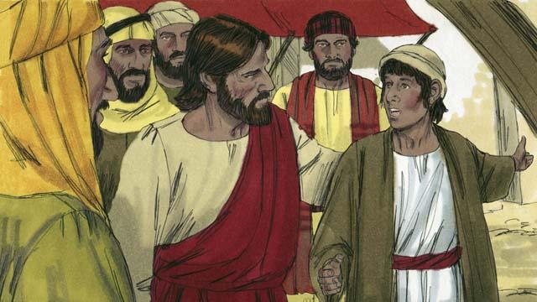
Wanpela taim Jisas i kisim tok olsem Lasarus i sik nogut tru. Lasarus na tupela susa bilong em, Maria na Mata tupela i stap gutpela pren bilong Jisas. Taim Jisas i harim dispela em i tok, “Dispela sik i no inap pinis long dai. Tasol dispela em bilong givim glori long God. Jisas i laikim ol pren bilong em, tasol em i wet long dispela hap tupela de moa.

Bihain long tupela de i go pinis, Jisas i tokim ol disaipel bilong em olsem, “Yumi i go bek long Judia.” Tasol tisa, Ol disaipel i bekim tok, “Sotpela taim i go pinis na ol manmeri i laik kilim yu!” Jisas i tok, “Pren bilong yumi Lasarus i slip, mi mas i go kirapim em.”
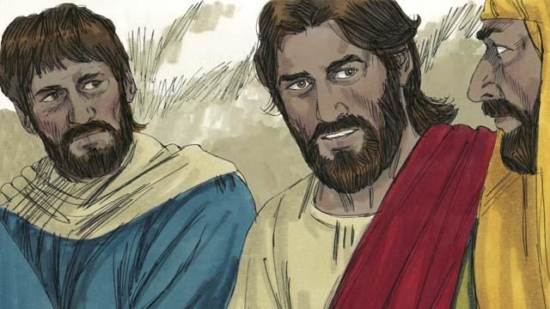
Ol disaipel bilong Jisas i tok, “Masta, sapos Lasarus i slip em inap stap orait. Jisas i tokim ol stret,”Lasarus i dai. Mi amamas olsem mi no bin i stap long hap. Olsem na yupela bai i bilip long mi."
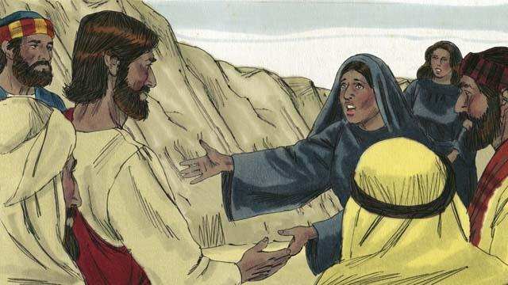
Taim Jisas i kamap long ples taun bilong Lasarus. Lasarus i bin dai pinis 4-pela de. Mata i go aut na bungim Jisas na i tok. “Masta, sapos yu bin stap long hia, brata bilong mi i no inap dai. Tasol mi bilip God bai givim yu wanem samting yu askim em.”
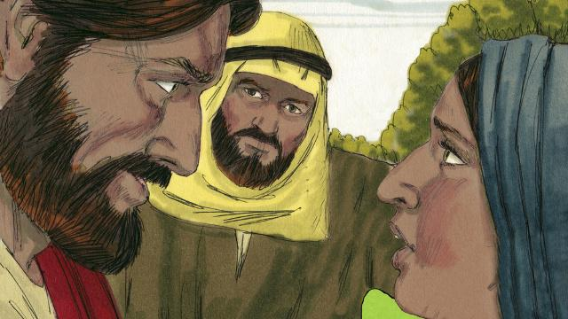
Jisas i bekim tok. “Mi man bilong kirapim bek dai man na givim laip. Husat manmeri i bilip long mi bai i stap laip. Maski em i dai pinis. Olgeta manmeri husat i bilip long mi bai i no inap dai. Yu bilipim dispela.” Mata i bekim tok, “Yes, Masta! Mi bilip, yu dispela Mesaia, Piknini bilong God.”
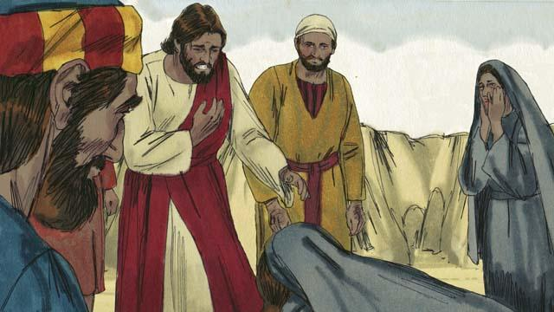
Maria i kam na em i pundaun i go daun long lek bilong Jisas na i tok, “Masta, sapos yu bin i stap hia, brata bilong mi i no inap dai.” Jisas i askim ol, “Yupela i putim Lasarus long wanem hap?” Ol i tokim em, “Em i stap insait long matmat, kam na lukim.” Jisas i krai.
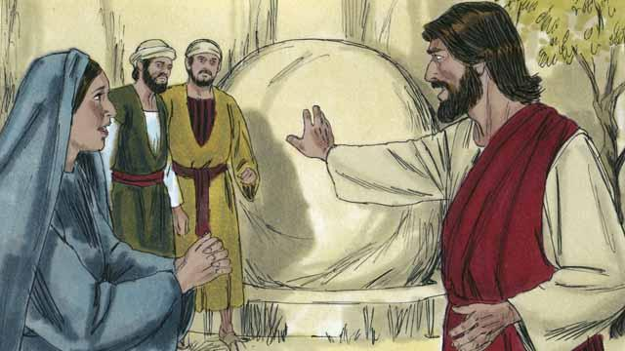
Dispela matmat em i hul wantaim ston ol i save tanim tanim long pasim maus bilong em. Taim Jisas i kamap long matmat, em i tokim ol. “Tanim ston i go longwe.” Tasol Mata i tok, “Em i bin dai pinis inap 4-pela de, em bai smel nogut.”
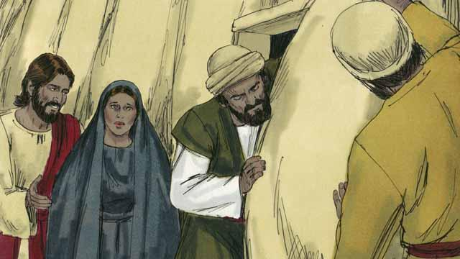
Jisas i bekim tok, “Mi no bin tokim yu olsem, taim yu bilip long mi, bai yu lukim strong bilong God.” Ol i tanim dispela ston i go.
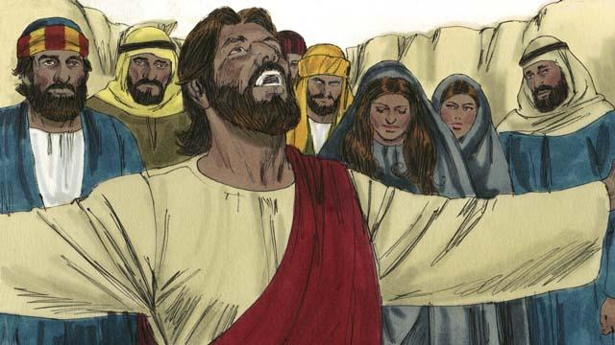
Olsem na Jisas i lukluk i go antap long heven na i tok, “Papa, Tenkyu long harim mi. Mi save, olgeta taim yu save harim tok bilong mi tasol mi toktok long gutpela bilong olgeta manmeri ol i sanap long hia, olsem na ol bai save olsem, yu salim mi i kam.” Em i singaut na tok, “Lasarus yu kam aut!”
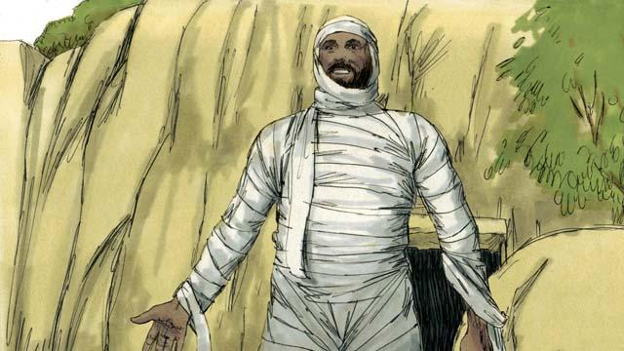
Olsem na Lasarus i kam aut. Klos bilong matmat i stap yet wantaim em na Jisas i tokim ol, “Helpim em na rausim ol matmat klos na lusim em!” Planti lain Juda i bilipim Jisas long wanem em i mekim dispela mirakel.
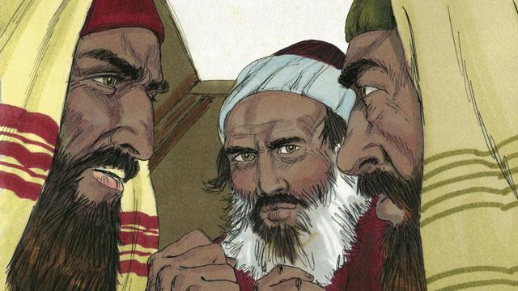
Tasol ol lida man bilong lotu bilong ol Juda i tingting nogut na olgeta i bung na pasim tok olsem wanem bai ol kilim Jisas na Lasarus.
Baibel Stori i Kam Long: Jon 11:1- 46

