Resource: unfoldingWord® Open Bible Stories
unfoldingWord® Open Bible Stories © 2022 unfoldingWord. Released under CC BY-SA 4.0 license. unfoldingWord® Open Bible Stories has been adapted in the following languages: Tok Pisin, Arabic (عربي), French (Français), Hindi (हिंदी), Indonesian (Bahasa Indonesia), Portuguese (Português), Russian (Русский), Spanish (Español), Swahili (Kiswahili), and Simplified Chinese (简体中文) from unfoldingWord® Open Bible Stories © 2022 unfoldingWord. Released under CC BY-SA 4.0 license by Mission Mutual

unfoldingWord® Open Bible Stories

41. God i Kirapim Jisas Bek Long Dai.

Bihain long ol soldia i hangamapim Jisas long diwai kros ol lida man bilong lain Juda husat i no bilip long Jisas, ol i go long Pailat na tokim em olsem, “Dispela man bilong giaman, em Jisas, taim em i stap laip, em i bin tok, em bai kirap bek gen long dai bihain long 3-pela de. Olsem na sampela lain i mas lukautim gut matmat bilong em. Nogut ol disaipel bilong em bai stilim bodi bilong em na tok em i kirap bek gen long dai.”
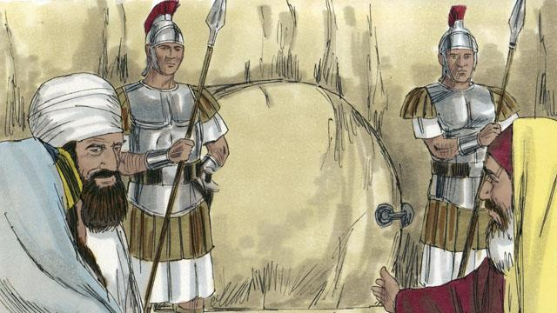
Pailat i tokim ol, “Kisim sampela soldia na pasim matmat gut na lukautim gut.” Olsem na ol i putim tambu long ston i pasim maus bilong matmat na putim sampela soldia long lukautim matmat. Ol i mekim dispela long stopim ol disaipel bilong Jisas i noken stilim bodi bilong em.
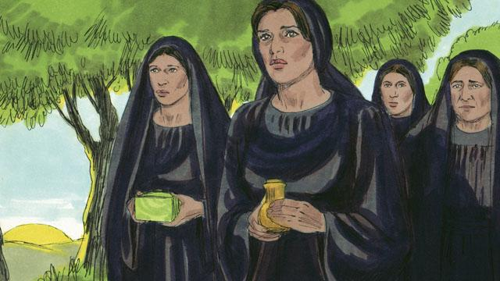
De bihain ol i planim Jisas, em i de Sabat. Na em i tambu tru long olgeta lain Juda long i go long matmat long de Sabat. Olsem na long monintaim long de bihain long de Sabat sampela meri i bin redim sampela smel sanda long kisim i go long matmat. Ol i bin tingting long putim smel sanda long bodi bilong Jisas.

Wantu wanpela bikpela guria i bin kamap na wanpela ensel, lukluk bilong em i olsem lait i bin kam daun long heven. Dispela ensel i bin kam na tanim bikpela ston i bin pasim maus bilong matmat na sindaun antap long en. Long dispela taim tu, olgeta soldia husat i was long matmat, ol i pret nogut tru na pundaun long graun na kamap olsem dai man.
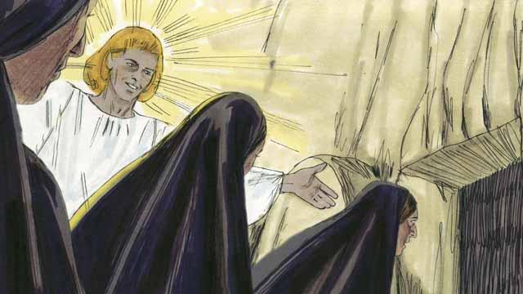
Taim ol meri i kamap long matmat, ensel i tokim ol olsem, “Noken pret. Jisas i no stap long hia. Em i bin kirap bek long dai olsem em i bin tok! Lukluk insait long matmat na painimaut.” Orait ol meri i lukluk insait long matmat tasol ol i no lukim bodi bilong Jisas.

Na ensel i tokim ol meri olsem, “Go na tokim olgeta disaipel bilong Jisas, em i bin kirap bek long dai na em bai i go pas long yupela long Galili.”

Ol meri i pulap wantaim pret na bikpela amamas tu na ol i ran i go long autim gutnius long ol disaipel.

Taim ol meri i wokabaut i go long tokaut long gutnius long ol disaipel, Jisas i bin kamap ples klia long ol na ol i lotuim em. Jisas i tokim ol olsem, “Noken pret, tokim ol disaipel bilong mi long i go long Galili. Mi bai lukim ol long hap.”
Baibel Stori i Kam Long: Matyu 27:62–28:15; Mak 16:1–11; Luk 24:1–12; Jon 20:1–18

