Resource: unfoldingWord® Open Bible Stories
unfoldingWord® Open Bible Stories © 2022 unfoldingWord. Released under CC BY-SA 4.0 license. unfoldingWord® Open Bible Stories has been adapted in the following languages: Tok Pisin, Arabic (عربي), French (Français), Hindi (हिंदी), Indonesian (Bahasa Indonesia), Portuguese (Português), Russian (Русский), Spanish (Español), Swahili (Kiswahili), and Simplified Chinese (简体中文) from unfoldingWord® Open Bible Stories © 2022 unfoldingWord. Released under CC BY-SA 4.0 license by Mission Mutual

unfoldingWord® Open Bible Stories

44. Pita Na Jon i Oraitim Wanpela Tarangu Man
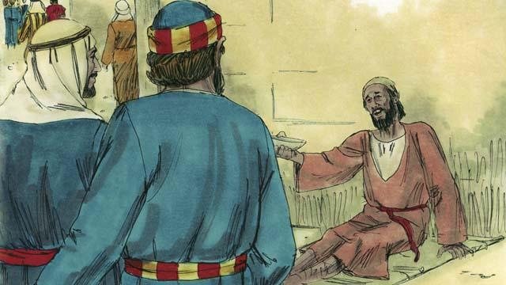
Wanpela de, Pita na Jon i wokabaut i go long Tempel. Taim ol i kam klostu long dua bilong Tempel, ol i lukim wanpela lek nogut man i sindaun i stap na askim long mani.
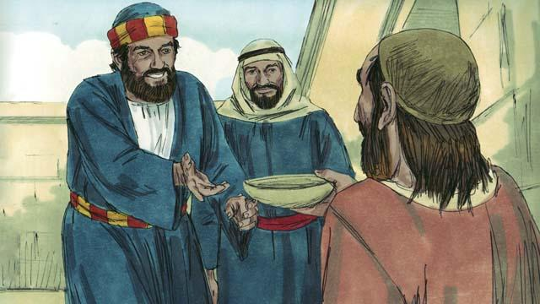
Pita i lukluk long lek nogut man na i tok, “Mi nogat mani long givim yu. Tasol bai mi givim yu wanem samting mi gat. Long nem bilong Jisas, kirap na wokabaut!”
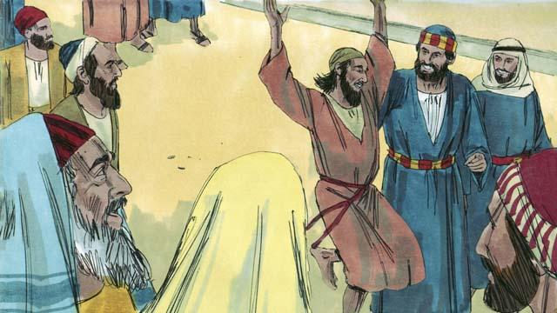
Kwiktaim tru, God i oraitim dispela lek nogut man, na em i stat long wokabaut na kalap nabaut, na amamas na litimapim nem bilong God. Ol manmeri i stap long Tempel ol i kirap nogut.
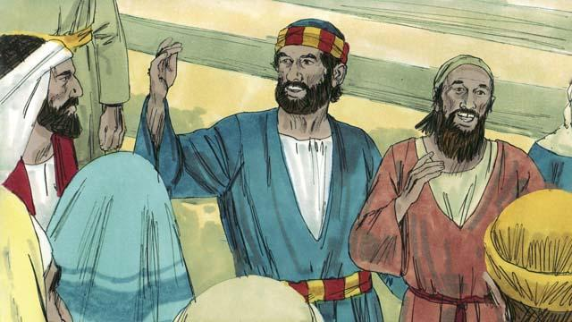
Kwiktaim, ol manmeri i kam na lukim dispela man i kamap orait. Pita i tokim ol, “Bilong wanem yupela i kirap nogut? Mipela i no oraitim em long strong o gutpela bilong mipela. Tasol, long strong bilong Jisas na bilip Jisas i givim, dispela i oraitim em.”
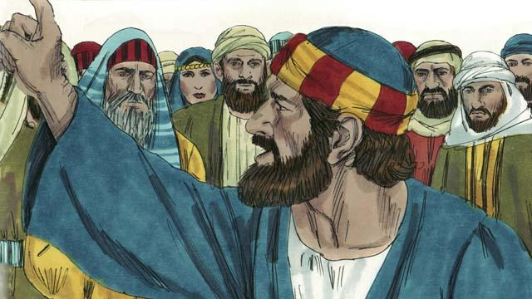
“Yupela tasol i bin tokim gavman bilong Rom long kilim Jisas. Yupela i kilim man bilong givim laip, tasol God kirapim em long dai. Yupela i no bin klia o save wanem samting yupela i mekim, tasol dispela em inapim ol toktok ol profet i bin mekim olsem Mesaia bai kisim bikpela bagarap na i dai. Olsem na nau yupela i mas tanim bel na kam long God na em bai rausim sin bilong yupela.”
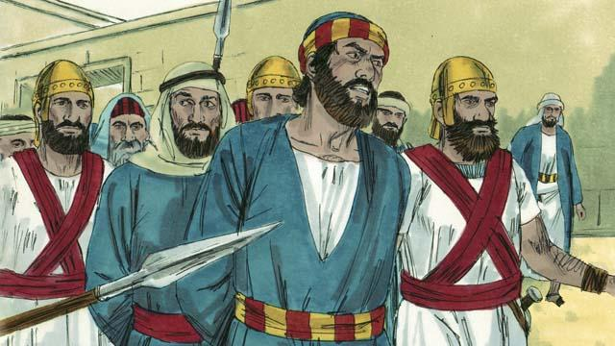
Ol lida bilong Tempel i no amamas long ol tottok bilong Pita na Jon. Olsem na ol i holim tupela na putim ol long kalabus. Tasol planti manmeri i bilipim toktok bilong Pita, na namba bilong ol man i bilip long Jisas i kamap olsem 5,000.
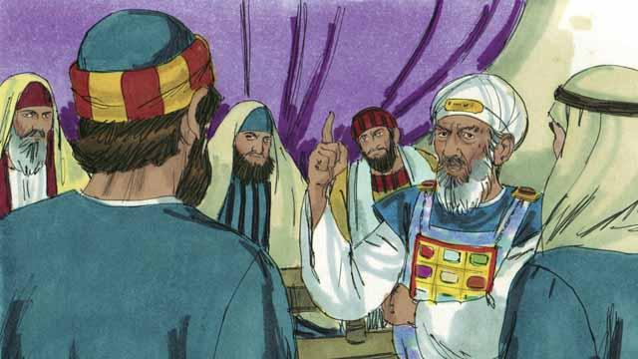
Long narapela de, ol lidaman bilong lain Juda i bringim Pita na Jon i go long hetpris na ol arapela lidaman bilong sios. Ol i askim Pita na Jon, “Long wanem strong na pawa yu oraitim dispela lek nogut man?”

Pita i bekim tok bilong ol olsem, “Dispela man i sanap long pes bilong yupela, em i kamap orait long strong na pawa bilong Jisas em Mesaia. Yupela i kilim em i dai long diwai kros, tasol God i kirapim em long dai na em i stap laip gen. Yupela i no laikim em, tasol i no gat narapela rot bai yupela inap long i stap gut. Nogat tru, long strong na pawa bilong Jisas tasol!”
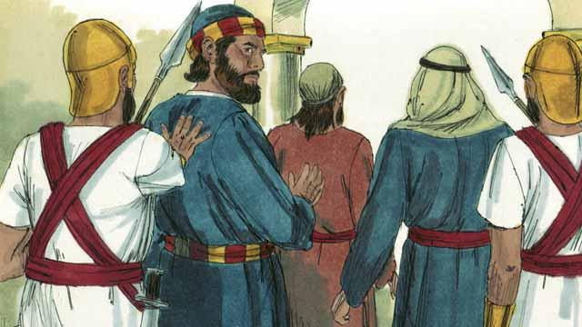
Ol lidaman i kirap nogut olsem Pita na Jon i toktok wantaim strong. Ol lidaman i lukim olsem ol dispela tupela man, olsem man nating na ol i no bin skul. Tasol long dispela taim ol i tinging olsem dispela tupela man i bin stap wantaim Jisas. Bihain long ol i mekim nogut long Pita na Jon, ol i lusim tupela i go.
Baibel Story i Kam Long: Aposel 3:1–4:22

