Resource: unfoldingWord® Open Bible Stories
unfoldingWord® Open Bible Stories © 2022 unfoldingWord. Released under CC BY-SA 4.0 license. unfoldingWord® Open Bible Stories has been adapted in the following languages: Tok Pisin, Arabic (عربي), French (Français), Hindi (हिंदी), Indonesian (Bahasa Indonesia), Portuguese (Português), Russian (Русский), Spanish (Español), Swahili (Kiswahili), and Simplified Chinese (简体中文) from unfoldingWord® Open Bible Stories © 2022 unfoldingWord. Released under CC BY-SA 4.0 license by Mission Mutual

unfoldingWord® Open Bible Stories

47. Pol Na Sailas i Stap Long Filipai
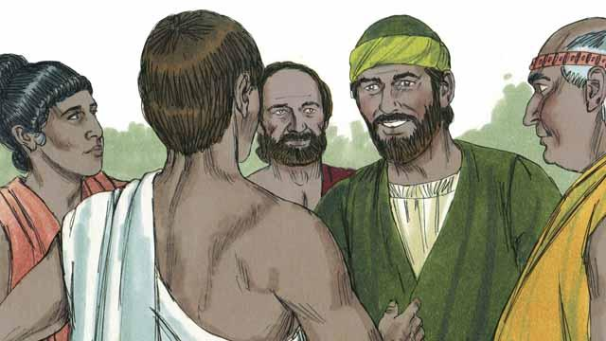
Taim Pol i wokabaut i go long olgeta hap graun bilong kingdom bilong Rom, em i stat long yusim dispela nem bilong ol Rom em “Pol,” i no Sol, long wanem, tokples Rom, Sol em Pol. Wanpela de, Pol na pren bilong em Sailas i bin i go long taun Filipai long autim gutnius bilong Jisas. Ol i bin i go long wanpela hap ples arere long bikpela wara autsait long taun, long dispela hap ol manmeri i bung long beten. Long dispela hap ol i bungim wanpela meri, nem bilong em Lidia husat em wanpela bisnis meri. Em i save laikim God na lotu long em.
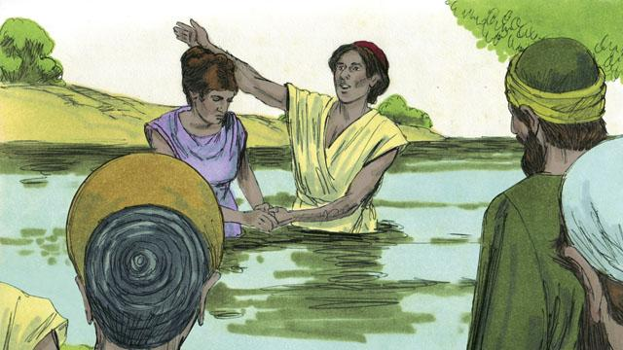
God i opim bel bilong Lidia long bilip long tok bilong Jisas, em yet na ol famili bilong em ol i kisim baptais. Em i askim Pol na Sailas long i stap long haus bilong em, olsem na tupela i stap long haus bilong em wantaim ol famalli bilong em.
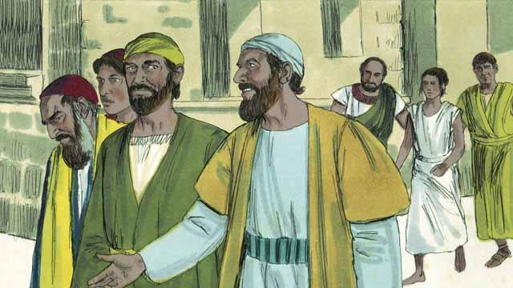
Pol na Sailas i save bung wantaim ol manmeri long ples bilong beten. Olgeta de ol i wokabaut i go long hap, wanpela wokmeri nating i gat spirit nogut i save bihainim tupela. Long ol dispela spirit nogut i stap insait long em, meri i save toktok long ol manmeri long ol samting bai i kamap bihain long ol. Olsem na em i mekim planti mani bilong ol bos bilong em taim em i tokim ol manmeri long ol samting bai i kamap long ol bihain taim.
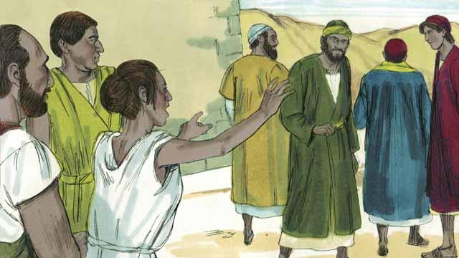
Dispela wokmeri nating i wok long singaut taim ol i wokabaut i go na em i tok olsem, “Dispela tupela man i wokman bilong Bikpela God Antap Tru. Ol i tokim yupela long rot bilong i stap gut!” Em i tok olsem planti taim, olsem na Pol i no amamas.
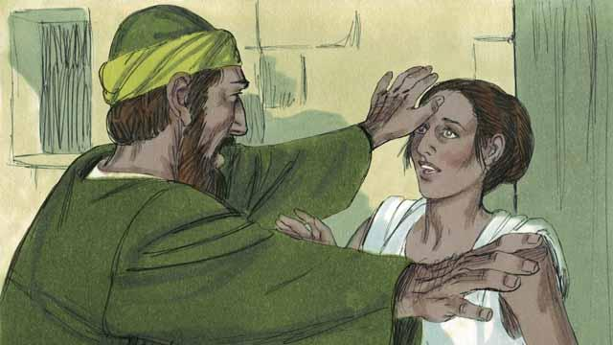
Long wanpela de dispela wokmeri nating i stat long singaut gen, Pol i tanim na tokim spirit nogut insait long em, “Long nem bilong Jisas, kam autsait na lusim dispela meri.” Kwiktaim long dispela taim stret spirit nogut i lusim em na i go.
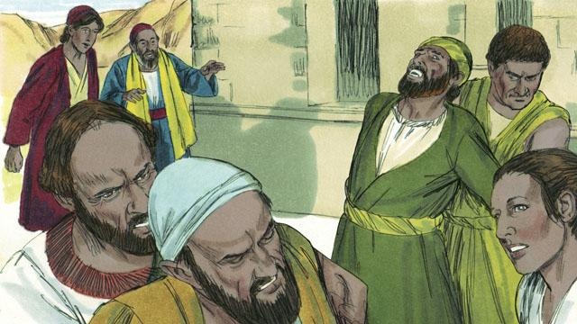
Ol man i bosim dispela wokmeri nating i belhat stret! Ol i luksave olsem ol man i no inap baim mani long ol lain i bosim dispela meri inap long em i tokim ol manmeri long wanem samting bai i kamap long ol long bihain taim.
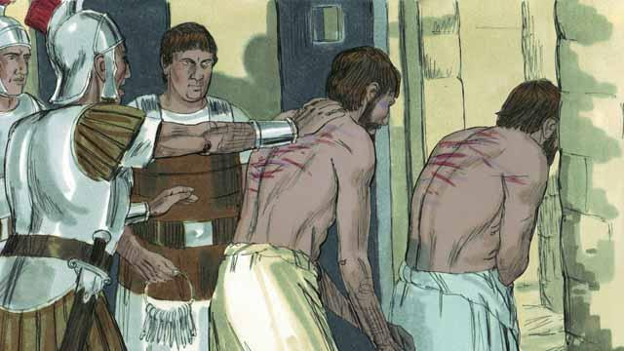
Olsem na ol bosman bilong wokmeri nating i kisim Pol na Sailas i go long gavman bilong Rom, na ol i paitim tupela na tromoi tupela i go insait long haus kalabus.
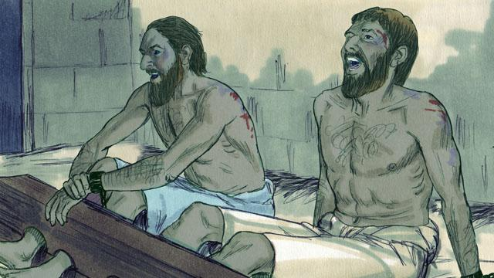
Ol i putim Pol na Sailas insait long rumkat i gat strongpela banis na pasim lek na han bilong tupela wantaim strongpela lok. Tasol namel long nait, tupela i singsing na lotuim God i stap .
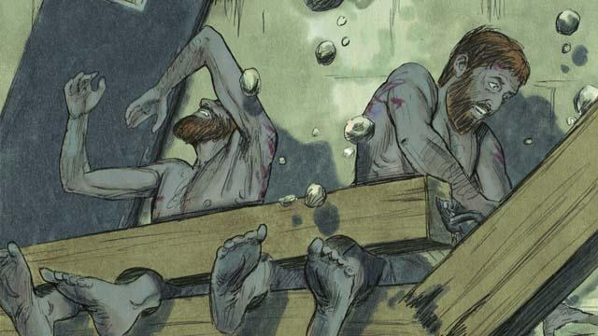
Kwiktaim Bikpela guria i kamap! Olgeta dua bilong haus kalabus i op, na sen bilong olgeta kalabus man i lus.
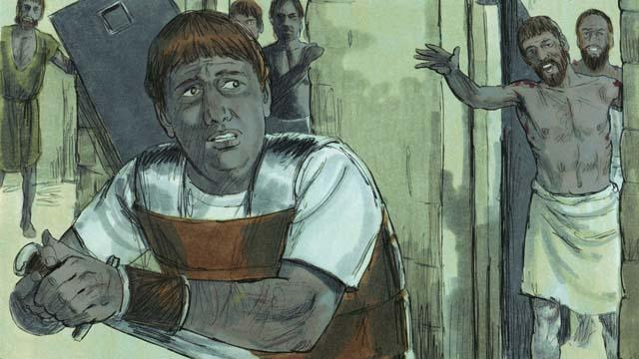
Man bilong lukautim haus kalabus i kirap. Taim em i lukim olgeta dua bilong haus kalabus i op, em i kirap nogut na pret! Em i ting olgeta kalabus i ranawe pinis. (Em i save olsem Rom gavman bai kilim em, sapos olgeta kalabusman i ranawe pinis). Tasol Pol i lukim em na i singaut, “Stop! Noken bagarapim yu yet. Mipela olgeta i stap.”
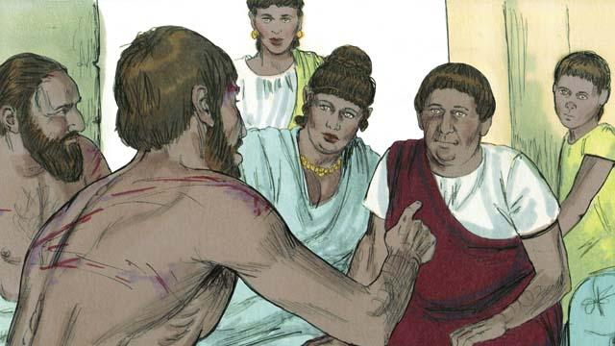
Bos bilong haus kalabus i guria nogut tru na i kam long Pol wantaim Sailas na askim, “Bai mi mekim wanem na i stap gut?” Pol i bekim tok olsem, “Bilip long Jisas, em i Bikpela bilong yu na lain bilong yu bai i stap gut.” Na bihain bos bilong haus kalabus i kisim Pol na Sailas i go insait long haus bilong em na i wasim ol sua long bodi bilong ol. Pol i autim gutnius bilong Jisas long olgeta lain i stap insait long haus.

Bos bilong haus kalabus na olgeta lain bilong en i bilip long Jisas na i kisim baptais. Bihain bos bilong haus kalabus i kukim kaikai na olgeta i amamas wantaim.
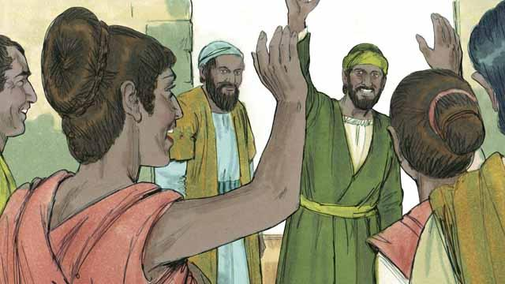
De bihain ol lida bilong taun i larim Pol na Sailas i lusim haus kalabus na i go. Ol i askim ol long lusim taun Filipai tu. Pol wantaim Sailas i go lukim Lidia na sampela arapela pren pastaim, na bihain ol i lusim taun Filipai. Gutnius bilong Jisas i kamap bikpela na i go long olgeta hap, na sios tu i kamap bikpela.
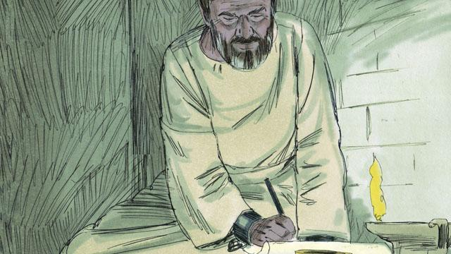
Pol na ol arapela Kristen lidaman i wokabaut i go long planti taun, na autim na skulim manmeri long gutnius bilong Jisas. Na tu, ol i raitim planti pas long helpim na skulim ol bilip manmeri insait long ol sios. Sampela bilong dispela pas, ol i kamap buk bilong Baibel.
Baibel Stori i Kam Long: Aposel 16:11- 40

