Resource: Video Bible Dictionary
Video Bible Dictionary © 2023 SRV Partners. Released under CC BY-SA 4.0 license. Video Bible Dictionary has been adapted in the following languages: Tok Pisin, عربي, Français, हिंदी, Bahasa Indonesia, Português, Русский, Español, Kiswahili, 简体中文 from Video Bible Dictionary © 2023 SRV Partners. Released under CC BY-SA 4.0 license by Mission Mutual

Video Bible Dictionary

B

bâton

Video Content
(53 seconds)
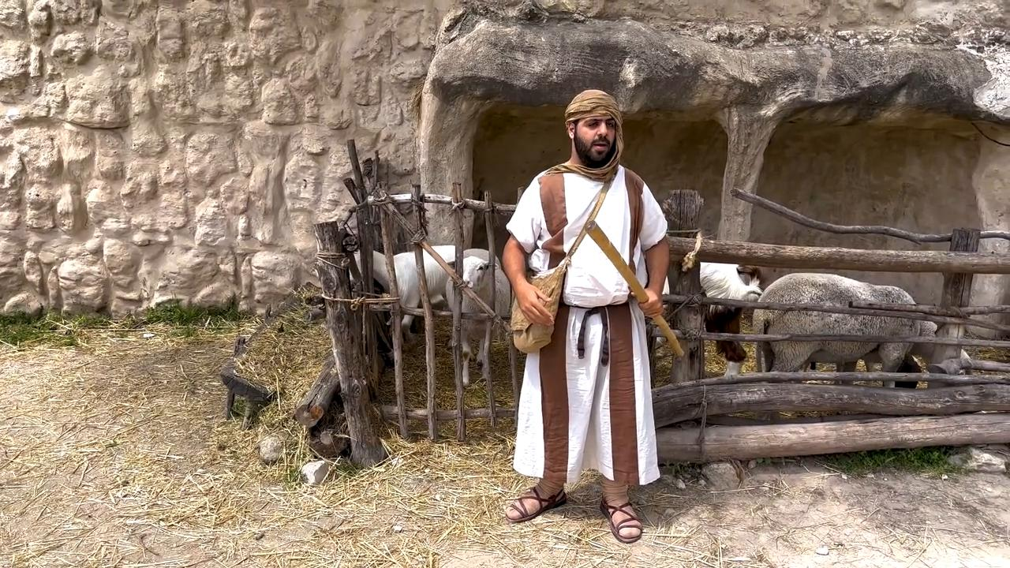
link

Blé avec des têtes de grain

Video Content
(131 seconds)
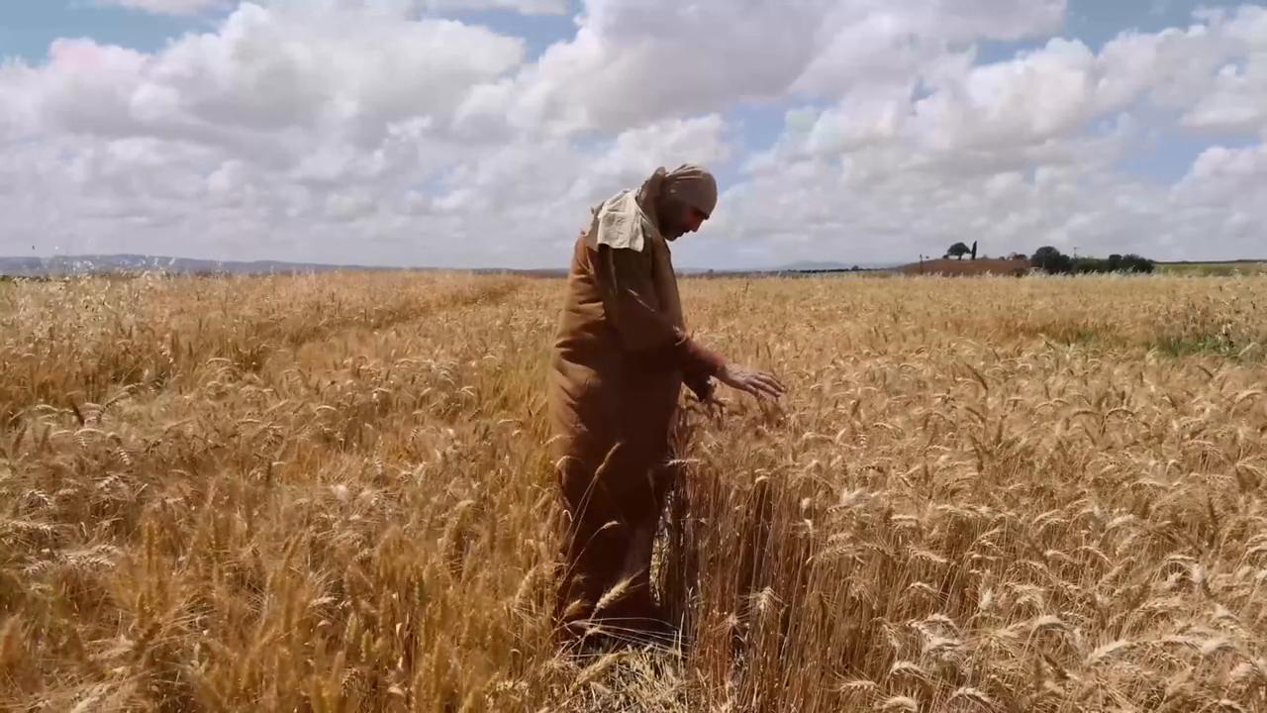
link

Blé Prêt Pour La Récolte

Video Content
(79 seconds)
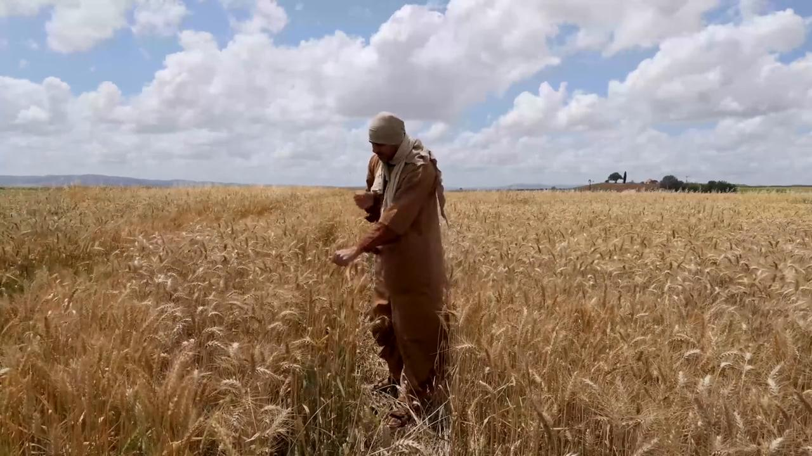
link

Branches d'olivier et de palmier

Video Content
(68 seconds)
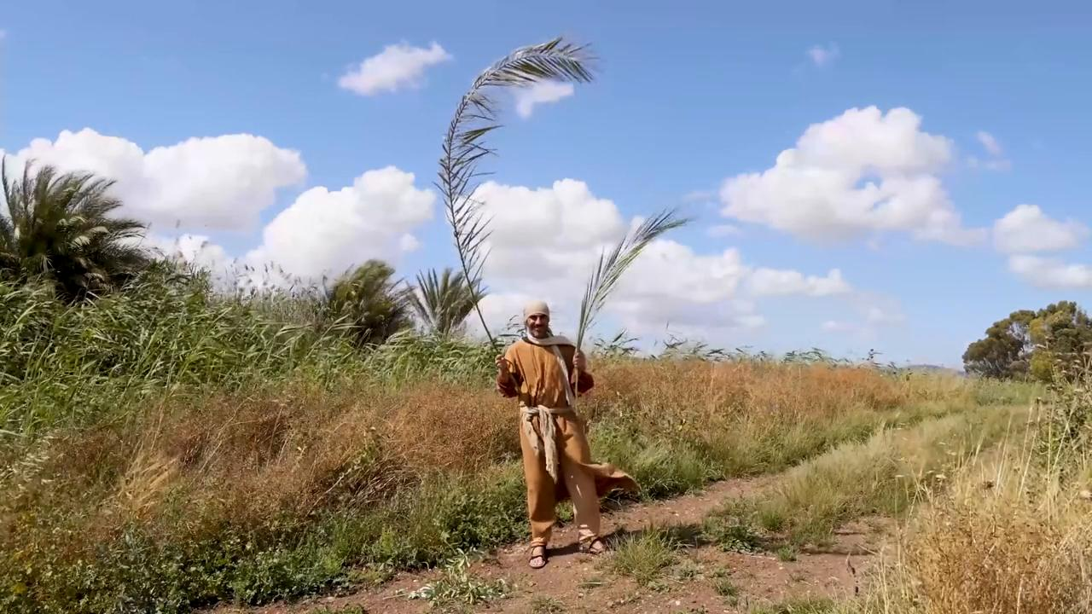
link

