Resource: Video Bible Dictionary
Video Bible Dictionary © 2023 SRV Partners. Released under CC BY-SA 4.0 license. Video Bible Dictionary has been adapted in the following languages: Tok Pisin, عربي, Français, हिंदी, Bahasa Indonesia, Português, Русский, Español, Kiswahili, 简体中文 from Video Bible Dictionary © 2023 SRV Partners. Released under CC BY-SA 4.0 license by Mission Mutual

Video Bible Dictionary

M

Maison à l'époque de Jésus

Video Content
(87 seconds)
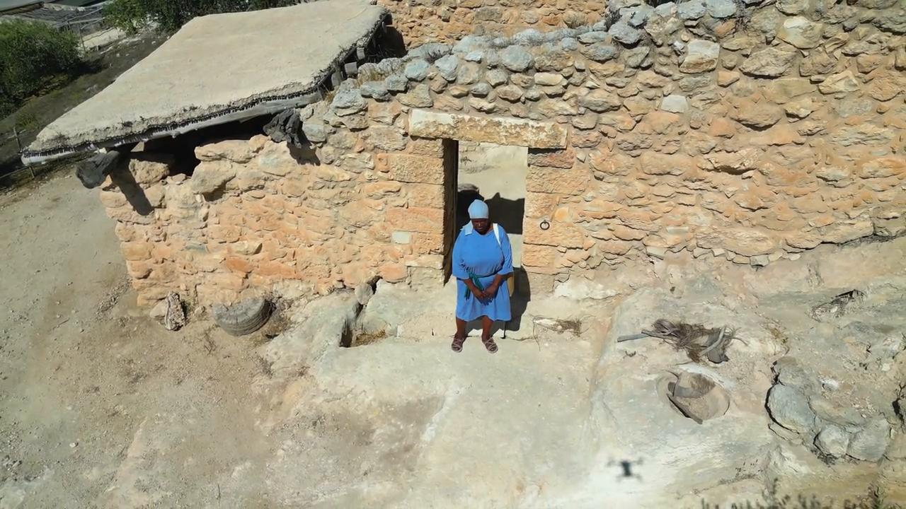
link

Manteau

Video Content
(72 seconds)
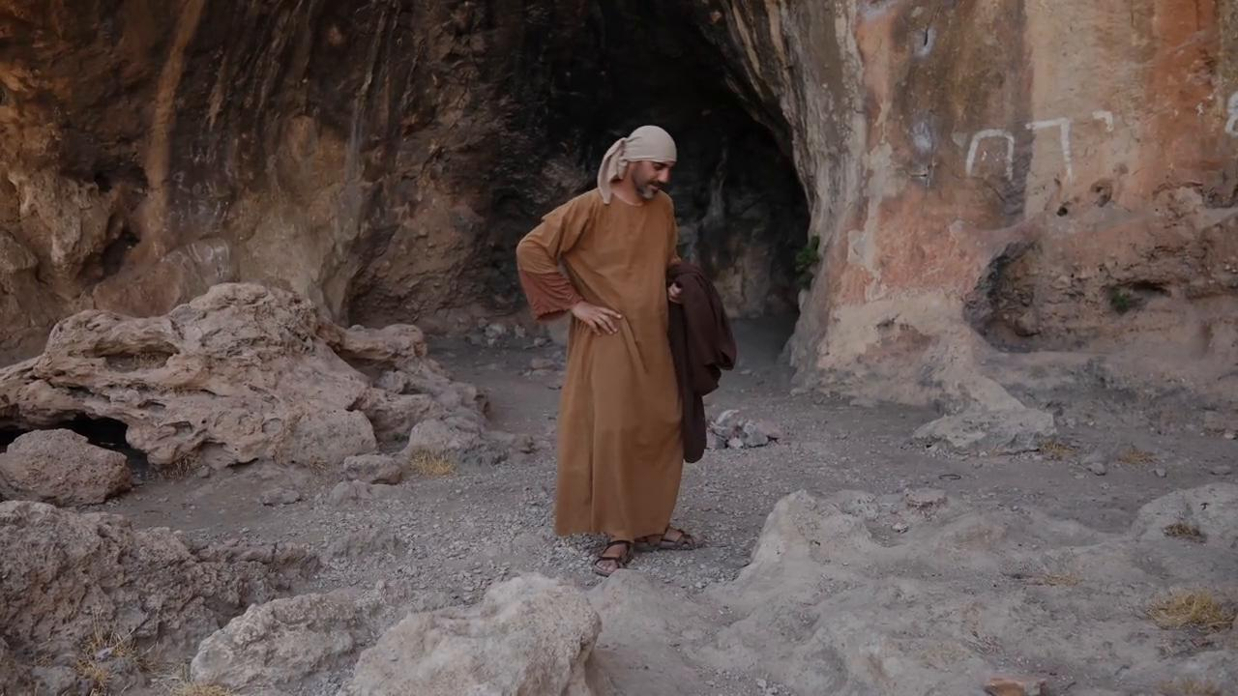
link

Mer de Galilée

Video Content
(114 seconds)
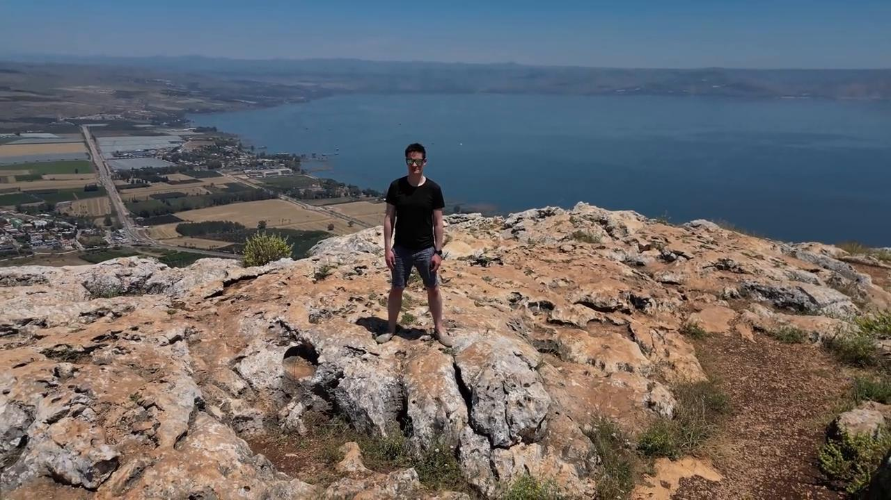
link

Mont des Oliviers

Video Content
(90 seconds)
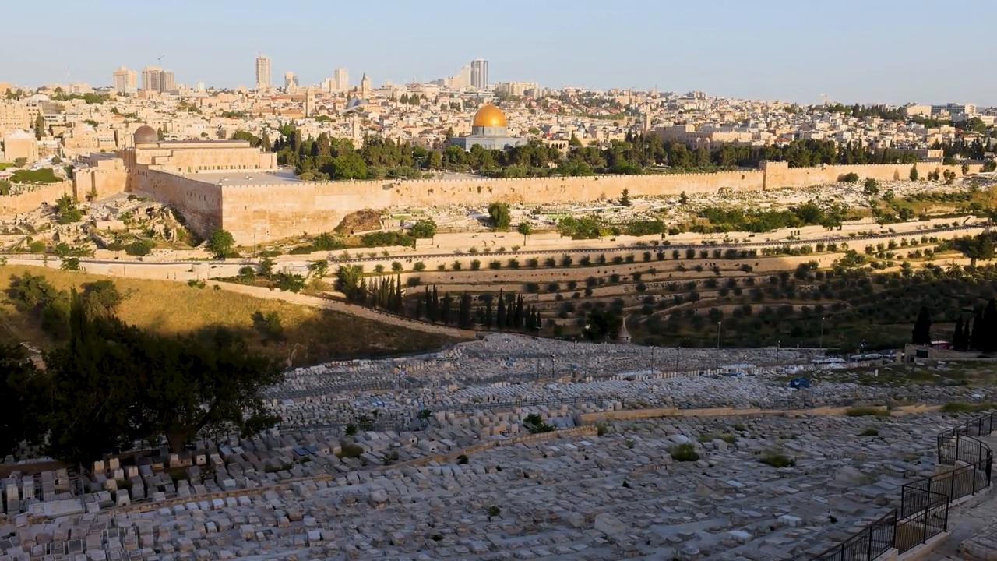
link

Mur de pierre autour d'une vigne

Video Content
(71 seconds)
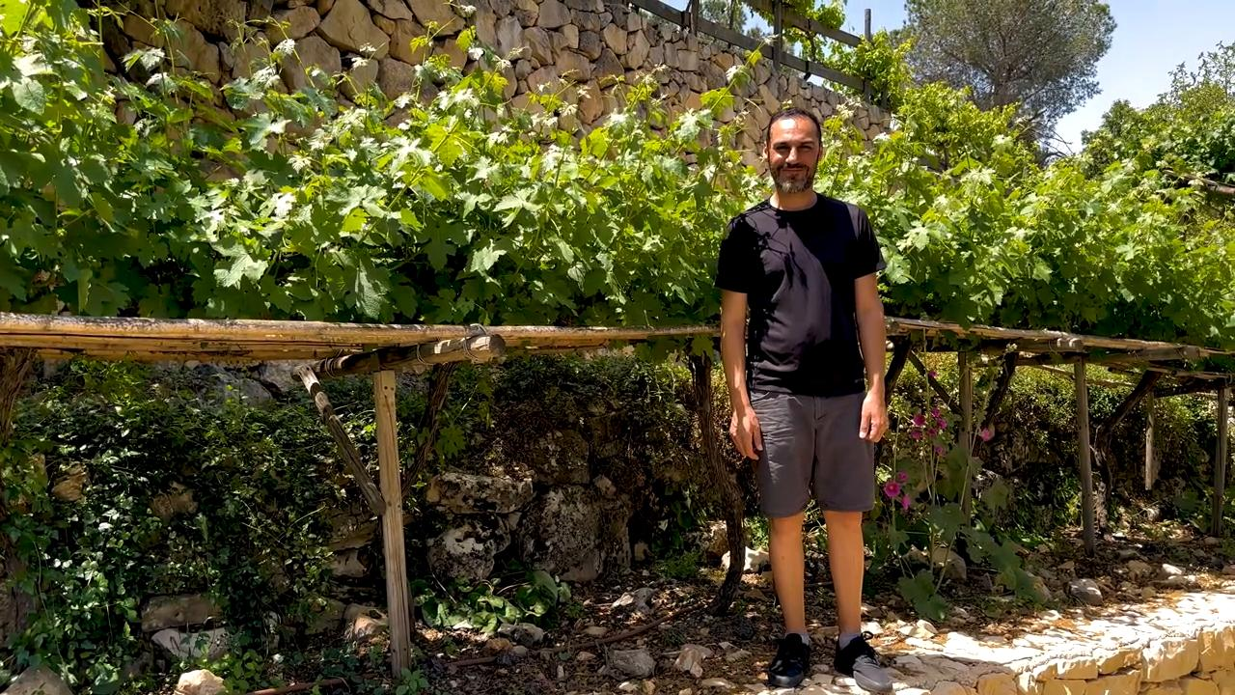
link

