Resource: Video Bible Dictionary
Video Bible Dictionary © 2023 SRV Partners. Released under CC BY-SA 4.0 license. Video Bible Dictionary has been adapted in the following languages: Tok Pisin, عربي, Français, हिंदी, Bahasa Indonesia, Português, Русский, Español, Kiswahili, 简体中文 from Video Bible Dictionary © 2023 SRV Partners. Released under CC BY-SA 4.0 license by Mission Mutual

Video Bible Dictionary

P

Panier de provisions

Video Content
(88 seconds)
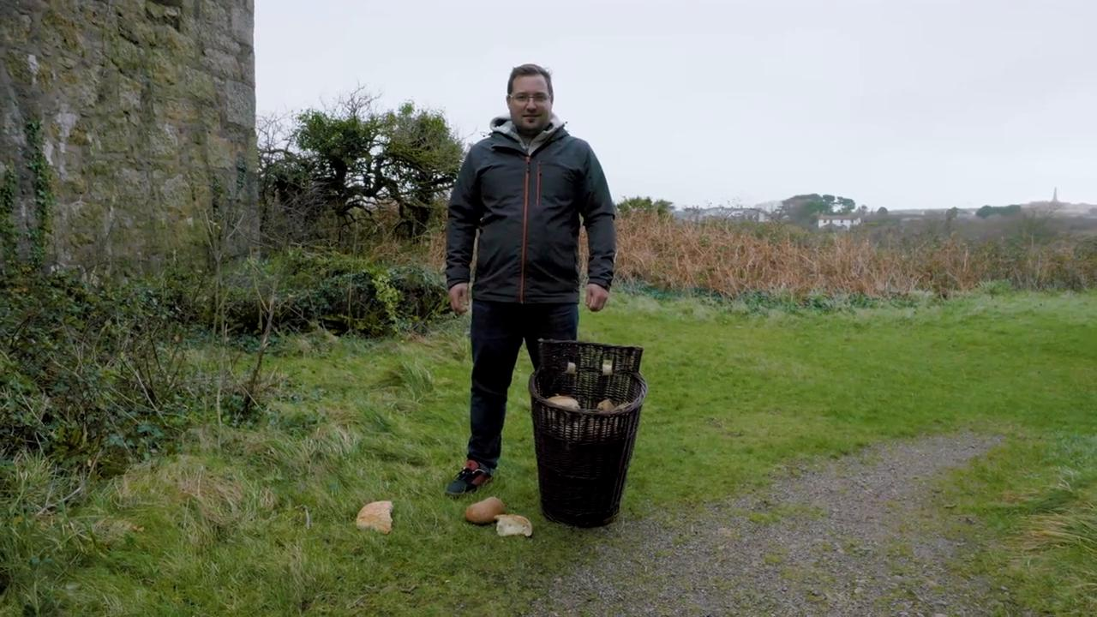
link

Panier en tant boisseau

Video Content
(77 seconds)
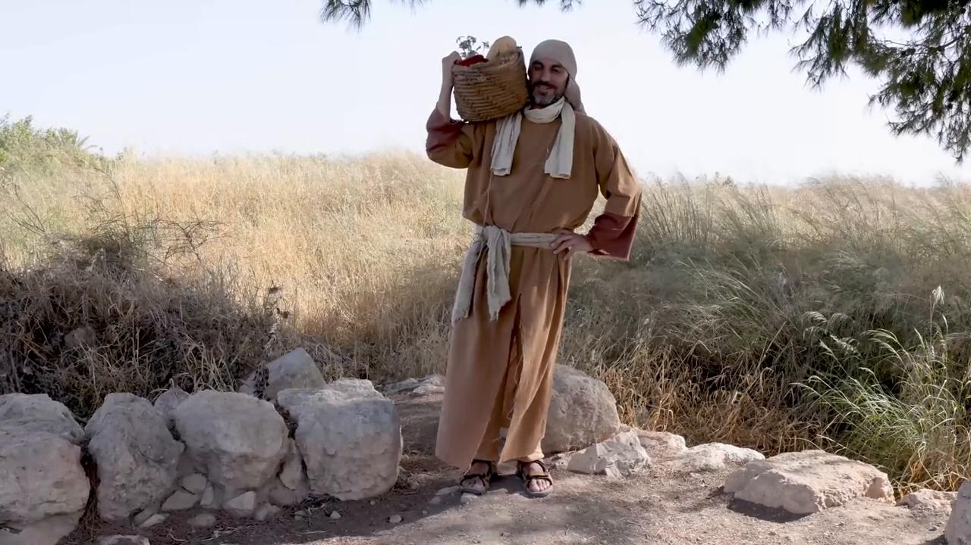
link

Pièces

Video Content
(65 seconds)
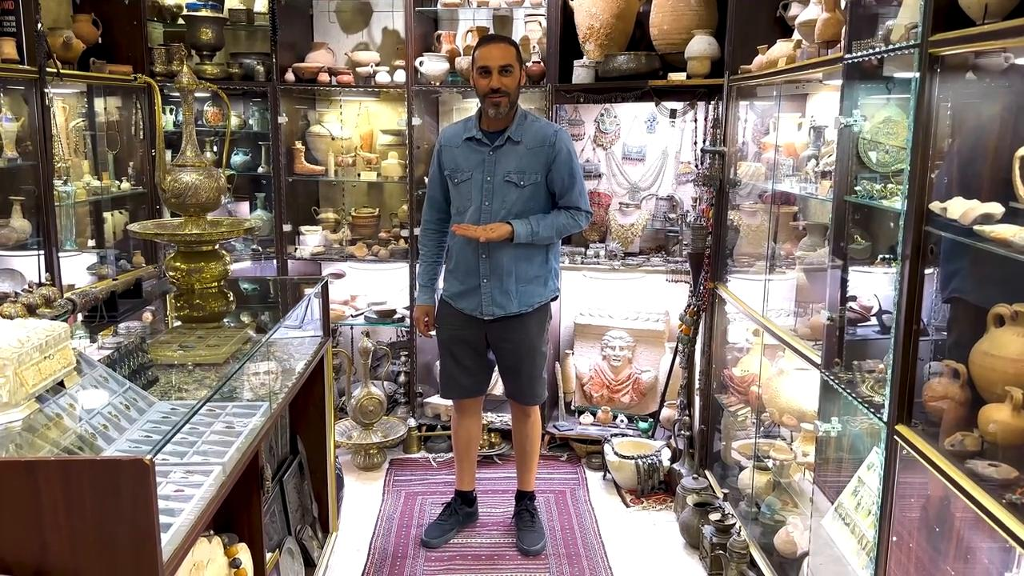
link

Pièces de cuivre

Video Content
(69 seconds)

link

Pierre à moudre

Video Content
(88 seconds)
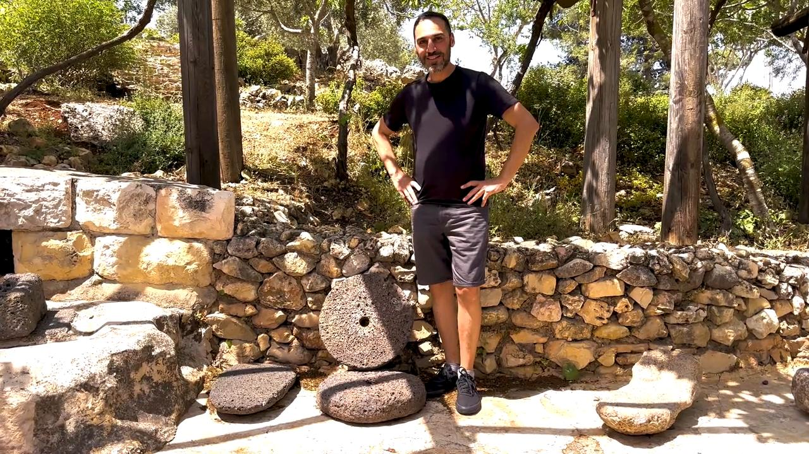
link

Pierre d'angle

Video Content
(77 seconds)
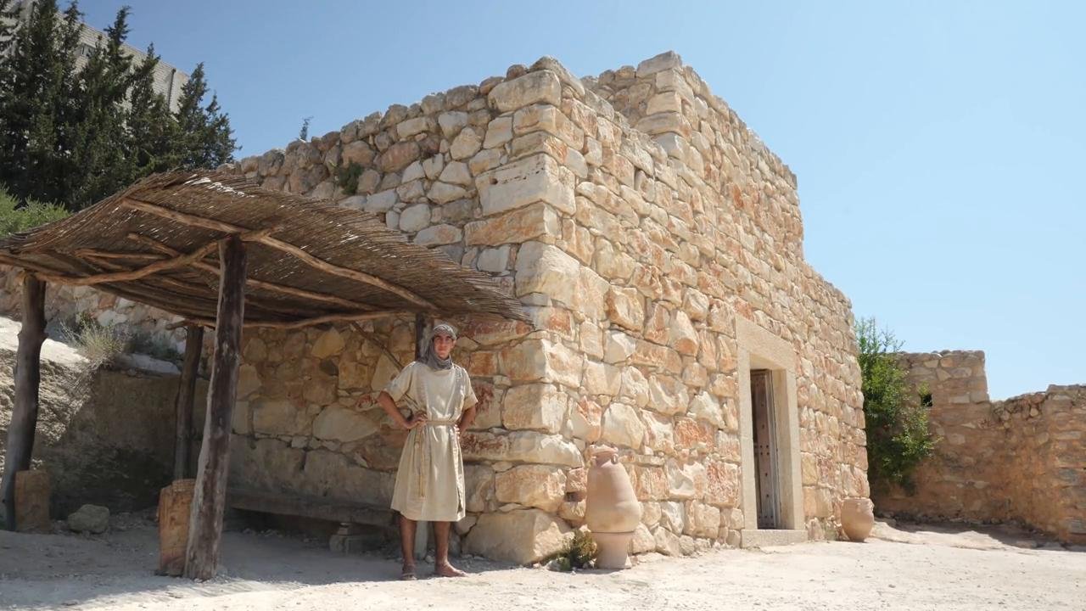
link

Pigeon

Video Content
(91 seconds)
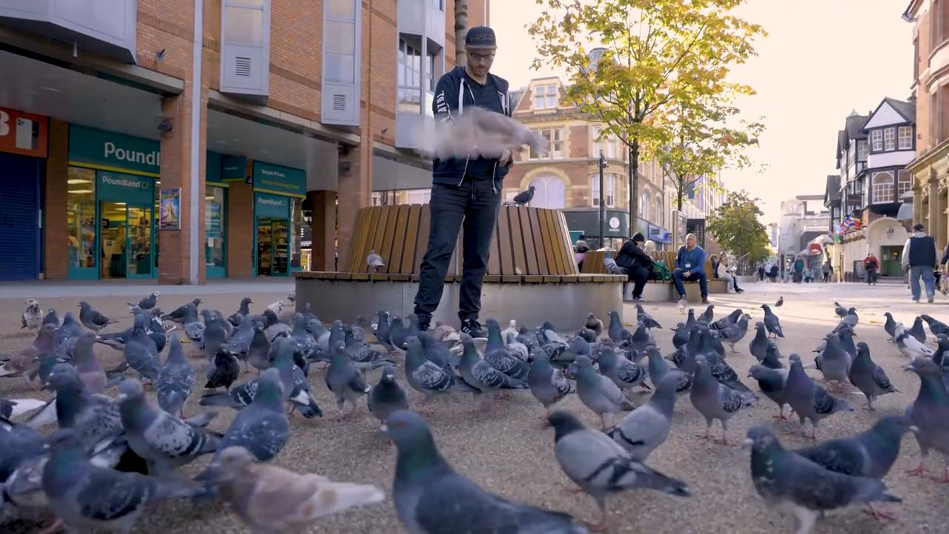
link

Plat

Video Content
(72 seconds)
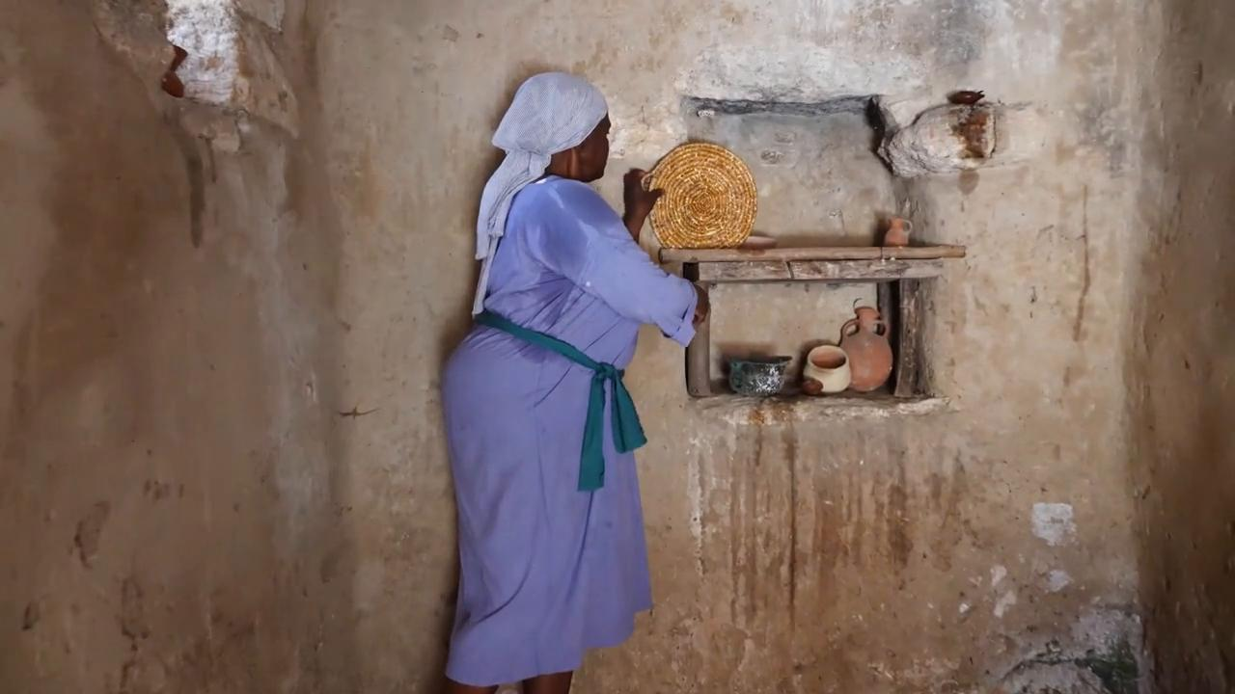
link

Poisson cuit

Video Content
(81 seconds)
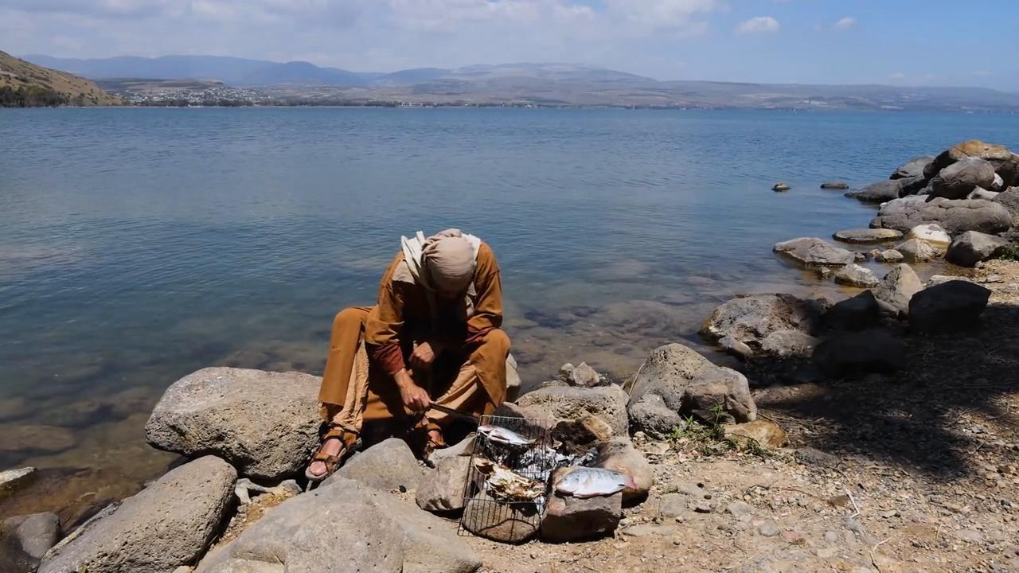
link

Pot d'eau

Video Content
(63 seconds)
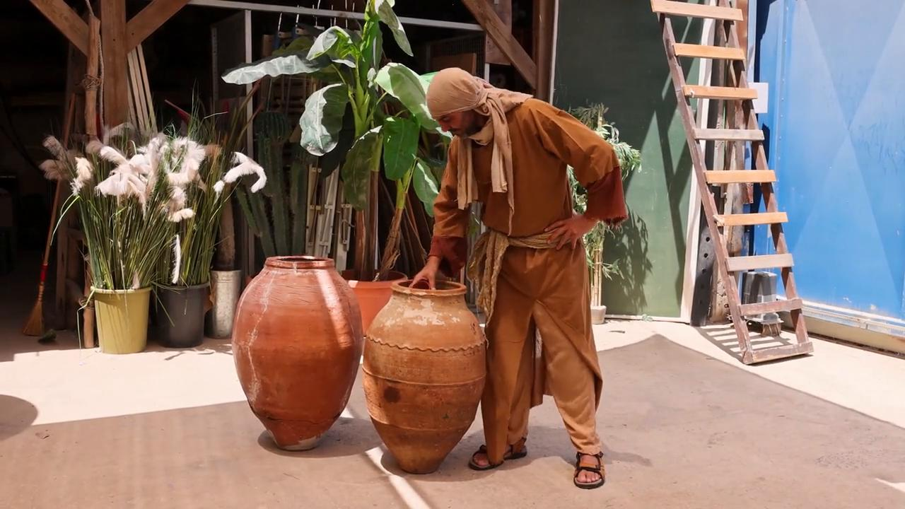
link

Pot en albâtre

Video Content
(73 seconds)
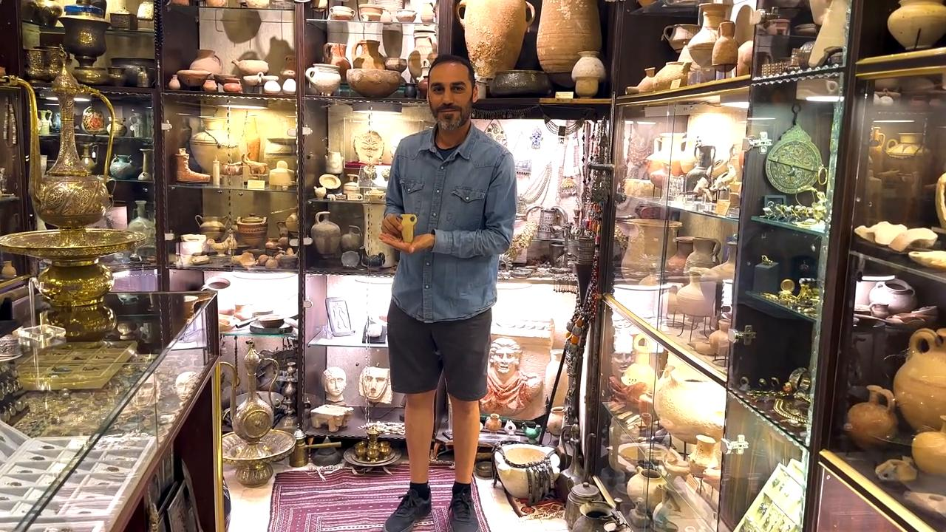
link

