Resource: Video Bible Dictionary
Video Bible Dictionary © 2023 SRV Partners. Released under CC BY-SA 4.0 license. Video Bible Dictionary has been adapted in the following languages: Tok Pisin, عربي, Français, हिंदी, Bahasa Indonesia, Português, Русский, Español, Kiswahili, 简体中文 from Video Bible Dictionary © 2023 SRV Partners. Released under CC BY-SA 4.0 license by Mission Mutual

Video Bible Dictionary

T

Tapis de couchage

Video Content
(59 seconds)
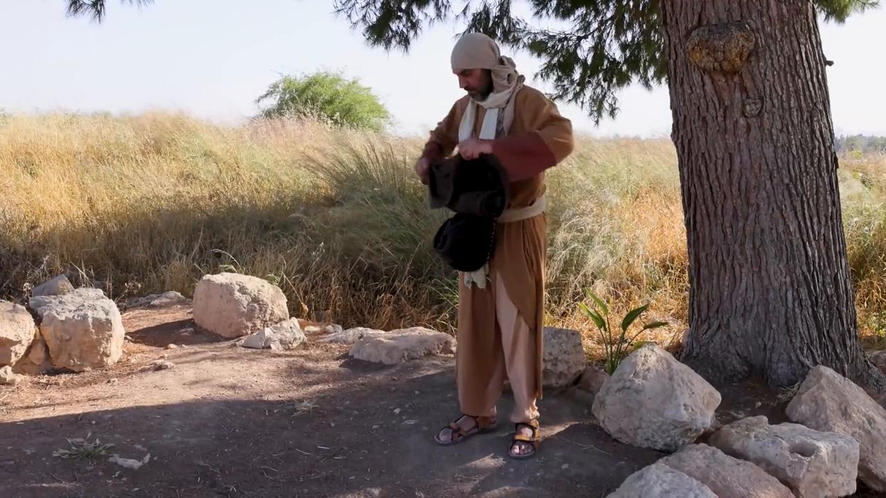
link

Tombeau de jardin

Video Content
(84 seconds)
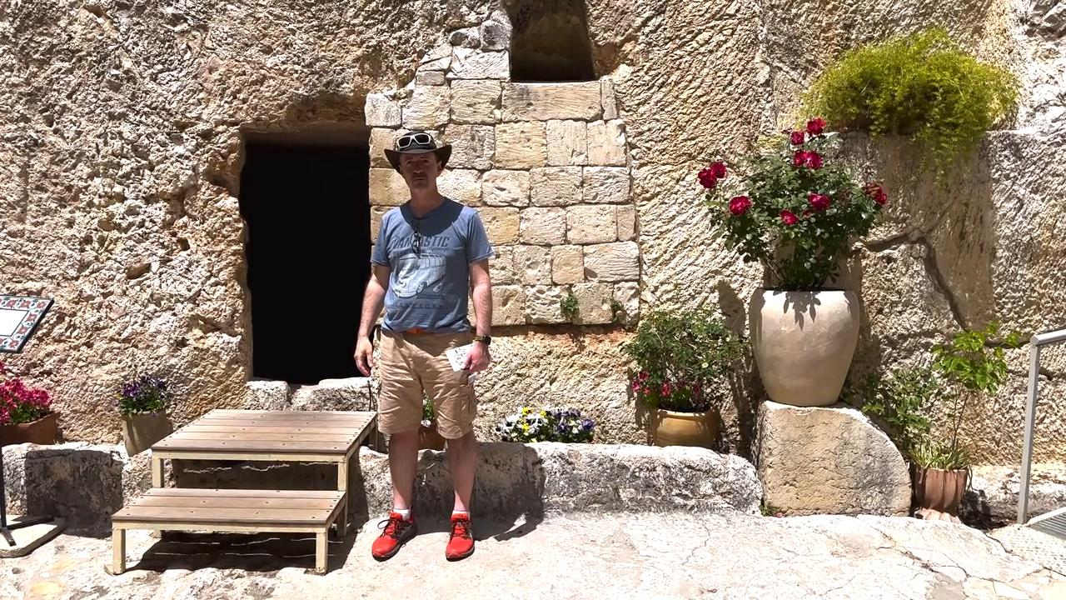
link

Tombeaux

Video Content
(93 seconds)
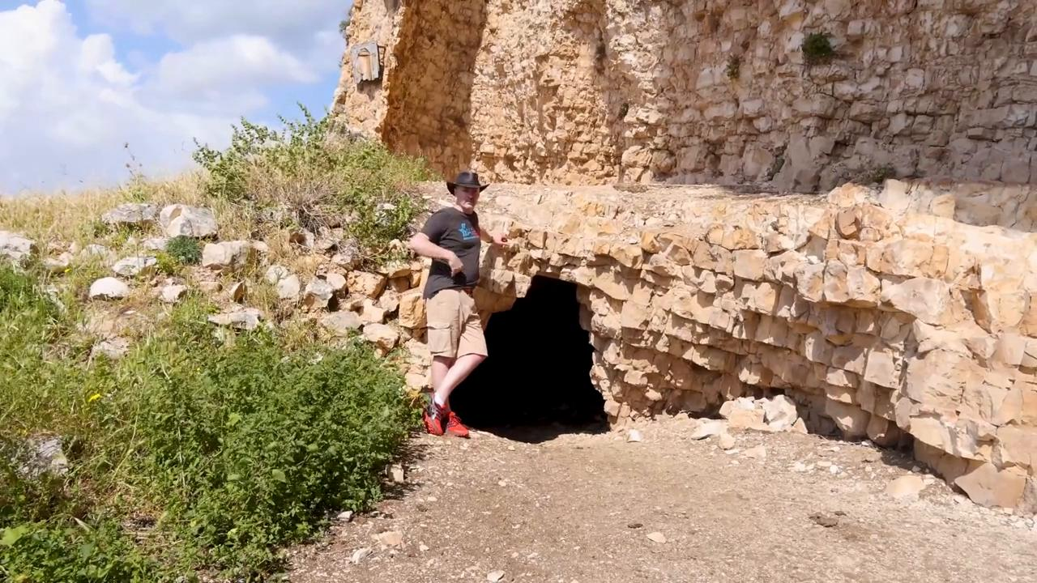
link

Tour de guet d'une vigne

Video Content
(97 seconds)
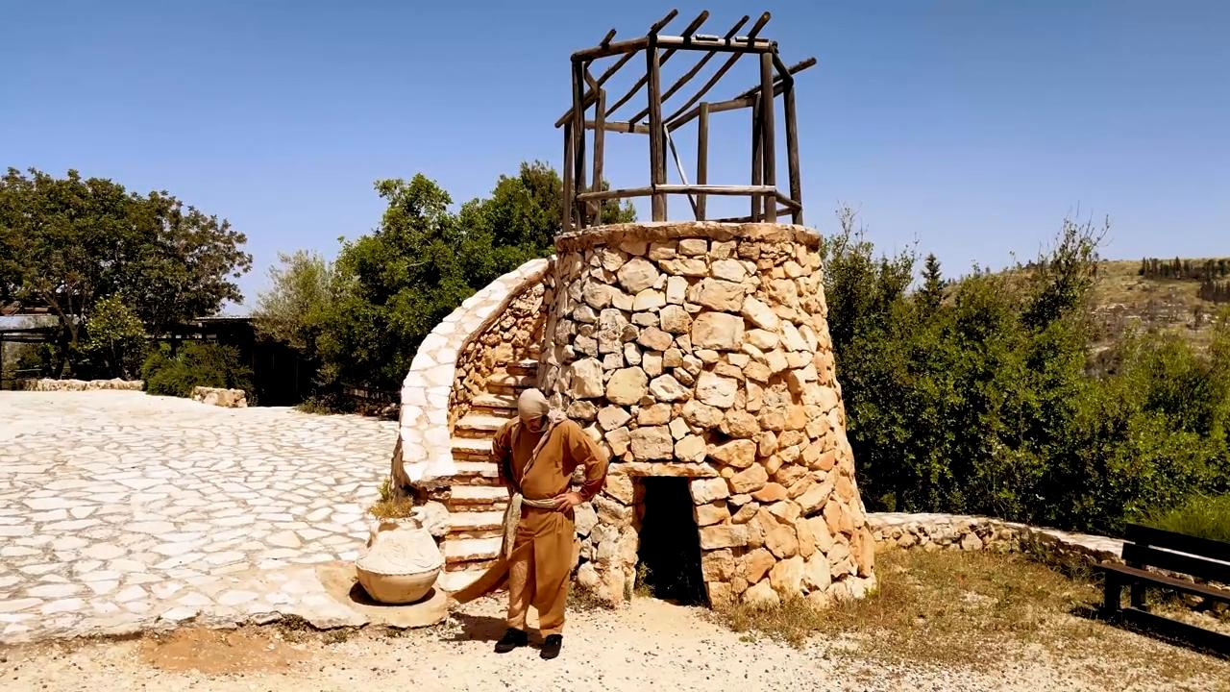
link

Tunique

Video Content
(82 seconds)
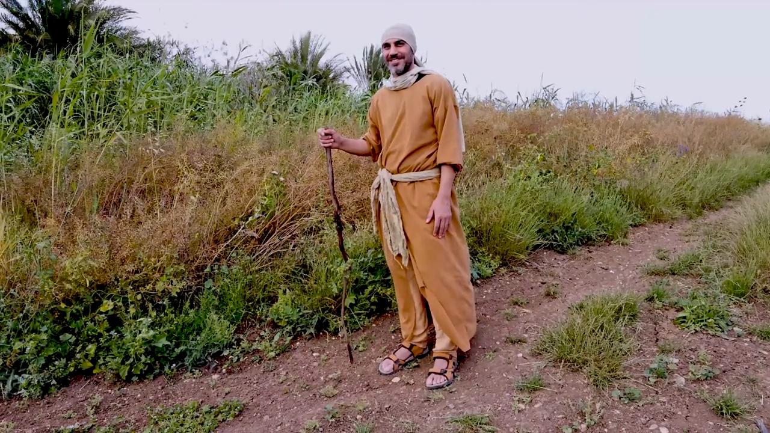
link

