Resource: Video Bible Dictionary
Video Bible Dictionary © 2023 SRV Partners. Released under CC BY-SA 4.0 license. Video Bible Dictionary has been adapted in the following languages: Tok Pisin, عربي, Français, हिंदी, Bahasa Indonesia, Português, Русский, Español, Kiswahili, 简体中文 from Video Bible Dictionary © 2023 SRV Partners. Released under CC BY-SA 4.0 license by Mission Mutual

Video Bible Dictionary

क

कड़वे सागपात

Video Content
(71 seconds)
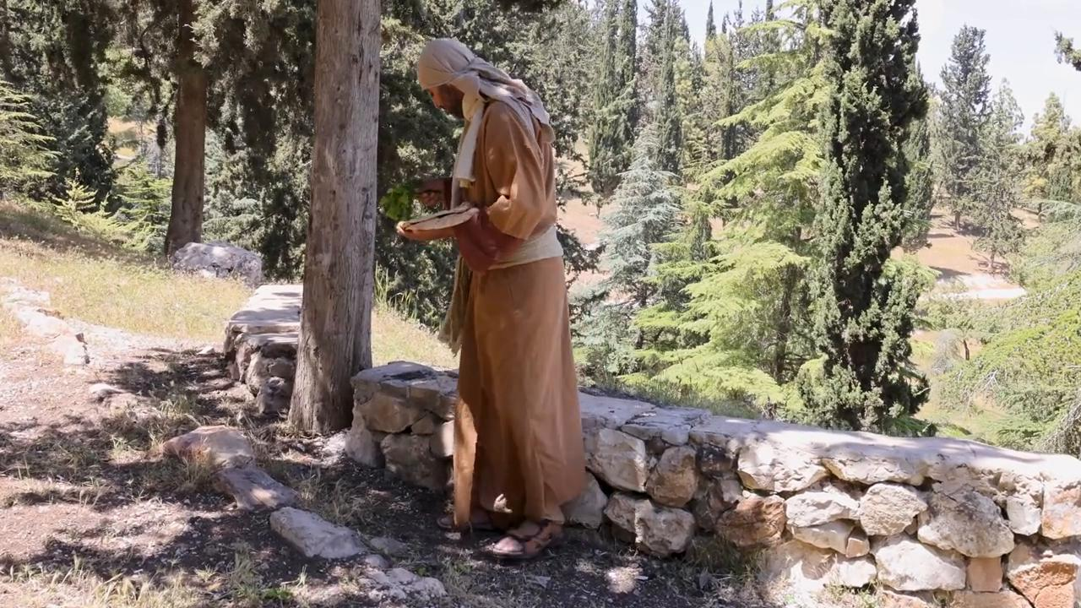
link

कब्रें

Video Content
(93 seconds)

link

कमर बाँधे हुआ मनुष्य

Video Content
(67 seconds)
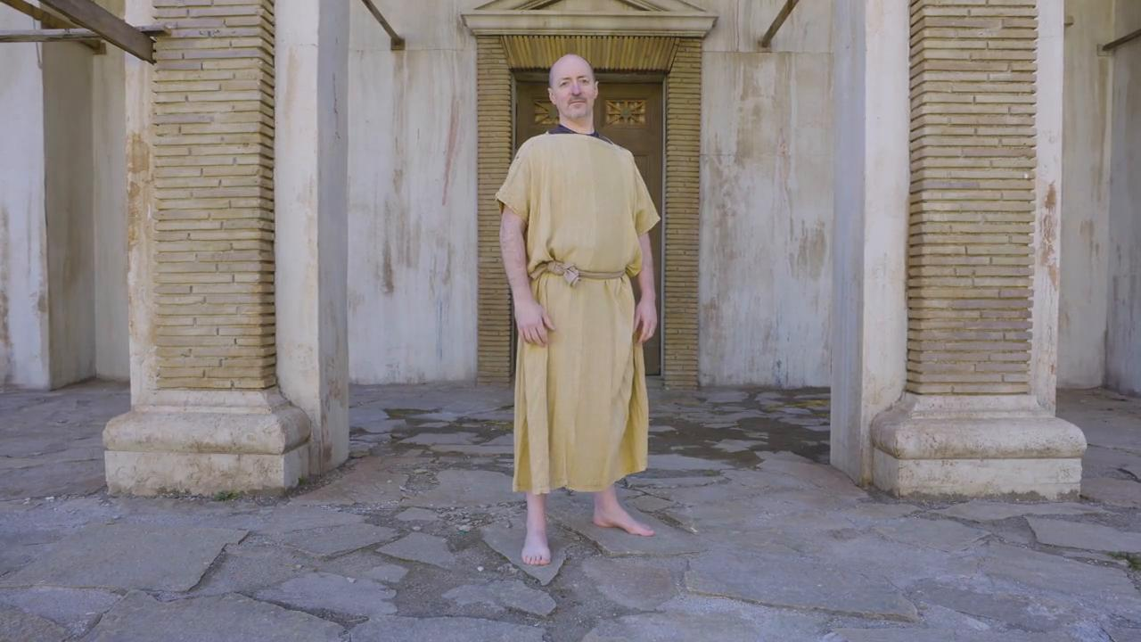
link

कमरबन्द

Video Content
(71 seconds)
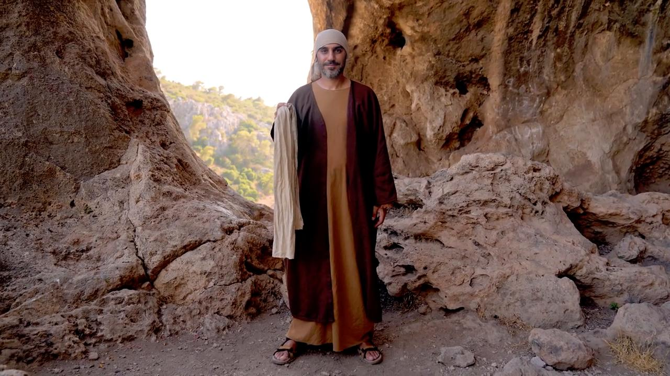
link

कुर्ता

Video Content
(82 seconds)
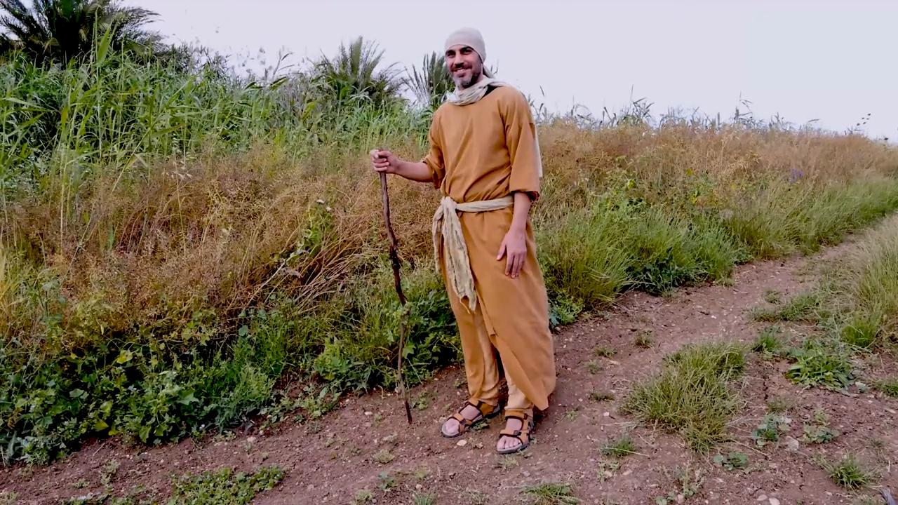
link

कुल्हाड़ी

Video Content
(69 seconds)
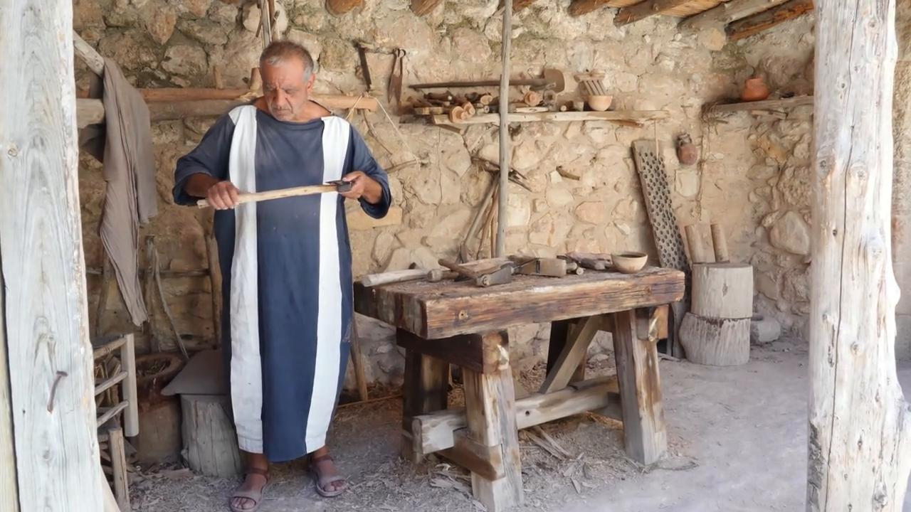
link

