Resource: Video Bible Dictionary
Video Bible Dictionary © 2023 SRV Partners. Released under CC BY-SA 4.0 license. Video Bible Dictionary has been adapted in the following languages: Tok Pisin, عربي, Français, हिंदी, Bahasa Indonesia, Português, Русский, Español, Kiswahili, 简体中文 from Video Bible Dictionary © 2023 SRV Partners. Released under CC BY-SA 4.0 license by Mission Mutual

Video Bible Dictionary

ग

गतसमनी का बगीचा

Video Content
(108 seconds)
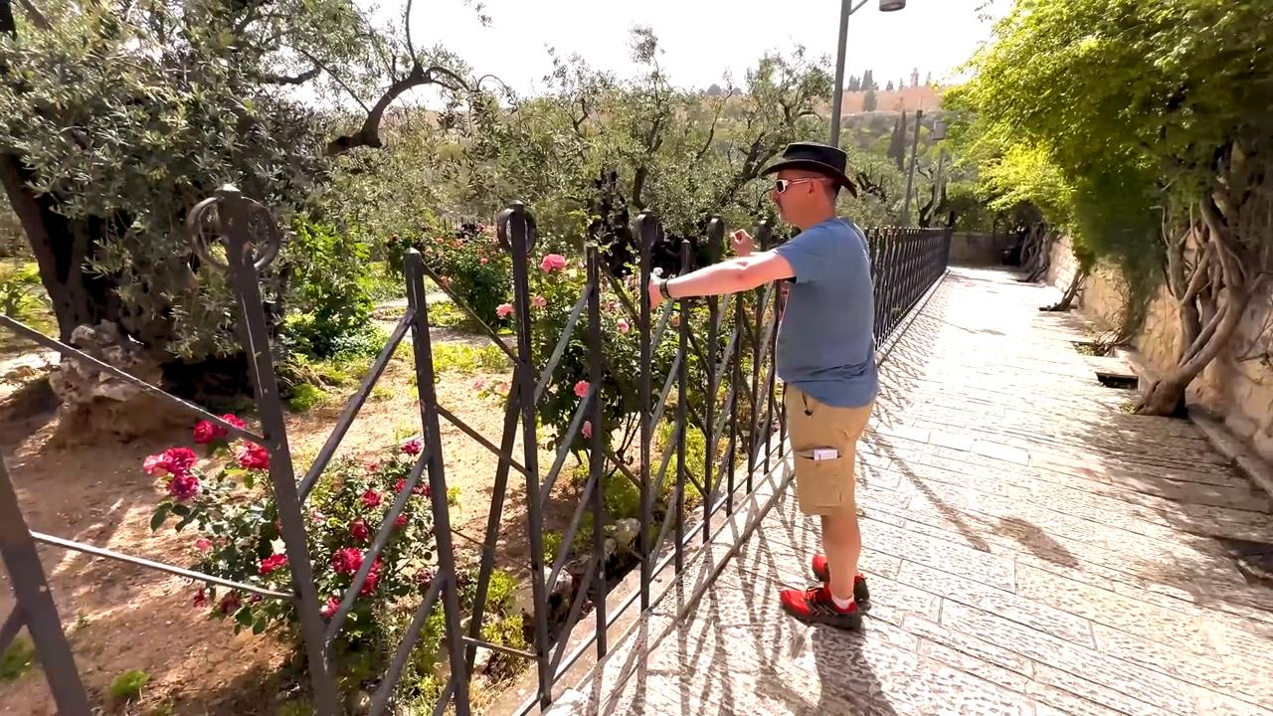
link

गलील की झील

Video Content
(114 seconds)
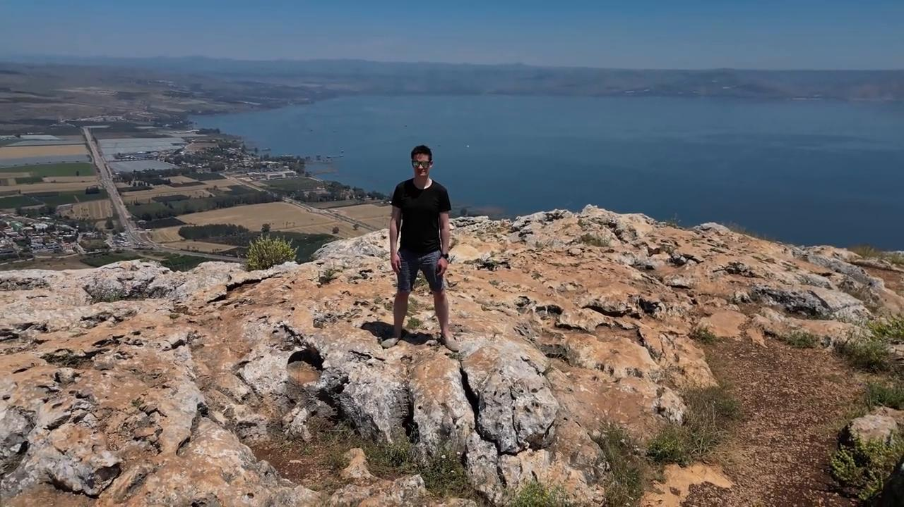
link

गुफा

Video Content
(94 seconds)
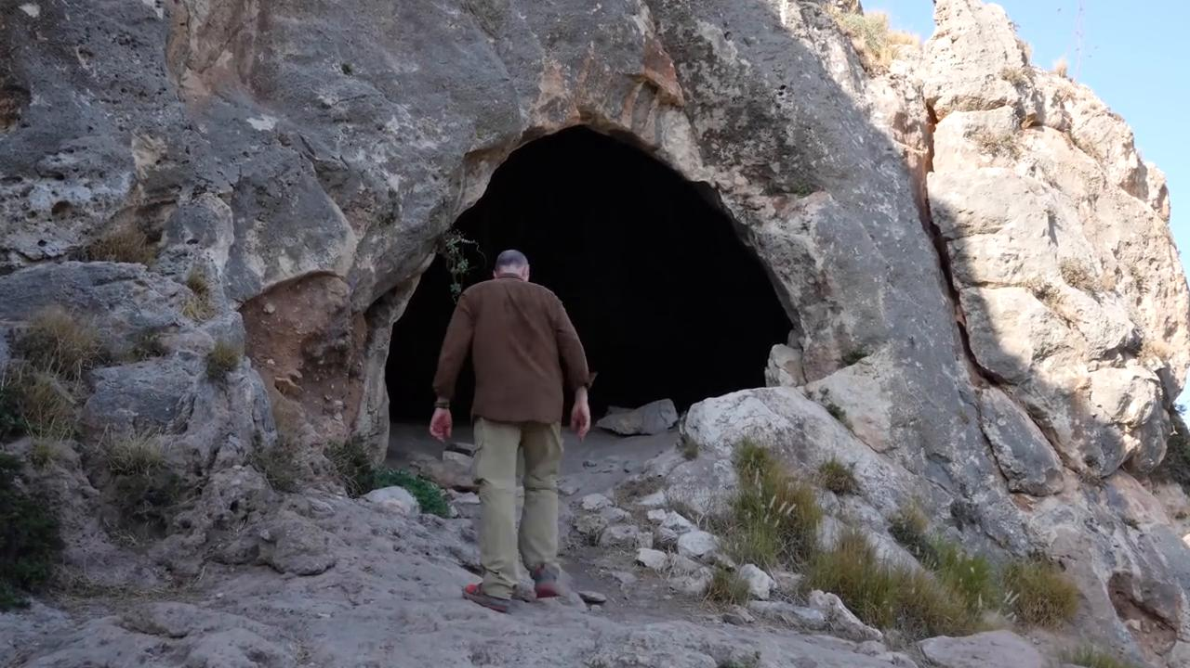
link

गेहूँ कटनी के लिए तैयार है

Video Content
(79 seconds)
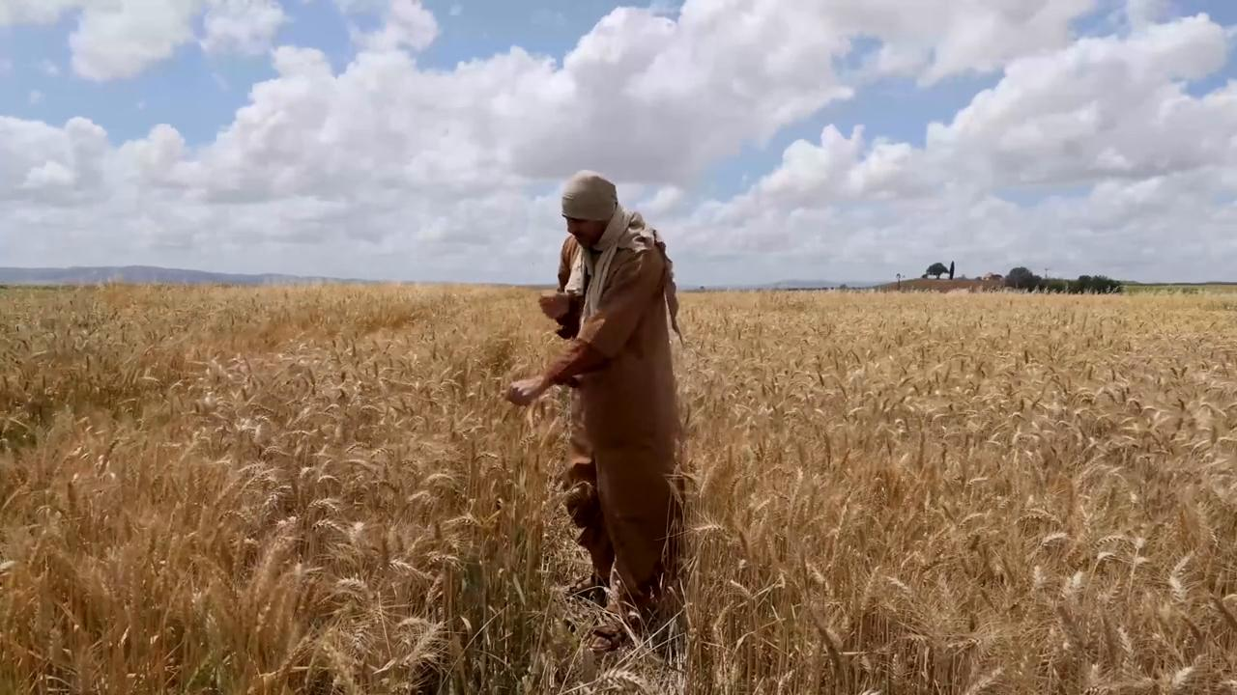
link

गेहूँ की बालियाँ

Video Content
(131 seconds)
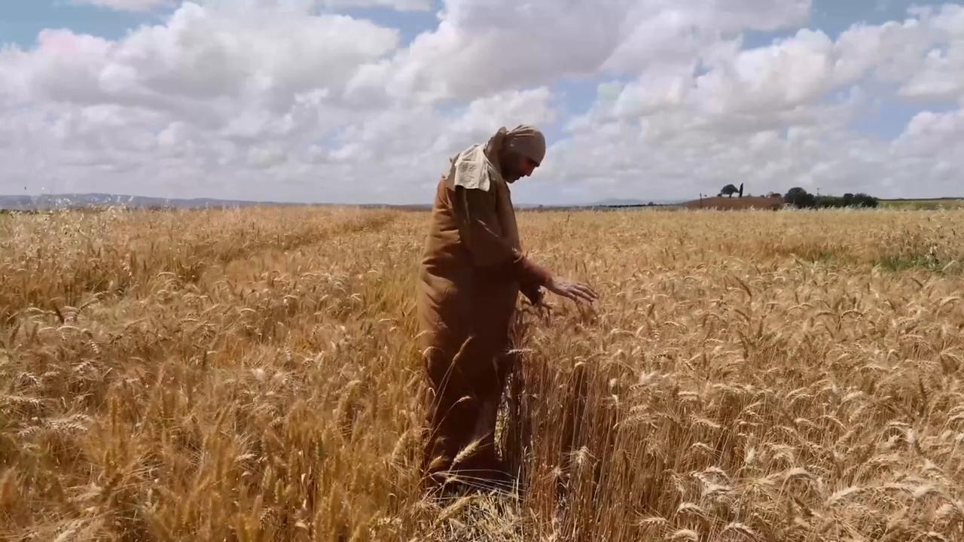
link

