Resource: Video Bible Dictionary
Video Bible Dictionary © 2023 SRV Partners. Released under CC BY-SA 4.0 license. Video Bible Dictionary has been adapted in the following languages: Tok Pisin, عربي, Français, हिंदी, Bahasa Indonesia, Português, Русский, Español, Kiswahili, 简体中文 from Video Bible Dictionary © 2023 SRV Partners. Released under CC BY-SA 4.0 license by Mission Mutual

Video Bible Dictionary

म

मछली की पंखुड़ी

Video Content
(72 seconds)
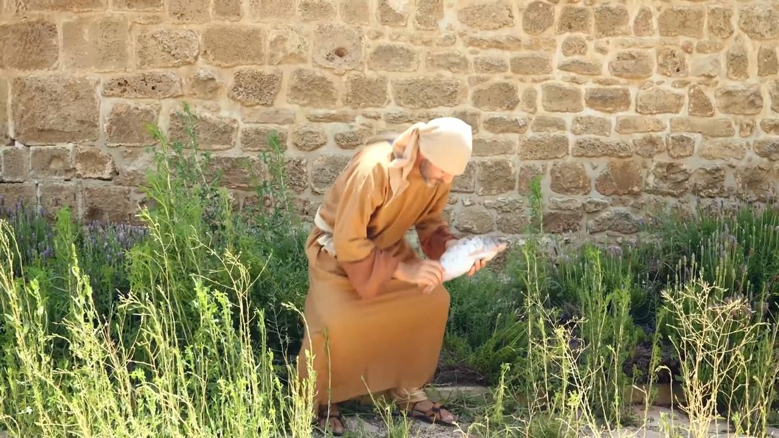
link

मछली पकड़ने का जाल

Video Content
(82 seconds)
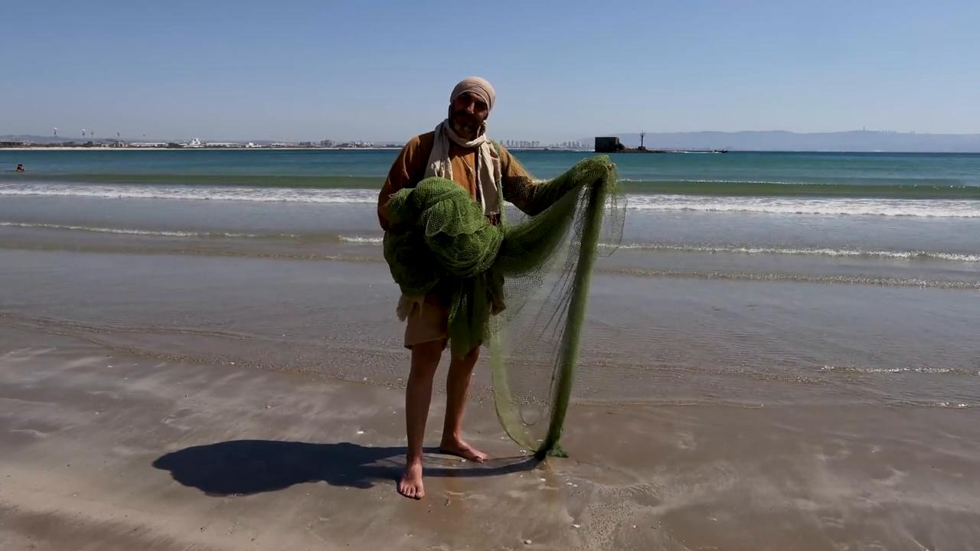
link

मशक

Video Content
(59 seconds)
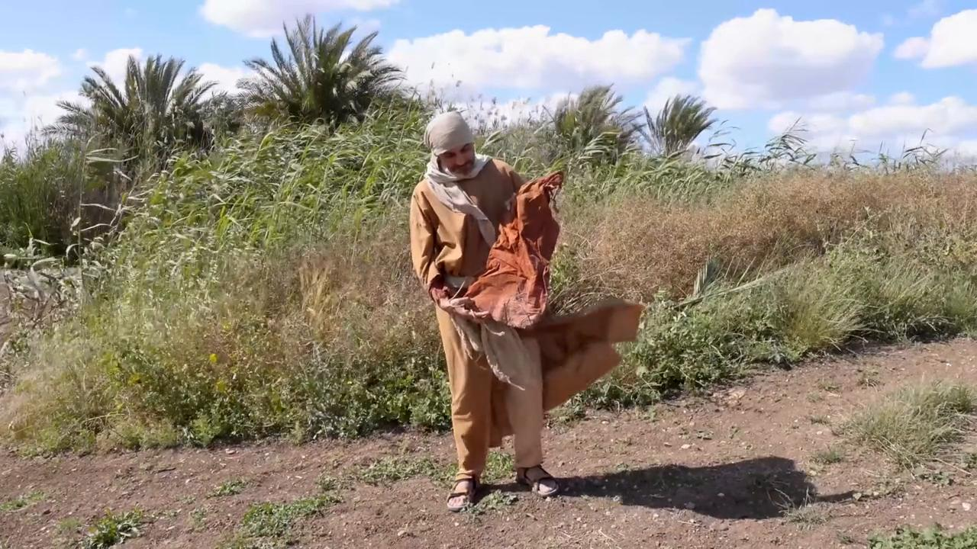
link

महीन मलमल का कपड़ा

Video Content
(68 seconds)

link

मिस्र का वस्त्र

Video Content
(72 seconds)
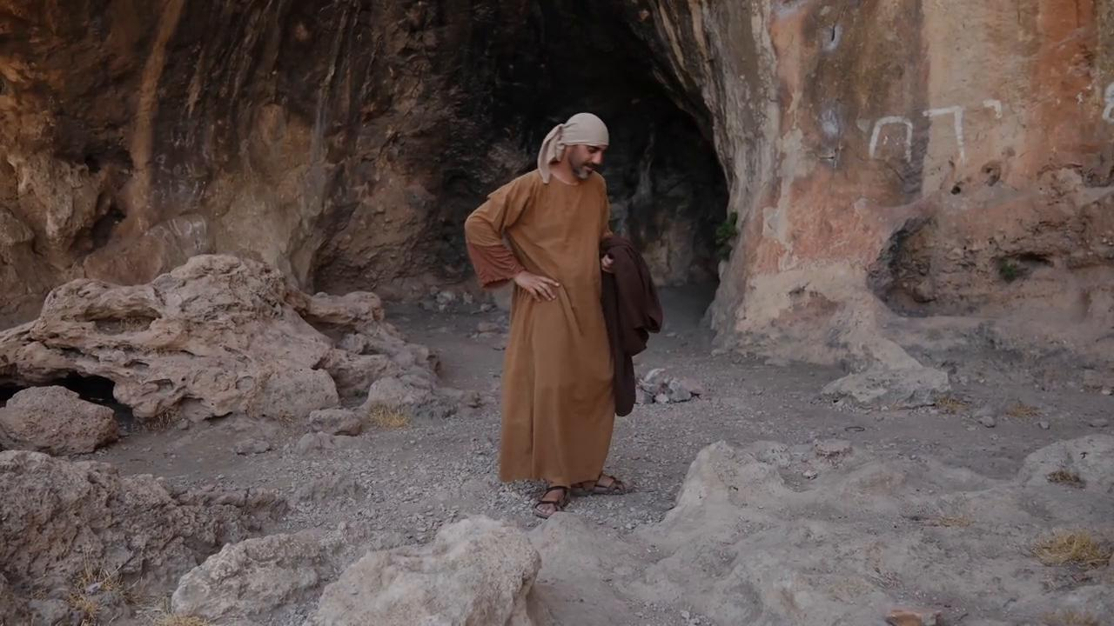
link

मुर्गा

Video Content
(5 seconds)
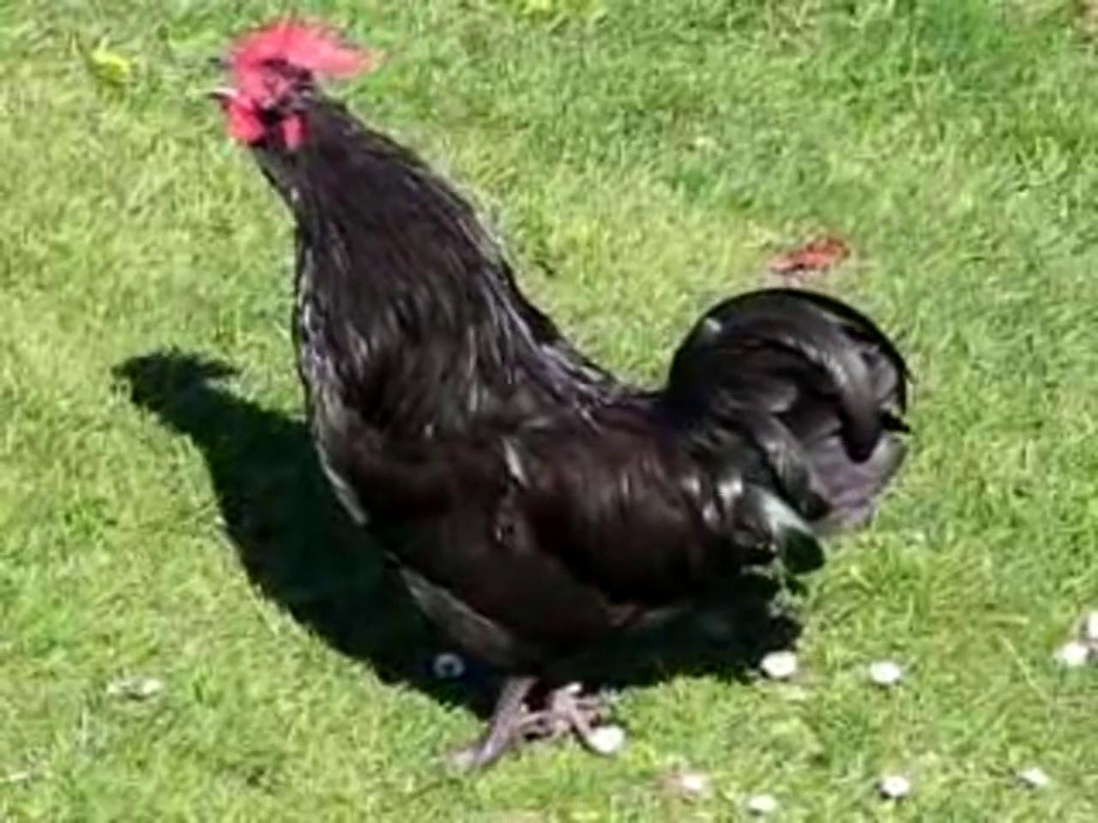
link

मोती

Video Content
(75 seconds)
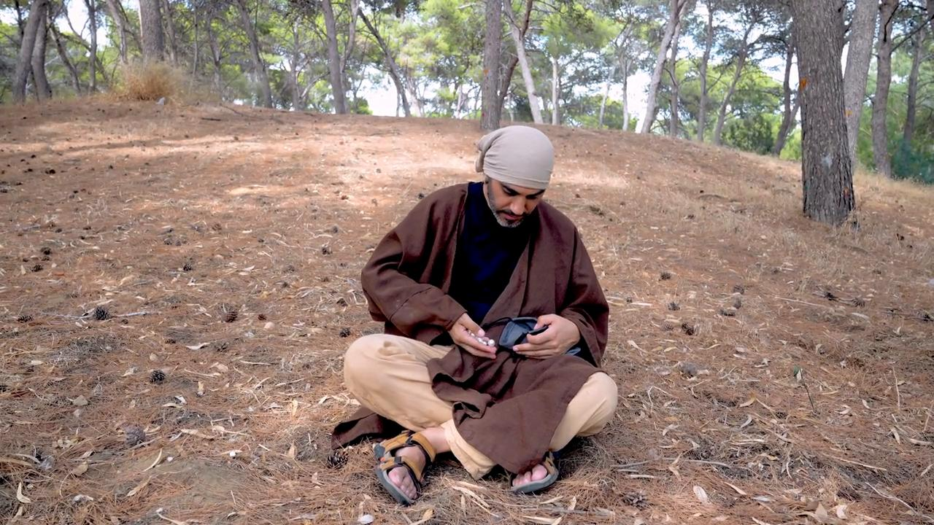
link

