Resource: Video Bible Dictionary
Video Bible Dictionary © 2023 SRV Partners. Released under CC BY-SA 4.0 license. Video Bible Dictionary has been adapted in the following languages: Tok Pisin, عربي, Français, हिंदी, Bahasa Indonesia, Português, Русский, Español, Kiswahili, 简体中文 from Video Bible Dictionary © 2023 SRV Partners. Released under CC BY-SA 4.0 license by Mission Mutual

Video Bible Dictionary

ह

हँसिया

Video Content
(68 seconds)
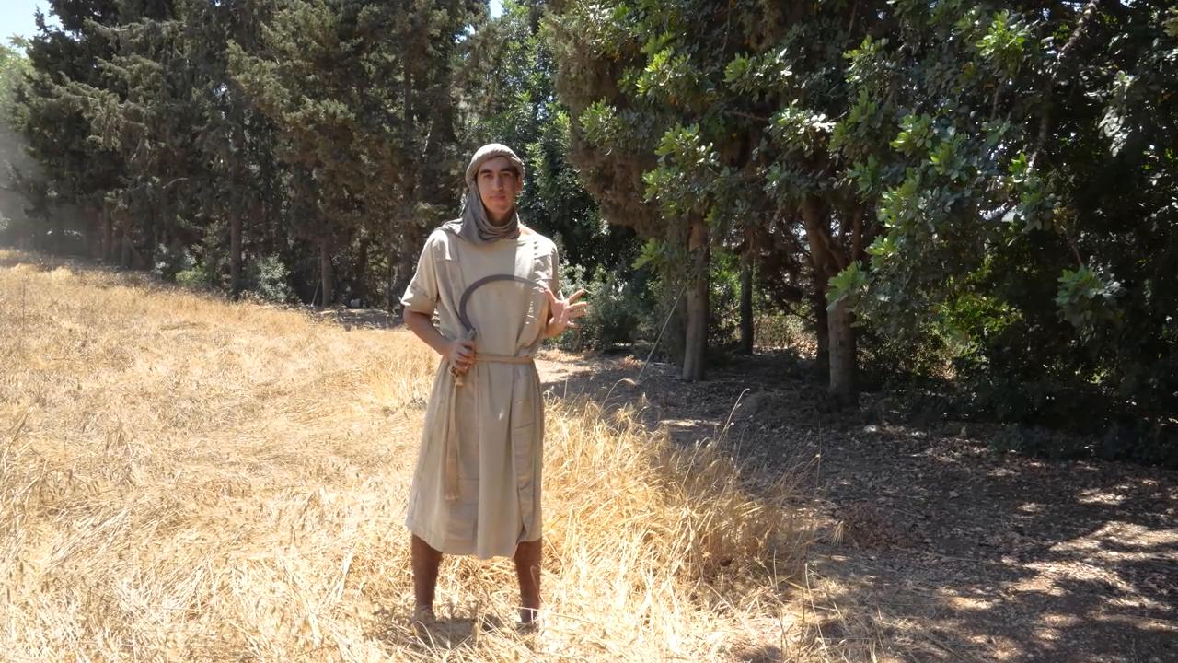
link

