Resource: Video Bible Dictionary
Video Bible Dictionary © 2023 SRV Partners. Released under CC BY-SA 4.0 license. Video Bible Dictionary has been adapted in the following languages: Tok Pisin, عربي, Français, हिंदी, Bahasa Indonesia, Português, Русский, Español, Kiswahili, 简体中文 from Video Bible Dictionary © 2023 SRV Partners. Released under CC BY-SA 4.0 license by Mission Mutual

Video Bible Dictionary

C

Cajado

Video Content
(53 seconds)
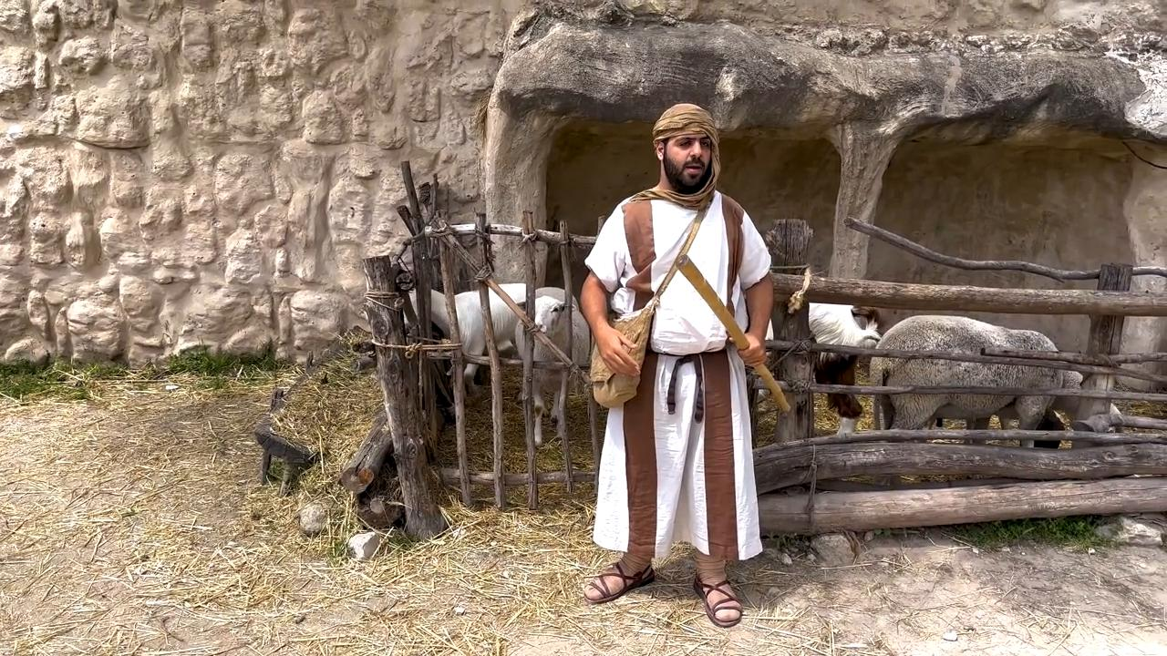
link

Camelo

Video Content
(58 seconds)
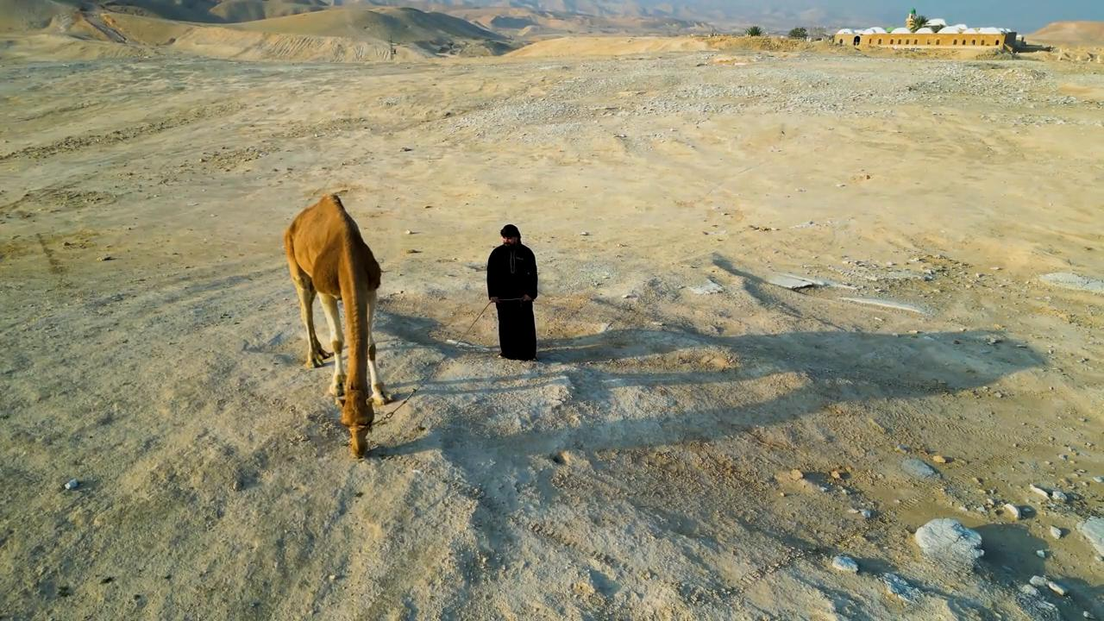
link

Capa

Video Content
(72 seconds)
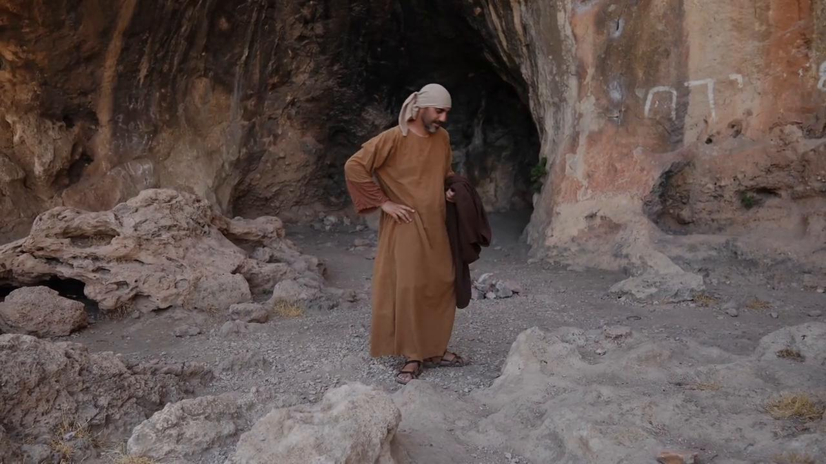
link

Casa no tempo de Jesus

Video Content
(87 seconds)
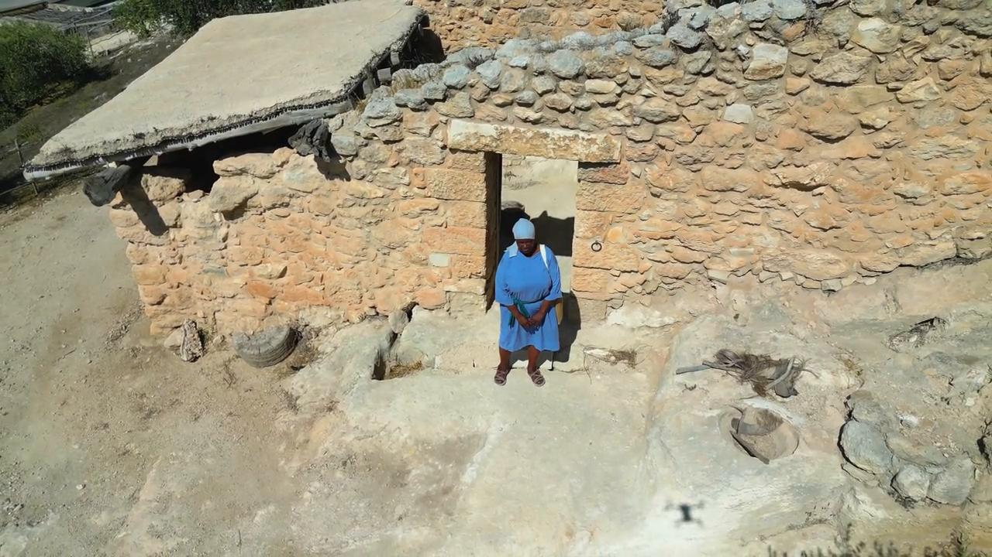
link

Caverna

Video Content
(94 seconds)
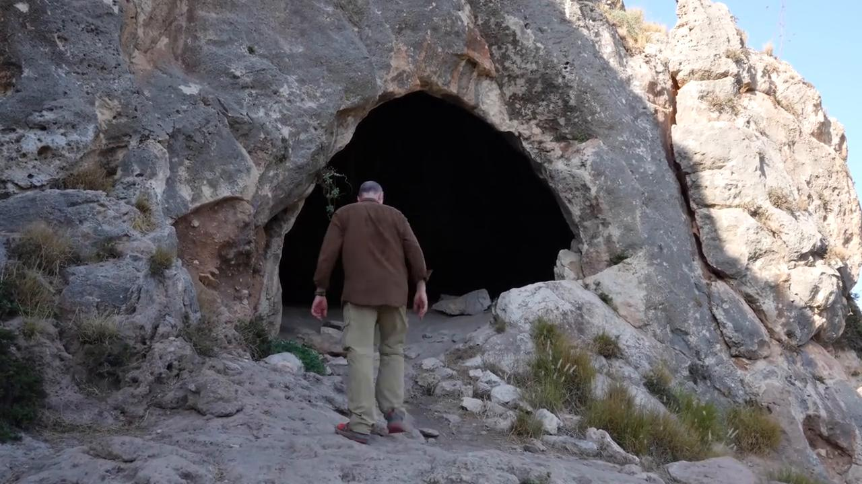
link

Cesta como alqueire

Video Content
(77 seconds)
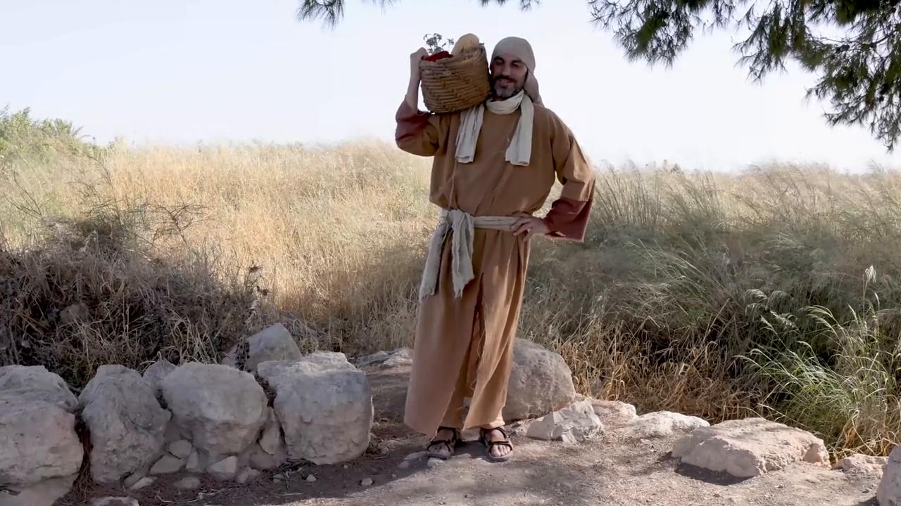
link

Cesta de mantimentos

Video Content
(88 seconds)
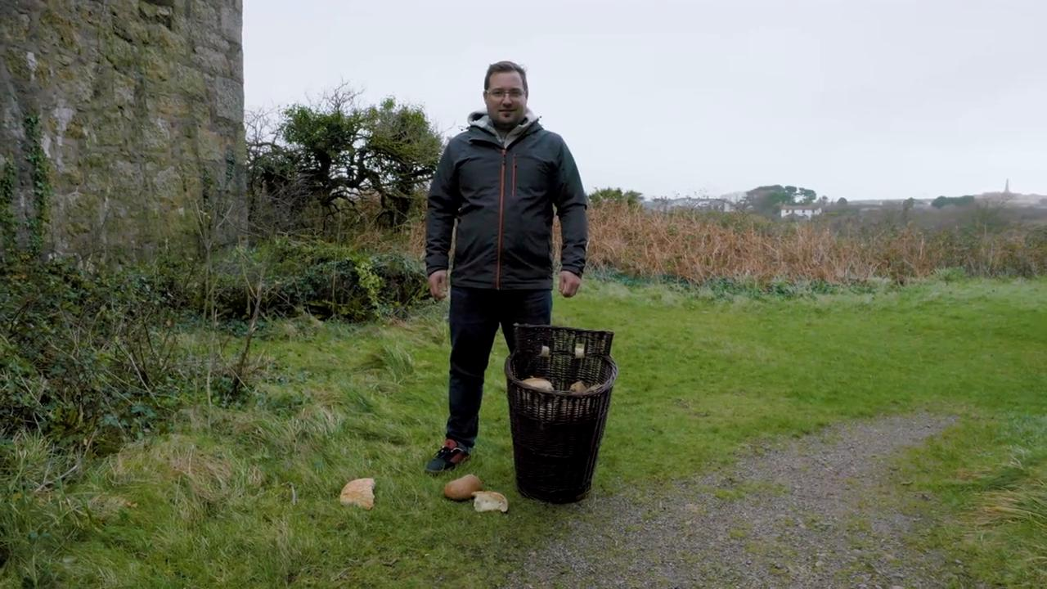
link

Cesta grande

Video Content
(83 seconds)
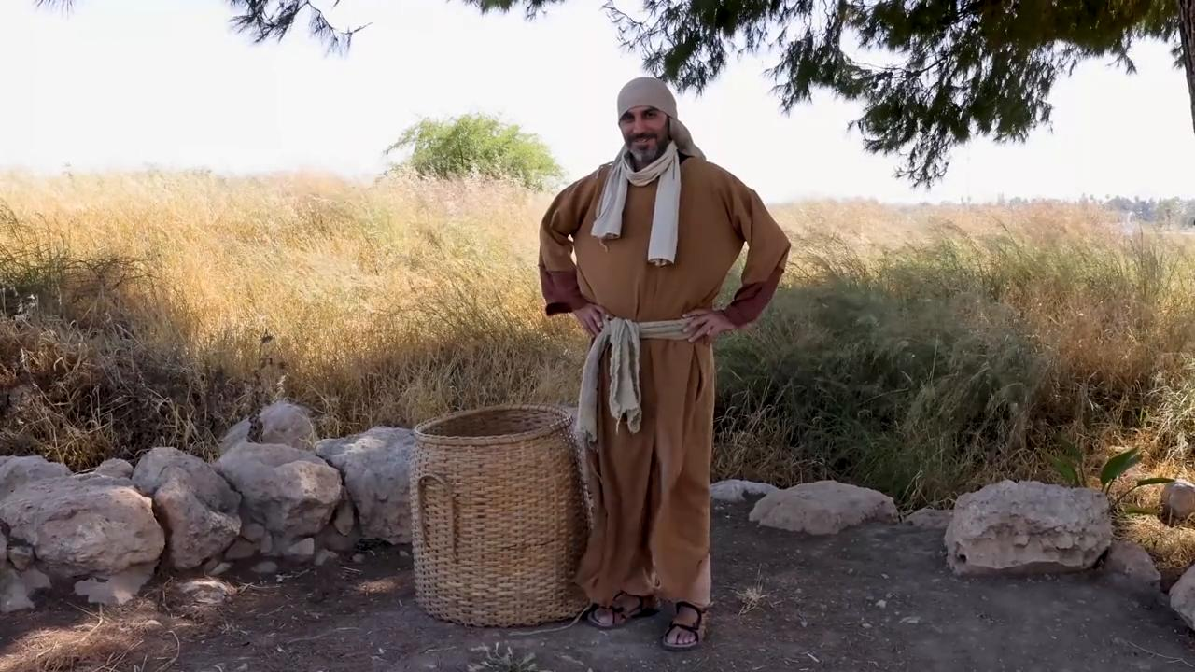
link

Cinto

Video Content
(71 seconds)
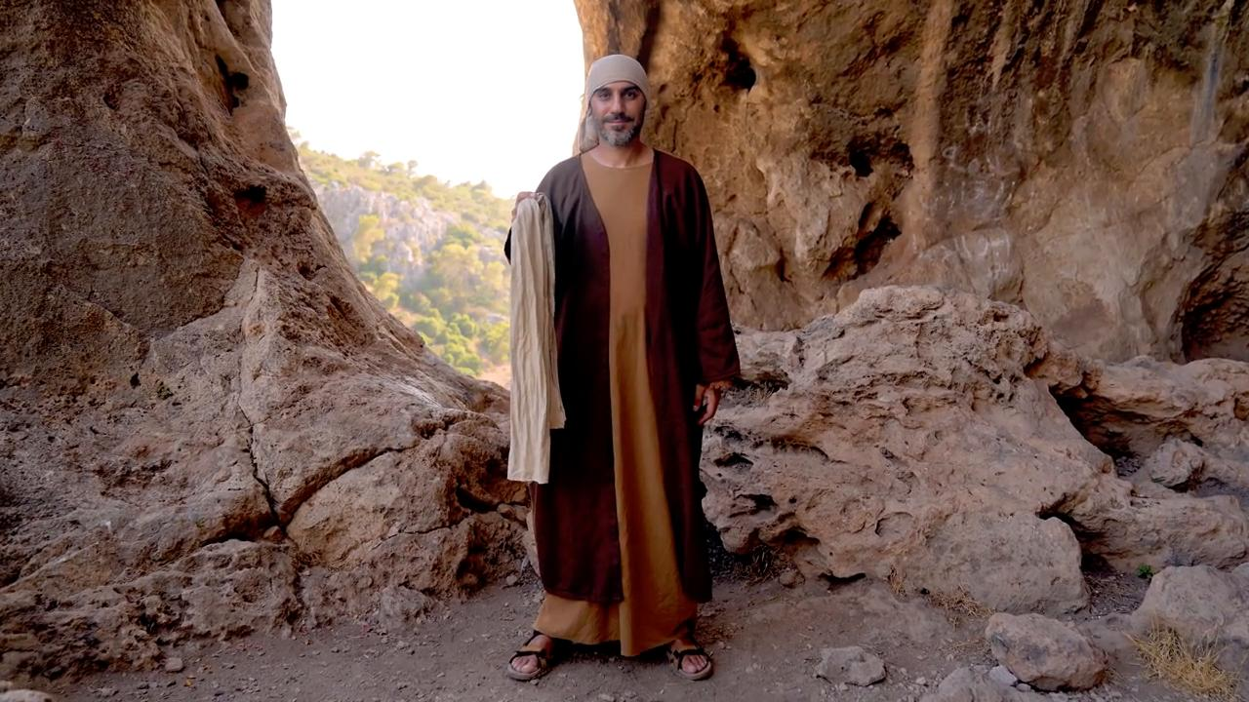
link

Correntes

Video Content
(73 seconds)
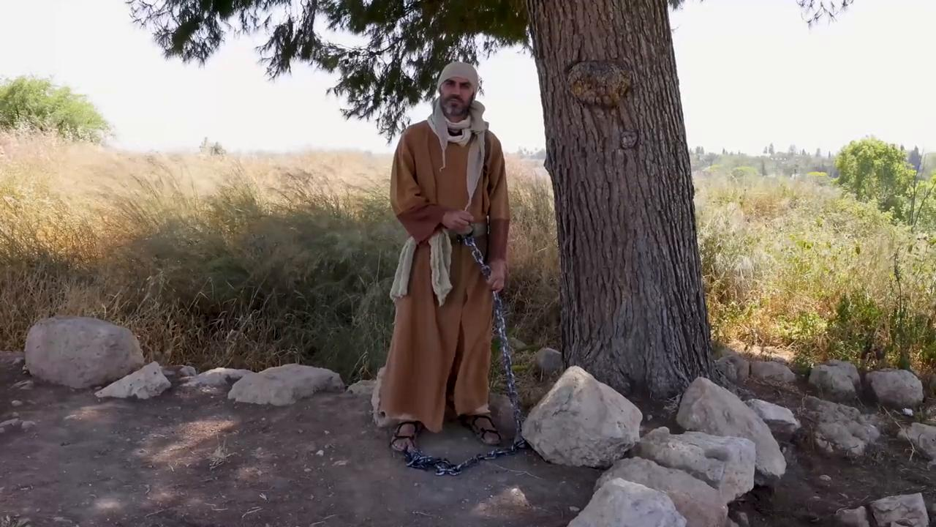
link

