Resource: Video Bible Dictionary
Video Bible Dictionary © 2023 SRV Partners. Released under CC BY-SA 4.0 license. Video Bible Dictionary has been adapted in the following languages: Tok Pisin, عربي, Français, हिंदी, Bahasa Indonesia, Português, Русский, Español, Kiswahili, 简体中文 from Video Bible Dictionary © 2023 SRV Partners. Released under CC BY-SA 4.0 license by Mission Mutual

Video Bible Dictionary

E

Entrada de uma casa judaica

Video Content
(88 seconds)
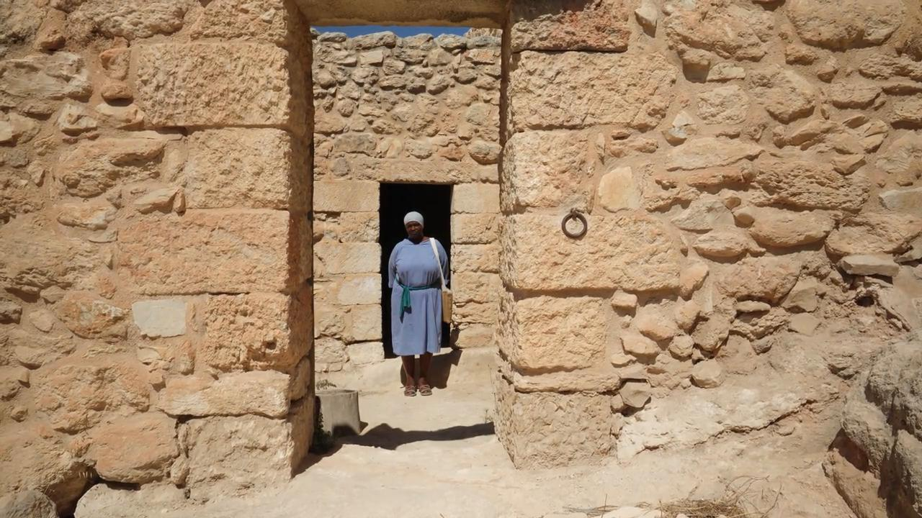
link

Ermo ou deserto

Video Content
(55 seconds)
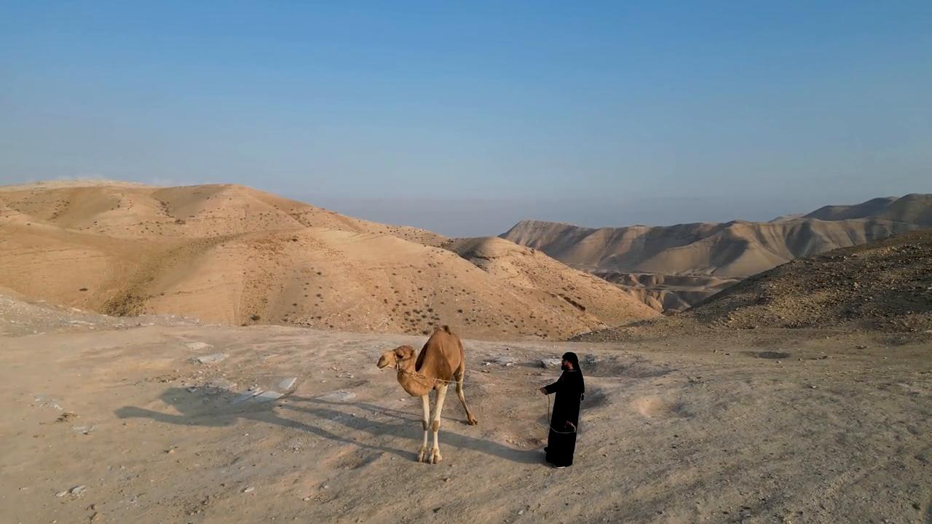
link

Ervas amargas

Video Content
(71 seconds)
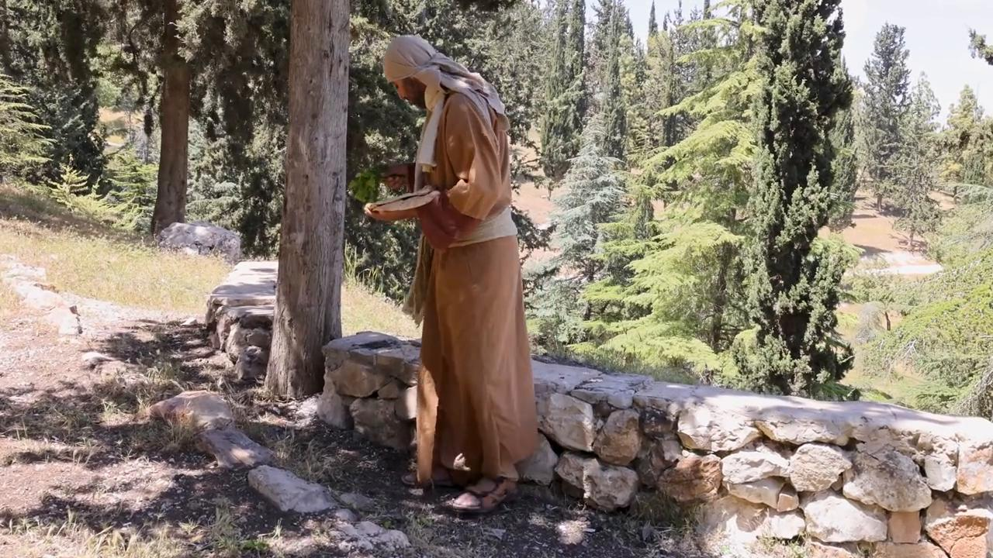
link

Escamas de peixe

Video Content
(72 seconds)
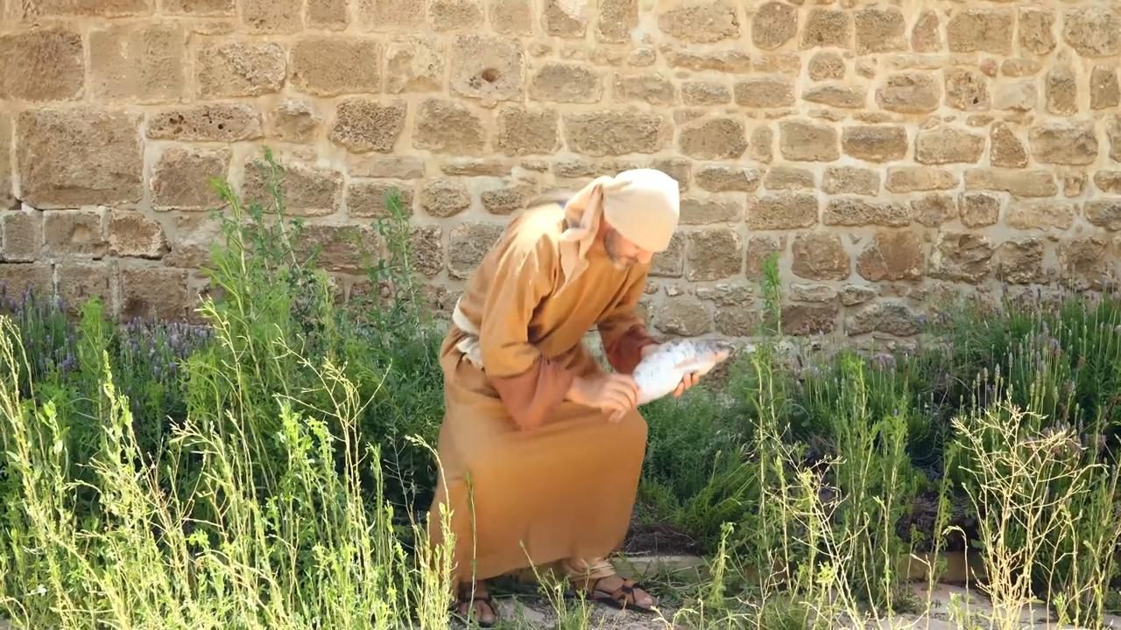
link

Esponja com vinho em uma vara

Video Content
(73 seconds)
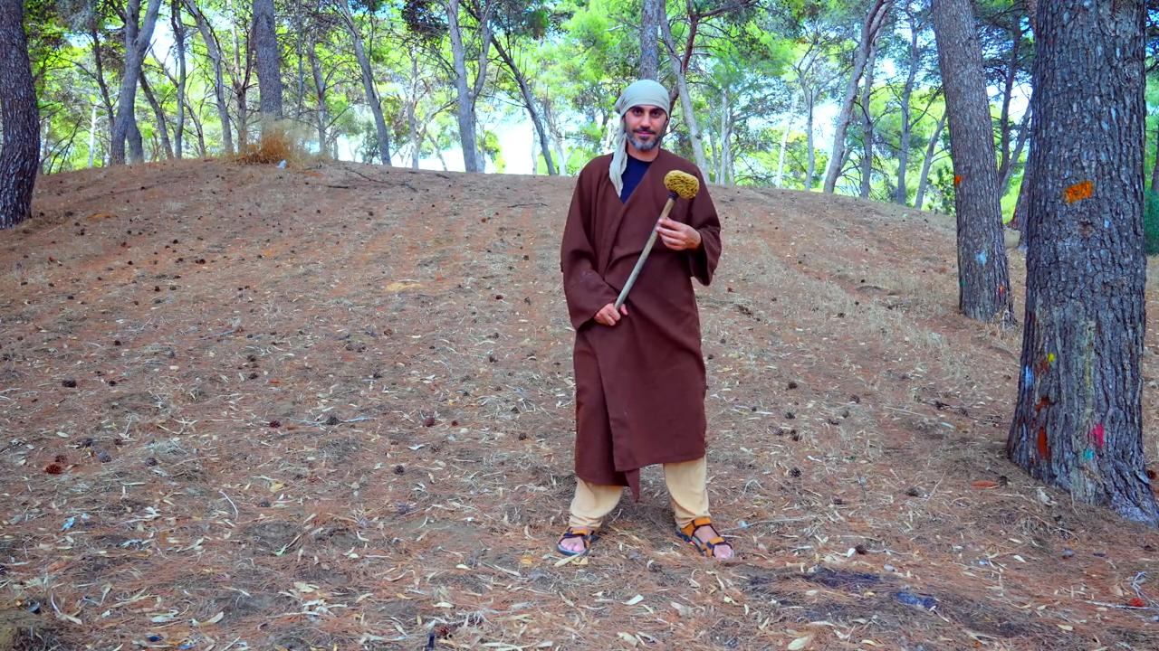
link

Esteira de dormir

Video Content
(59 seconds)
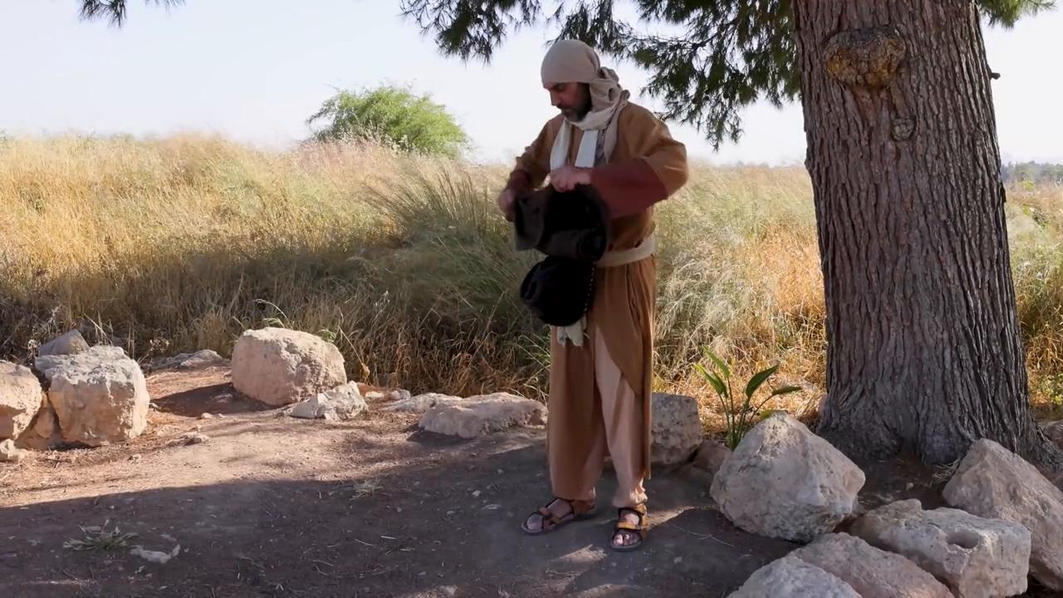
link

