Resource: Video Bible Dictionary
Video Bible Dictionary © 2023 SRV Partners. Released under CC BY-SA 4.0 license. Video Bible Dictionary has been adapted in the following languages: Tok Pisin, عربي, Français, हिंदी, Bahasa Indonesia, Português, Русский, Español, Kiswahili, 简体中文 from Video Bible Dictionary © 2023 SRV Partners. Released under CC BY-SA 4.0 license by Mission Mutual

Video Bible Dictionary

M

Machado

Video Content
(69 seconds)
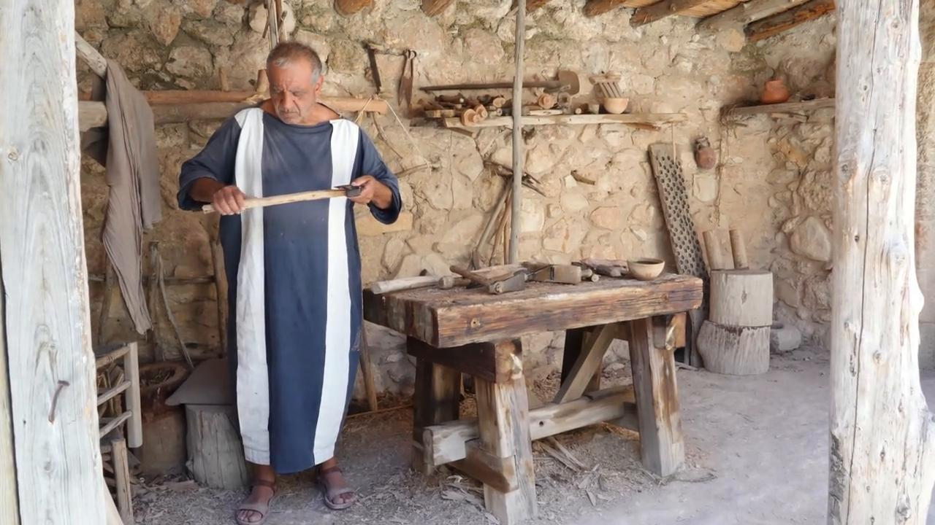
link

Manjedoura

Video Content
(70 seconds)
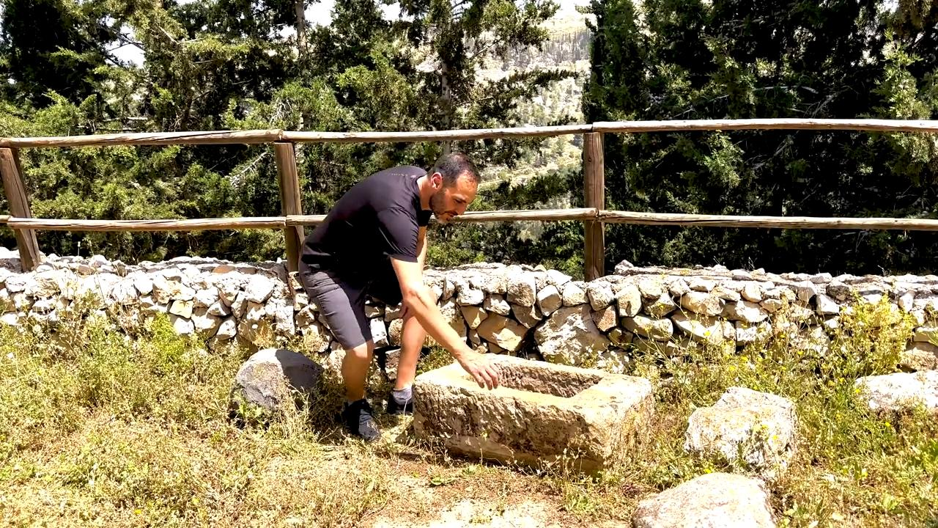
link

Manto branco

Video Content
(76 seconds)
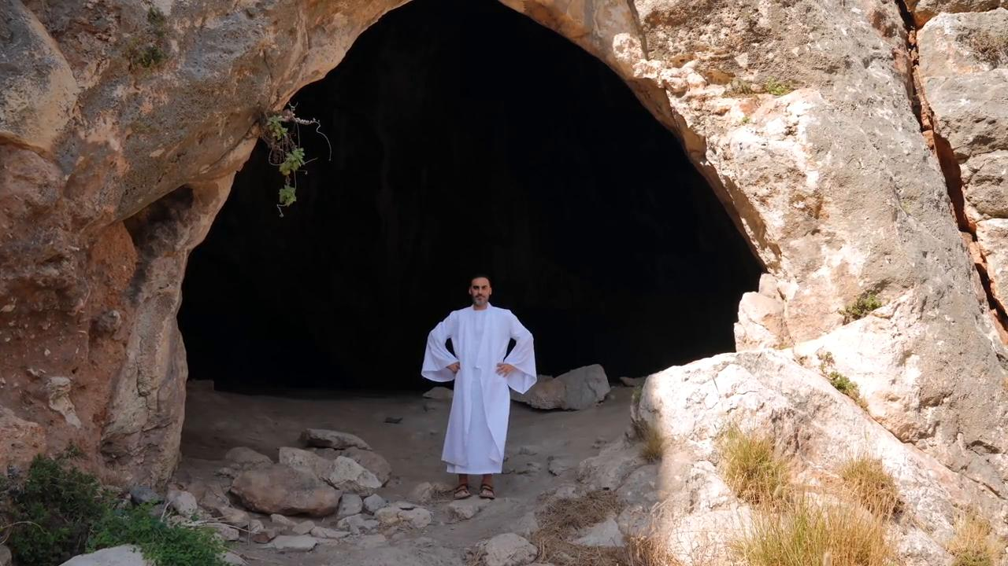
link

Manto roxo

Video Content
(89 seconds)
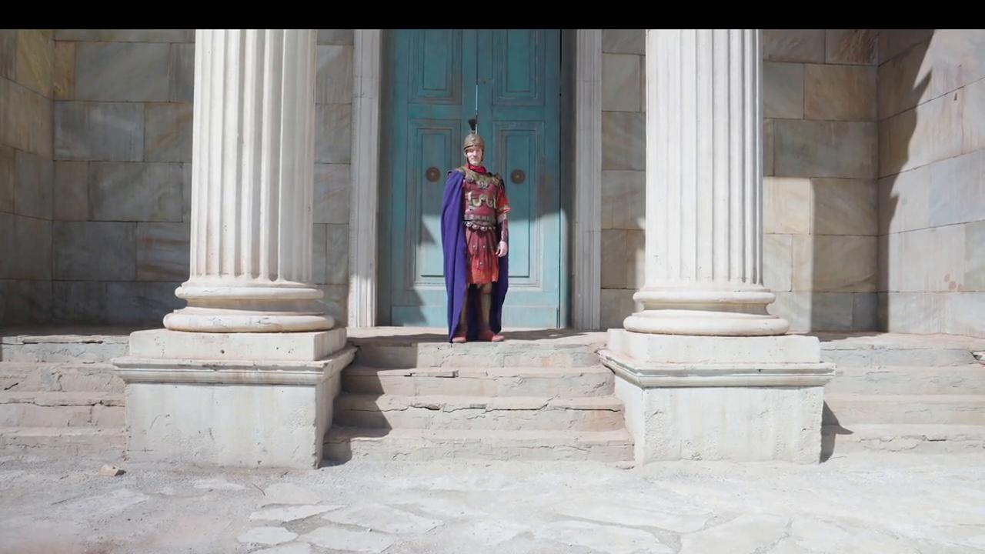
link

Mar da Galileia

Video Content
(114 seconds)
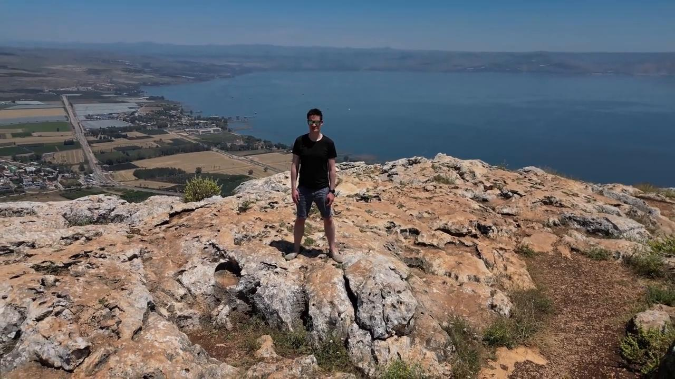
link

Mó de moinho

Video Content
(88 seconds)
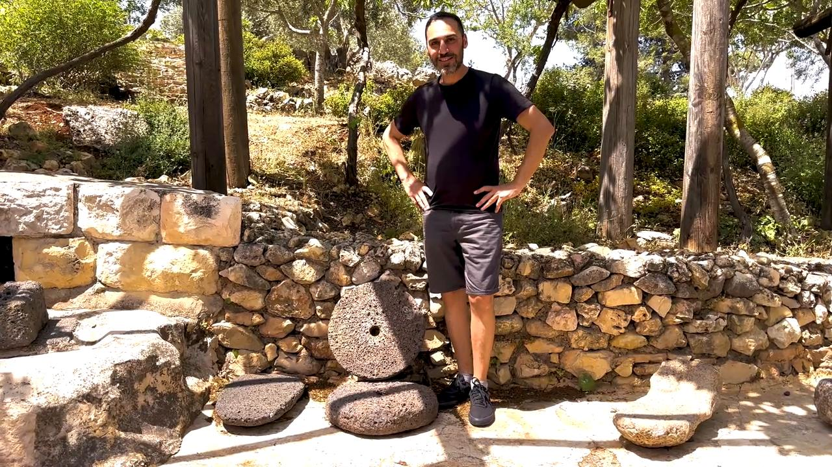
link

Moedas

Video Content
(65 seconds)
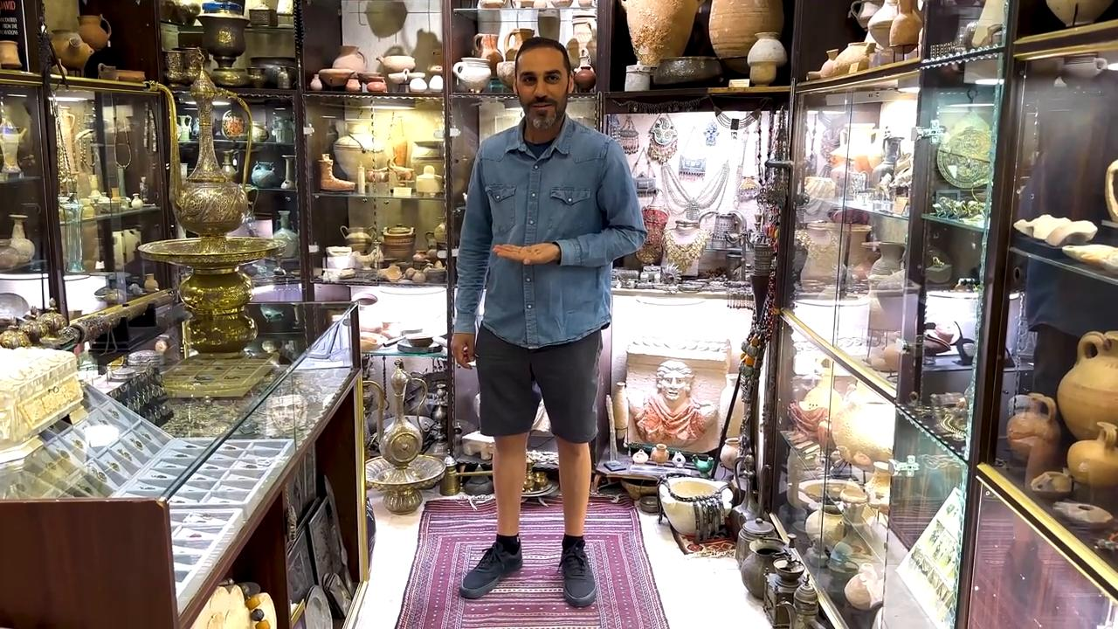
link

Moedas de cobre

Video Content
(69 seconds)

link

Monte das Oliveiras

Video Content
(90 seconds)
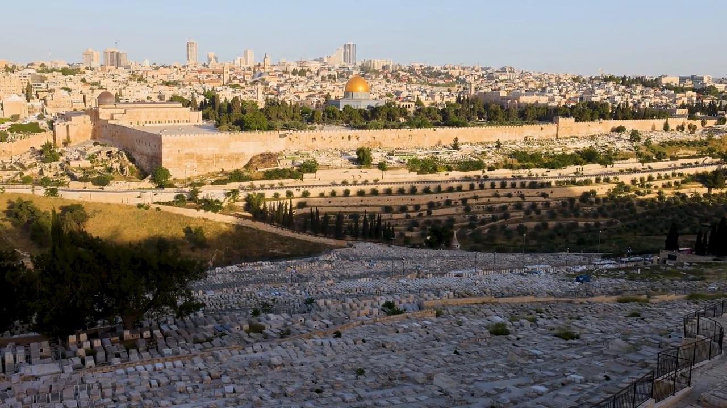
link

Muro de pedras ao redor de uma vinha

Video Content
(71 seconds)
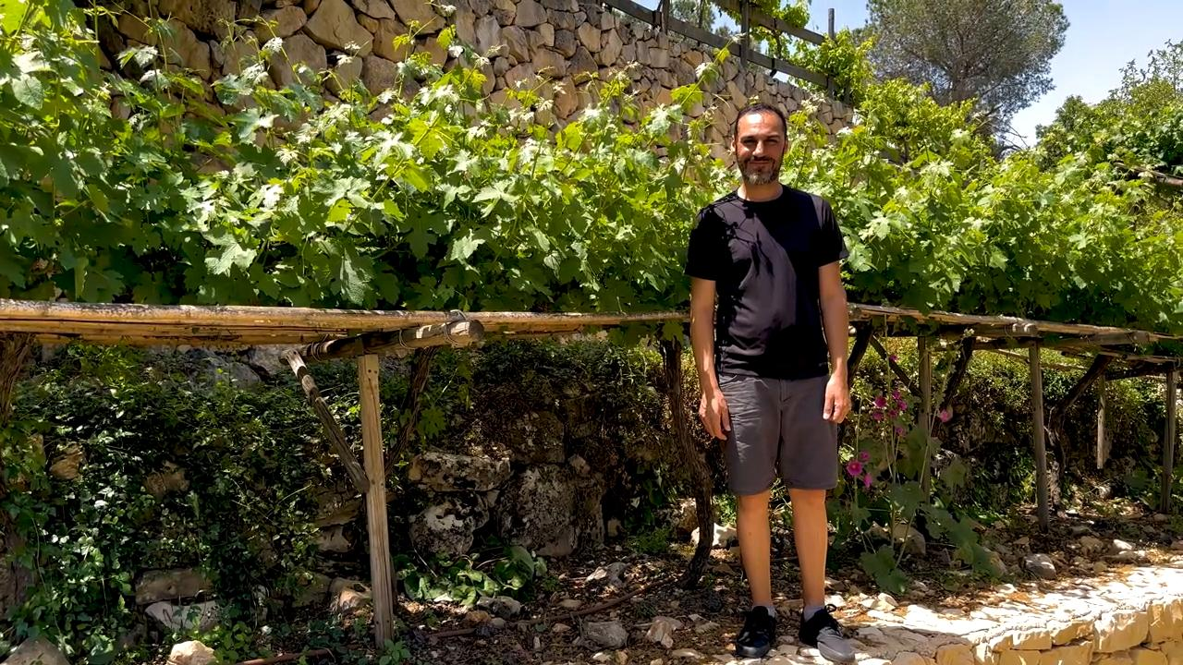
link

