Resource: Video Bible Dictionary
Video Bible Dictionary © 2023 SRV Partners. Released under CC BY-SA 4.0 license. Video Bible Dictionary has been adapted in the following languages: Tok Pisin, عربي, Français, हिंदी, Bahasa Indonesia, Português, Русский, Español, Kiswahili, 简体中文 from Video Bible Dictionary © 2023 SRV Partners. Released under CC BY-SA 4.0 license by Mission Mutual

Video Bible Dictionary

P

Pá de joeirar

Video Content
(75 seconds)
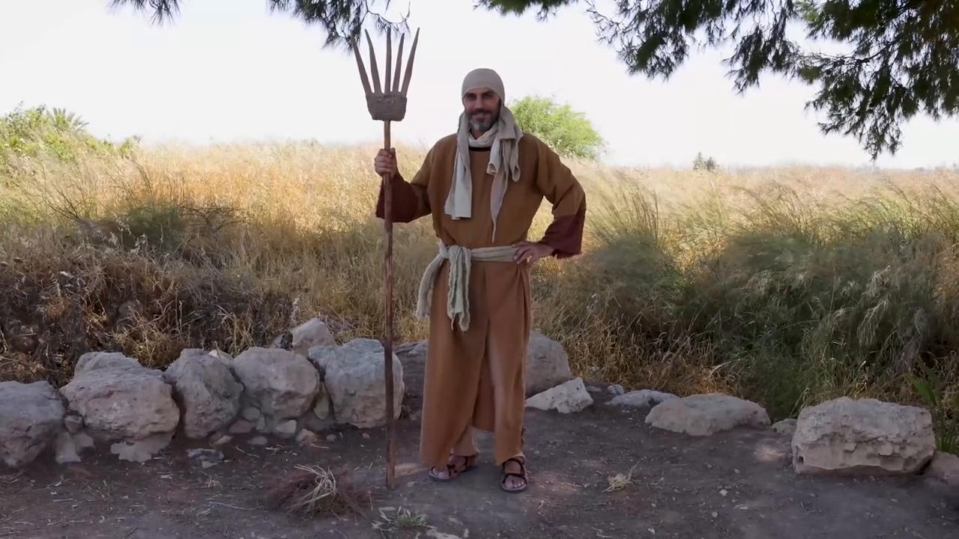
link

Pano de saco

Video Content
(70 seconds)
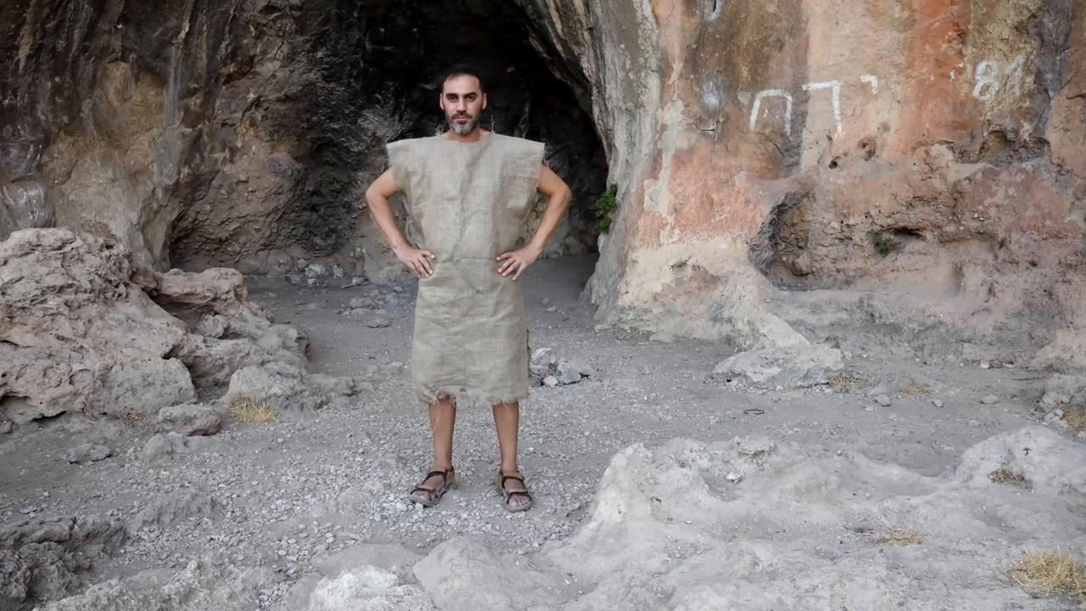
link

Pão sem fermento

Video Content
(71 seconds)
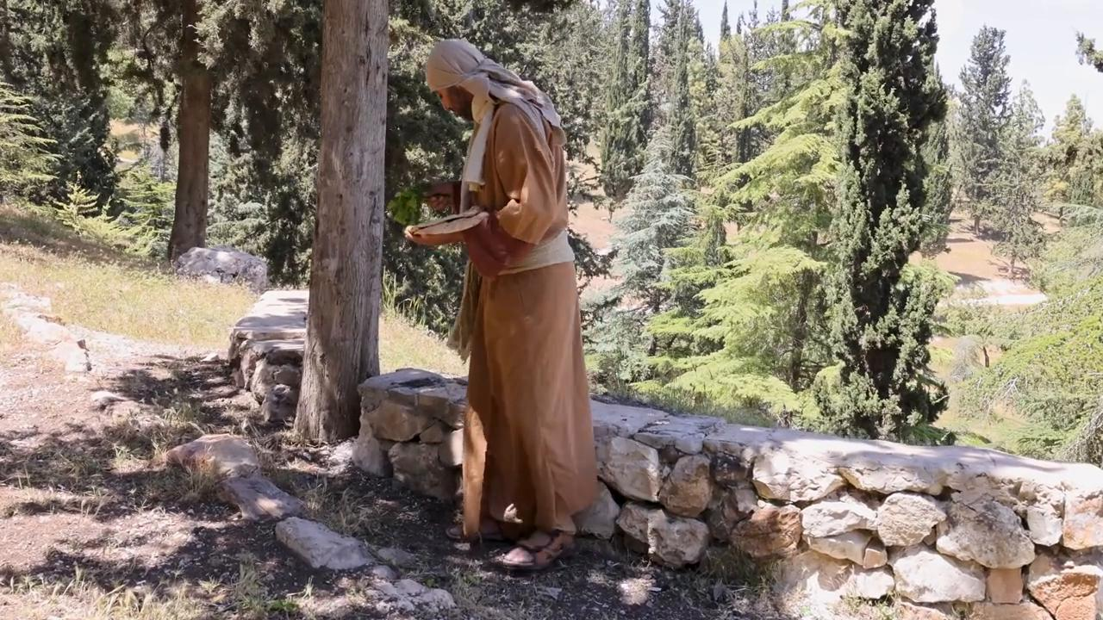
link

Pedra angular

Video Content
(77 seconds)
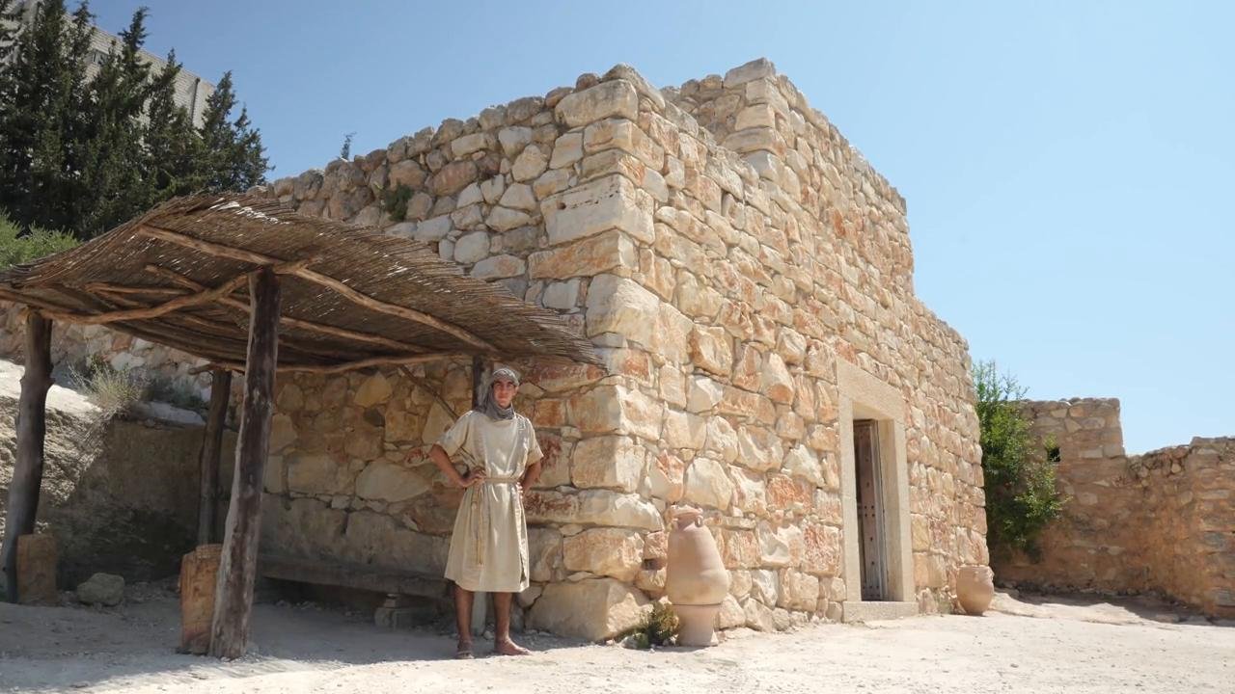
link

Peixe

Video Content
(85 seconds)
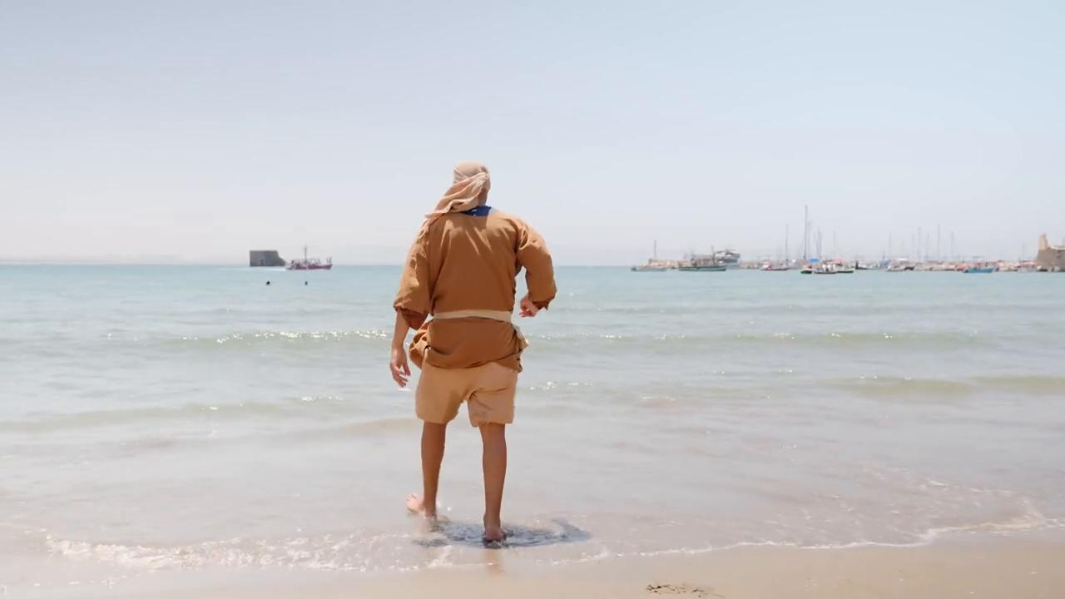
link

Peixe cozido

Video Content
(81 seconds)
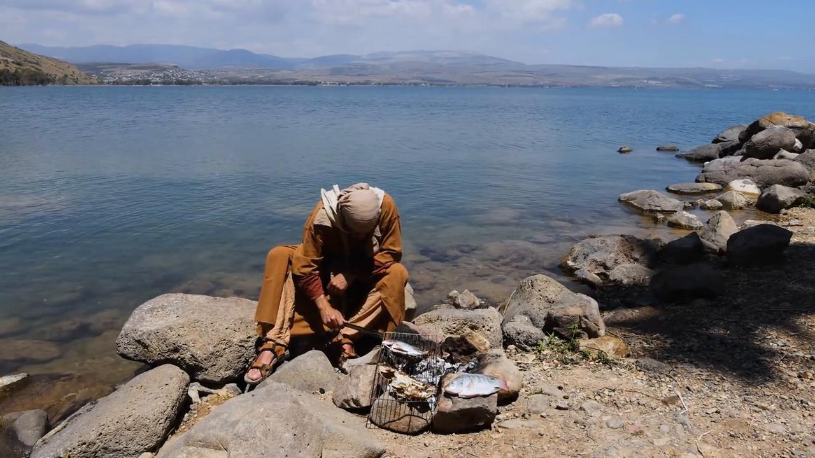
link

Penhascos

Video Content
(49 seconds)
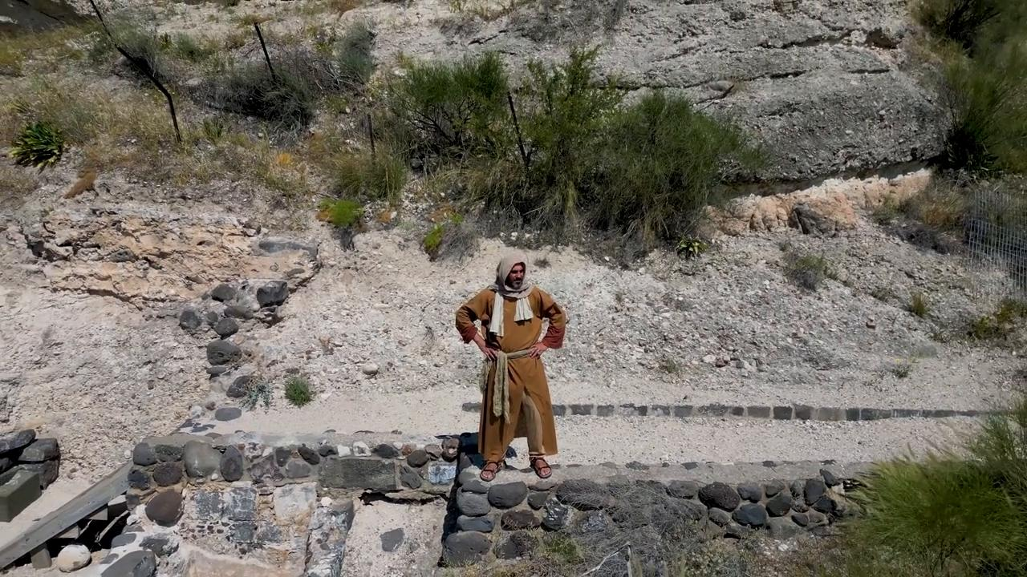
link

Pérolas

Video Content
(75 seconds)
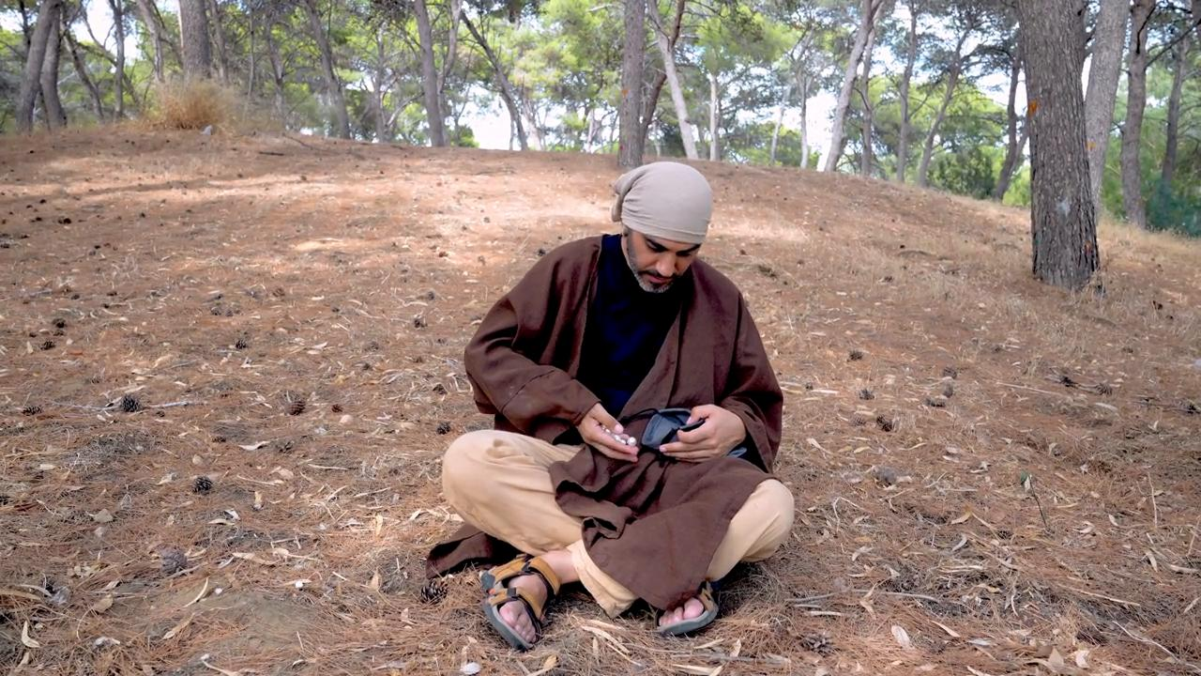
link

Planta de junco

Video Content
(82 seconds)
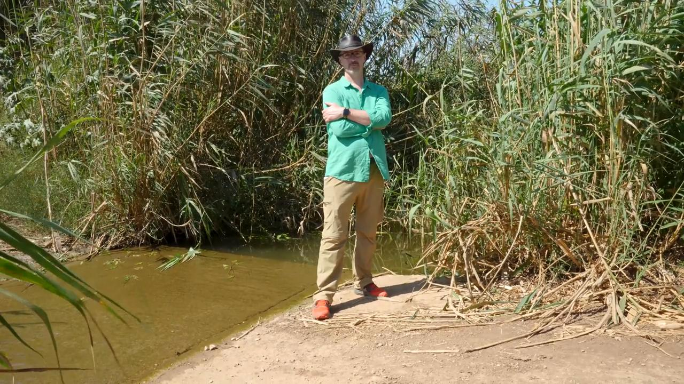
link

Portão da cidade

Video Content
(118 seconds)
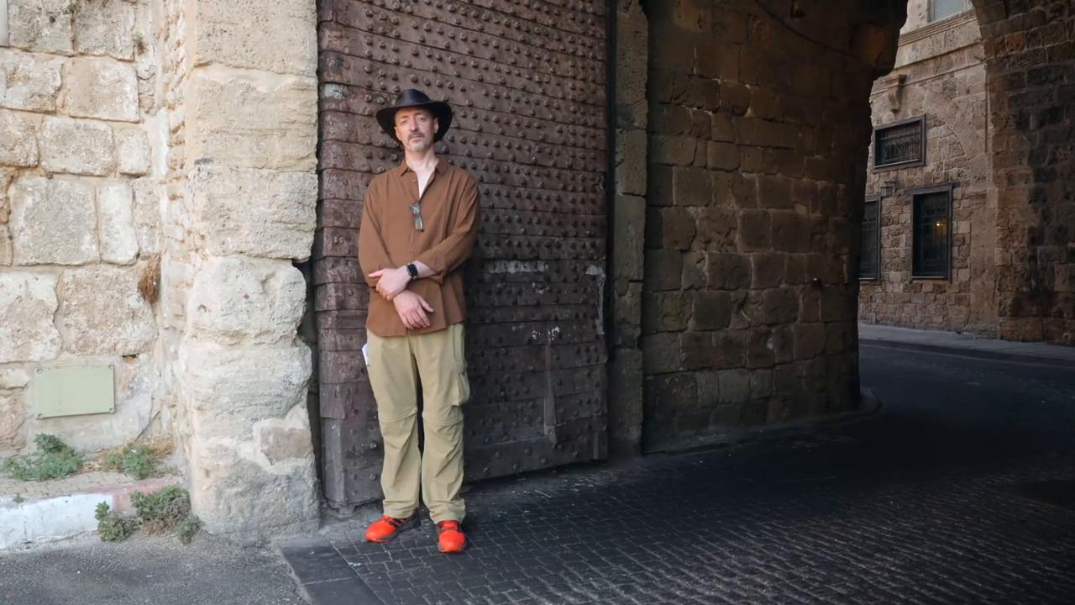
link

Portão de ferro

Video Content
(59 seconds)
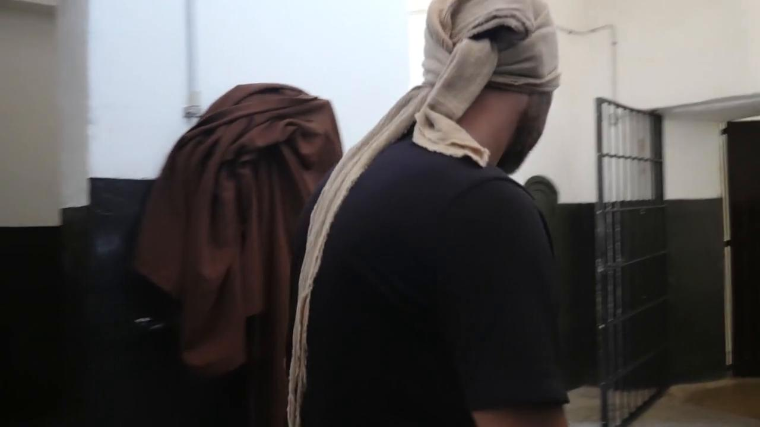
link

