Resource: Video Bible Dictionary
Video Bible Dictionary © 2023 SRV Partners. Released under CC BY-SA 4.0 license. Video Bible Dictionary has been adapted in the following languages: Tok Pisin, عربي, Français, हिंदी, Bahasa Indonesia, Português, Русский, Español, Kiswahili, 简体中文 from Video Bible Dictionary © 2023 SRV Partners. Released under CC BY-SA 4.0 license by Mission Mutual

Video Bible Dictionary

T

Tabuinha

Video Content
(72 seconds)
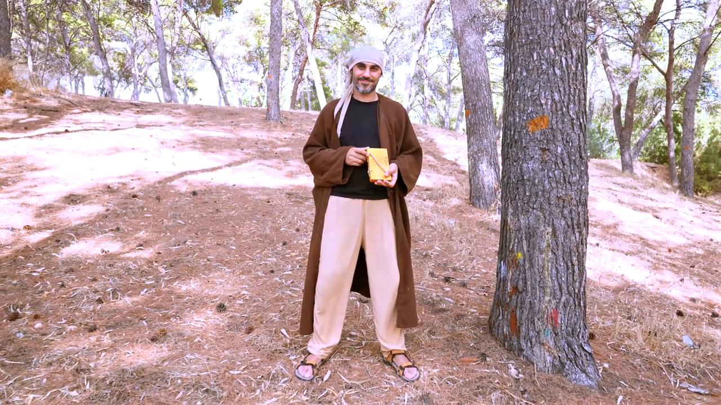
link

Topo da colina

Video Content
(101 seconds)
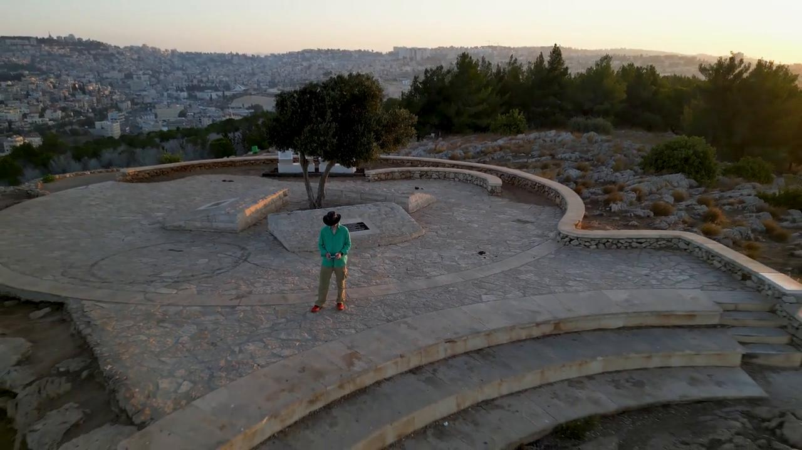
link

Torre de vigia para uma vinha

Video Content
(97 seconds)
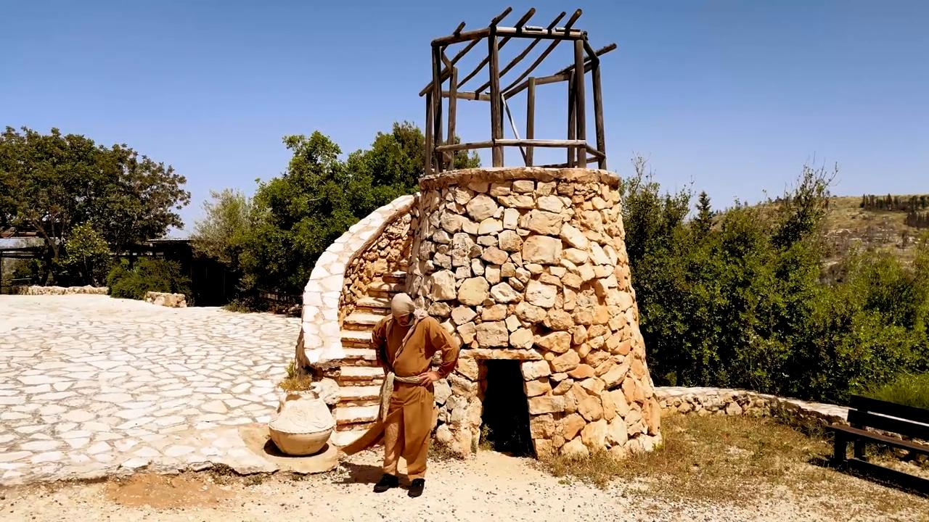
link

Trigo com espigas

Video Content
(131 seconds)
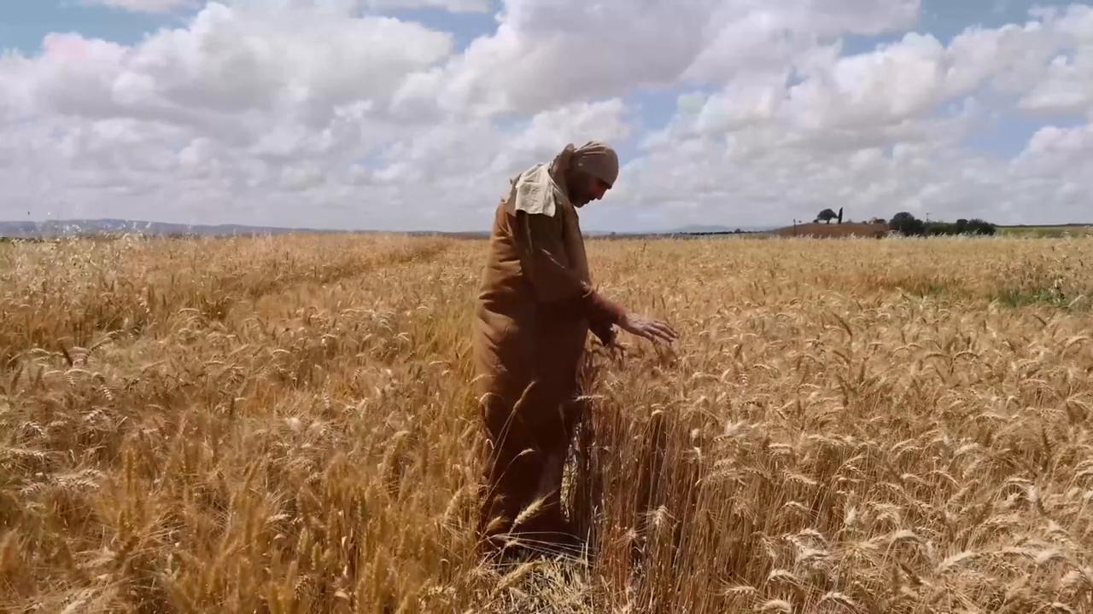
link

Trigo pronto para a colheita

Video Content
(79 seconds)
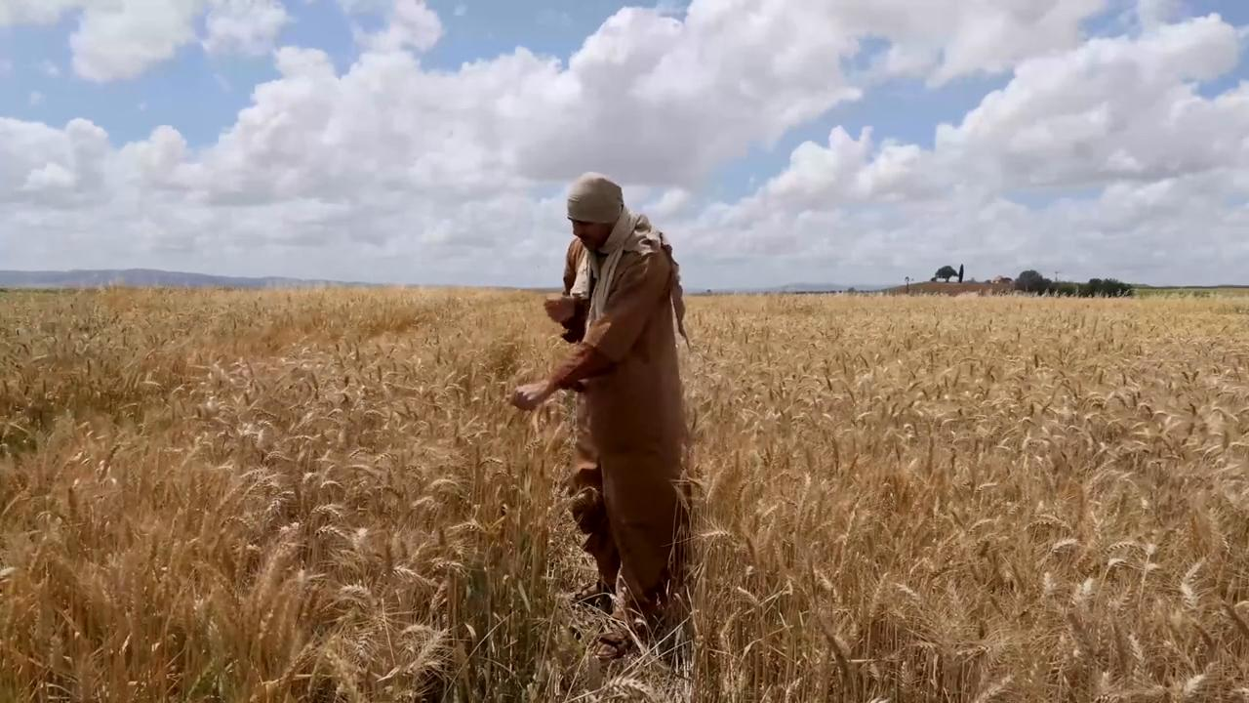
link

Túmulo do jardim

Video Content
(84 seconds)
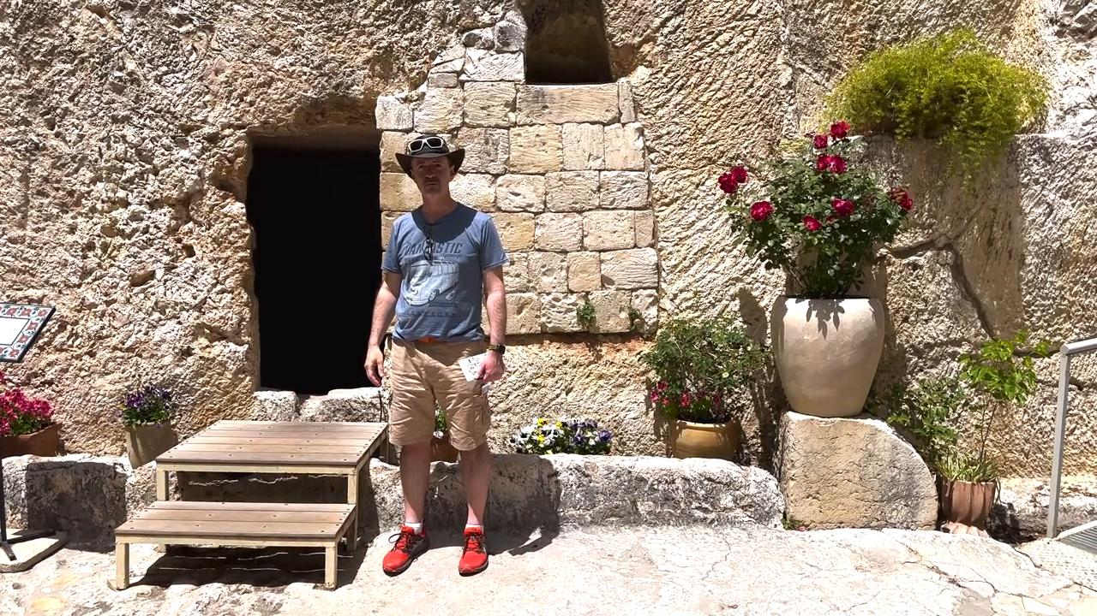
link

Túmulos

Video Content
(93 seconds)
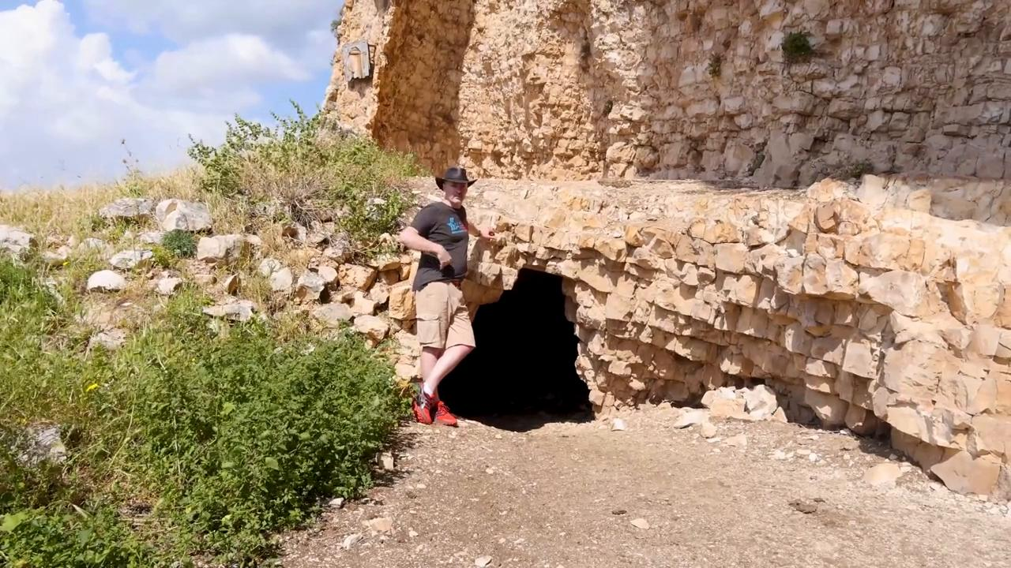
link

Túnica

Video Content
(82 seconds)
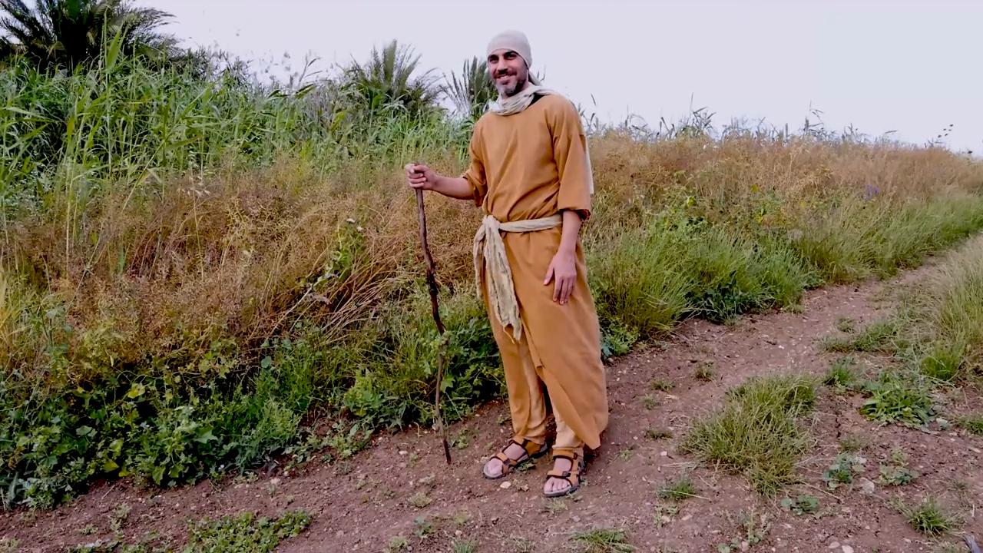
link

