Resource: Video Bible Dictionary
Video Bible Dictionary © 2023 SRV Partners. Released under CC BY-SA 4.0 license. Video Bible Dictionary has been adapted in the following languages: Tok Pisin, عربي, Français, हिंदी, Bahasa Indonesia, Português, Русский, Español, Kiswahili, 简体中文 from Video Bible Dictionary © 2023 SRV Partners. Released under CC BY-SA 4.0 license by Mission Mutual

Video Bible Dictionary

C

Cadenas

Video Content
(73 seconds)
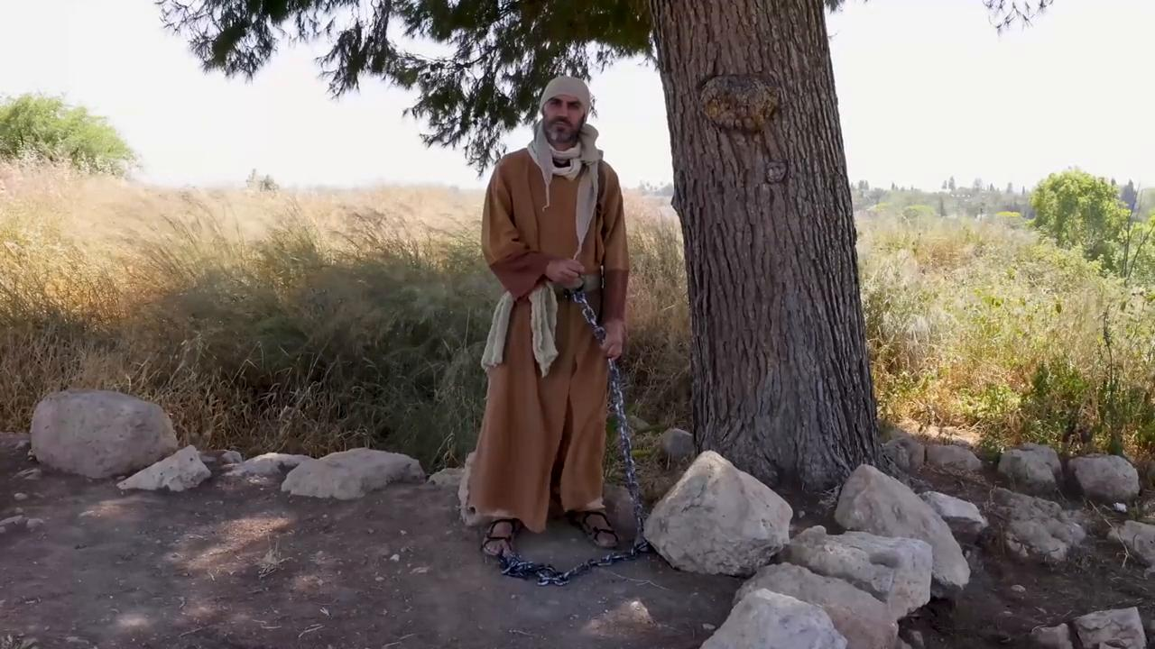
link

Camello

Video Content
(58 seconds)
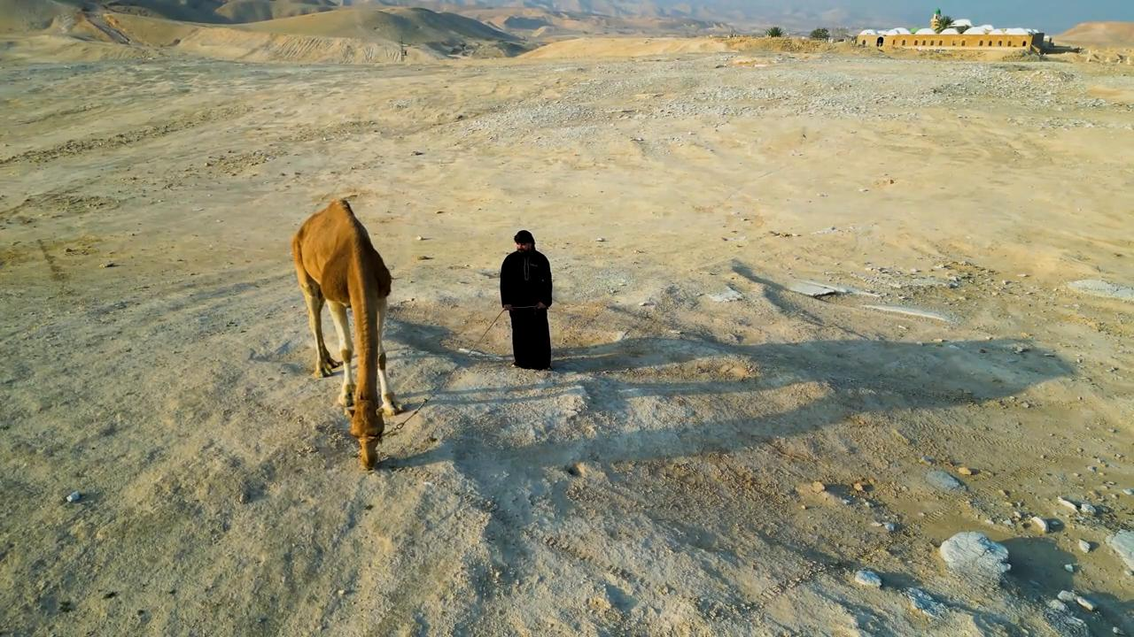
link

Candelero

Video Content
(84 seconds)
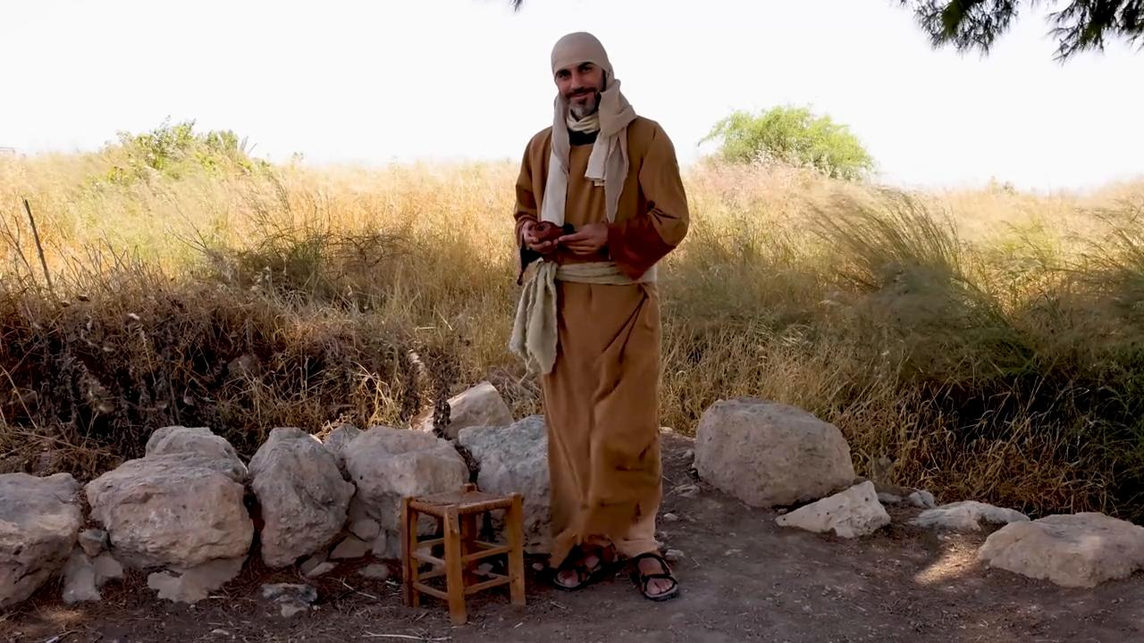
link

Casa en el tiempo de Jesús

Video Content
(87 seconds)
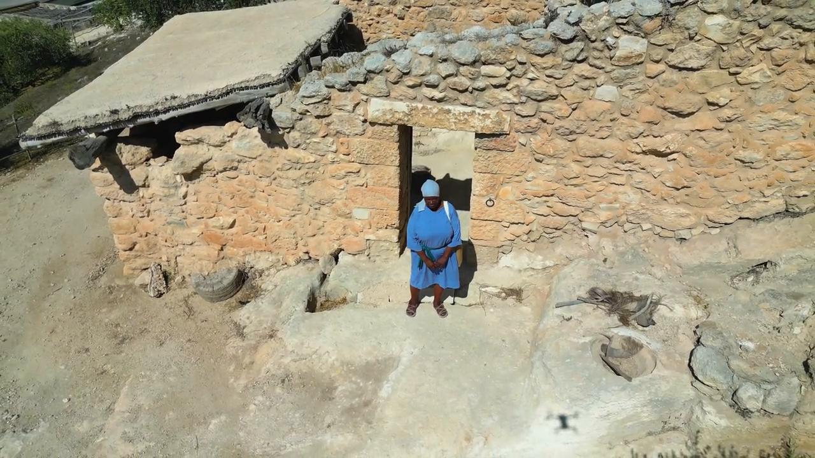
link

Cesta como celemín

Video Content
(77 seconds)
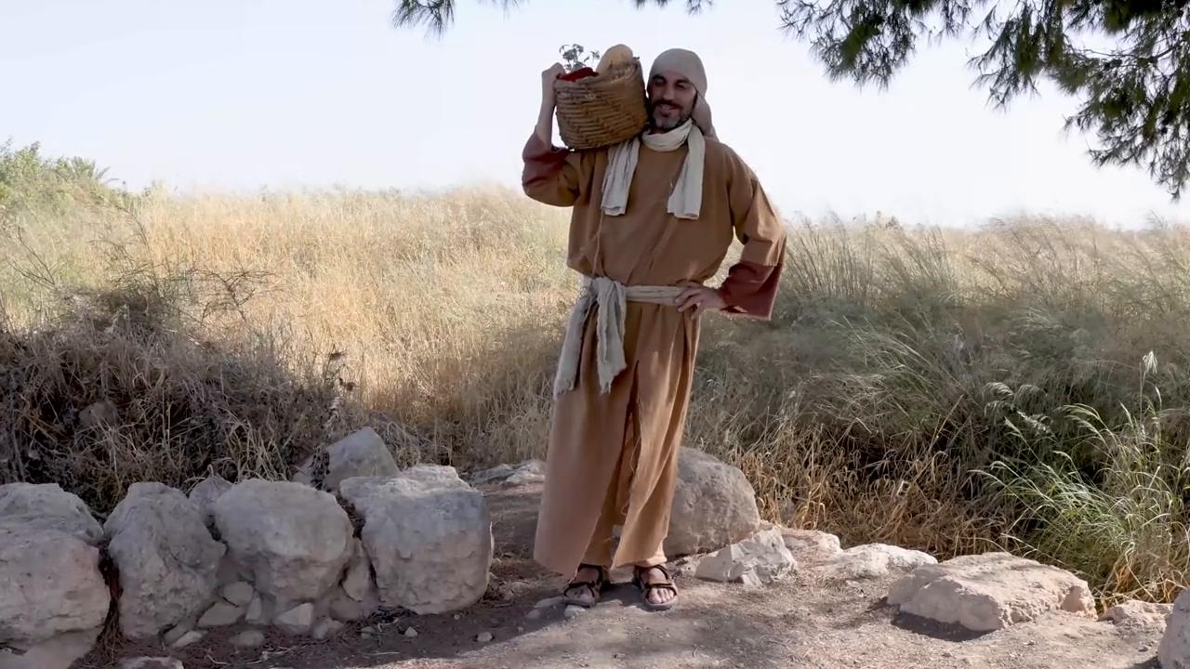
link

Cesta grande

Video Content
(83 seconds)
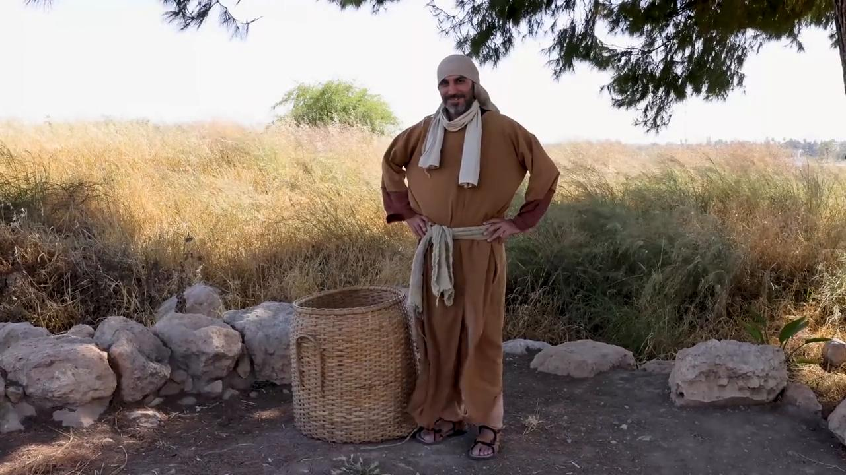
link

Cesta para provisiones

Video Content
(88 seconds)
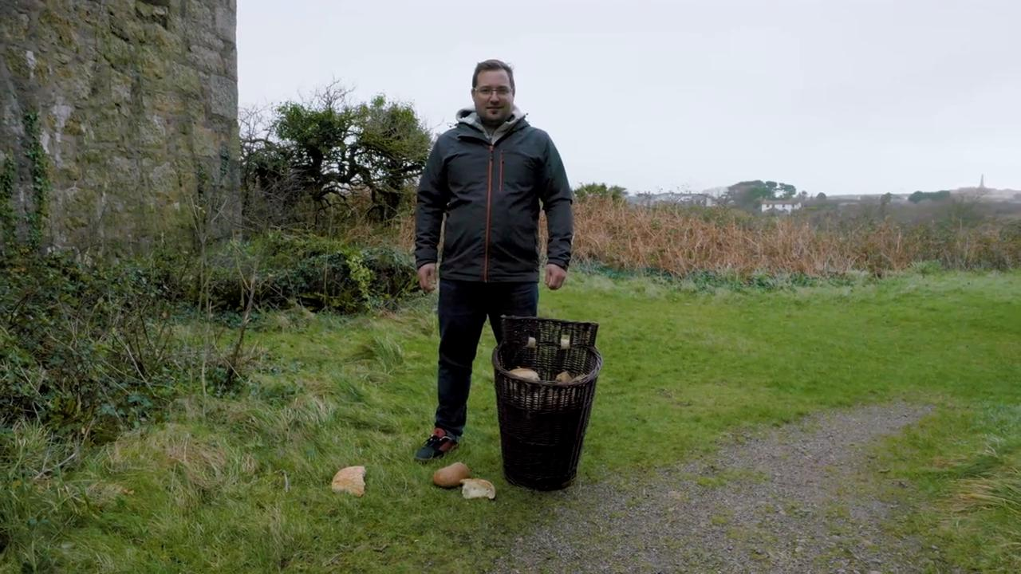
link

Cuatro suelos

Video Content
(89 seconds)
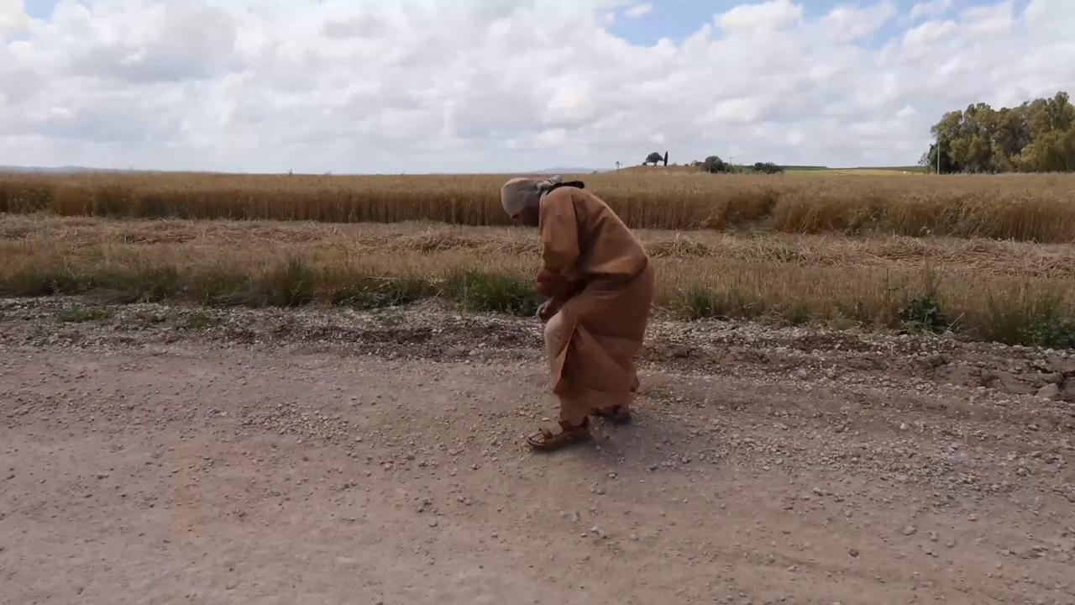
link

