Resource: Video Bible Dictionary
Video Bible Dictionary © 2023 SRV Partners. Released under CC BY-SA 4.0 license. Video Bible Dictionary has been adapted in the following languages: Tok Pisin, عربي, Français, हिंदी, Bahasa Indonesia, Português, Русский, Español, Kiswahili, 简体中文 from Video Bible Dictionary © 2023 SRV Partners. Released under CC BY-SA 4.0 license by Mission Mutual

Video Bible Dictionary

M

Manto

Video Content
(72 seconds)
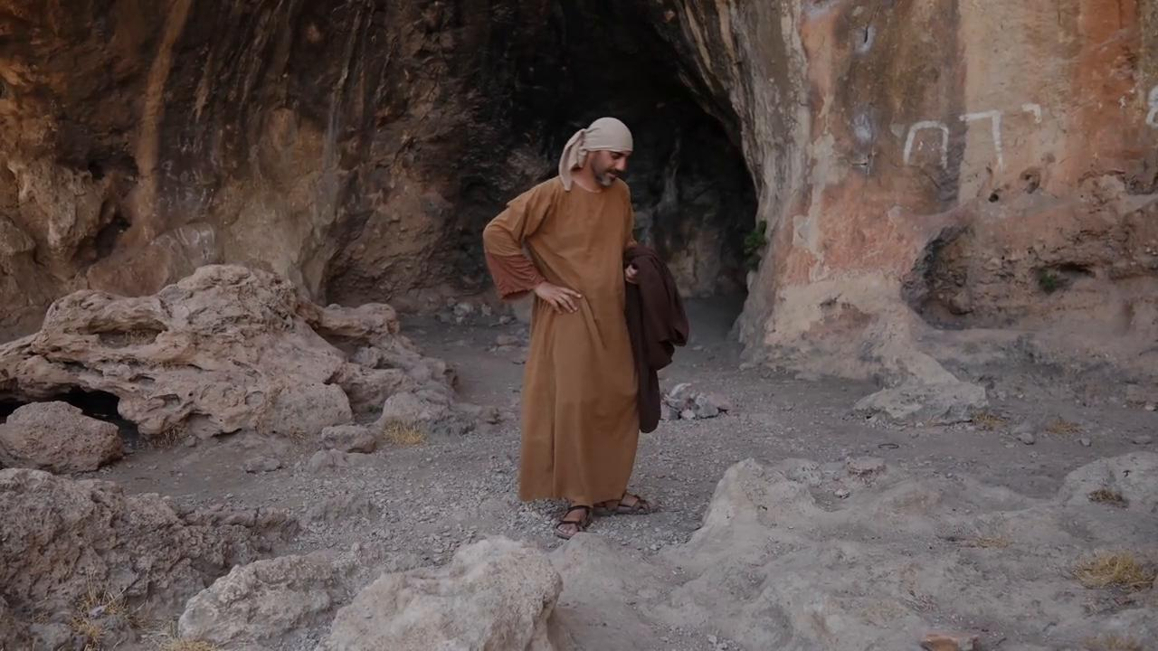
link

Mar de Galilea

Video Content
(114 seconds)
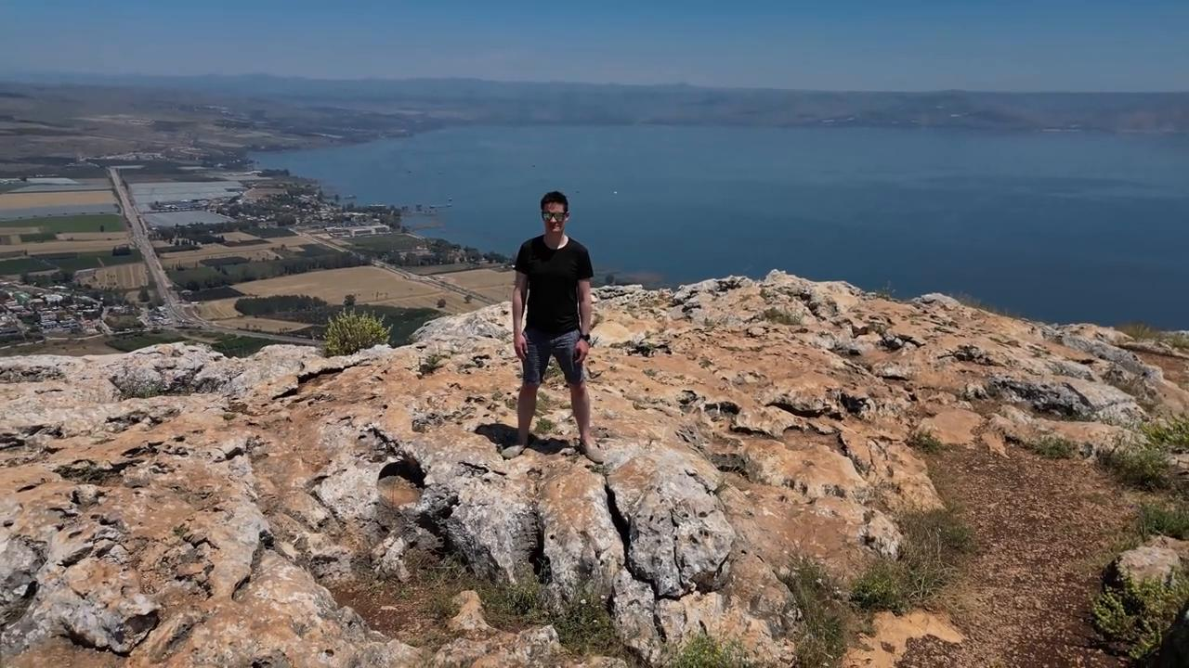
link

Monedas

Video Content
(65 seconds)
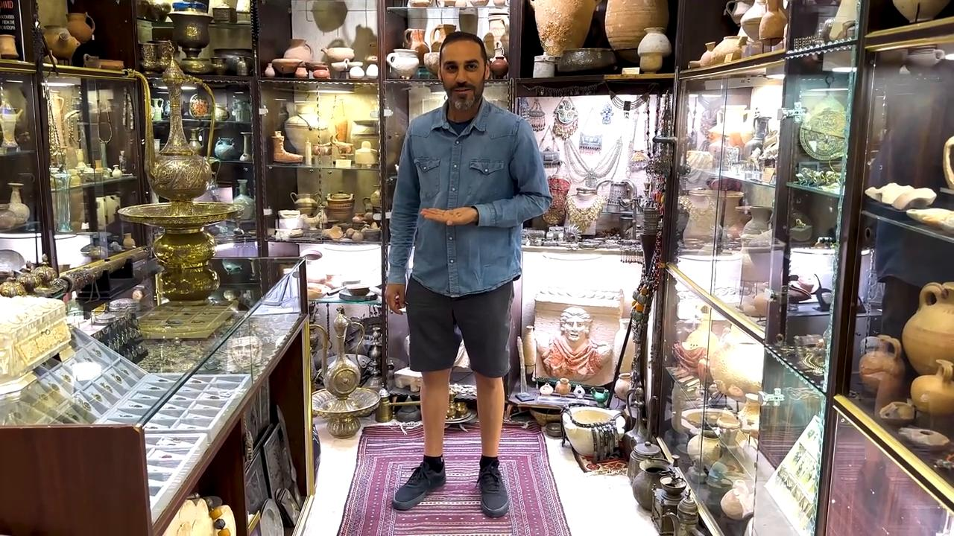
link

Monedas de cobre

Video Content
(69 seconds)

link

Monte de los Olivos

Video Content
(90 seconds)
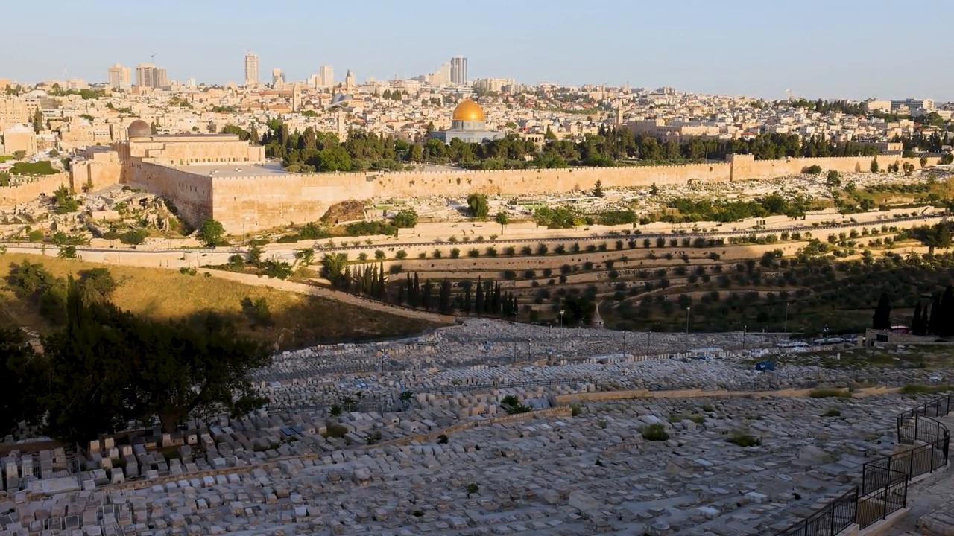
link

Muro de piedra alrededor de un viñedo

Video Content
(71 seconds)
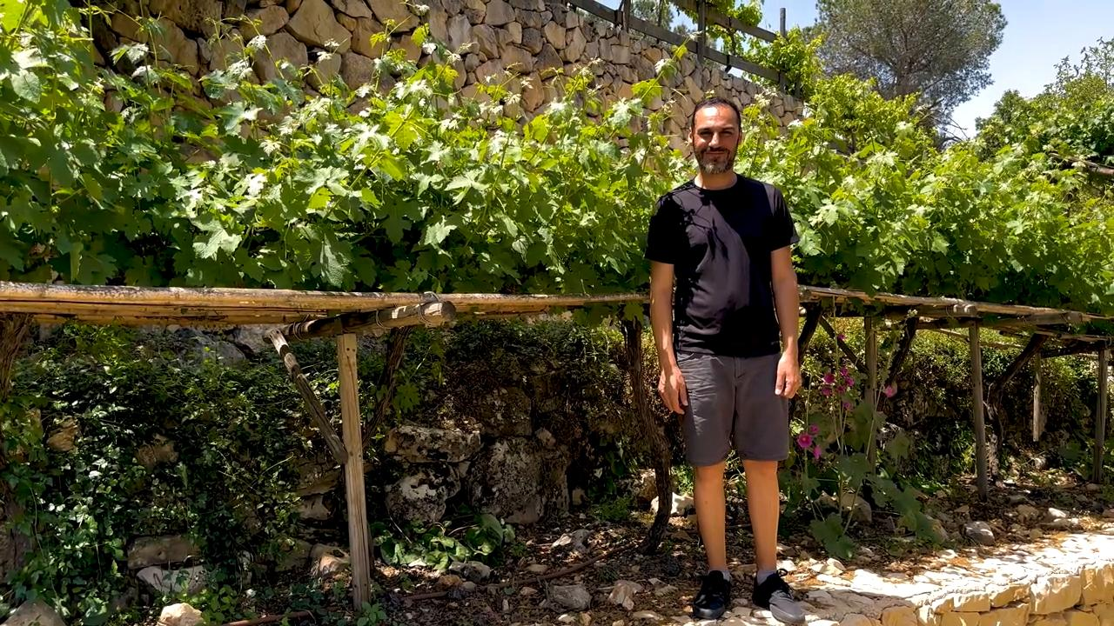
link

